1. Search in Project listing screen, Program Listing screen -> select is not converted (Chinese and Spanish)

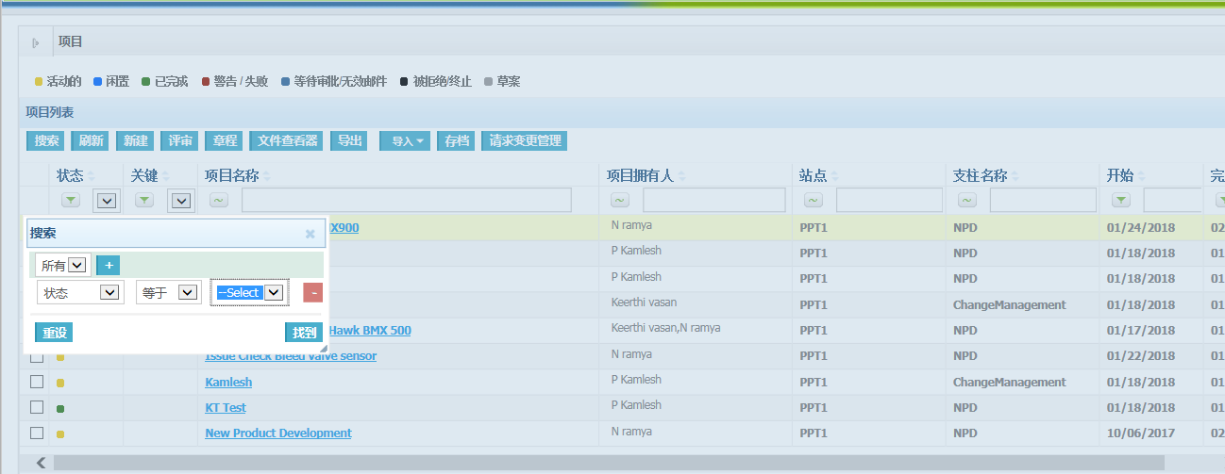

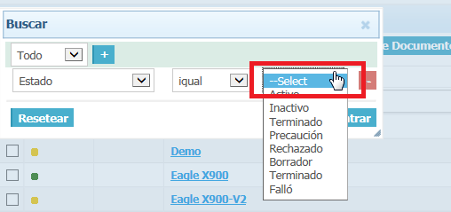

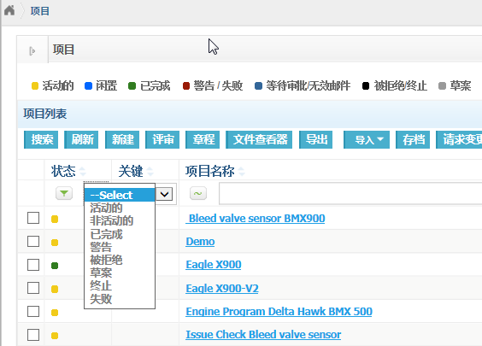

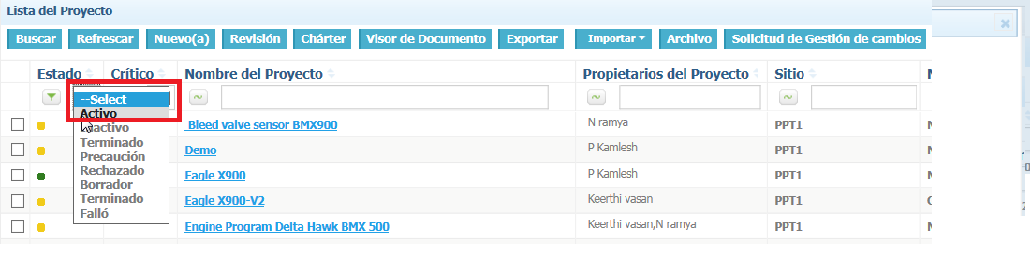

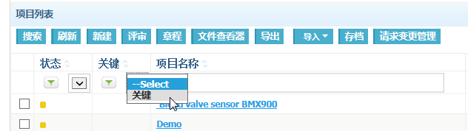

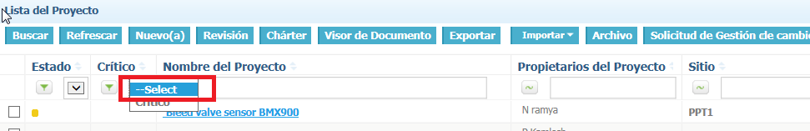

1. Project charter page: Project route-> Select option is displayed as ???

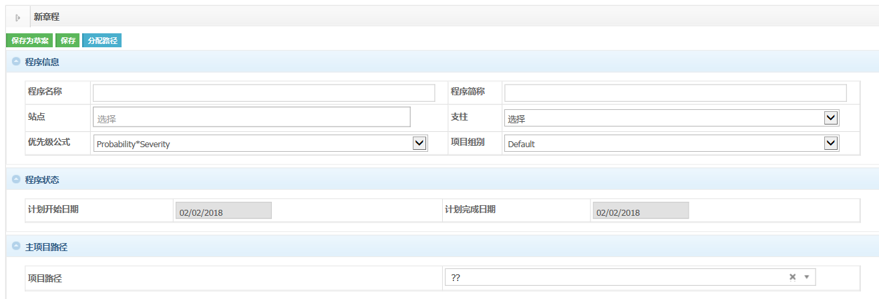

1. Charter template: Radio field

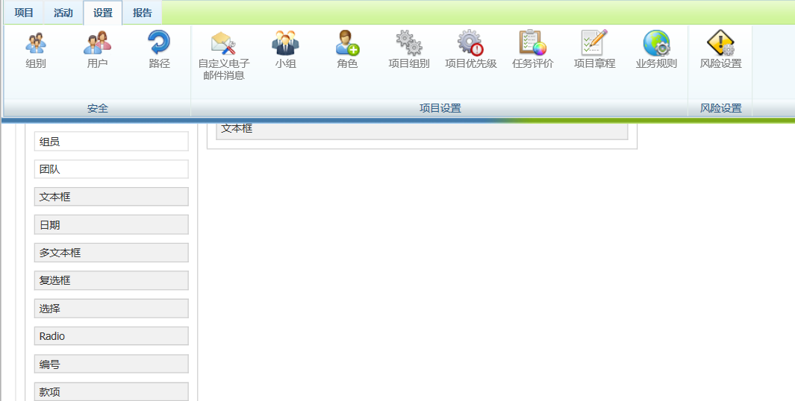

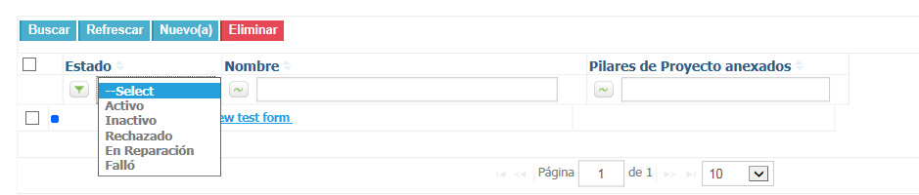

1. Project and program charter page:

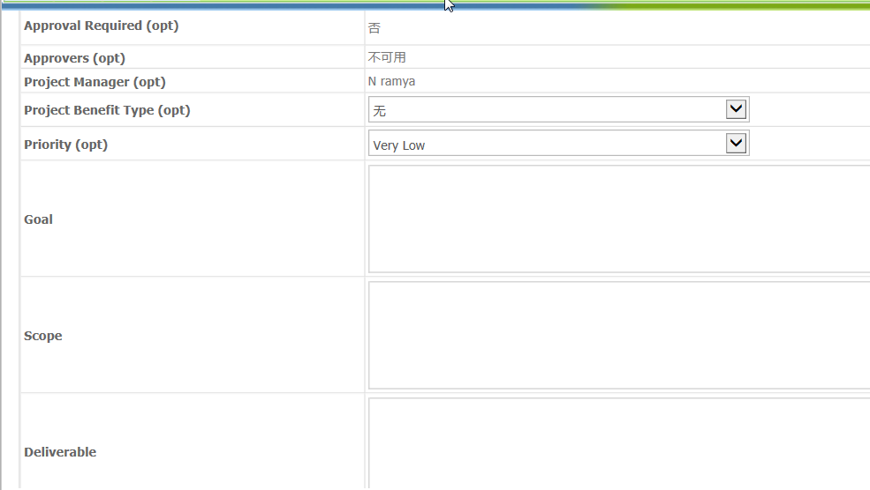

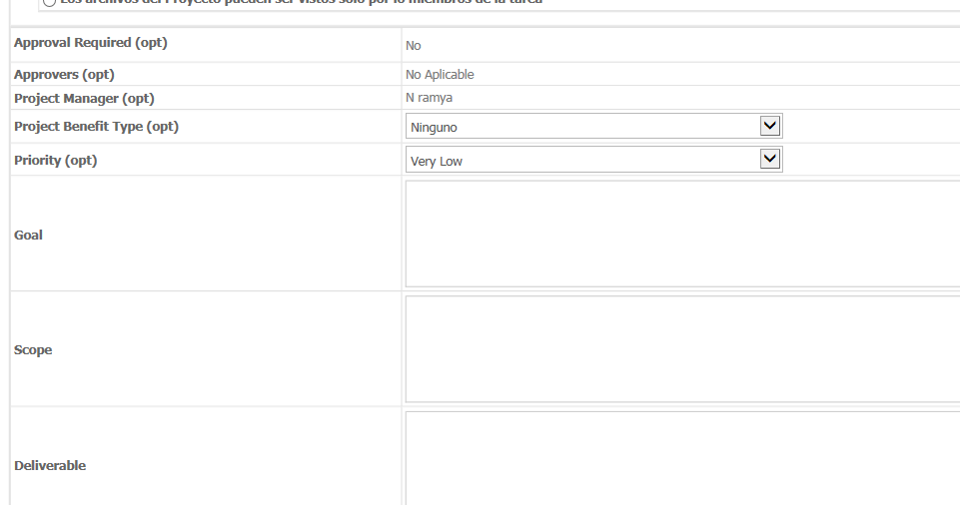

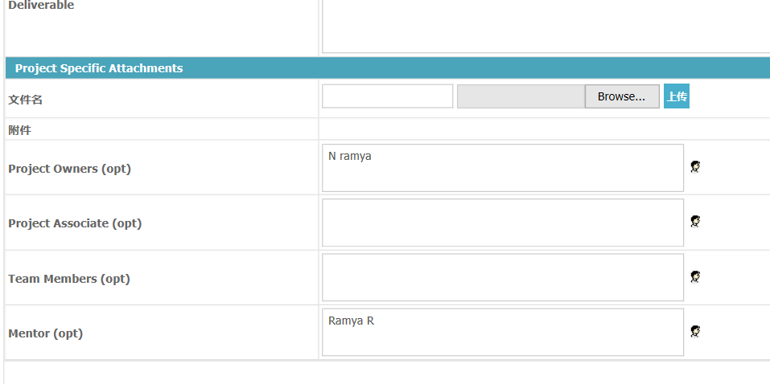

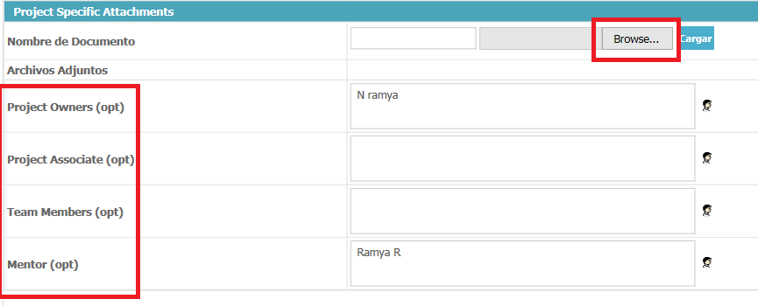

1. Project and program charter page: When clicking on save button without providing project information.

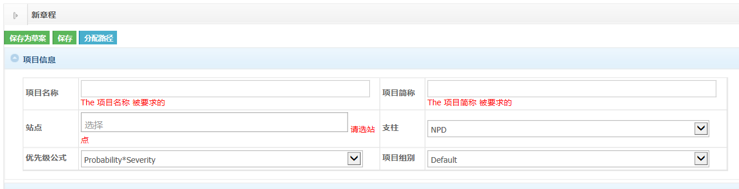

THE

THE

1. Document viewer

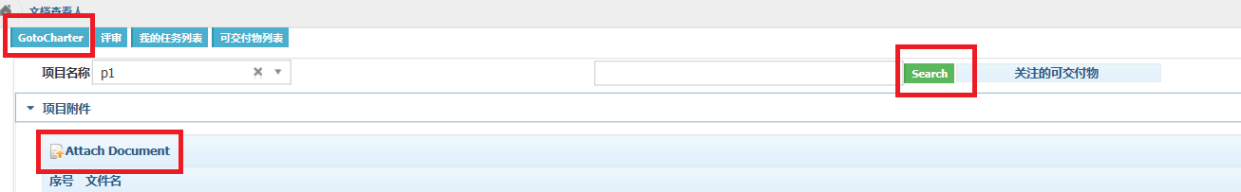

1. Review page

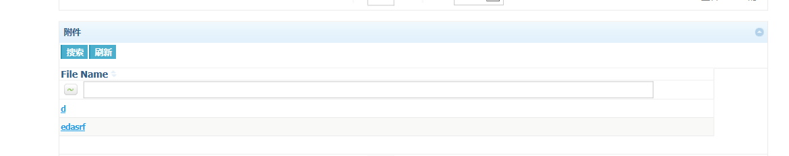

1. Import form Excel

Chinese

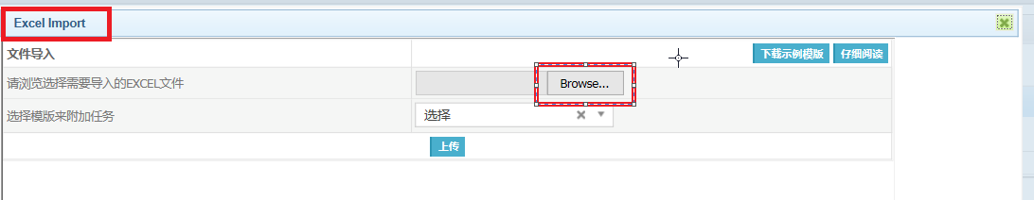

Spanish

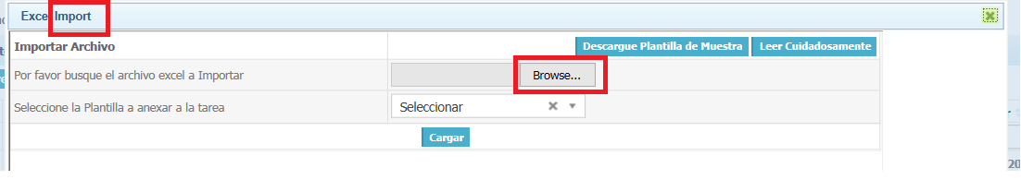

1. XML import

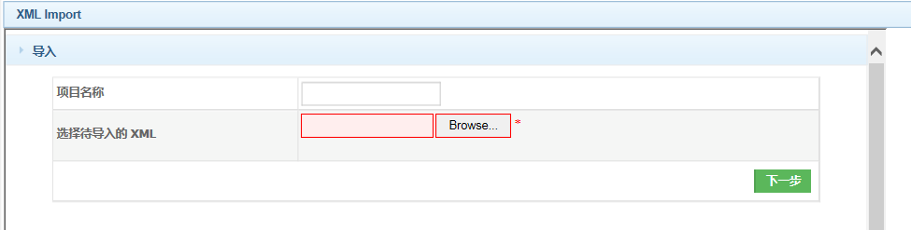

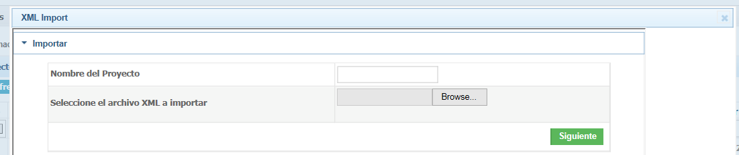

1. Silverlight page-show dear (Actual finish date)

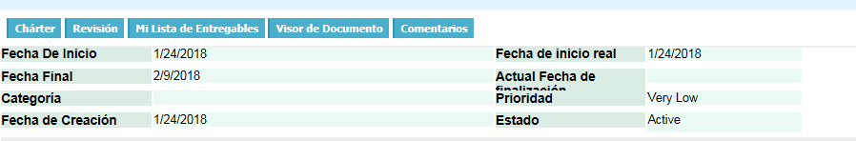

1. Gantt chart

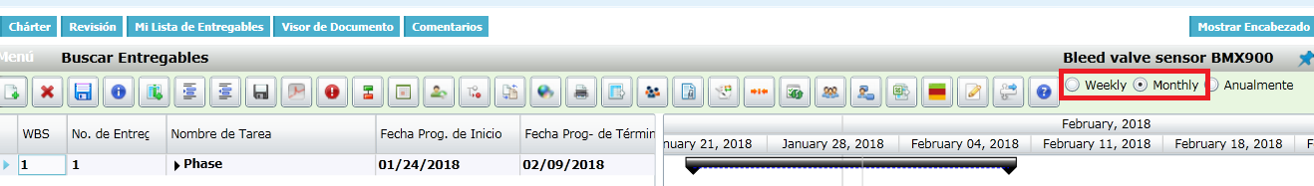

1. Enable effort driven, Constraints-Chinese language.



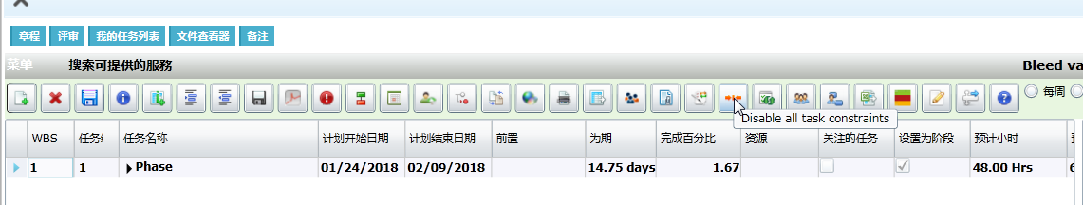

1. Action page: Spanish language

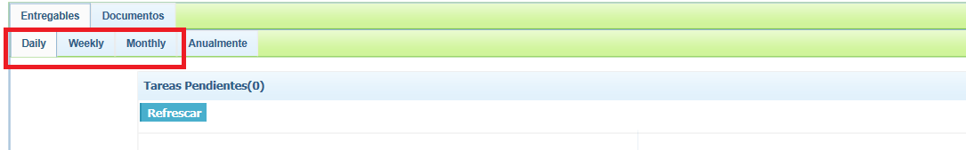

1. My deliverable list: Spanish and Chinese language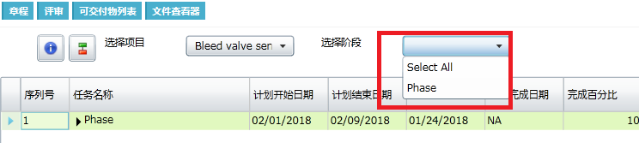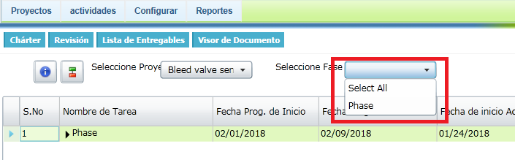
2. Hide and Show menu icon: when chinese lang is selected tool tip is displayed in spanish.

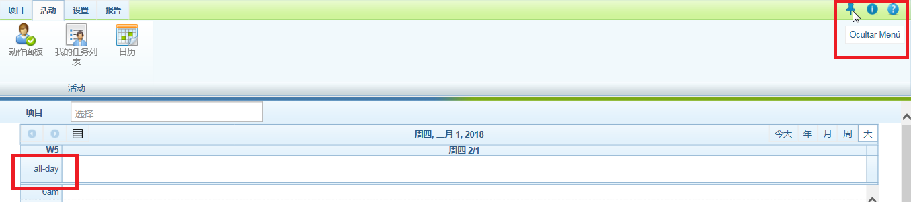

1. Users page: Rights replacement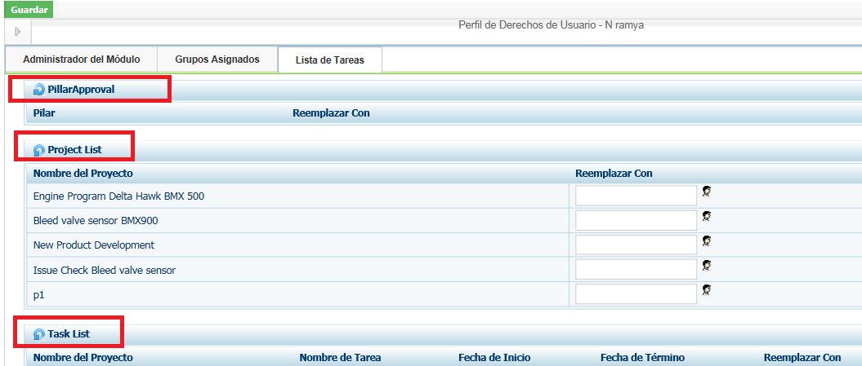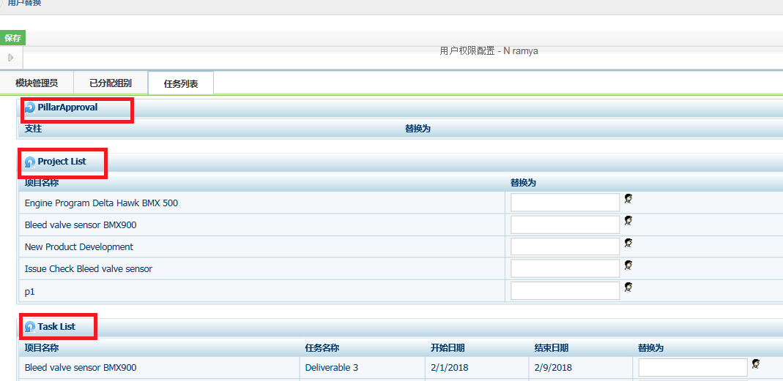
2. Routes page-Spanish language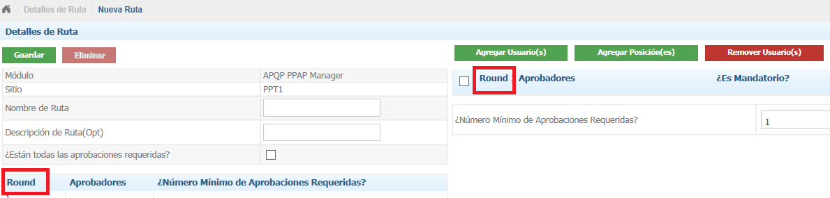
3. Customized email messages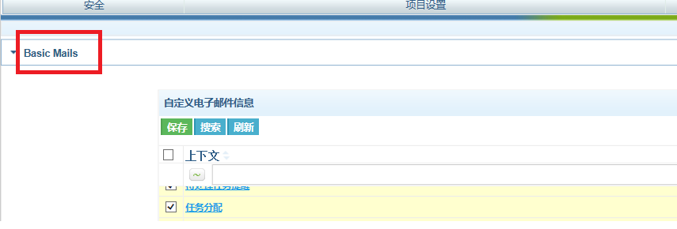
4. Charter form: form name not converted to Spanish language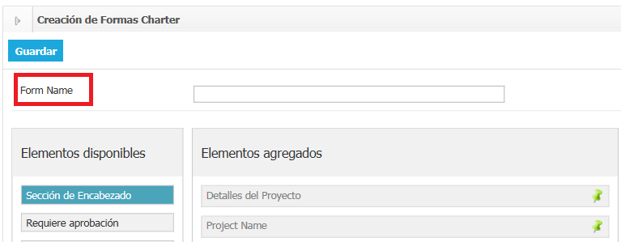
5. Charter form: Element added in Spanish is not converted to chinese 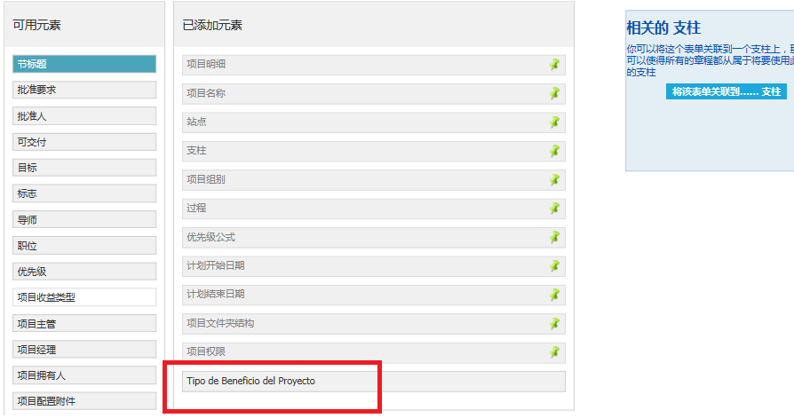
6. Charter form: Associate to pillar page (Spanish lang)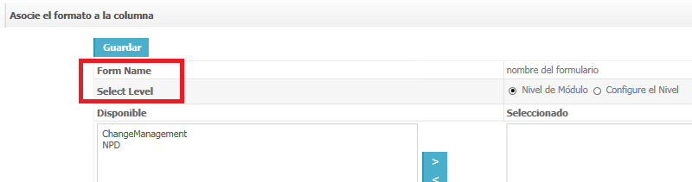
7. Business rule: docpro Route selection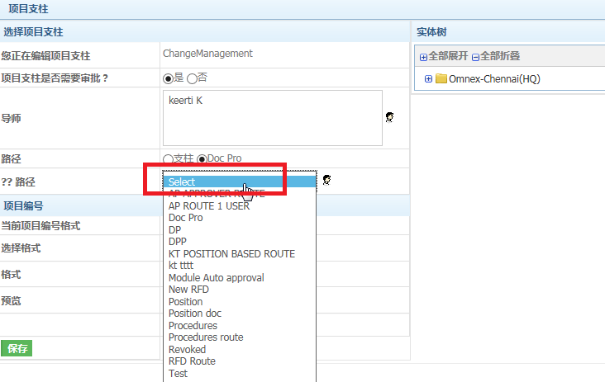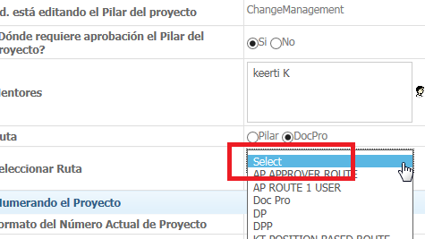
8. Deliverable info(Silver light page) 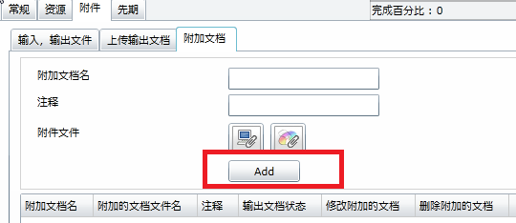

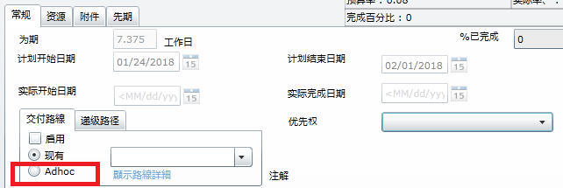

1. Right Click on selected deliverable