1. Business Rules – ‘Business Rule’ header

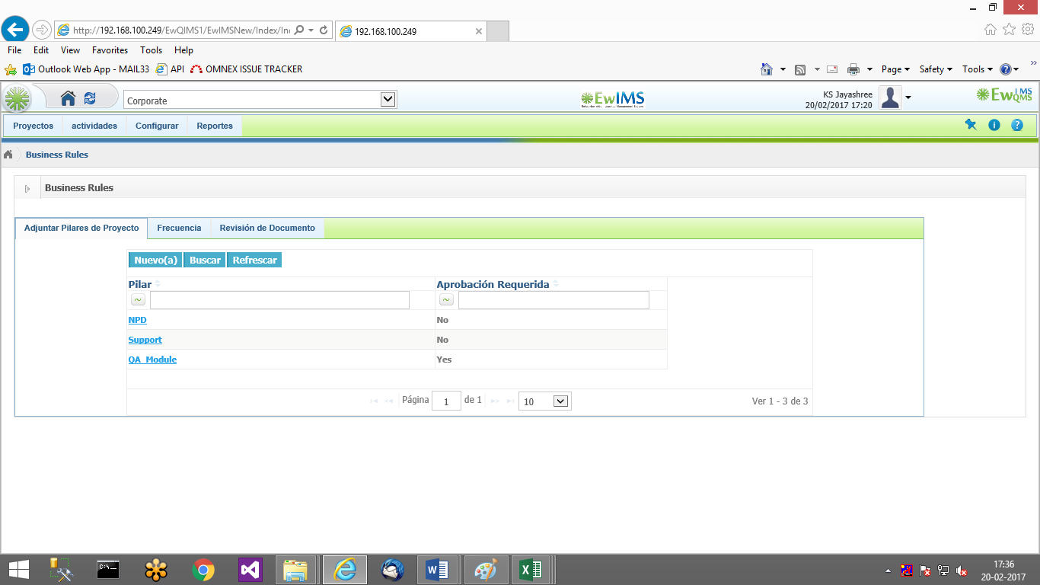

1. Business Rules –>Frequency:

Task Due and Pending Reminder

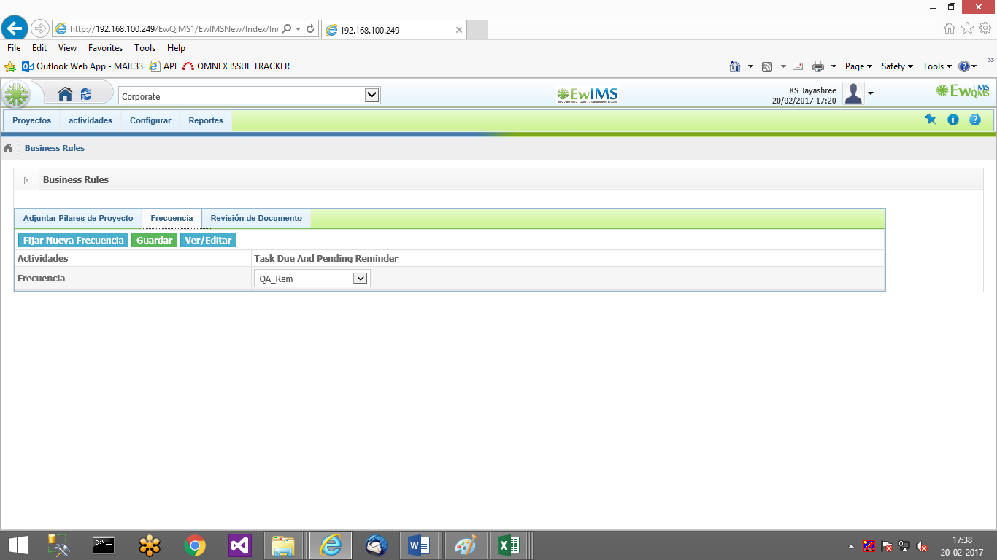

1. Programs – Alert message

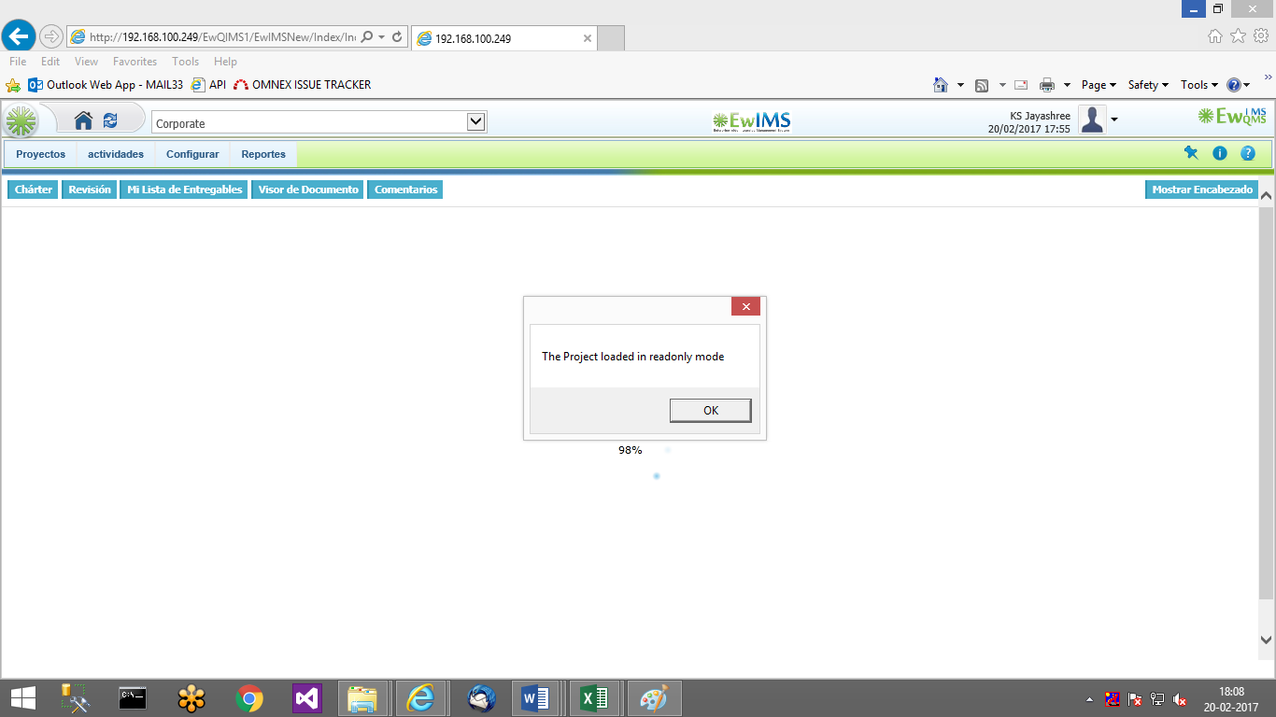

1. ECR – Forms are not displayed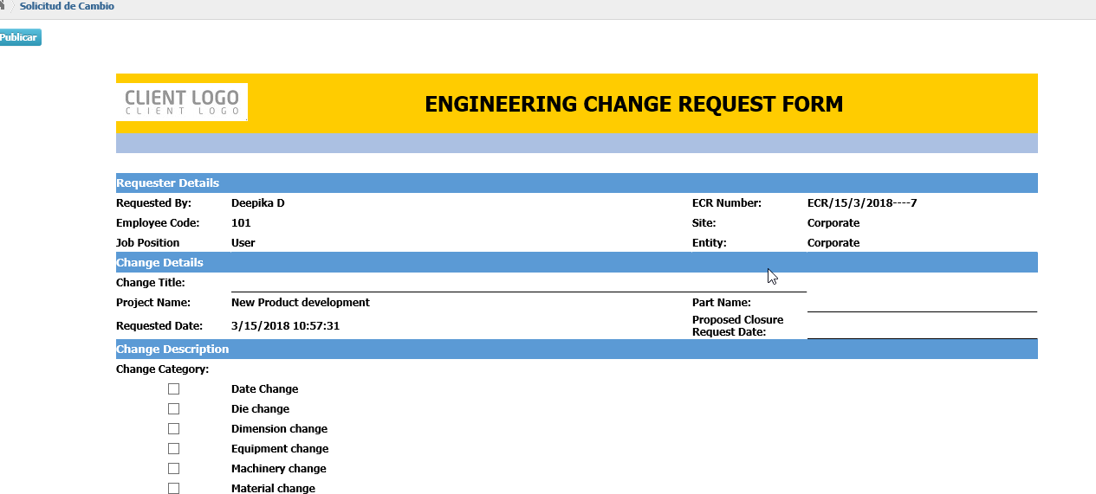 in Spanish. Same for risk forms too.