1. Doc Pro settings: Set rights by batch process label is not converted

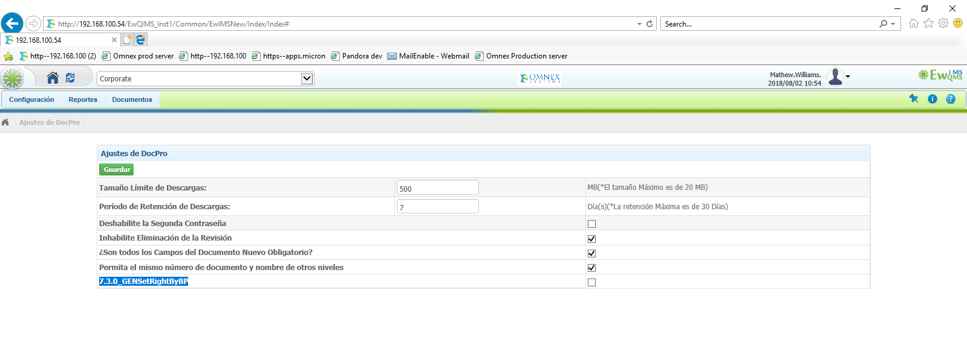

2.Groups: Save button is not converted

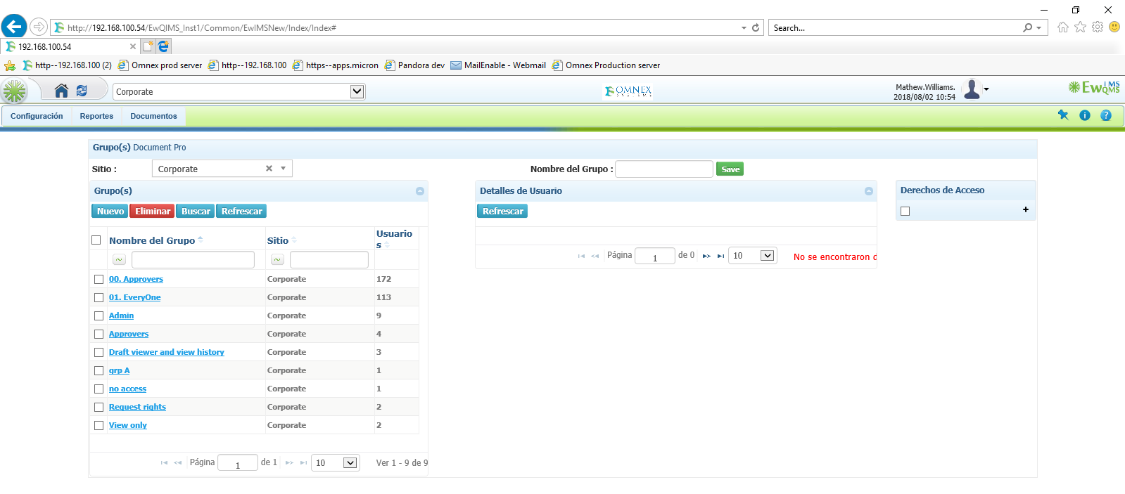

3.Folder mangament: Levels tree: Search by folder/doc num/doc name is not converted (in all levels tree layout)

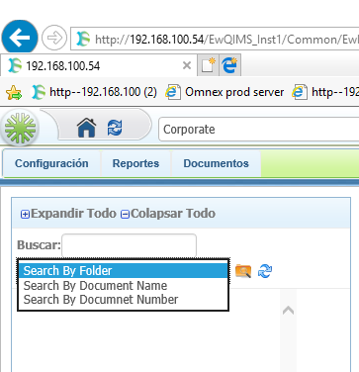

4.Folder mgmt.: Select user text is not converted(same in configure email)

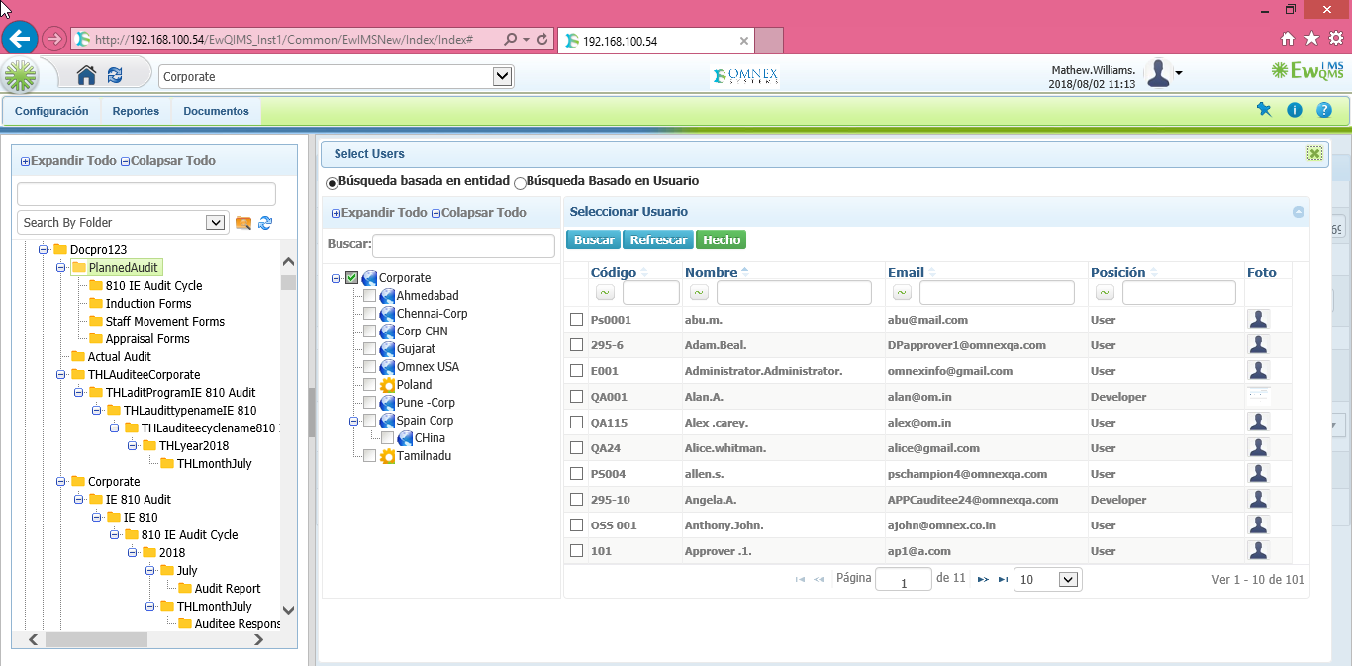

5.Route options: Reset successfully alert message is not converted

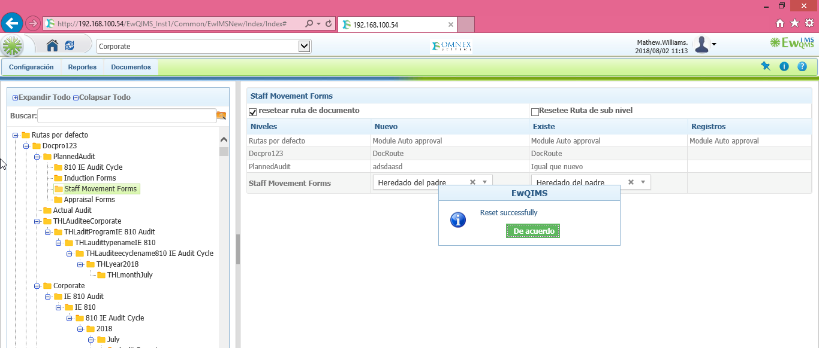

6.Select level popup: Done button is not converted

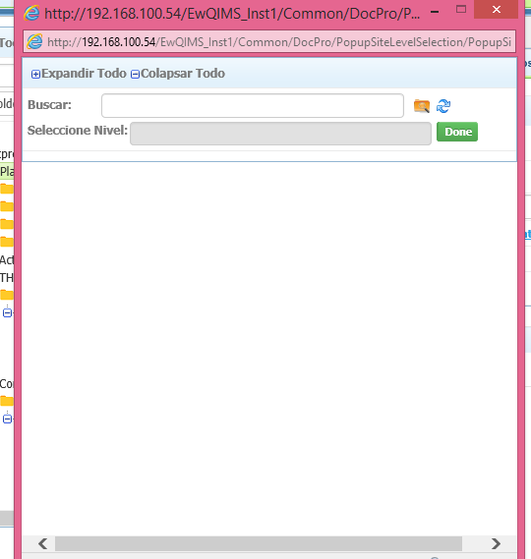

7. Route: Round text is not converted

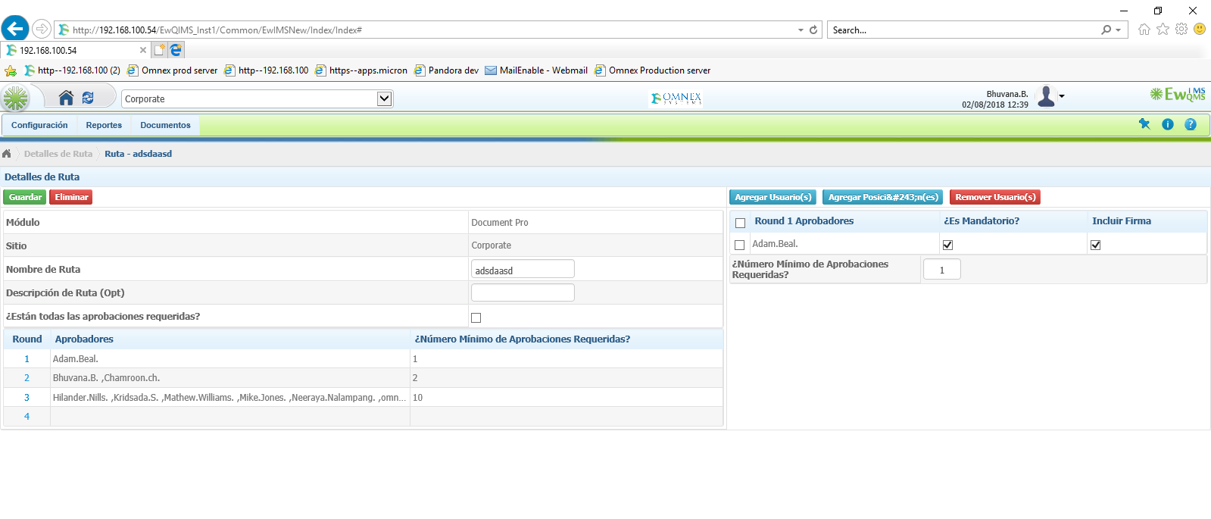

8.Configure Group emails text is not converted

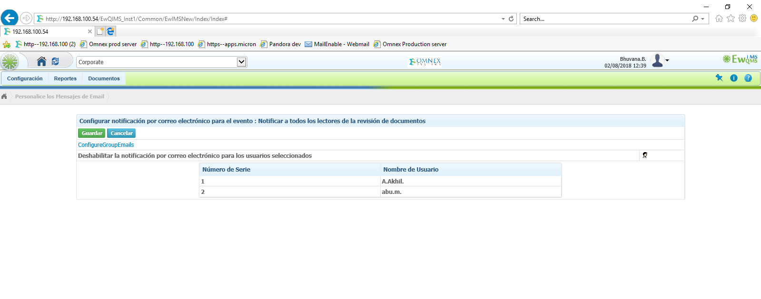9.Error text in batch manager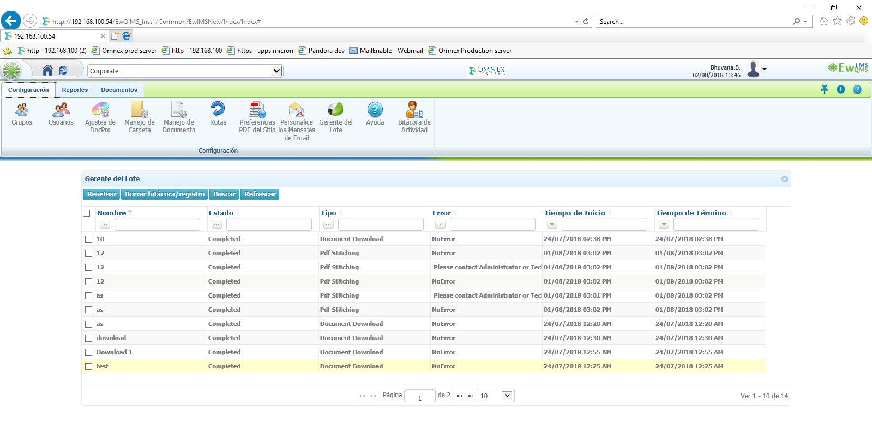

10.Advacned search popup heading shows **B&#250;squeda Avanzada**

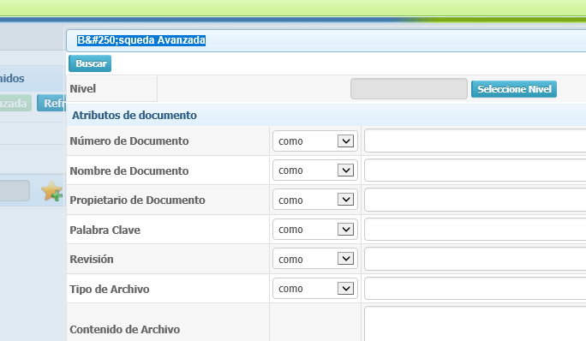

**11.Levels When saving with spanish charcters ónónónón prefix showing as (n�n),**

**Same in new doc request**

**Document details showing ?**

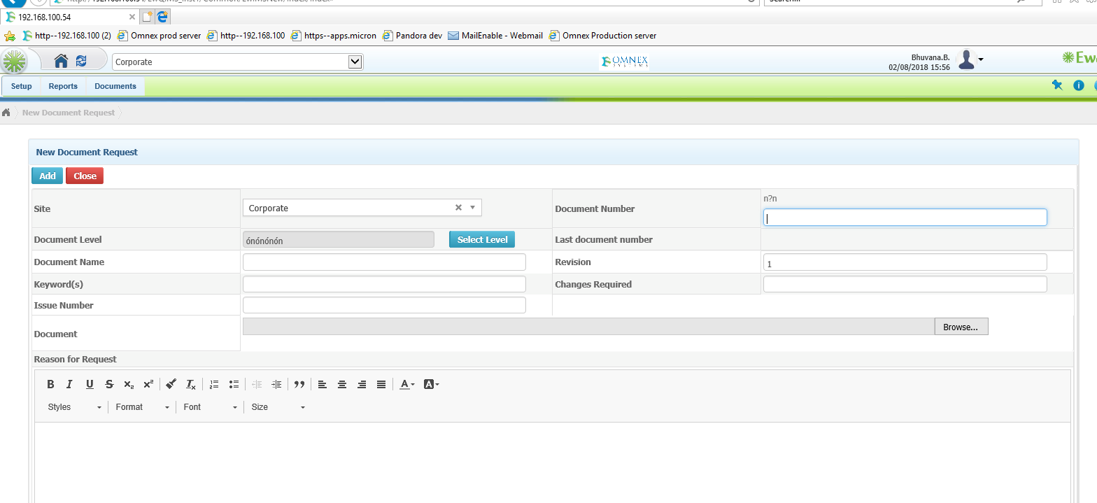

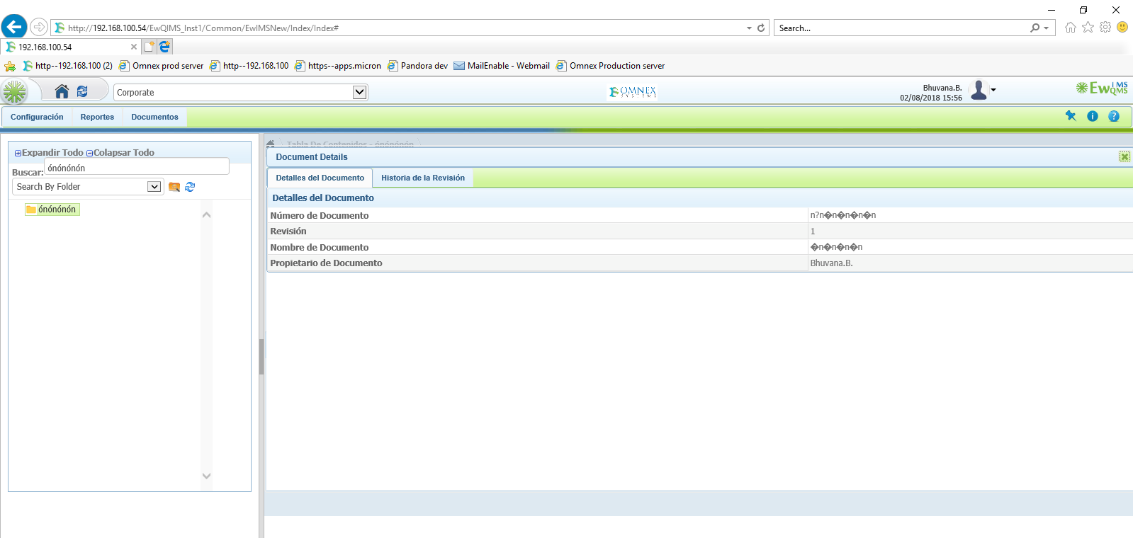

**12.TOC: Document details heading text is not converted**

**13.Draft viewer mandatory alert message is showing with some numbers in prefix**

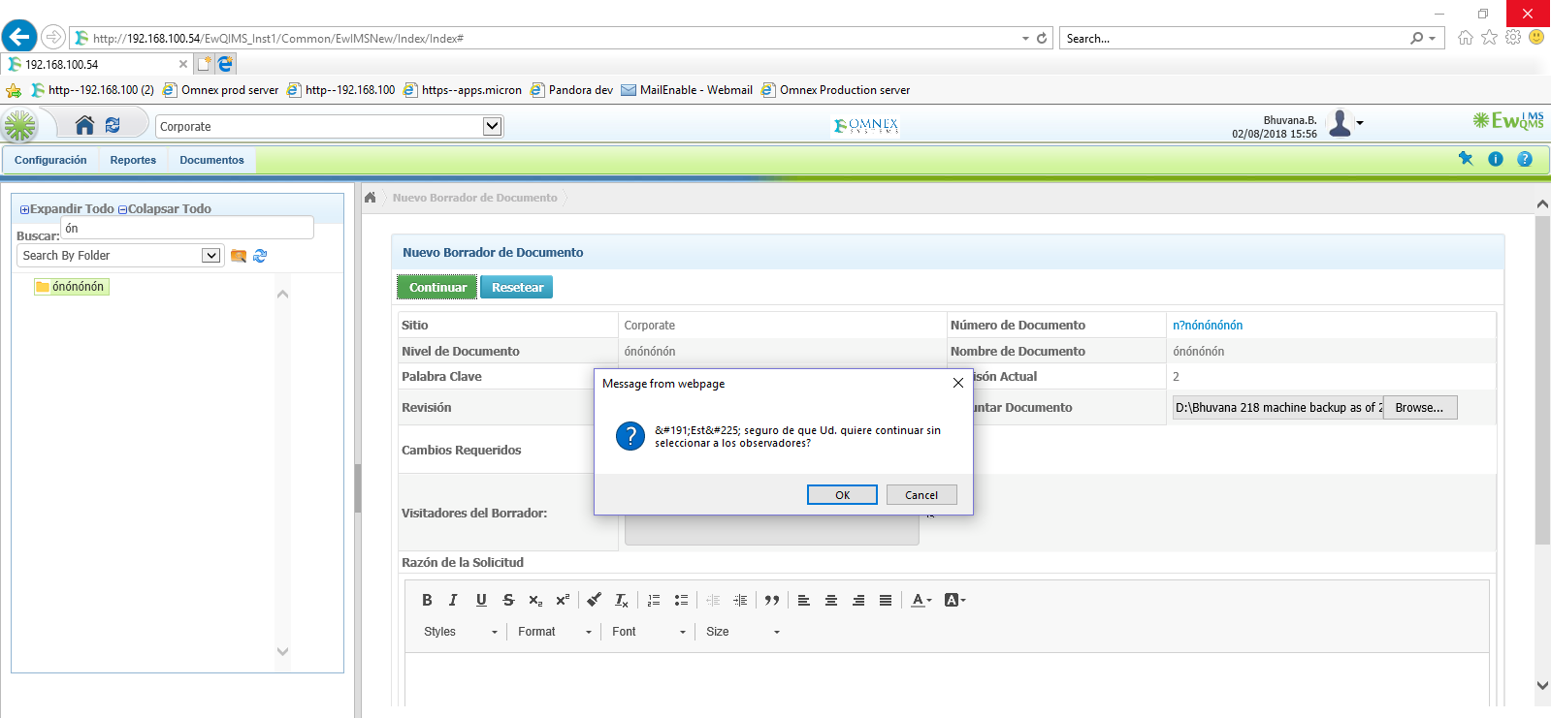

**14.TOC:Right click options: Rev his sum Text is showing out of the box3**

