Project tracking matrix

Project structure

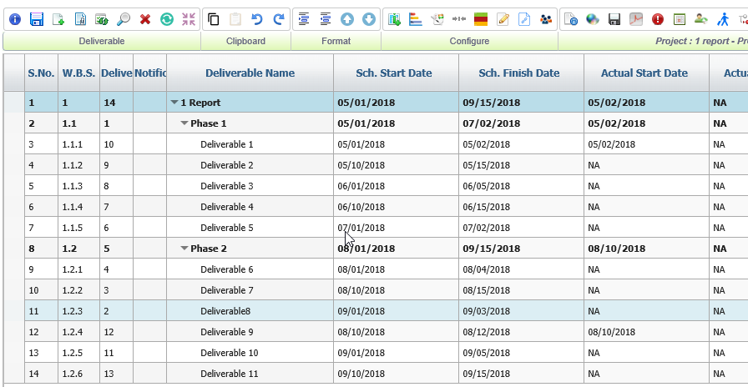

1. When Clicking on one project, there is no option to the listing of all projects

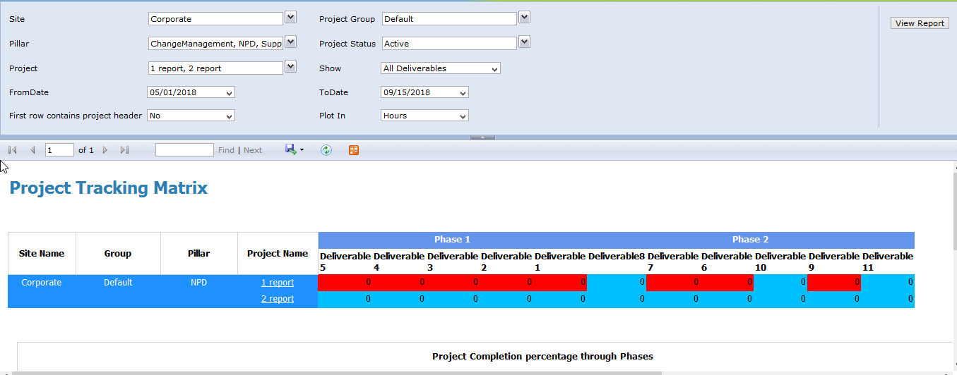

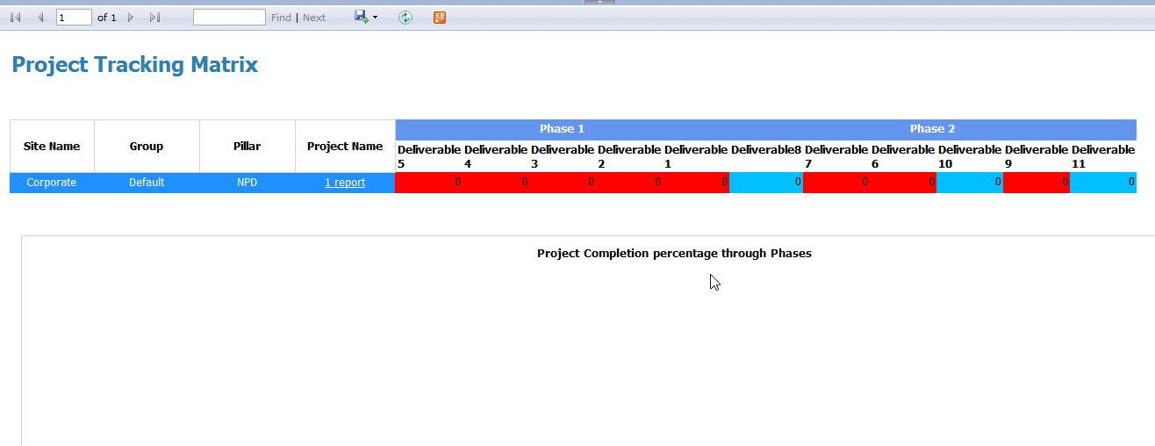

1. Red and blue color differentiation are not similar

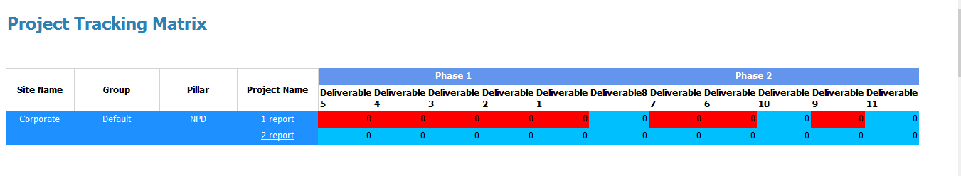

1. Alignent of the charter header is different in different browsers

Safari

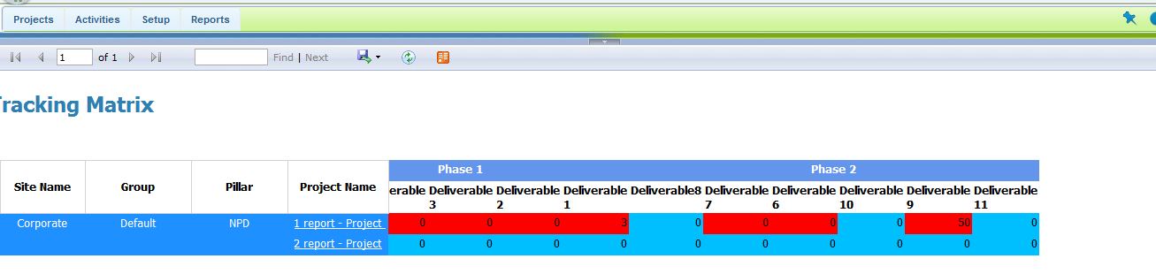

Chrome, ie, firefox

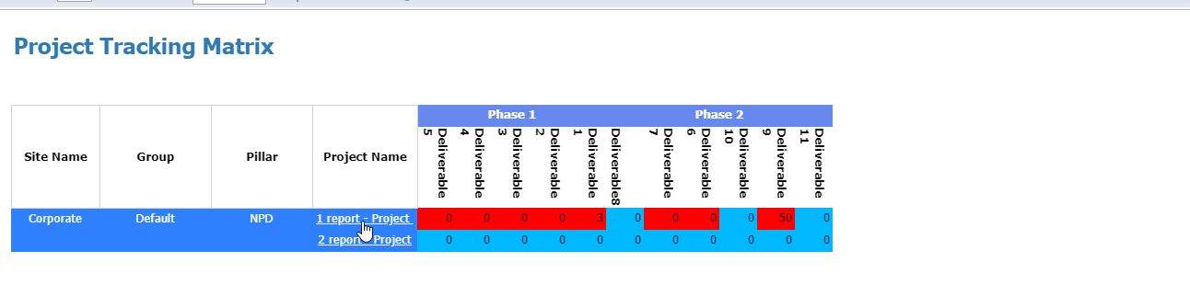

1. If the phases are intended under the base deliverable, the chart is depicted wrongly

