1. After entering incorrect data and clicking on search button – No response

Need “No data found” alert.

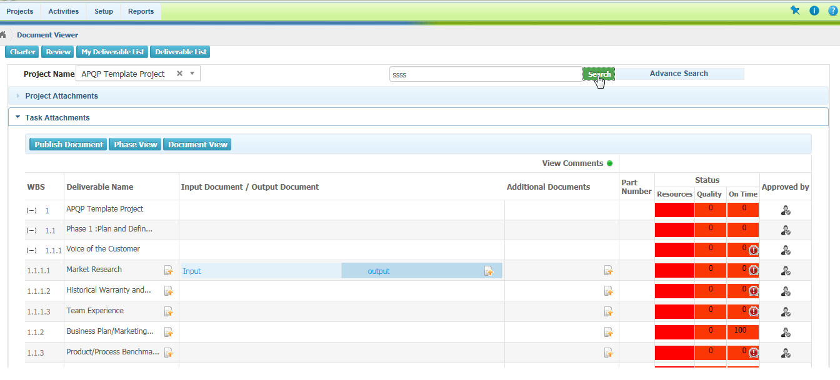

1. When the search option filter is selected as % completed then it allows entering the alphabetic values also, it should allow only accepting numeric value.

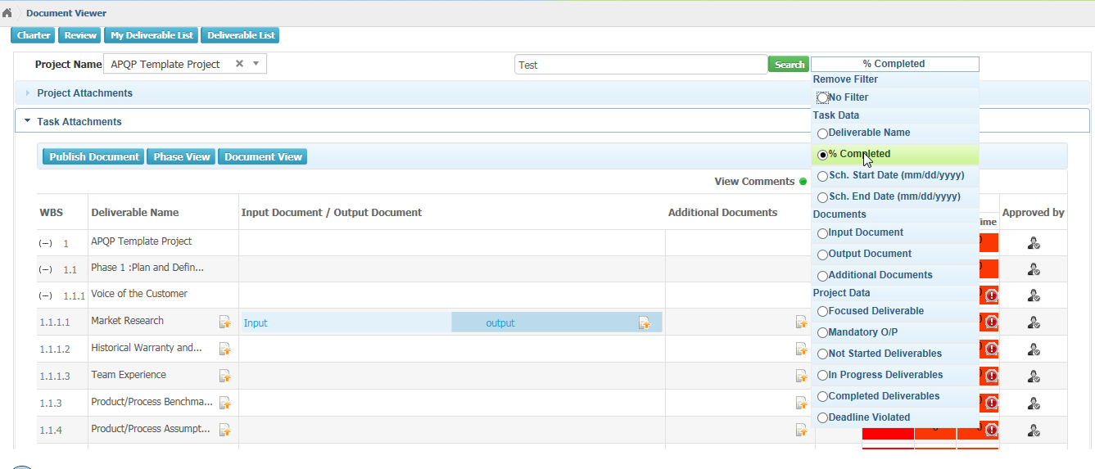

1. After selecting the filters in advanced search and reset filter is needed instead of No filter.

Because the name advanced search will not be displayed after the selection of any filter.

1. When the cursor is placed in the deliverable name it shows clickable option.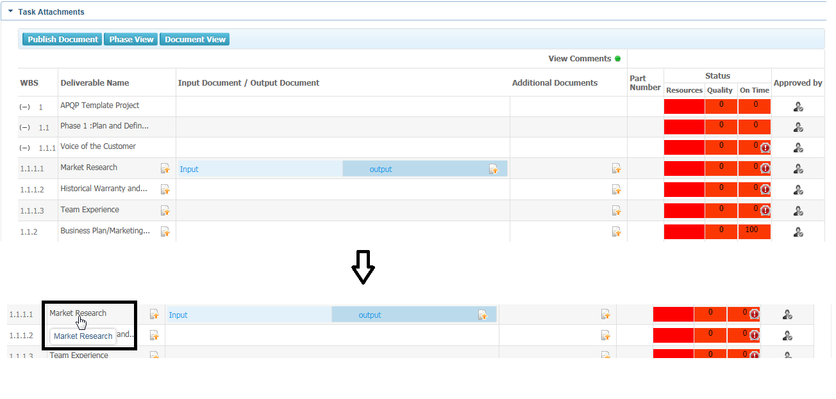
2. **“Advanced search”** option is not looking in the button view.