1. Customized Email – ‘Basic Mails’ header - open

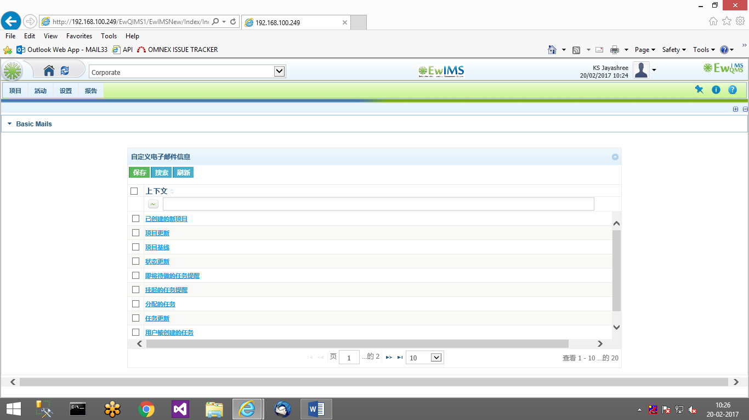

closed

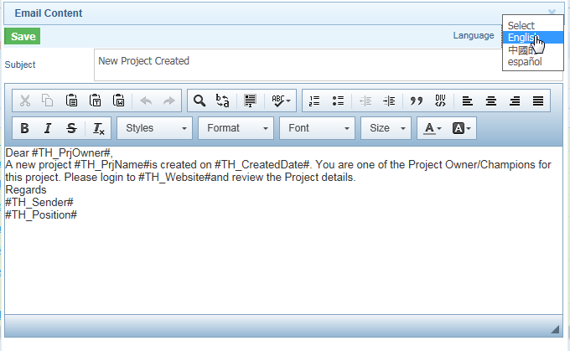

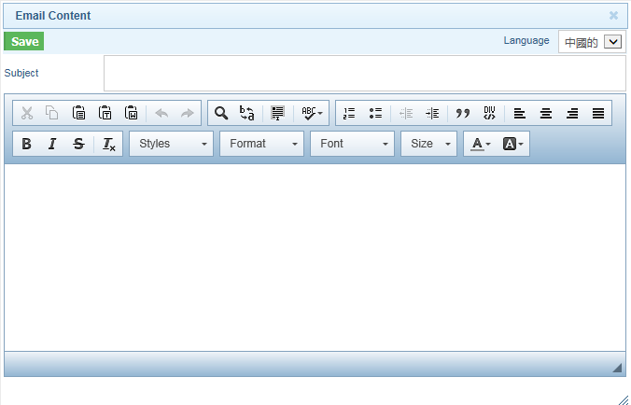

1. User Rights Profile – Pillar Approved, Project List, Task List header - open

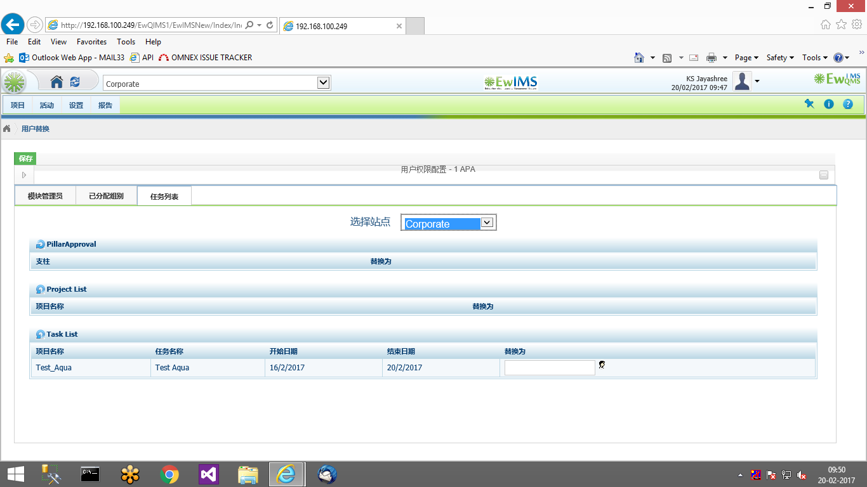

1. Project Groups – ‘Descriptions’ label - closed

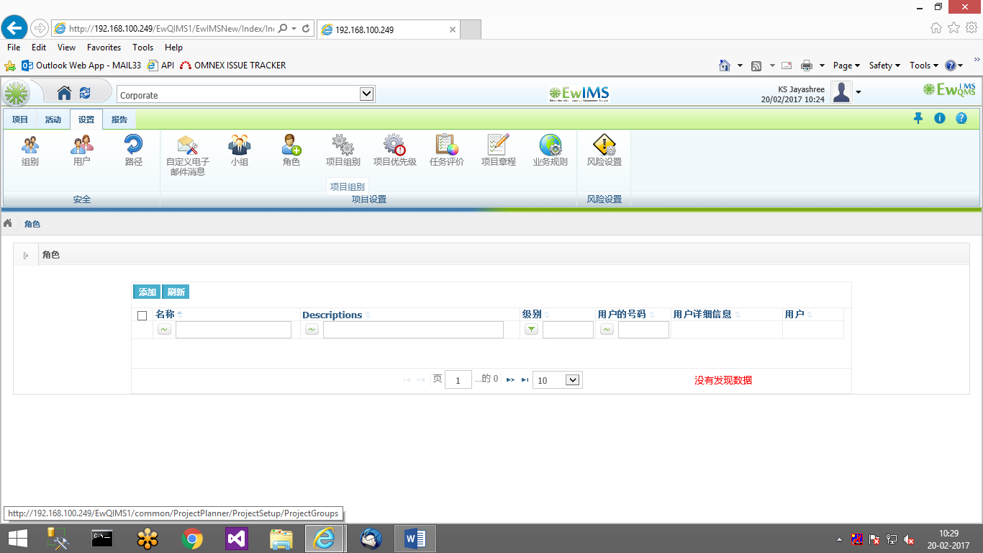

1. Business Rules – ‘ Document’ field - closed

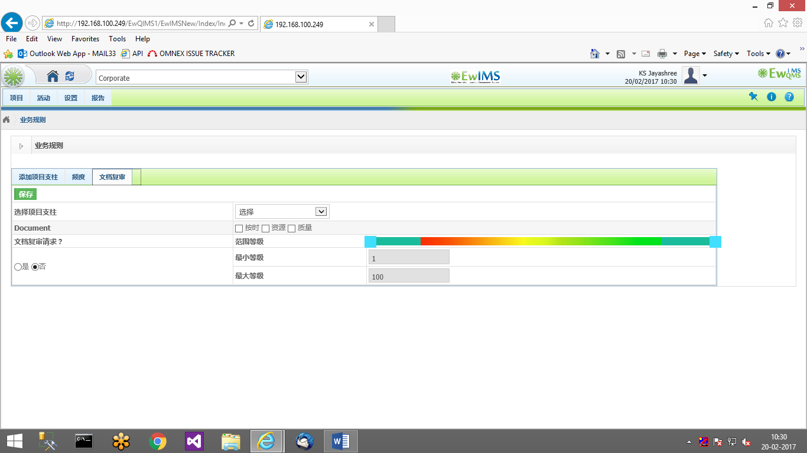

1. Project page – Task right click popup - open

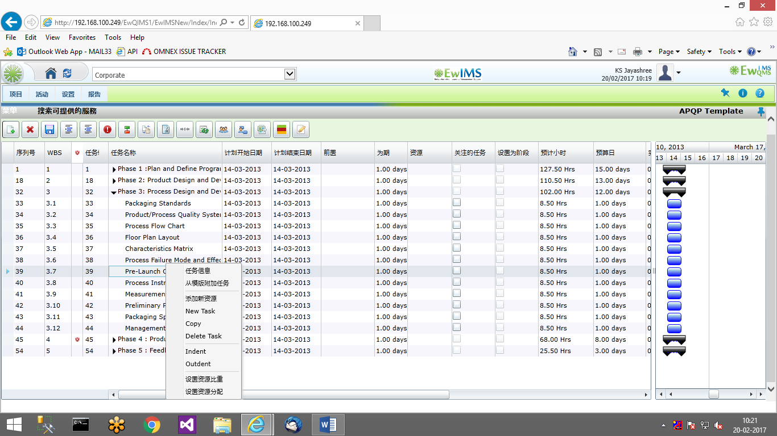

1. Project – Route - open

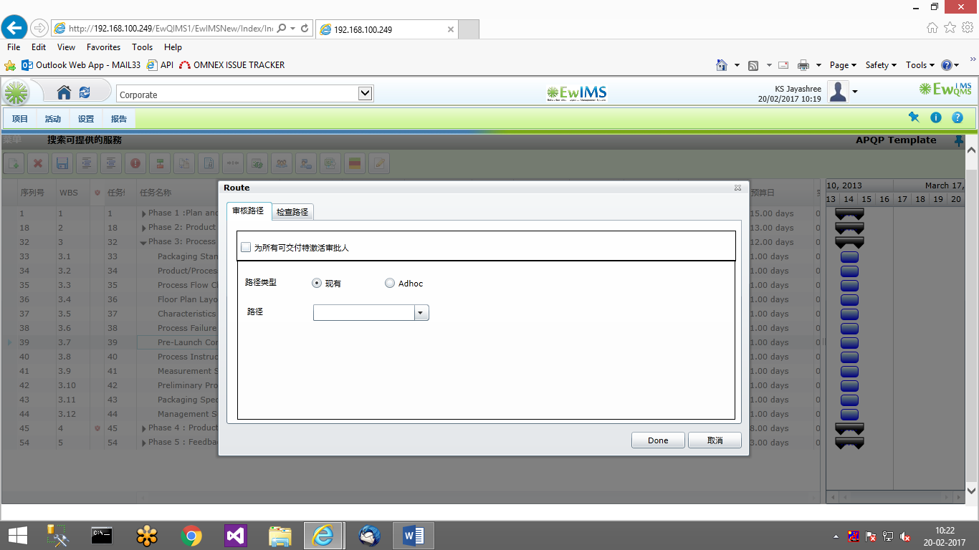

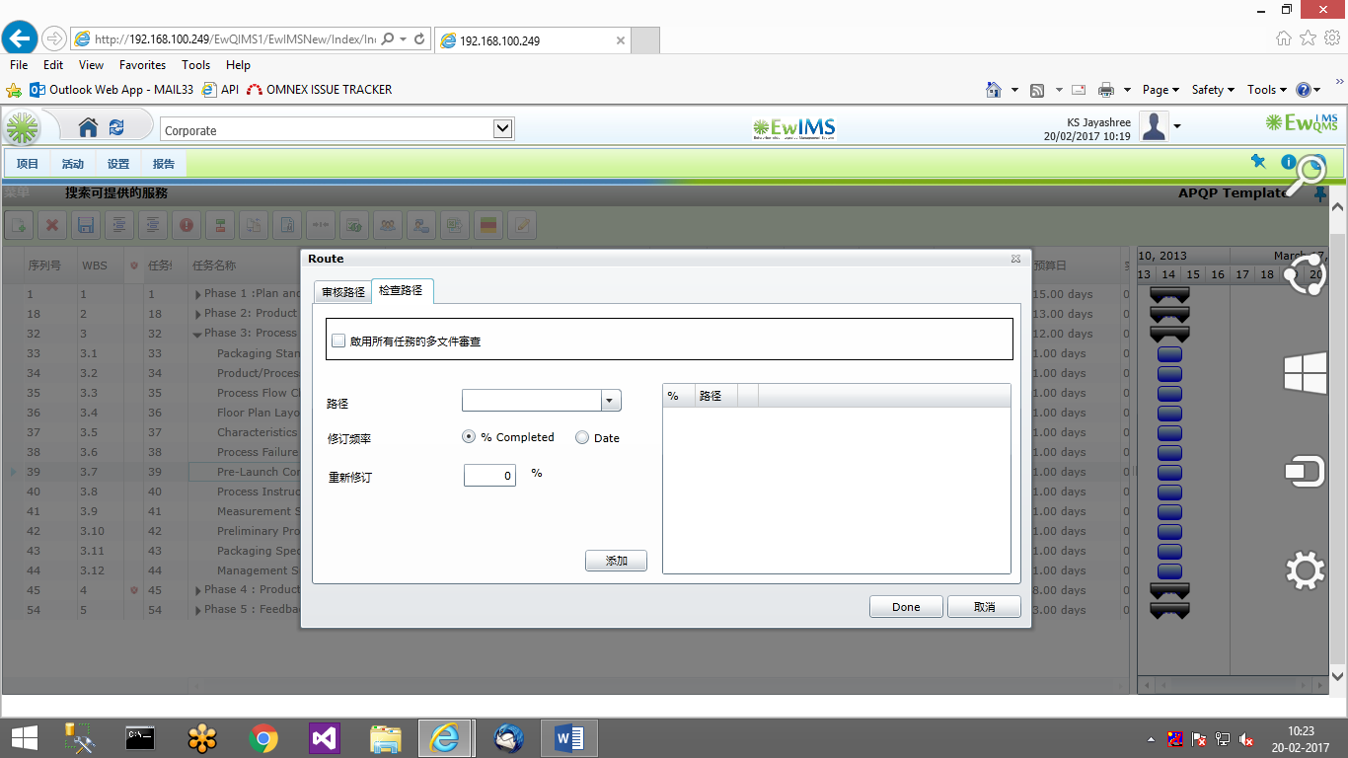

1. Project – Escalation page: Label not found -closed

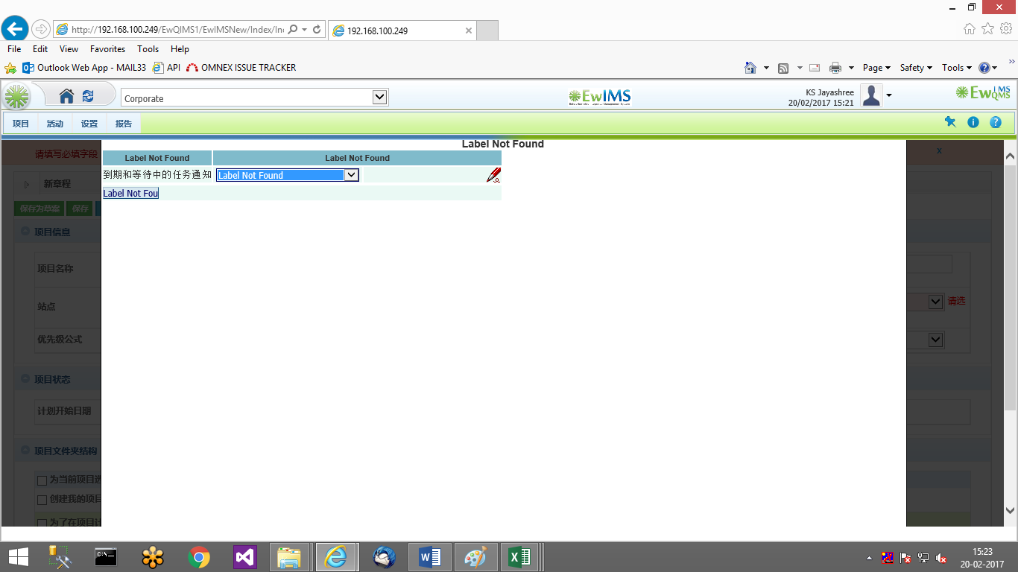

1. Programs: Alert is read only - open

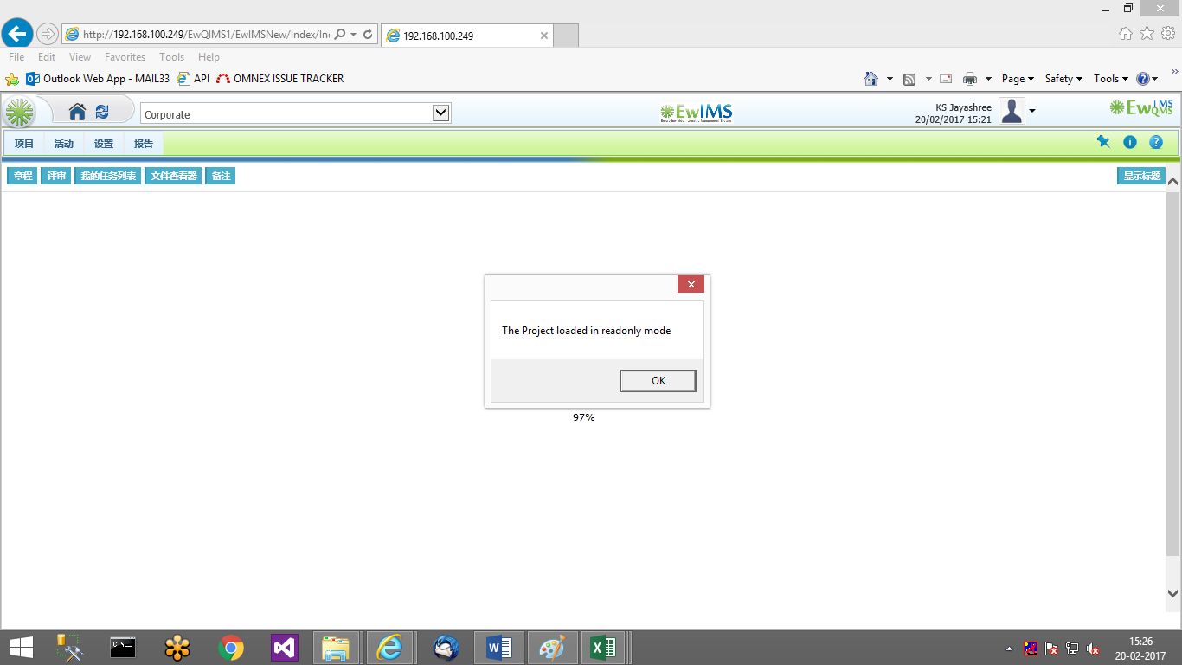

1. Change management – Forms are not displayed in Chinese. Risk forms are also not displayed in multilanguage

