**Approving the Document**

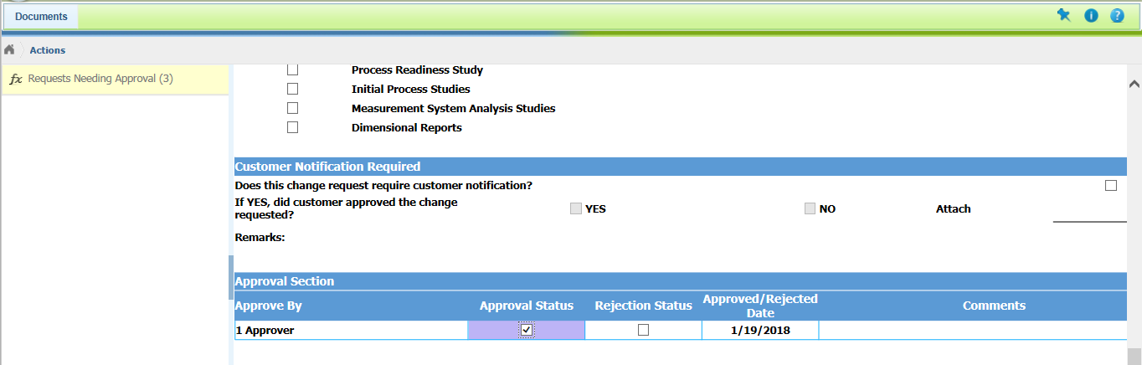

**After the approval of Document**: Request needing Approval count is not reduced.

