Suggestion: In new training request page, Training course expand button itself is showing even for collapse option.

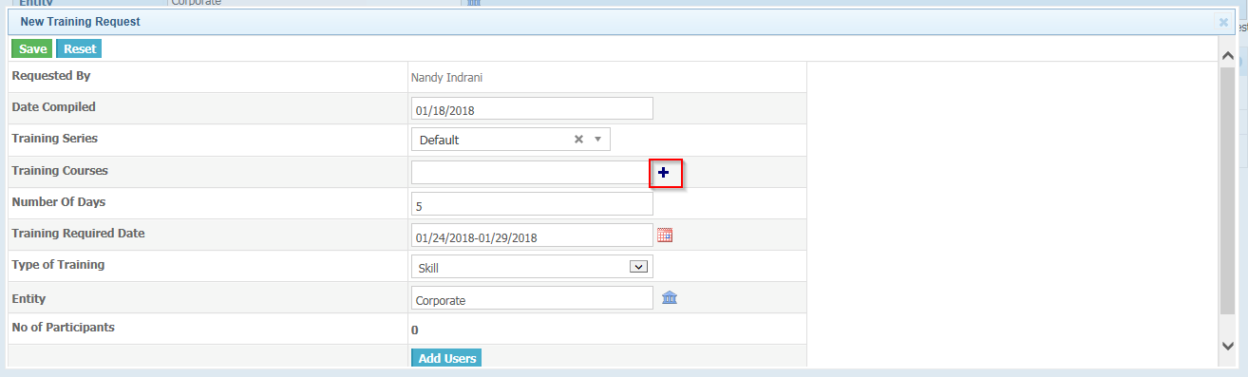In new training request pop up, tool tip missing for, reset, Training calendar, Entity selection, Add user and remove user icon as well.

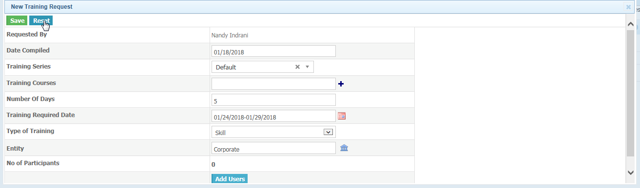

In new consolidation page, tool tip for entity selection is missing

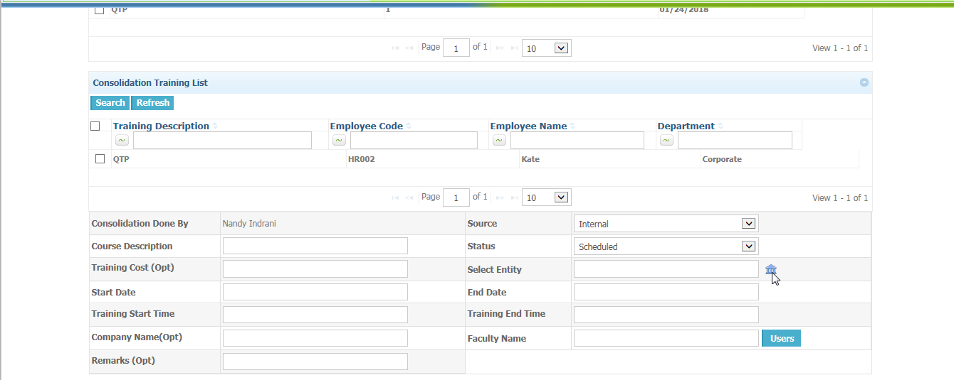

In consolidation page, checklist button tooltip is displayed as undefined.

