Tool tip missing for Competency evaluation button in Job requirements page.

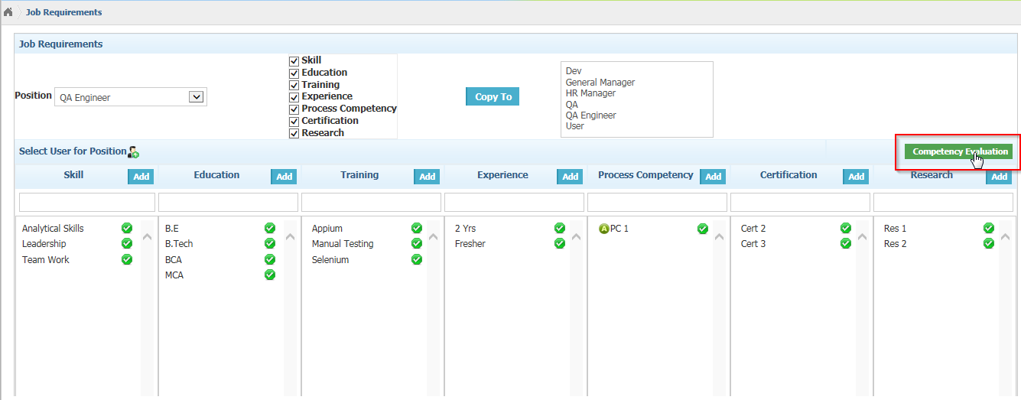 In Competency Evaluation page, Update competent button’s Tool tip is missing

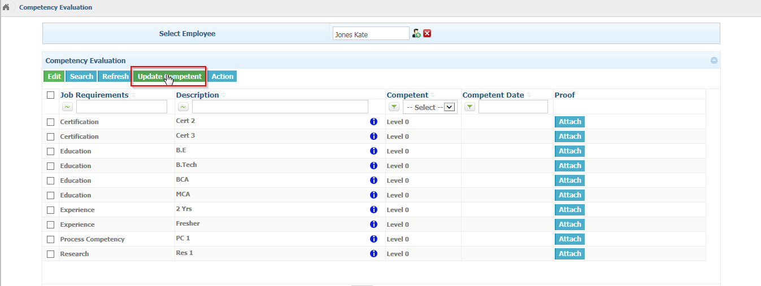

Action button tooltip is missing.

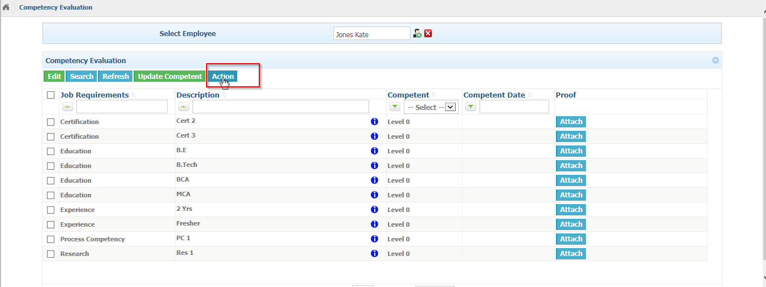

Shows unwanted tooltips near attach button in comp evaluation

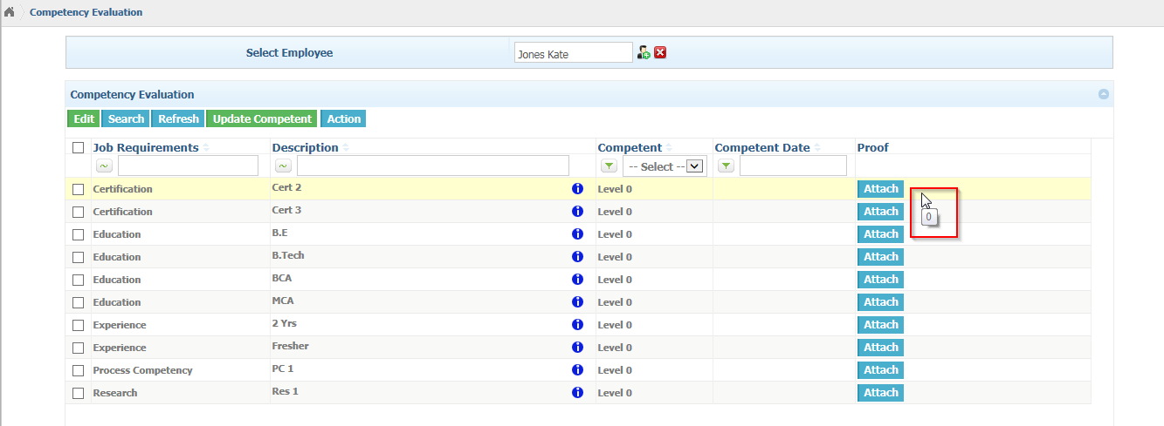

Competency search page, near view shows empty tooltip.

