1. Horizontal scroll is displayed in ride side of the page. Need to utilize empty space on bottom of the page

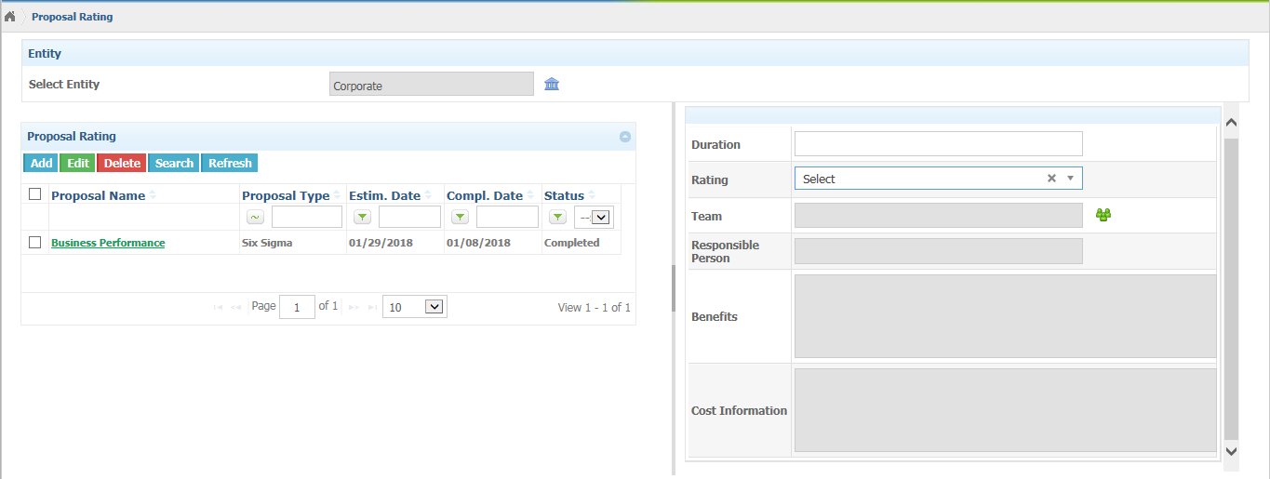

2. Ratings Dropdown -> Horizontal scroll is displayed in list

