1. The page Size needs to increase

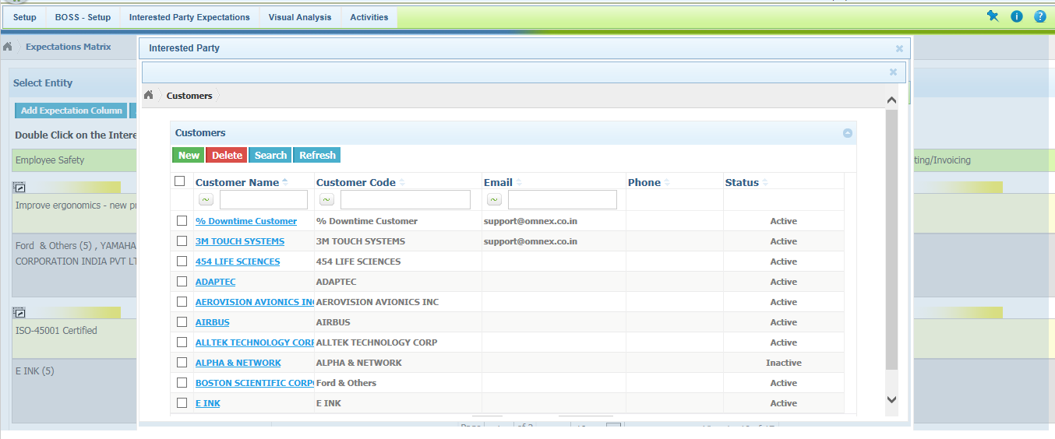

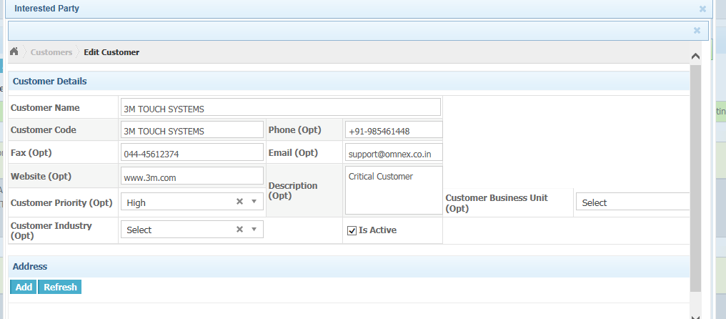

1. Customer/Supplier/Other Interested Party Listing Page-> Horizontal scroll is displayed if more data’s available

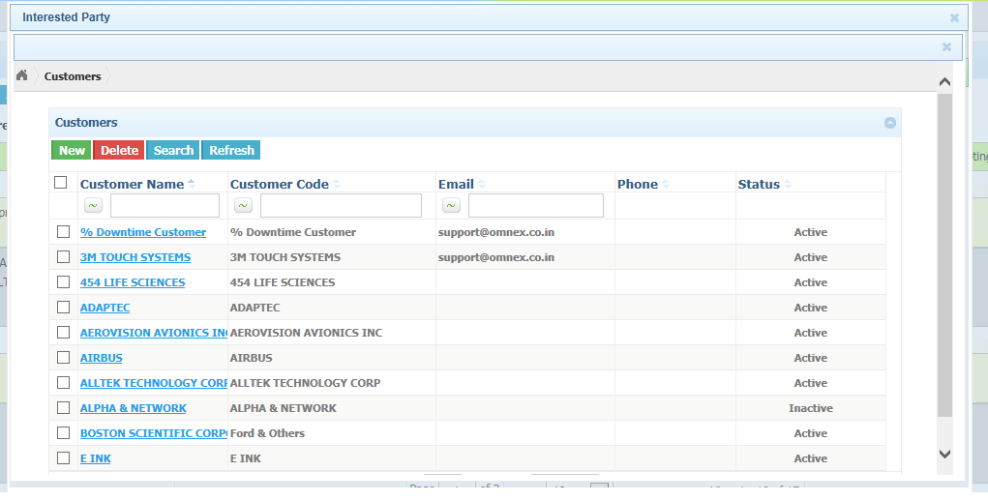

1. The Customer/Supplier/Other Interested Party details page -> the user could not view the page information’s properly after adding address/contact information for a customer

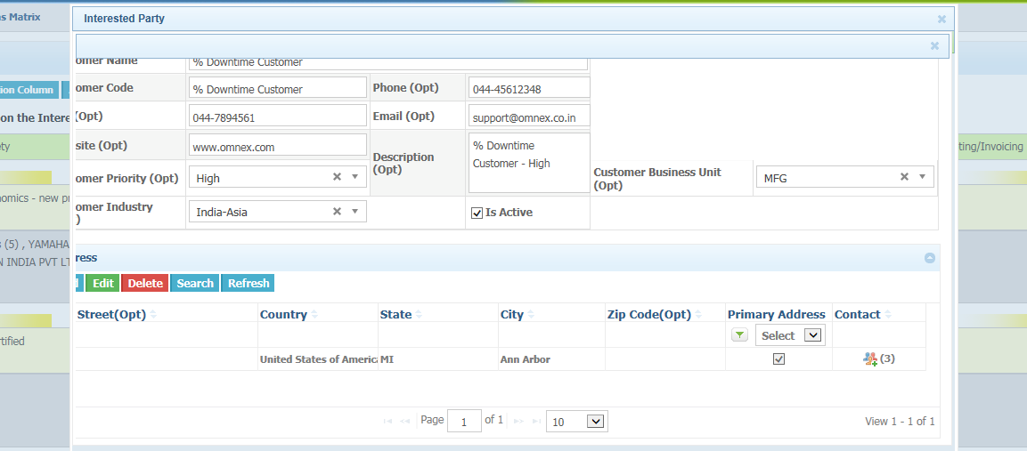

1. Customer/Supplier/Other Interested Party - Contact Page -> Couple of vertical scroll bar is displayed.

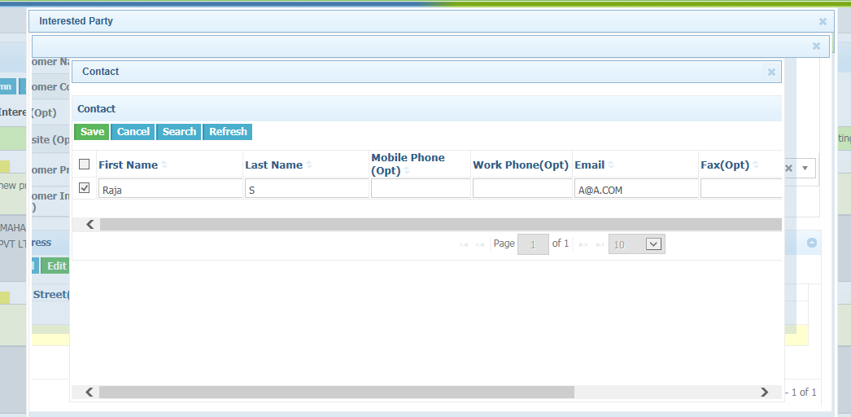

1. Supplier - Supplier Quality Engineer Selection Page - Multiple vertical and Horizontal scroll bar is displayed.

