FSR Alert message changes:
- When trying to add a requirement without function:

Please add a function before proceeding with the requirement.
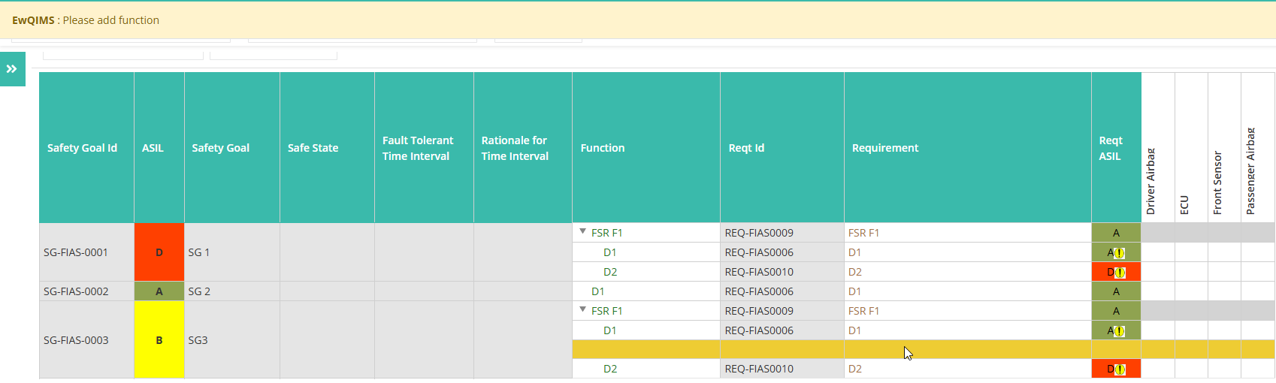

- Please add a requirement before starting the decomposition process.
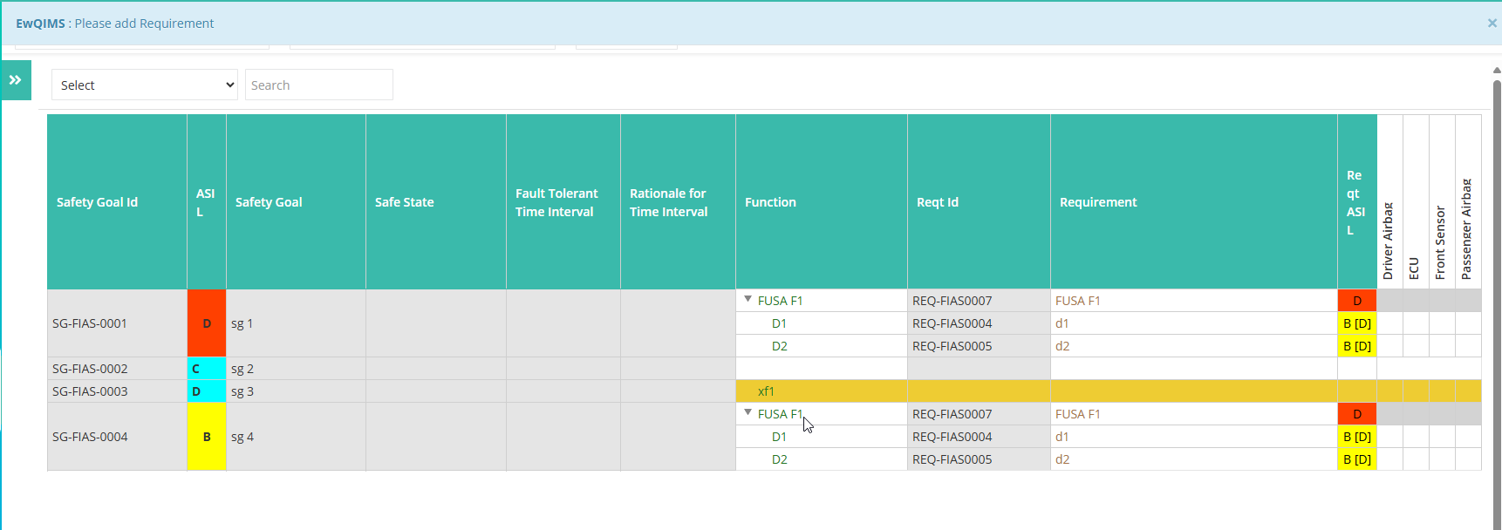

- Please ensure a requirement is added for the decomposed function
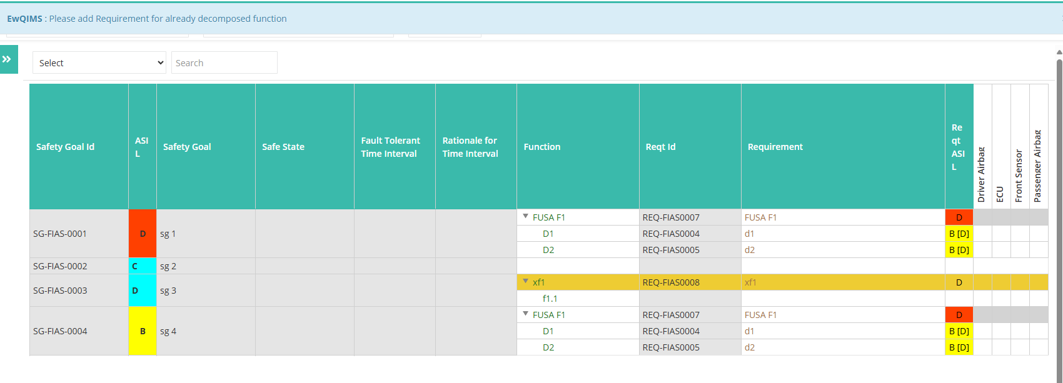

- The selected function is already associated with the safety goal. 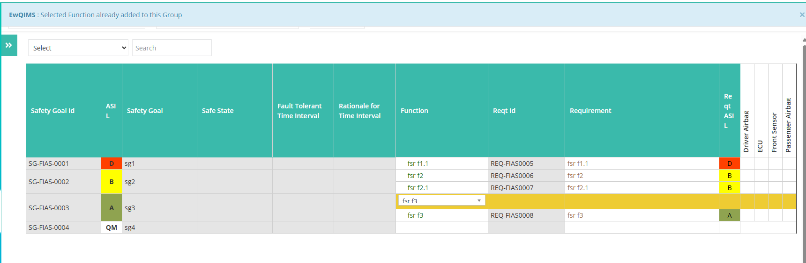

- The selected function is the same as the parent function. Please select a different function.

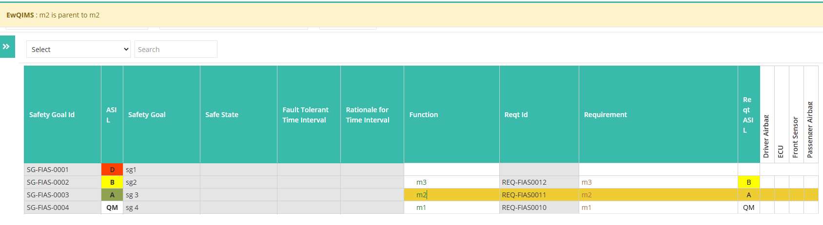

6. Requirement cannot be edited or deleted after decomposition

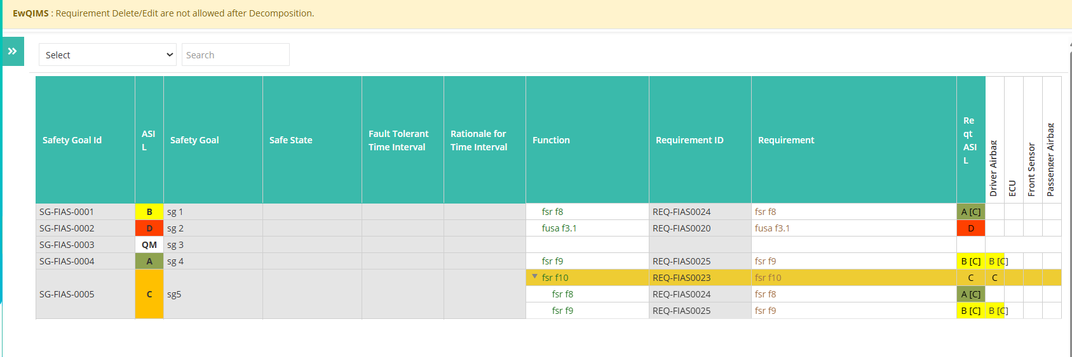

- No ASIL decompositions were found
If no decomposed asils are found and by clicking the Validate AISL button.
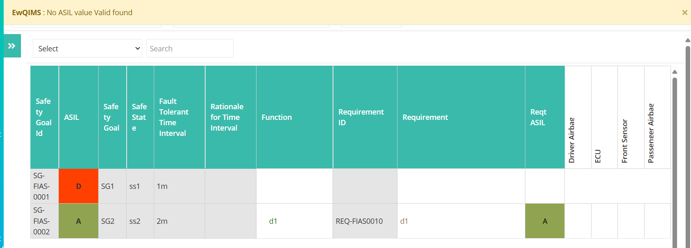

8. The allocation cannot be deleted as the technical function/requirement is currently mapped to the ASIL
