1. Production Item/BOM name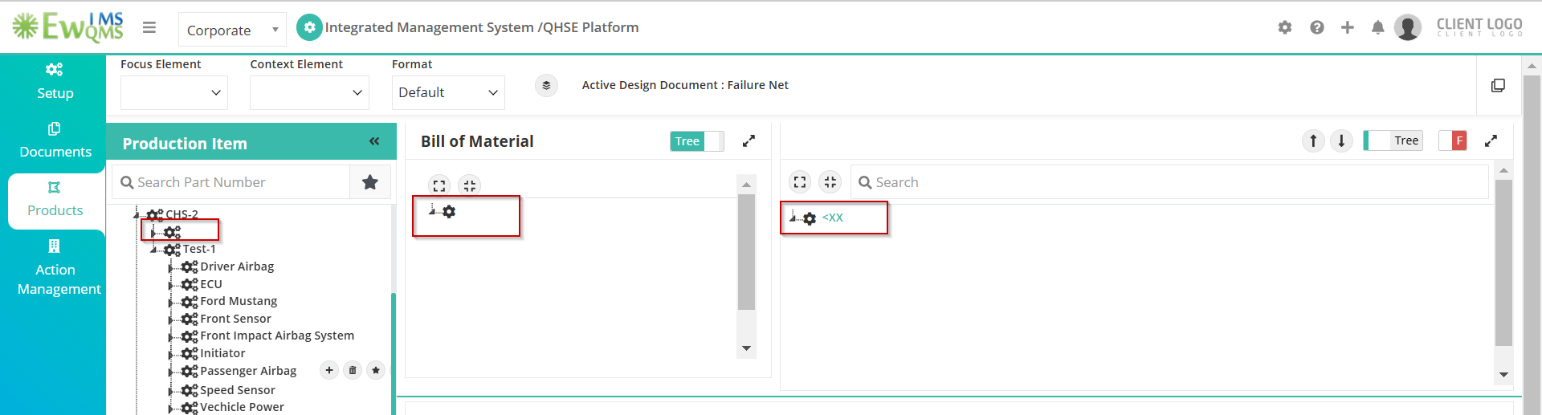
2. P-Diagram page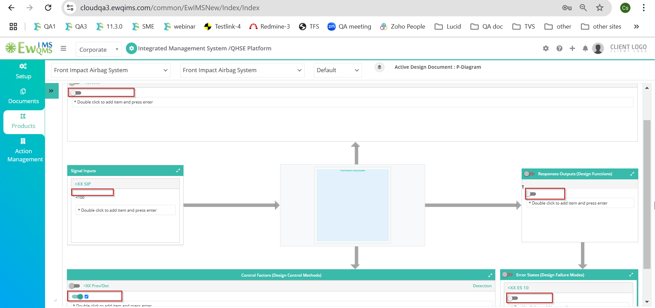
3. Flow up/Down pop up window Function/Requirement/Failure 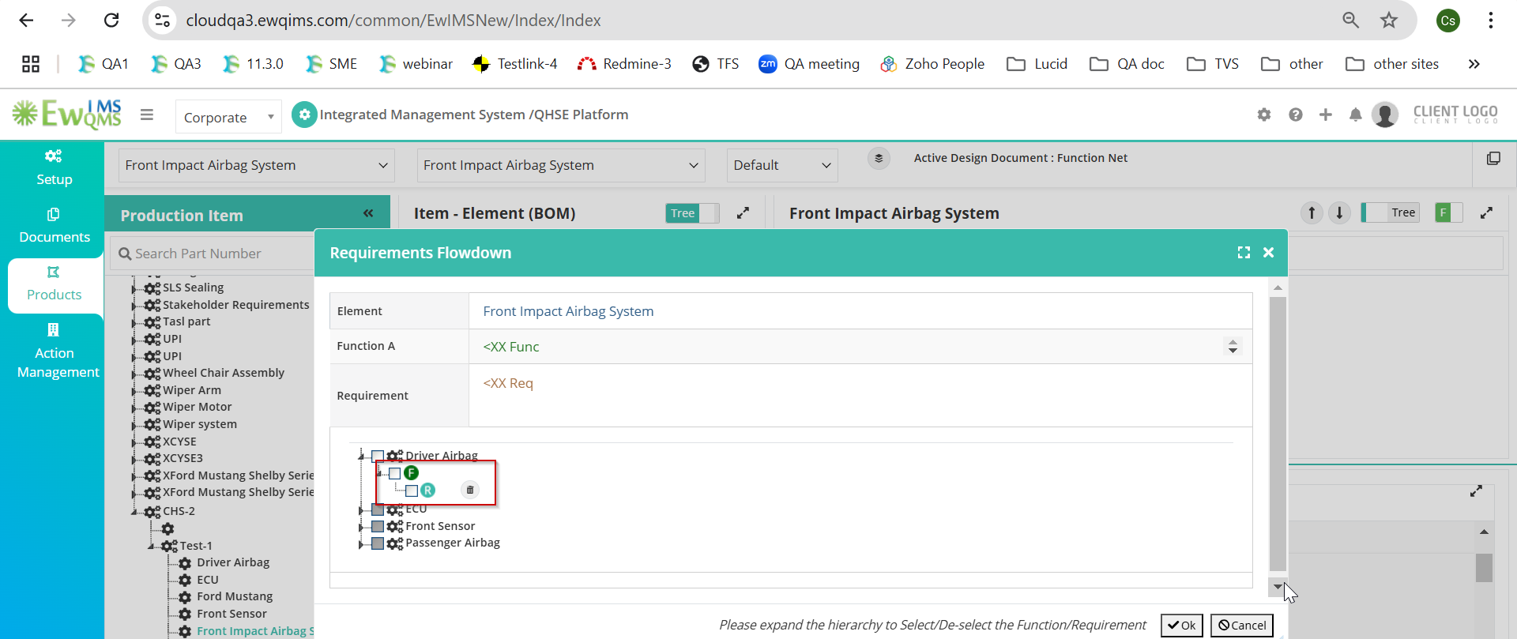
4. Tree view Add Requirement/Failure pop up window, <XX data not displayed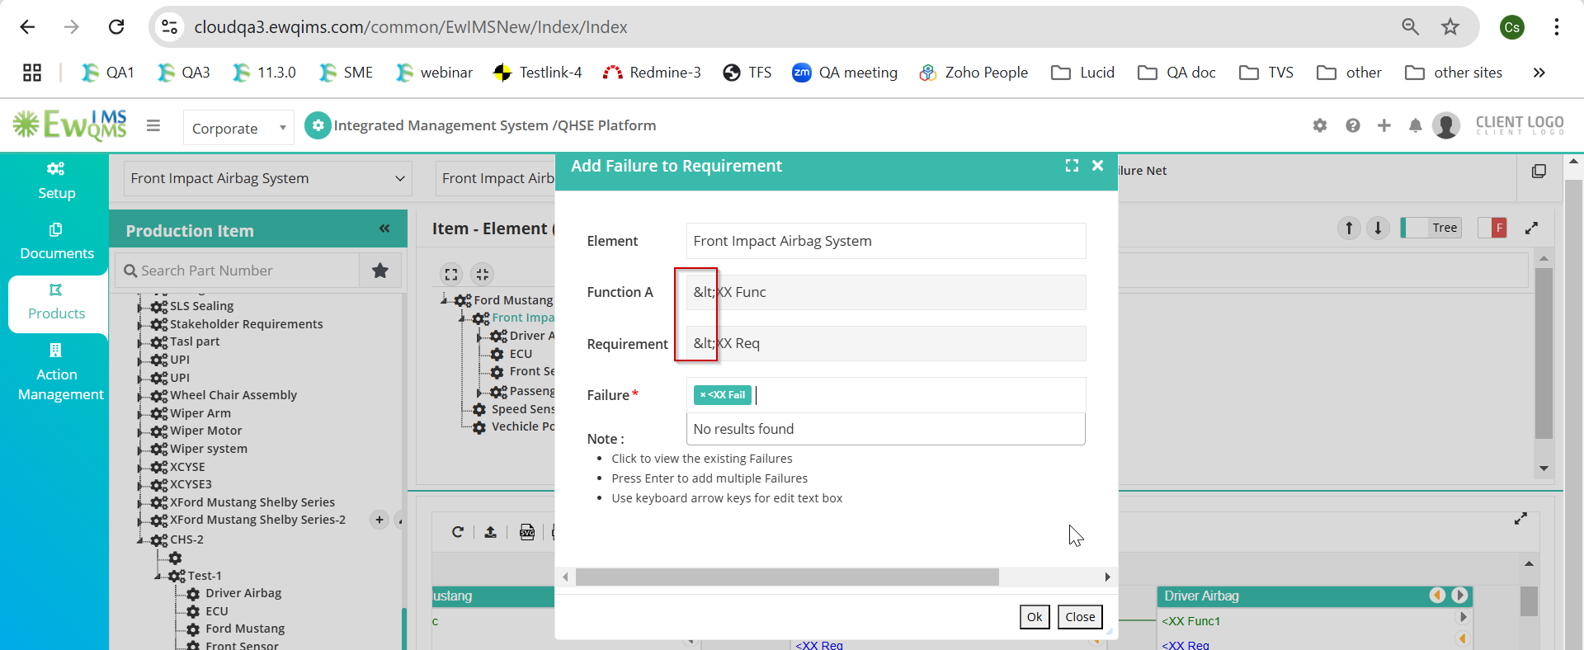
5. Design & Process: Risk and Optimization popup window failure <XX name not displayed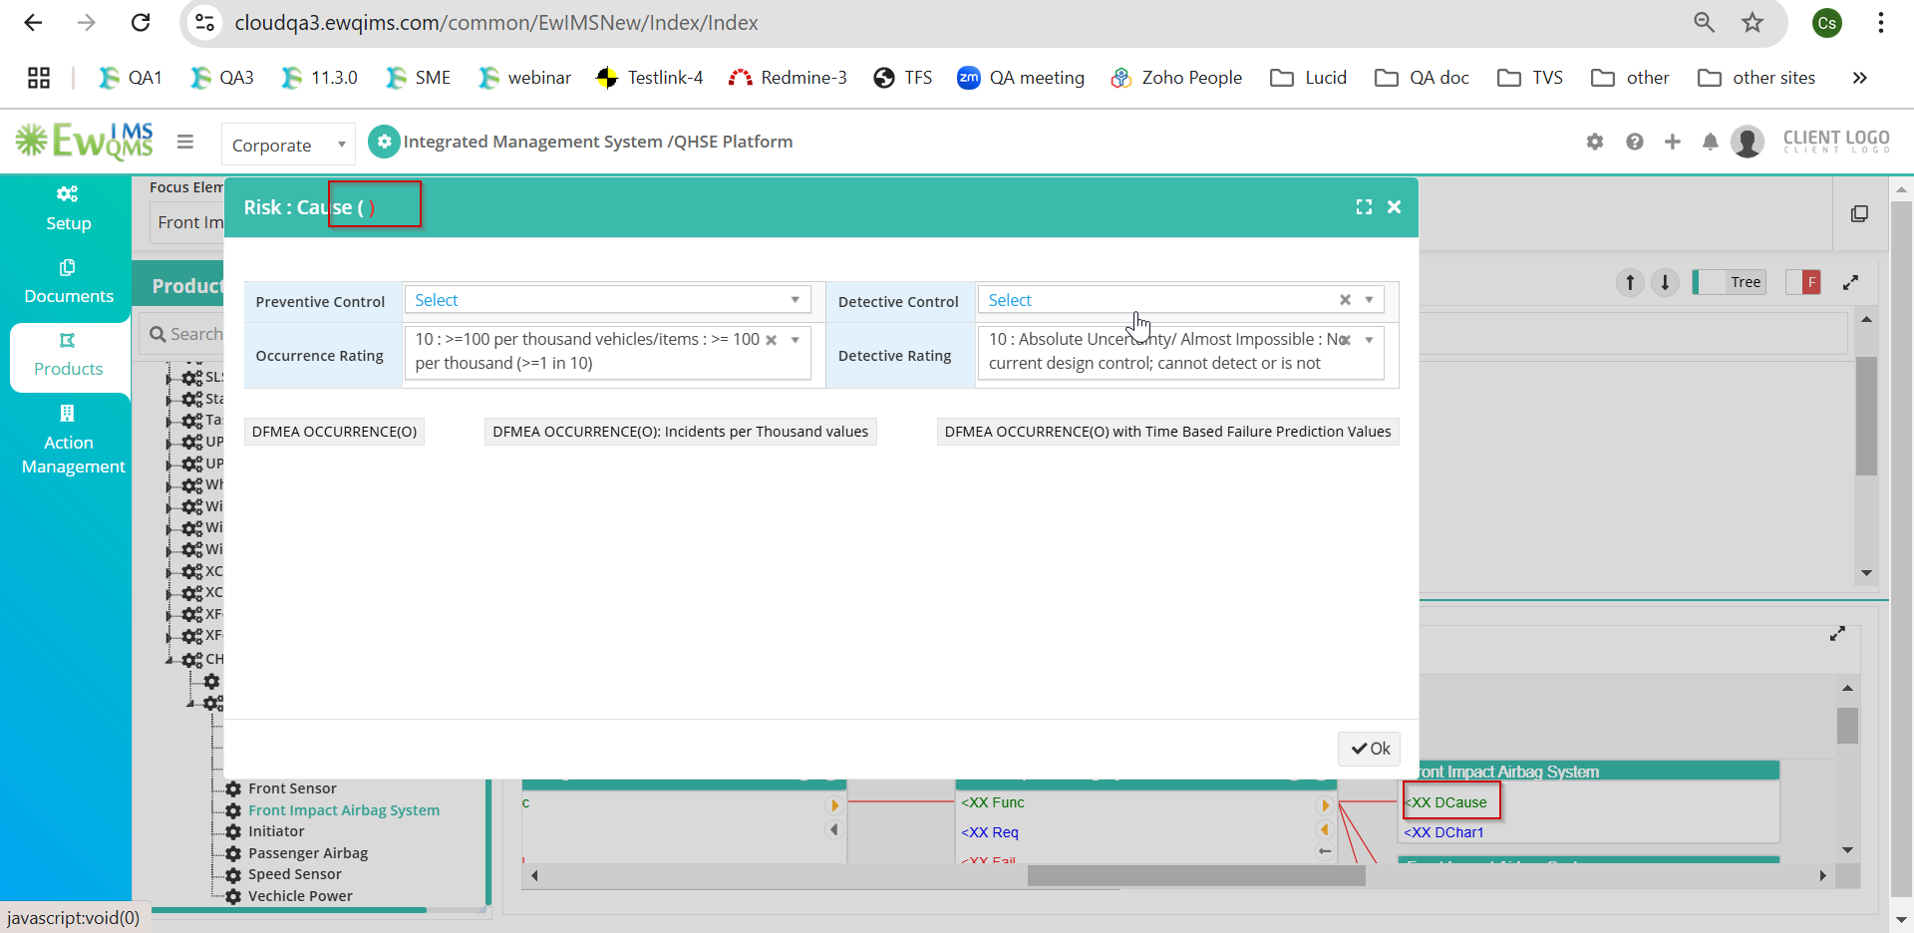
6. Design VDA: Diagrammatic view some icon displayed when hover on the <XX Data
7. Process ⁠Segment name
8. Operation name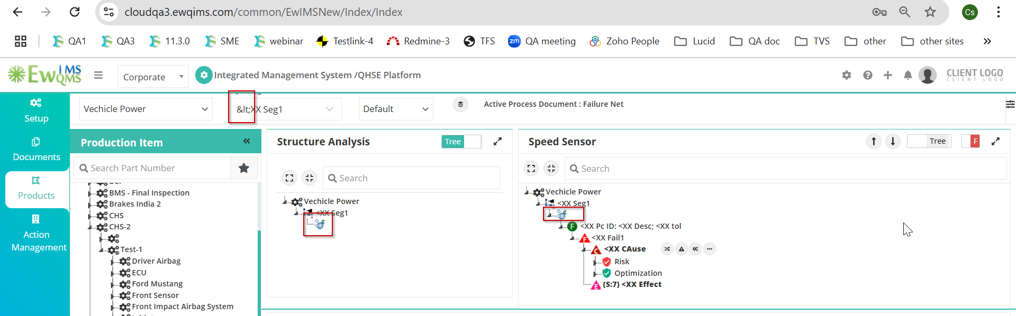
9. Process VDA: Work Element Function and Process Item Function dropdown