Characteristic Changes - Client Requested to add the Characteristic with respective Design cause

1. After adding the Cause and Characteristic, the Risk and Optimization context menu is not displayed in the Diagrammatic view. - Fixed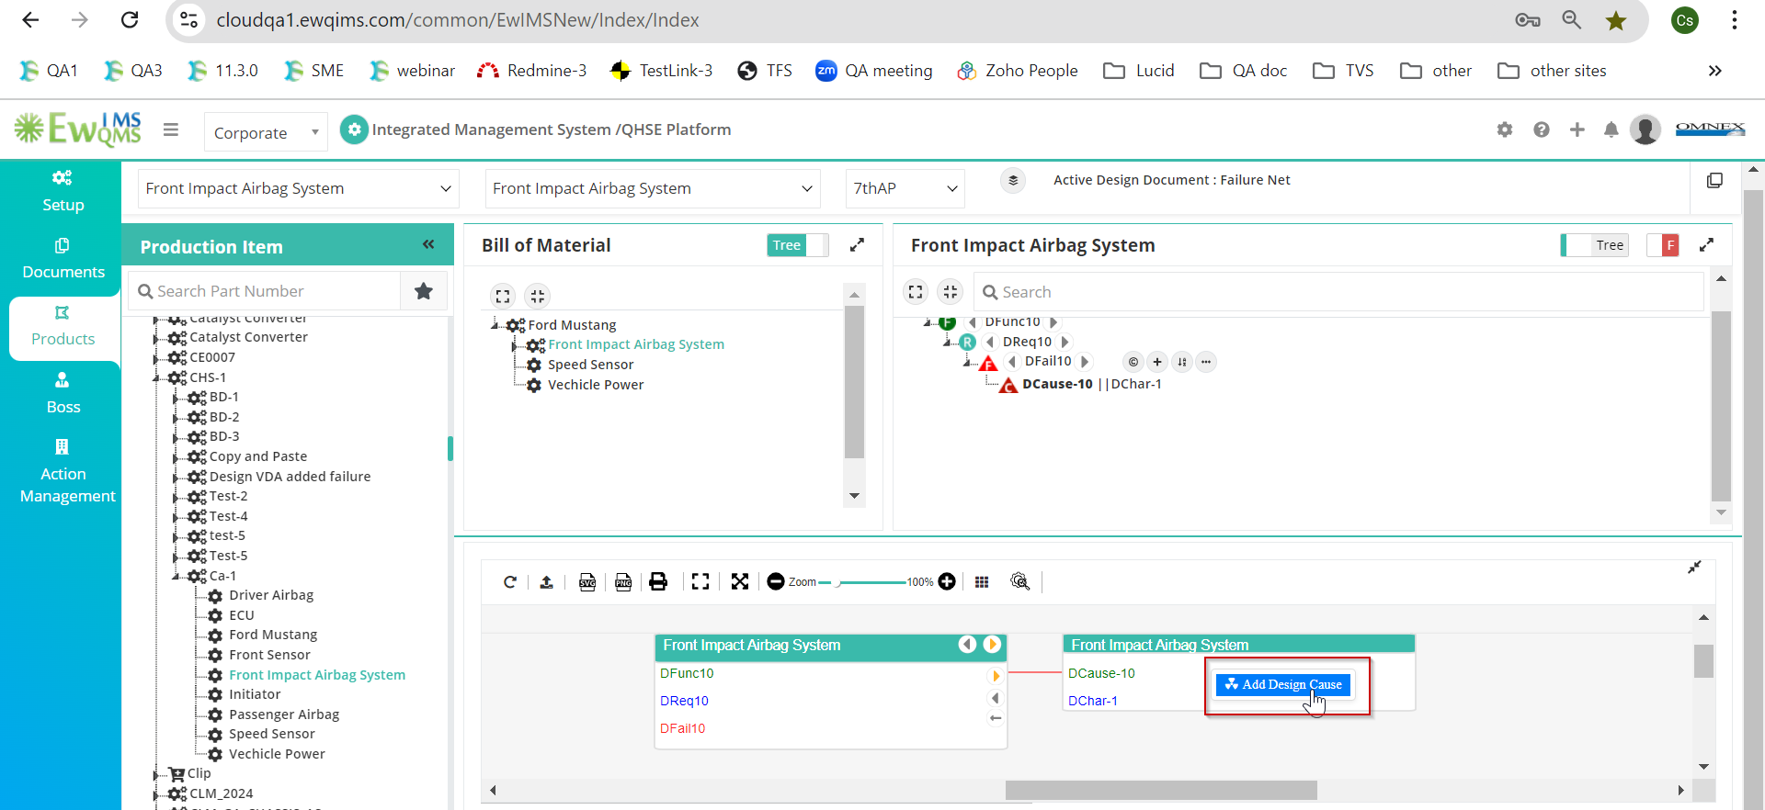
2. In the Diagrammatic view, when clicking the Hide/Unhide icon, the added characteristics are duplicated. Not Fixed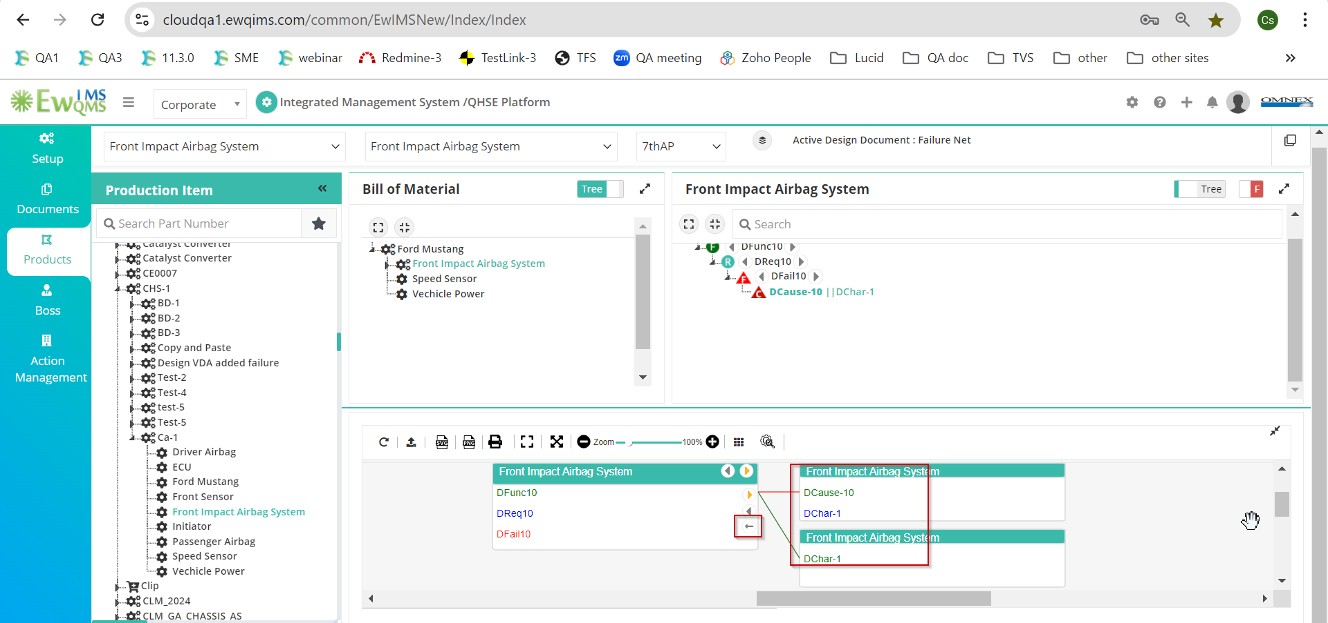
3. After editing a Cause, the Tree view shows the character value as null. Fixed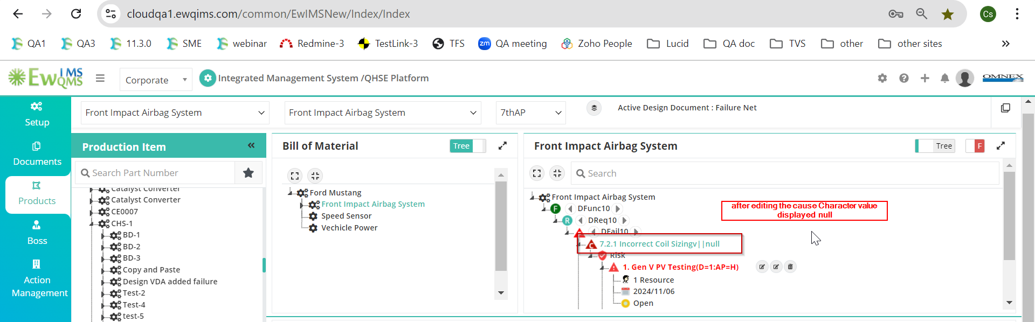
4. After adding a Character and Cause, the Edit and Delete character context menu is not displayed in the Tree view. Not Fixed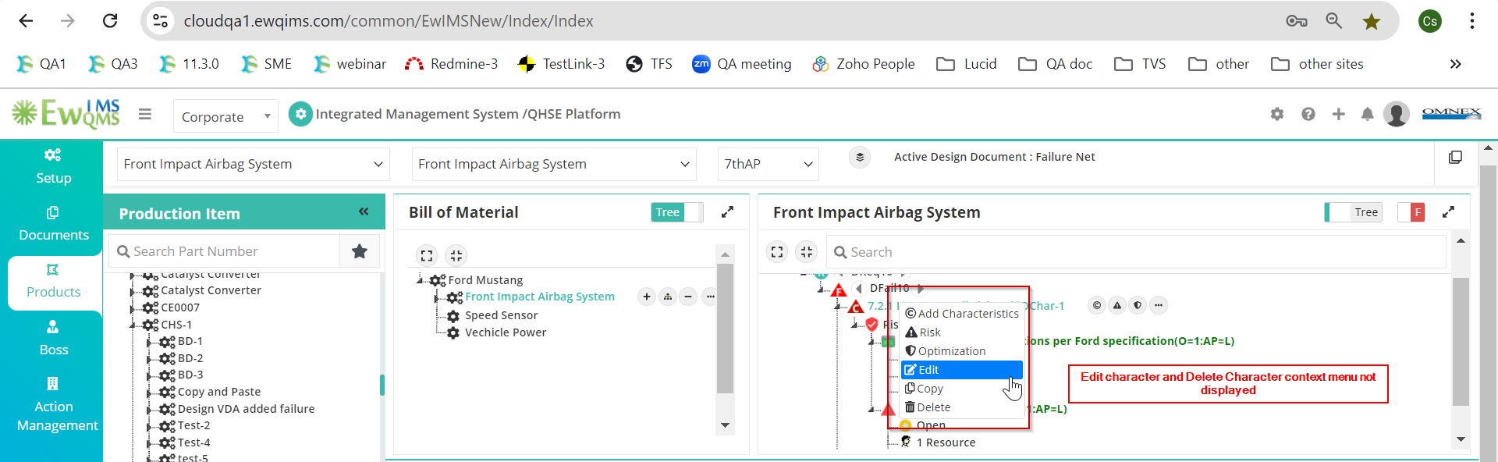
5. After selecting a checkbox, it becomes disabled, making it impossible to uncheck the character. Additionally, clicking the OK button does not work. Not an issue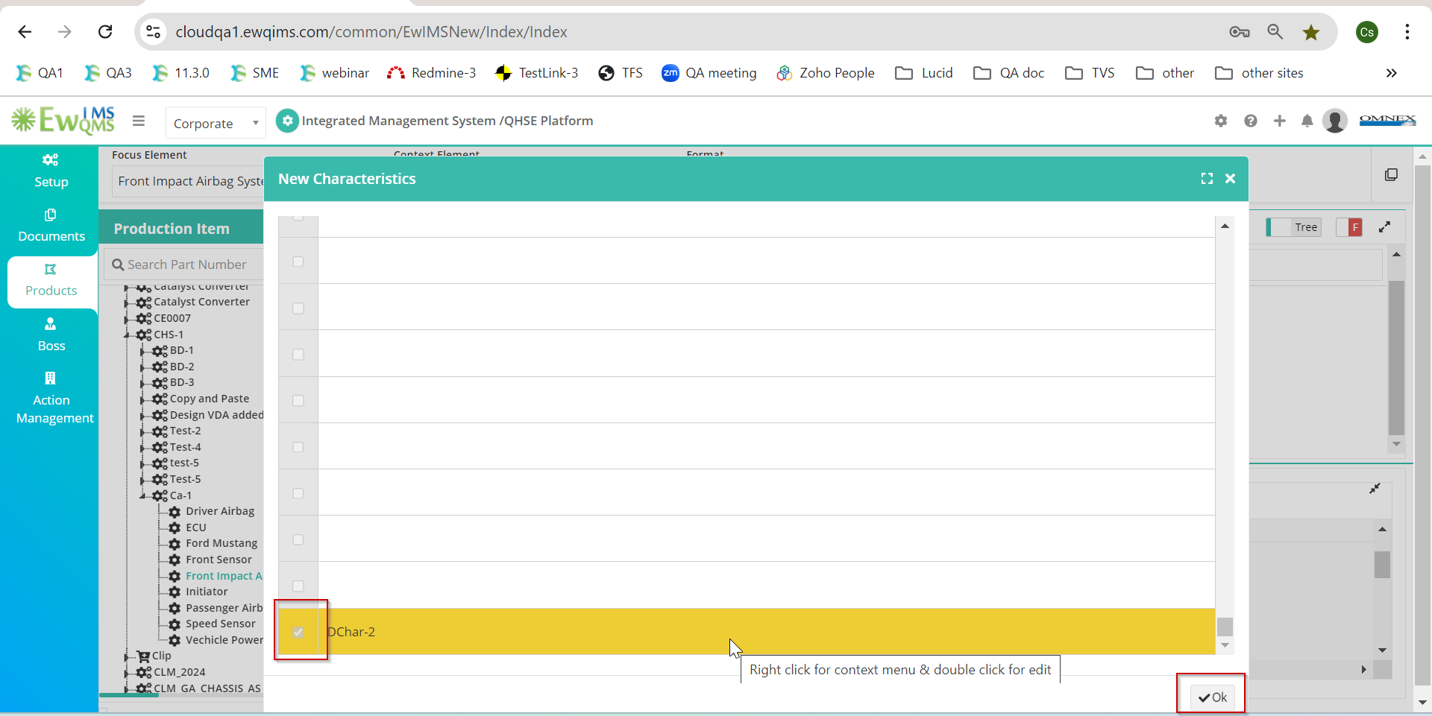
6. After adding a Cause in the Diagrammatic view against a Character, the Cause value is displayed as blank in the Tree view. Fixed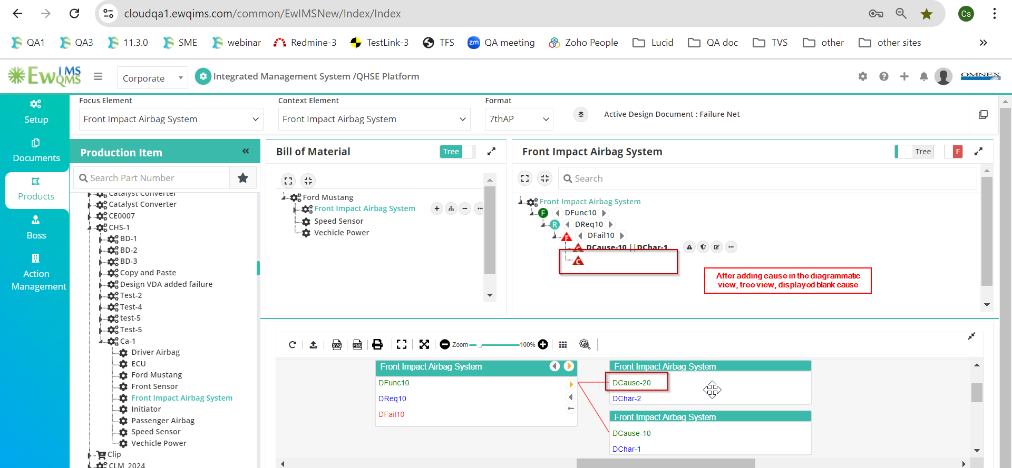
7. After adding **Risk and Optimization**, the **Delete Character** icon is unexpectedly displayed. Fixed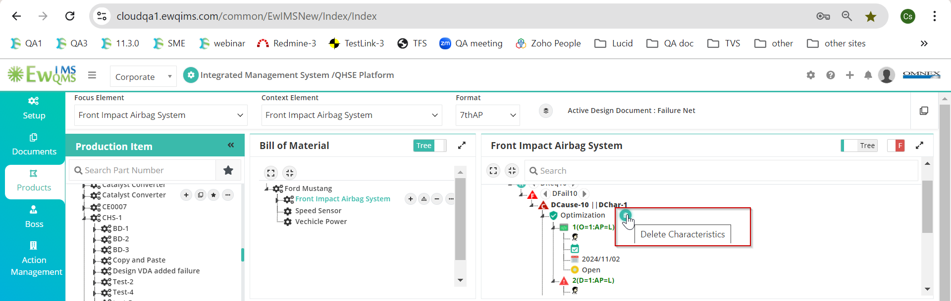
8. The **Character tooltip** is not displayed properly. Fixed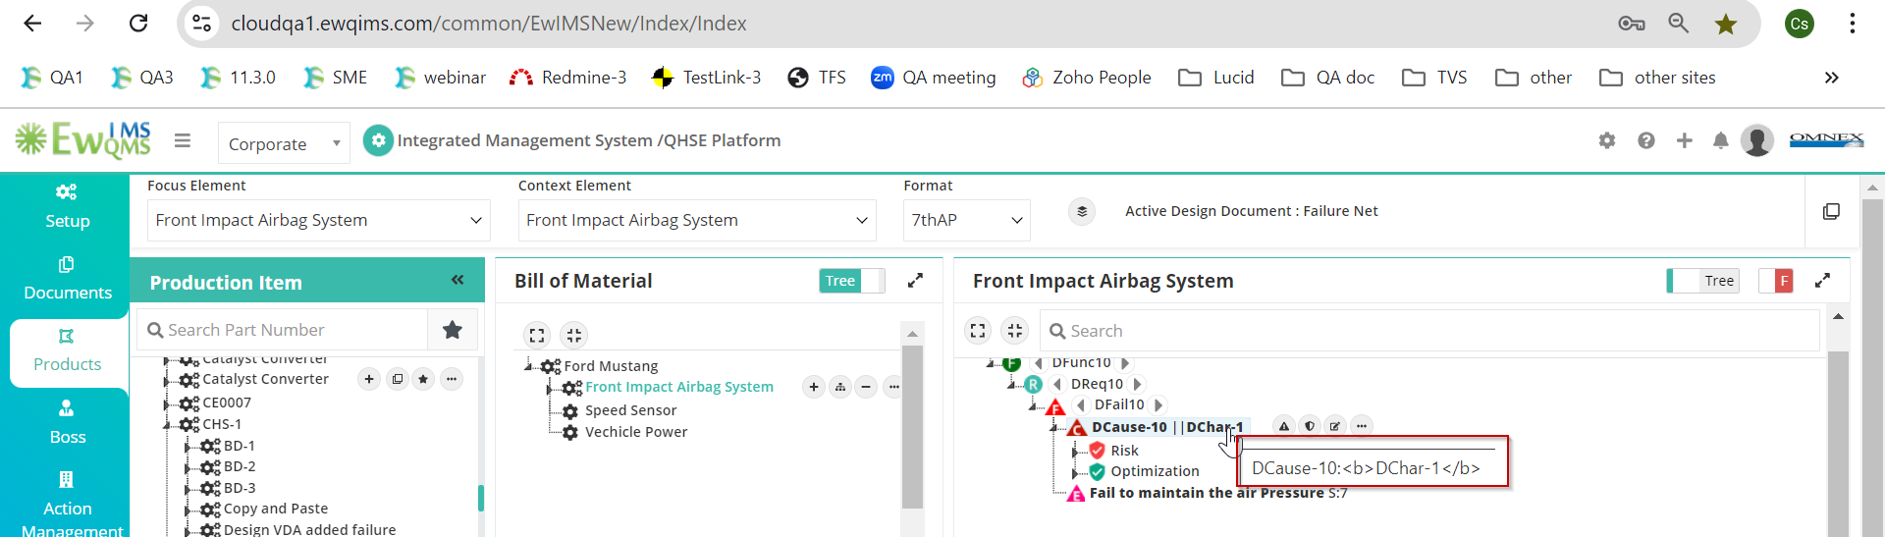
9. **Design VDA Function Analysis** page. In the **Diagrammatic view**, the **Add Cause** context menu is displayed. Fixed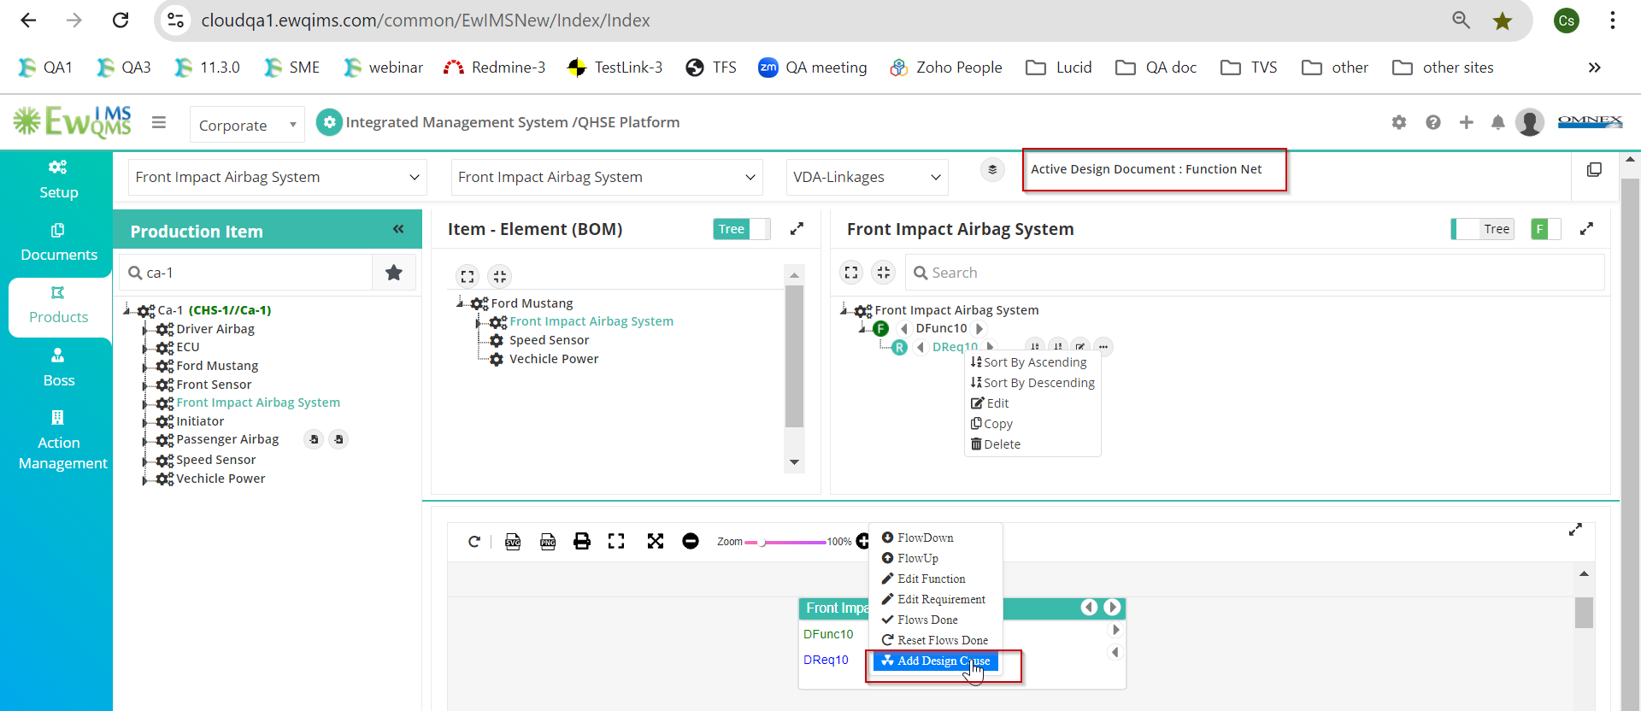
10. In the **Flow Down Failure** branch, the **Add Design Cause** context menu is not displayed **Not Fixed**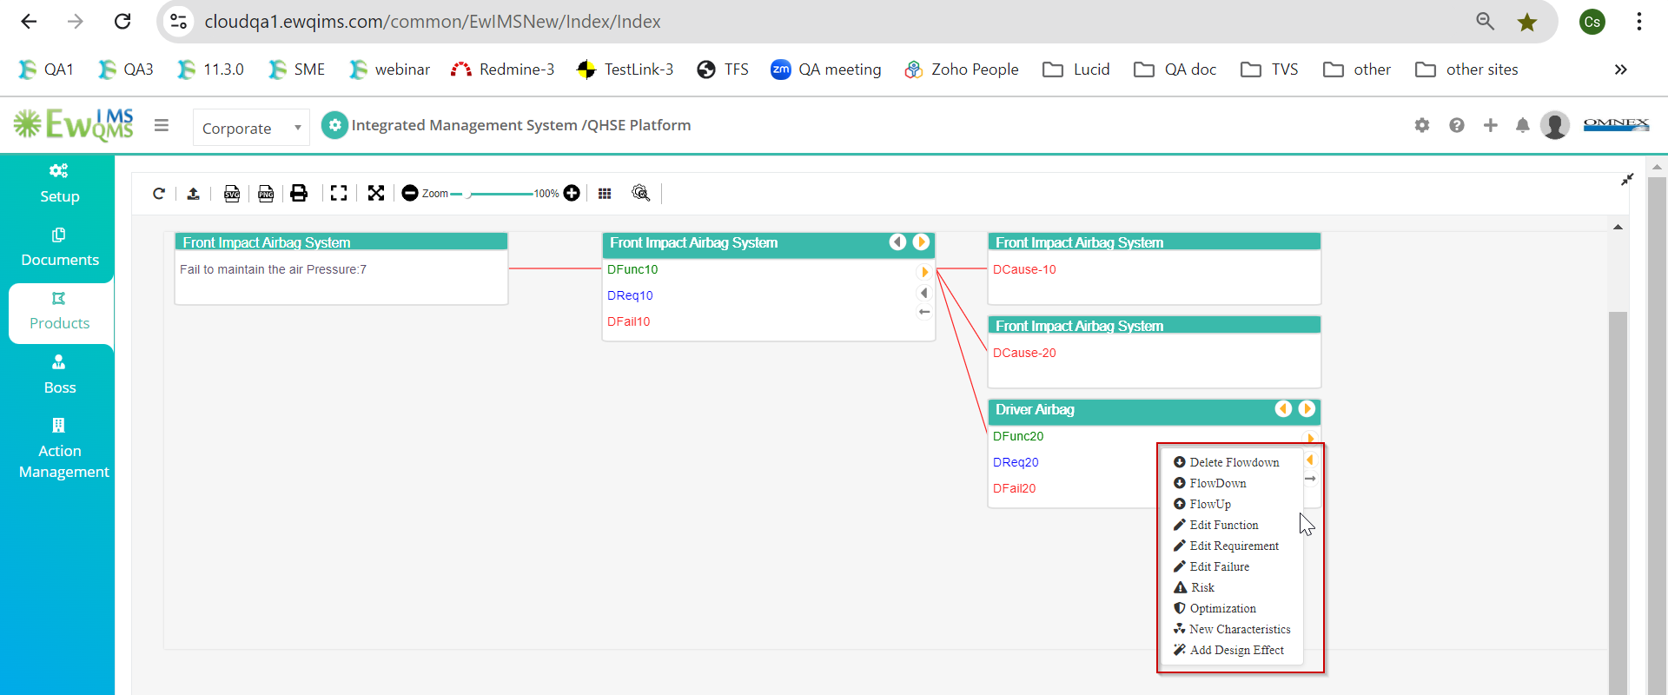

09/10/2024

1. I am able to add **Risk and Optimization** for lower-level elements, which should be restricted. Fixed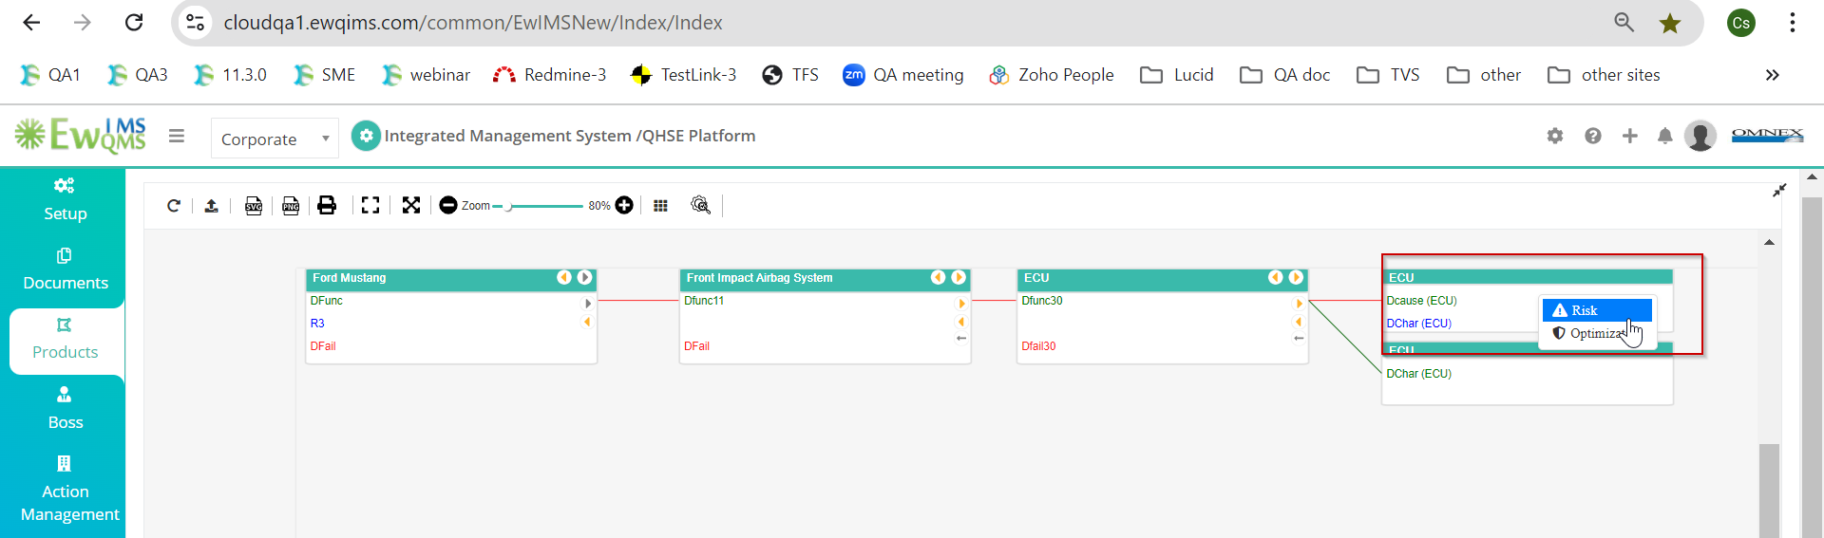
2. In **Main2**, when I add the **PCID** without adding a description, the **PCID** value is displayed in the Diagrammatic view but not in the Tree view. Doubt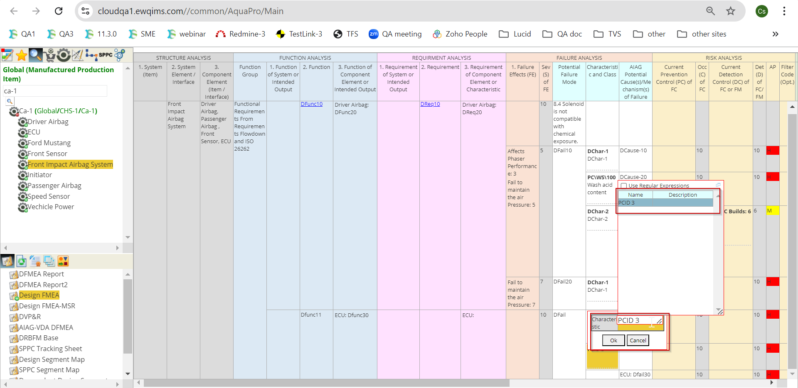 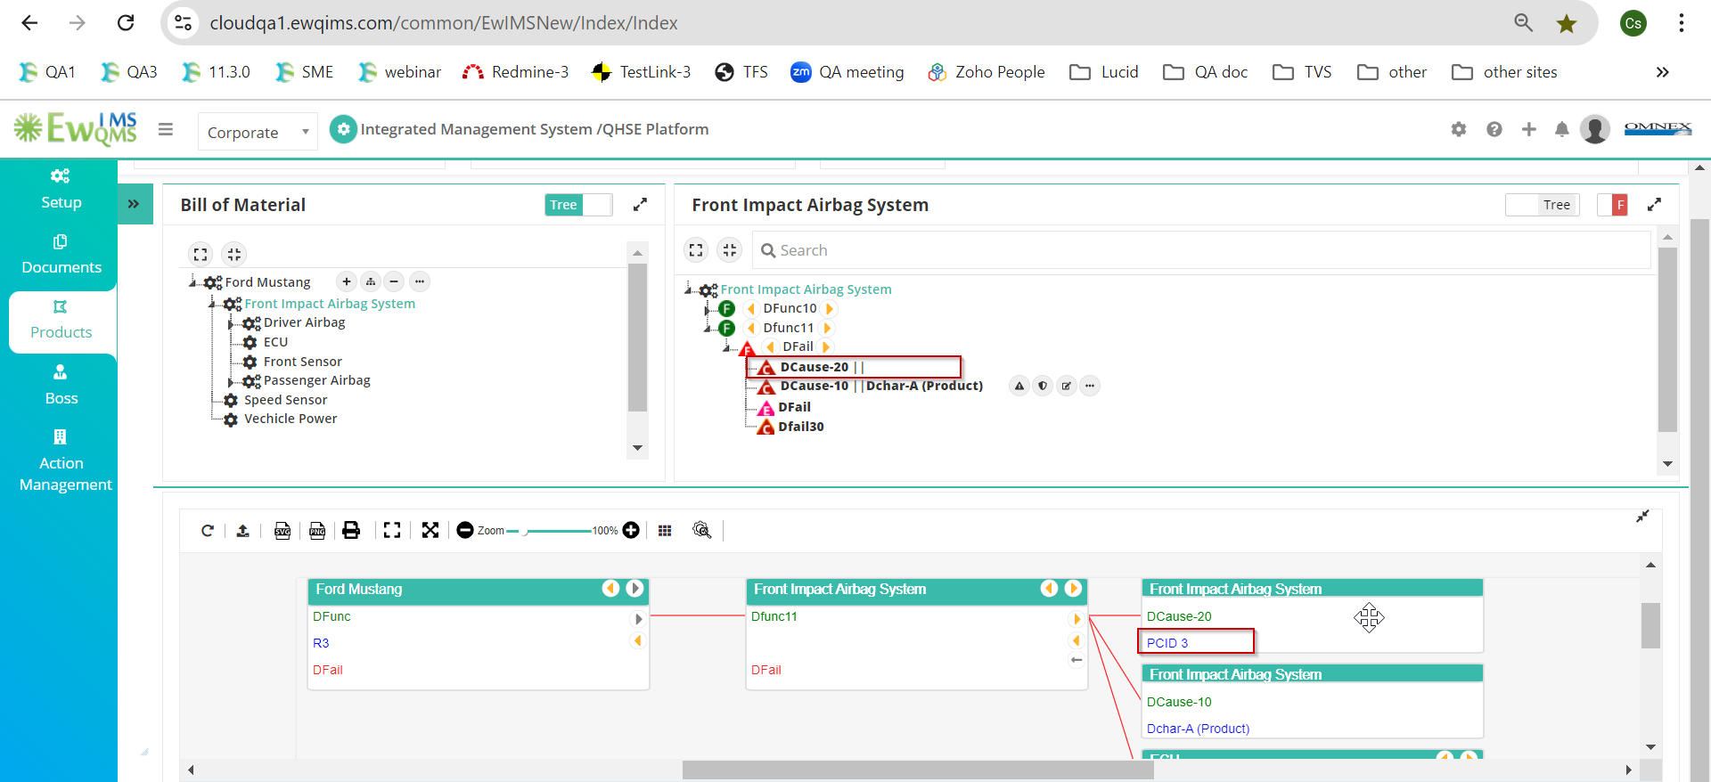

Need clarification:

1. When I edit the PCID value, the system updates both the PCID and Description columns in the master table. Is this the expected behavior, or should only the PCID column be updated?
2. On the **Main2** page, the user can add multiple **characters** against a single **design cause**, but this is not being displayed correctly in the **VDA**.

14/10/2024

1. The **Risk and Optimization** context menu should not be displayed unless a **Design Cause** has been added. 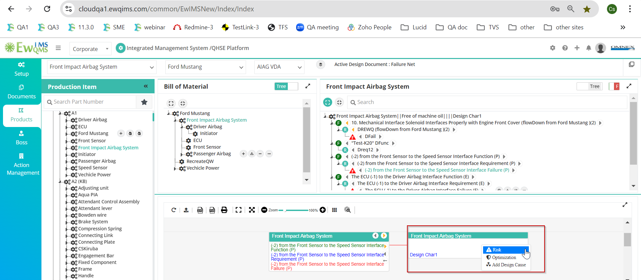
2. When adding a **character** from the **Diagrammatic view**, it is incorrectly updated in the **Tree view**. please Refer the screenshot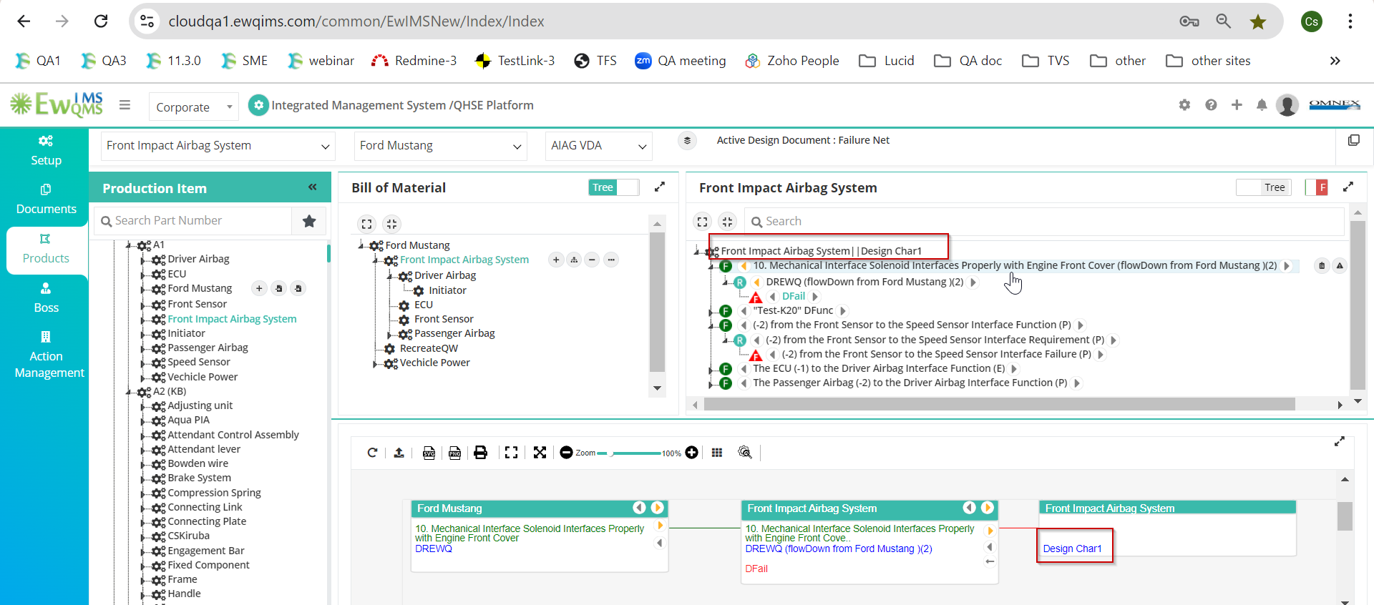
3. when adding a lengthy **Character** or **Cause** text, it is displayed **outside the box**, 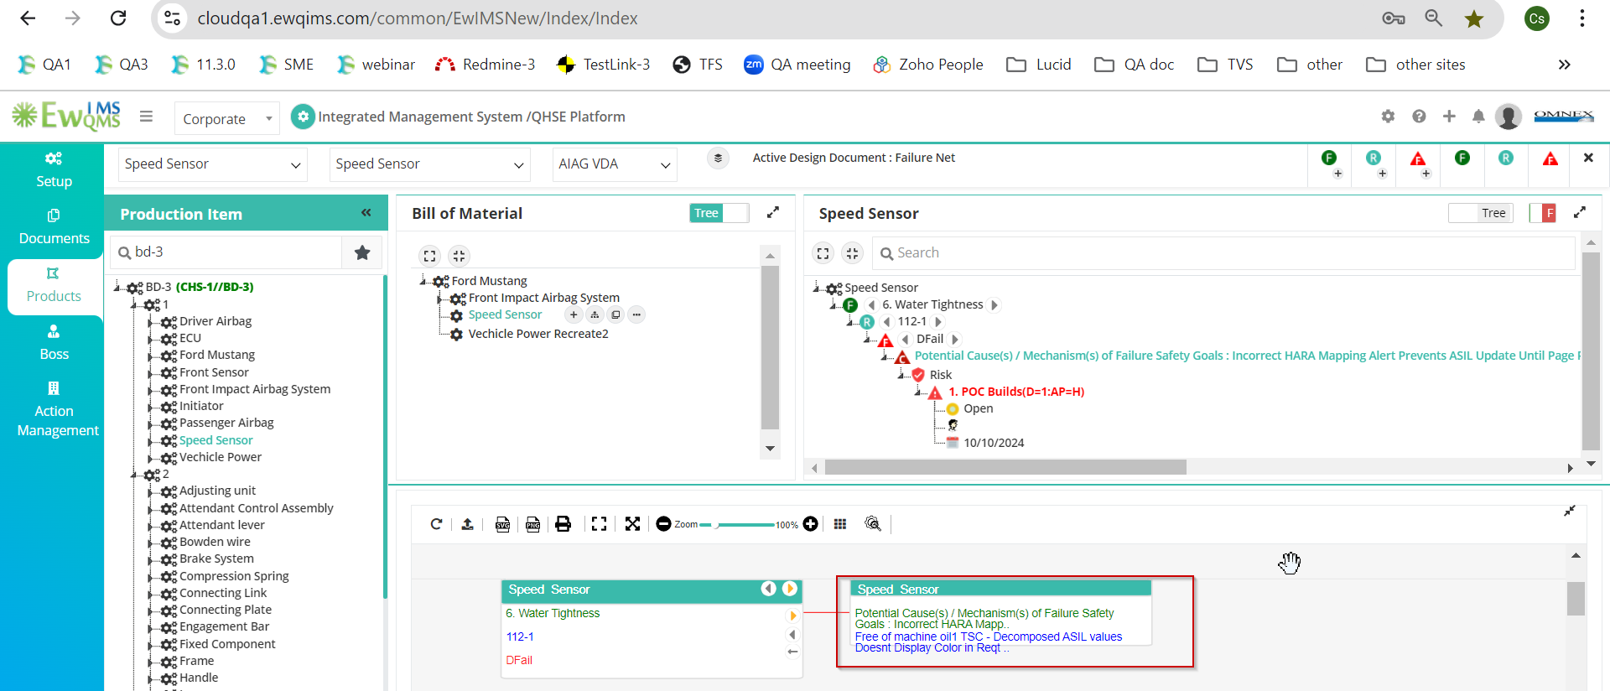
4. When adding a **Cause** and **Character**, and then attempting to edit the Character, the **edit popup window** is not displayed properly.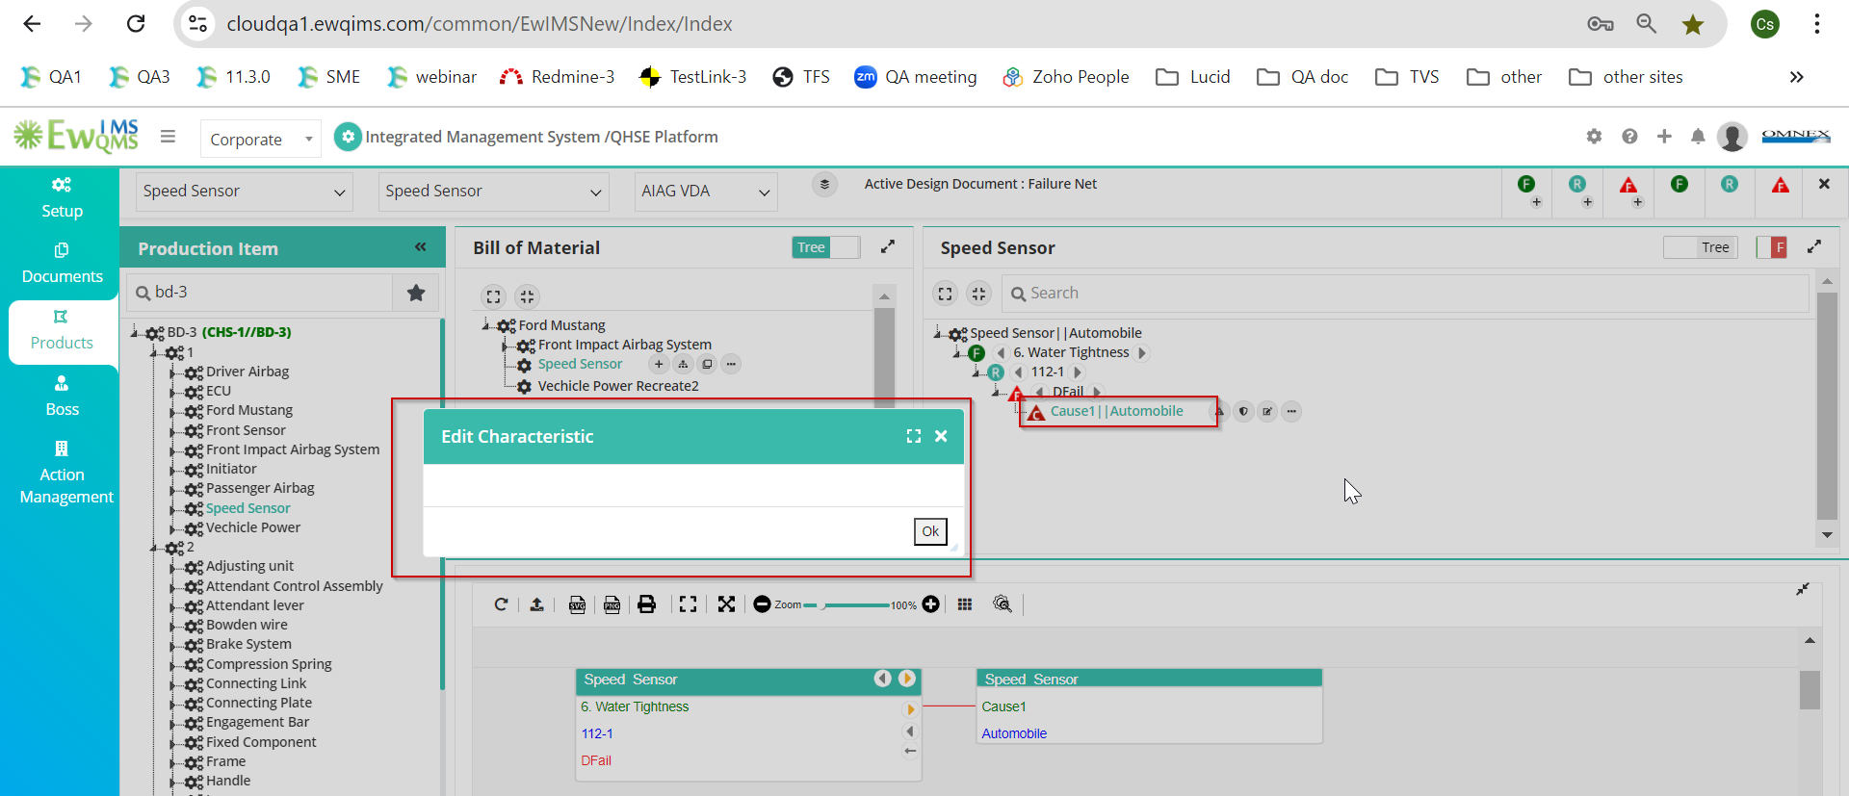
5. Performance issue when adding a Cause against Characteristics. The Design Cause popup takes a more time to load. 