**Bulk Publish Issues:**

1. Users are able to change the level in the level selection icon for already published documents. 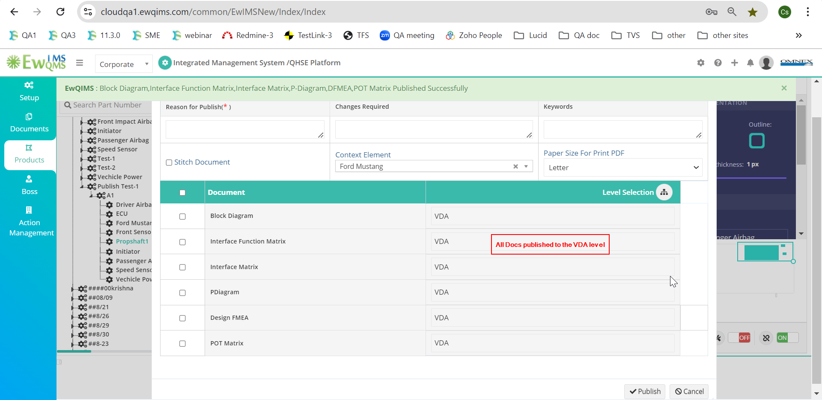 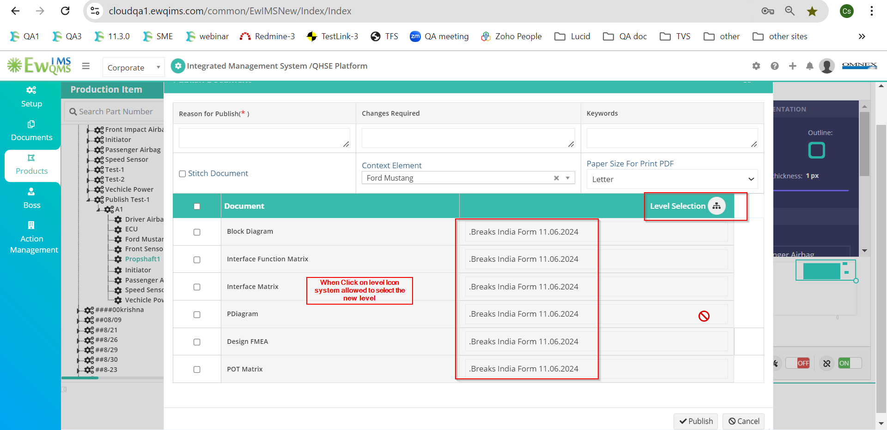
2. The Block Diagram is not being published properly (some elements or interface lines are missing in the published Block Diagram). 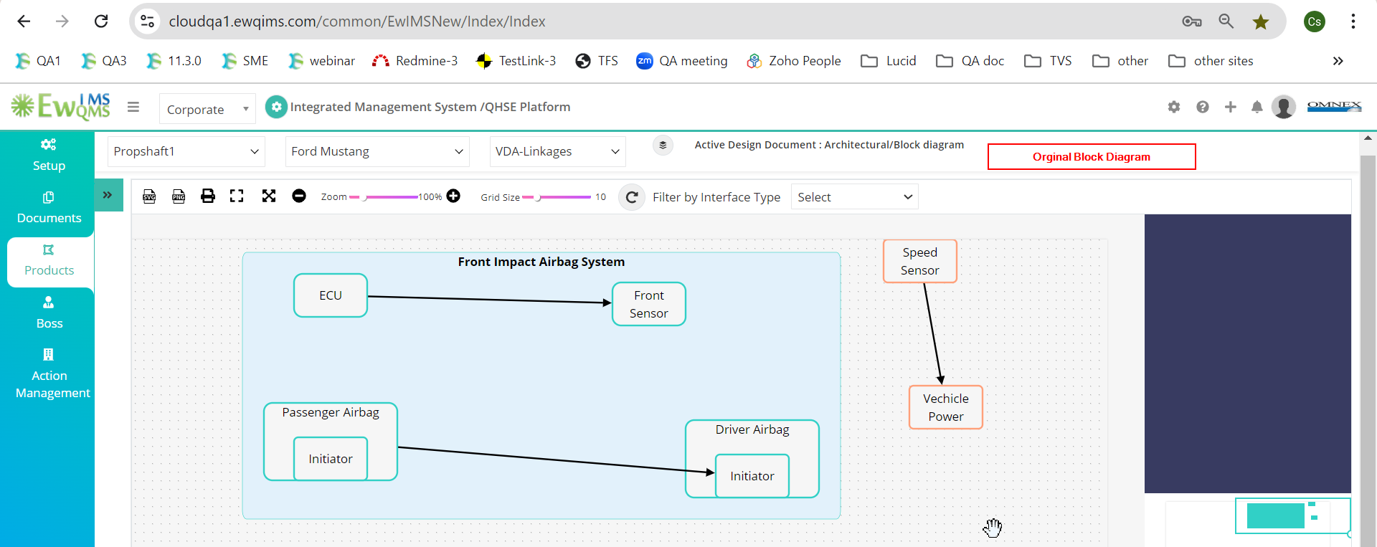 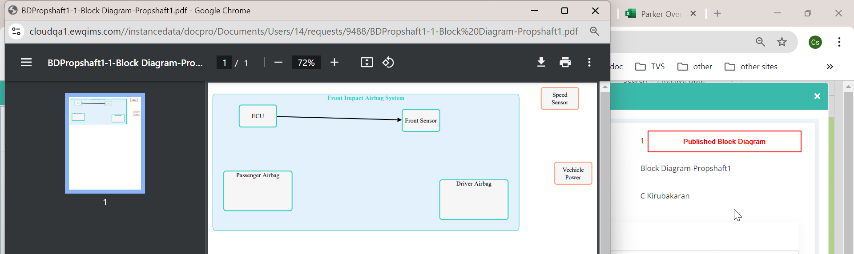
3. The published DFMEA document does not show the higher element. 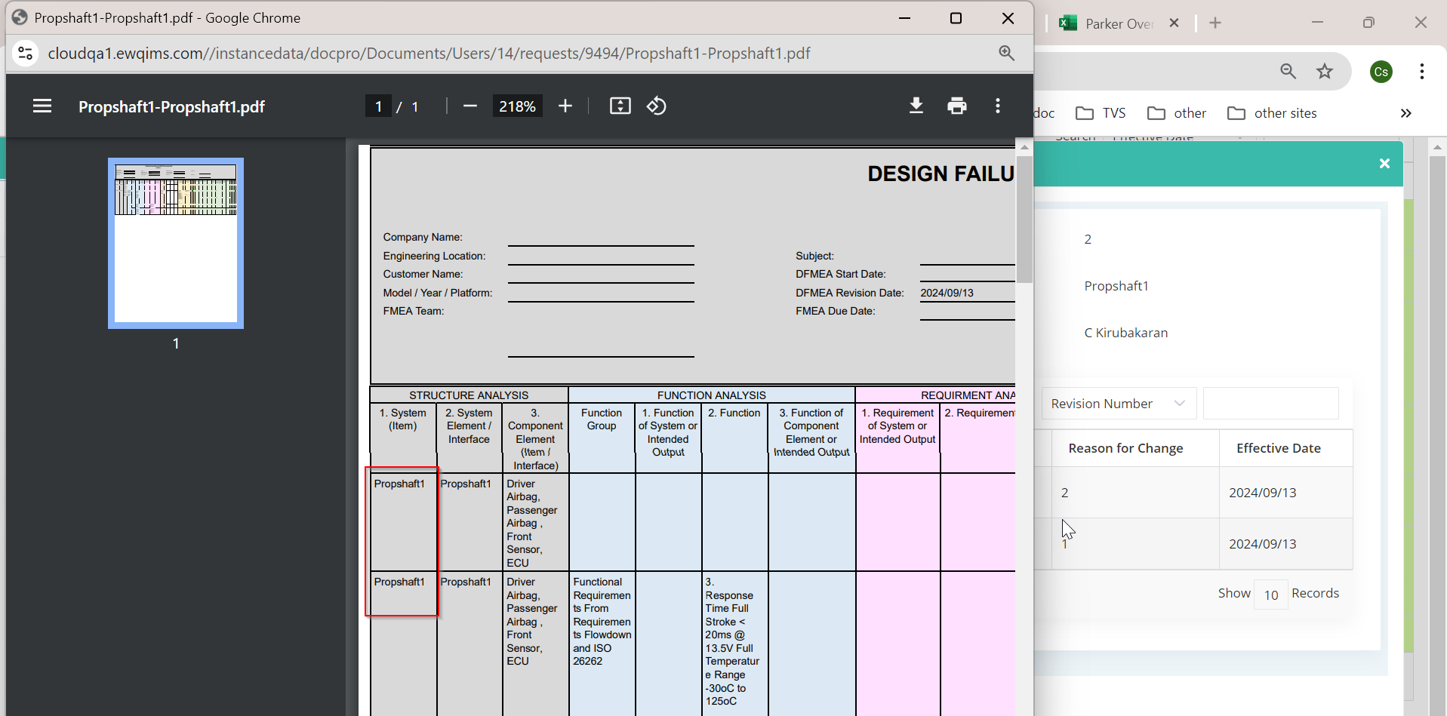
4. Route Approval is not working. 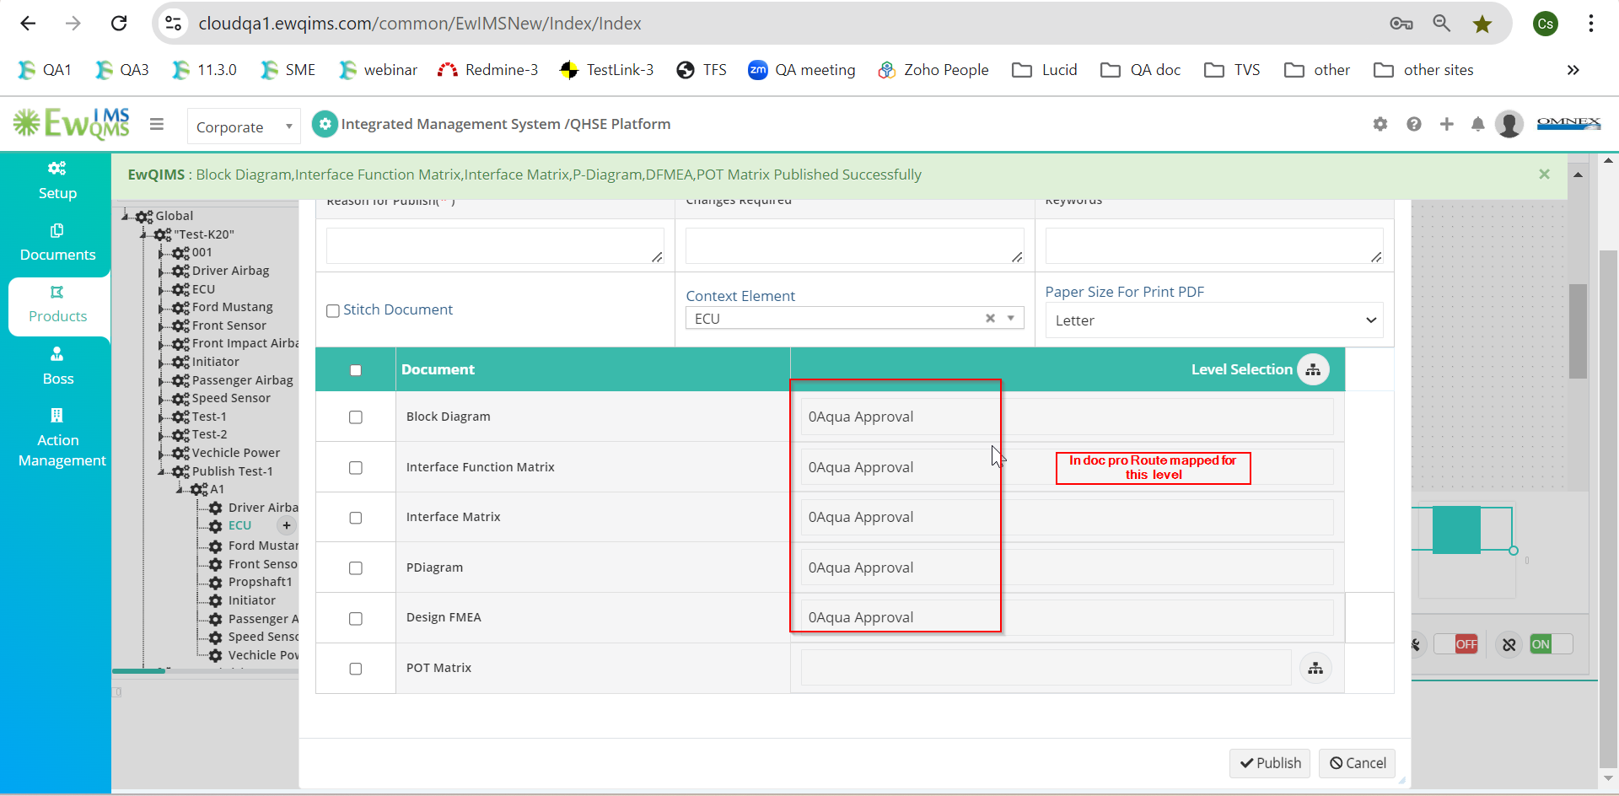
5. In the Single Publish page, the Approval Route is also not working. 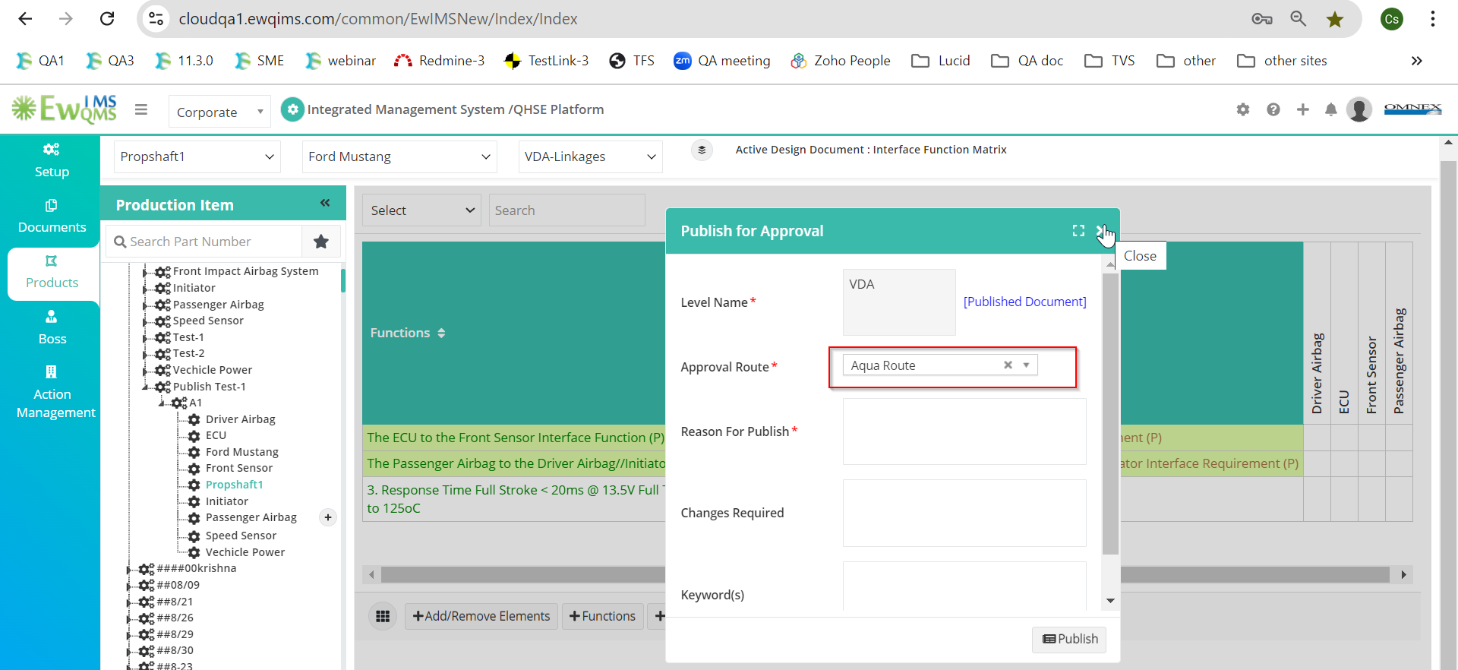
6. In the Bulk Publish pop-up window, the selected context element is not being published properly. 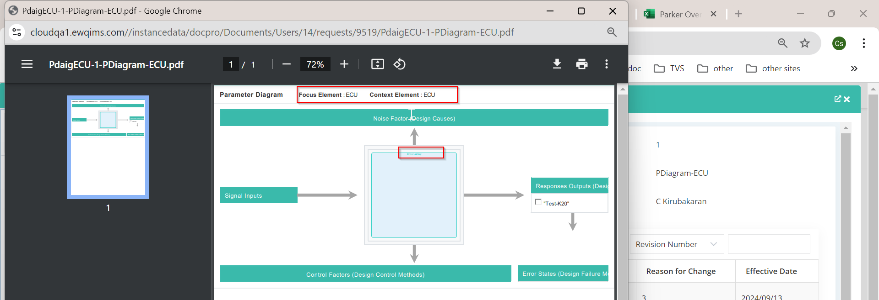
7. When publishing from Other PI (right-click and publish), the Focus Element name is displayed incorrectly. 