Published Document issue

1. Element Type

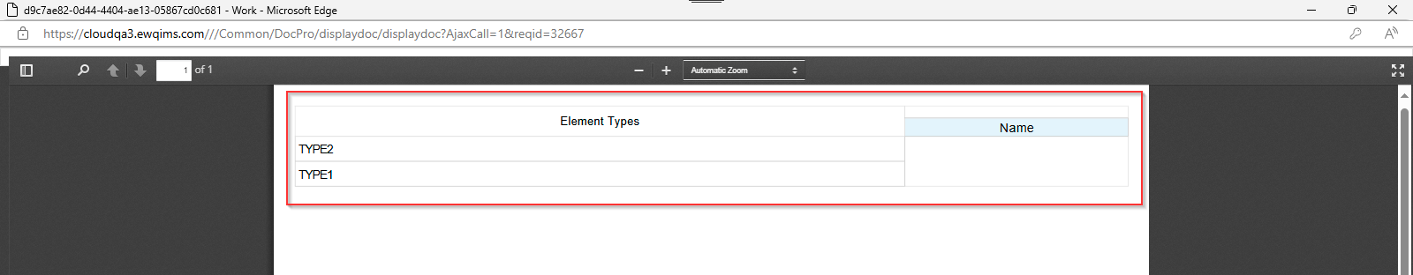

1. Interface Types

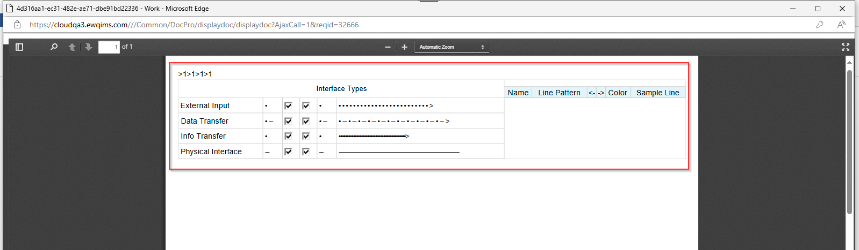

1. Item Boundaries

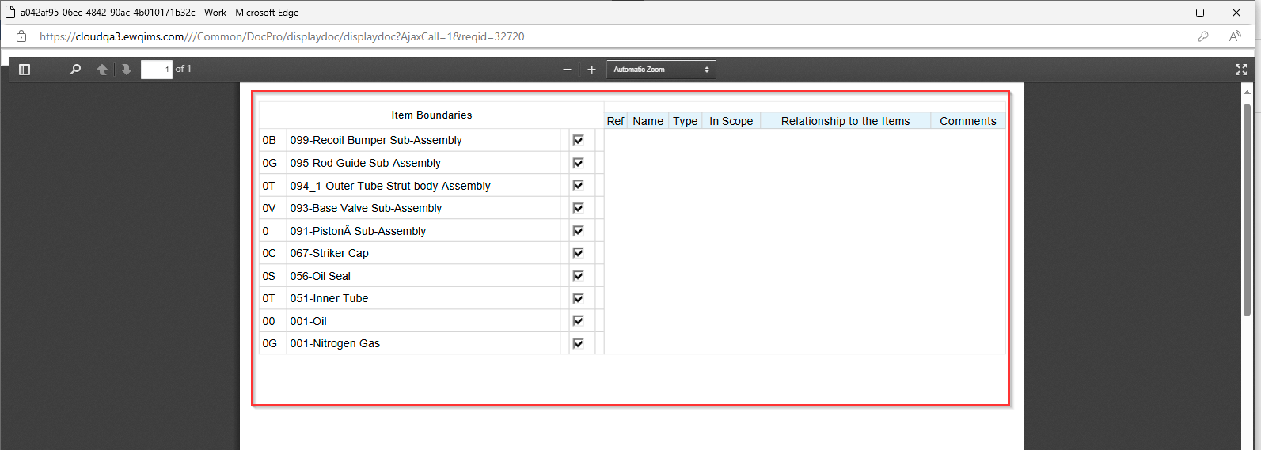

1. Malfunctions

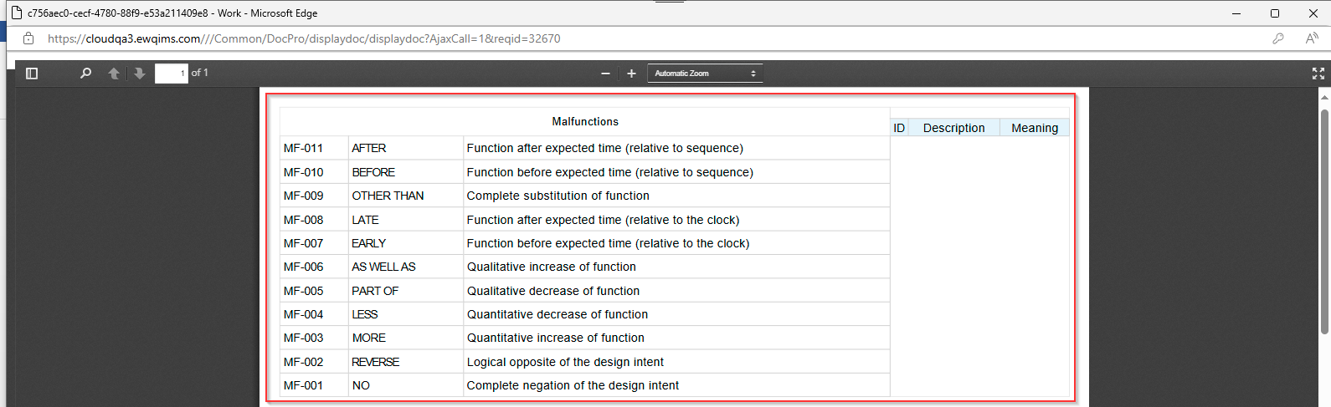

1. Functional Analysis

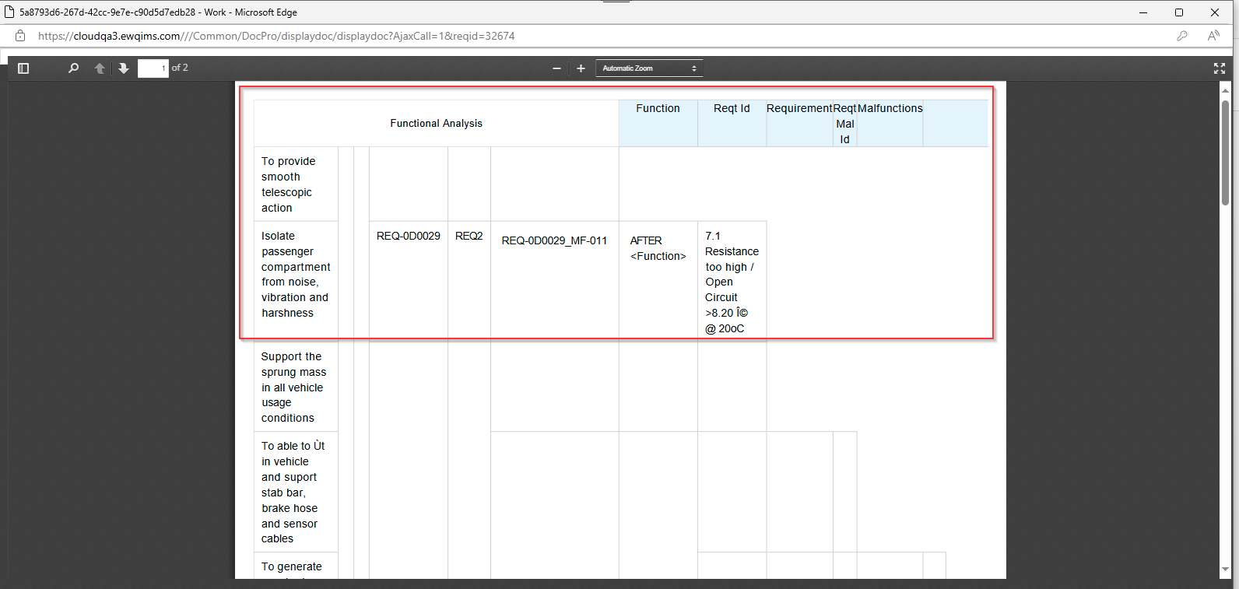

1. Safety Goal

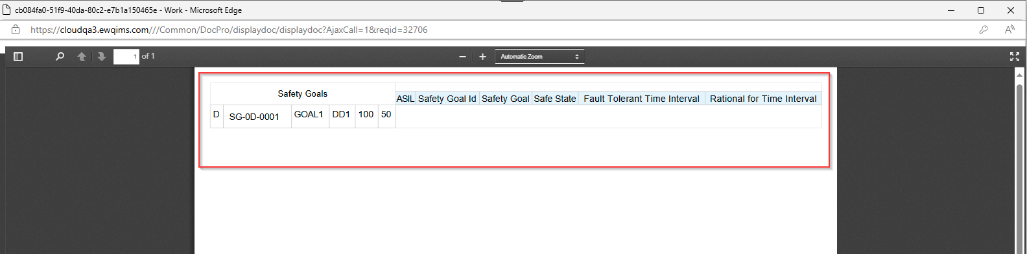

1. Safe State

