**SP 11.3.0 AIAG VDA Korean language Verification**

**URL:** [**https://cloudqa3.ewqims.com/**](https://cloudqa3.ewqims.com/)

**Design AIAG VDA:**

1. Step 1 5T Page: Some text labels have not been converted. 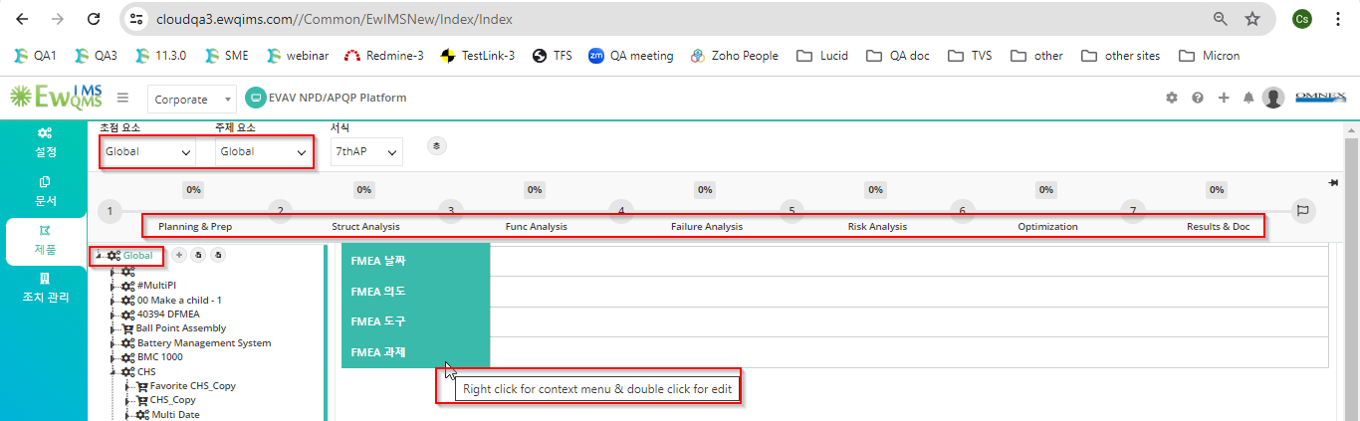
2. Percentage allocation pop up text labels have not been converted. 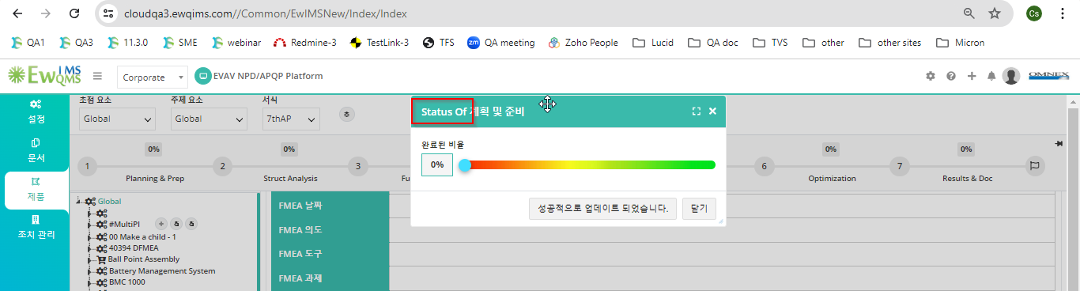
3. Create PI some text labels have not been converted. 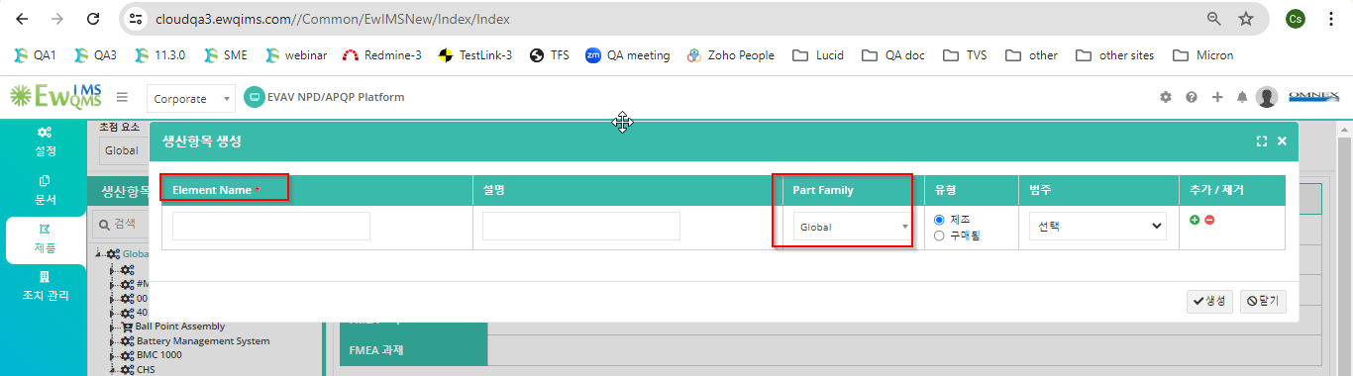
4. Delete PI alert message not converted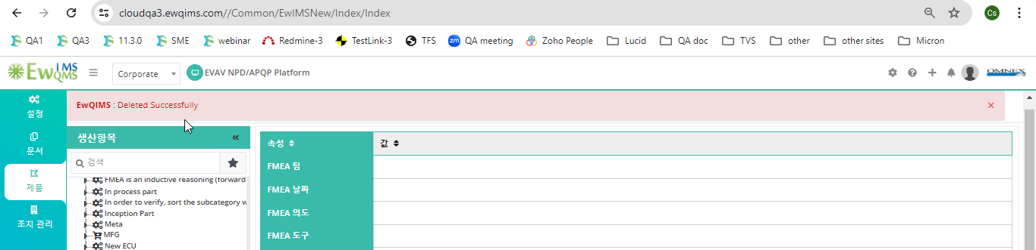
5. Import BOM pop up window text labels have not been converted. 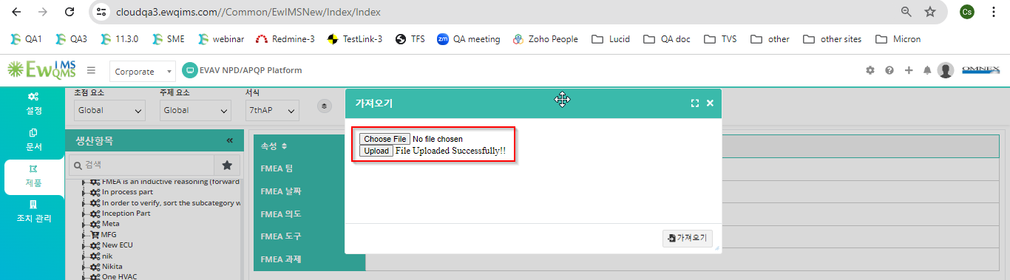
6. Import alert message not converted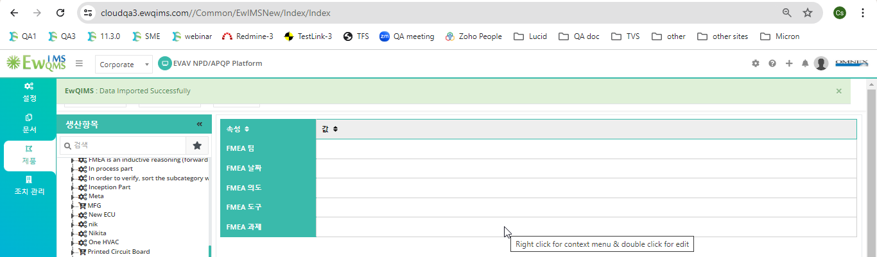
7. Color legend some text labels have not been converted. 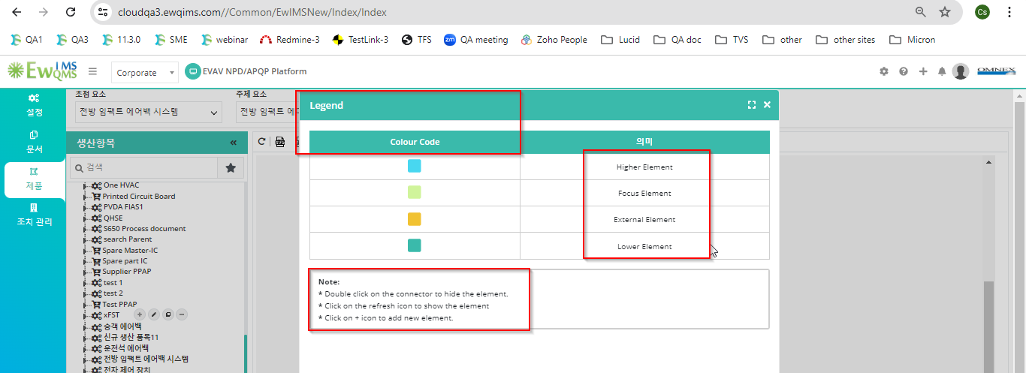
8. Save BOM tool tip alert message not converted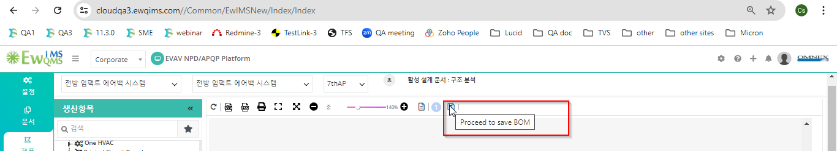
9. Exclude BOM alert message not converted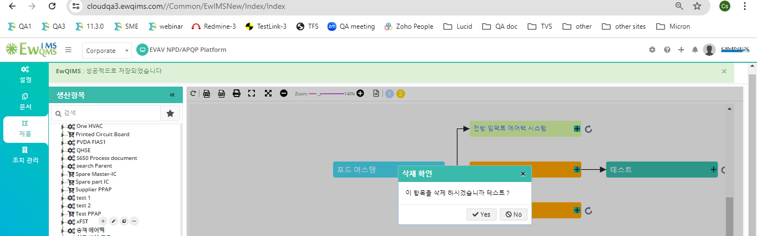
10. Save BOM alert message not converted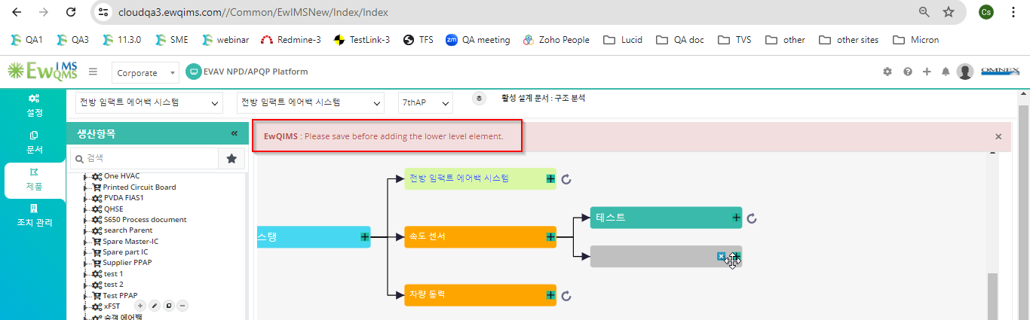

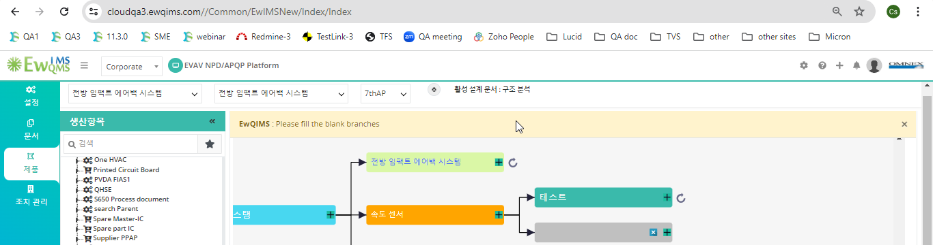

1. Structure Analysis tool tip not converted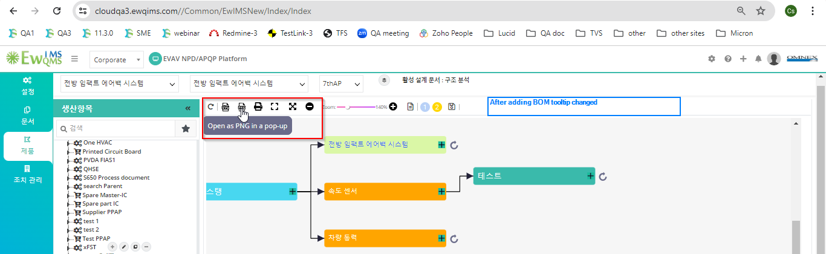
2. Save PNG and Image notes not converted.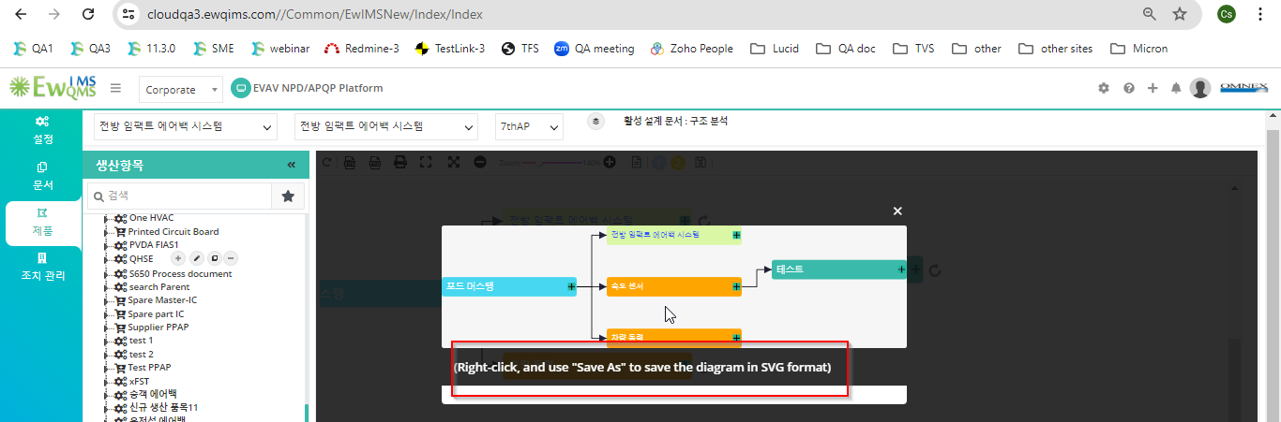
3. Block Diagram, some text labels have not been converted. 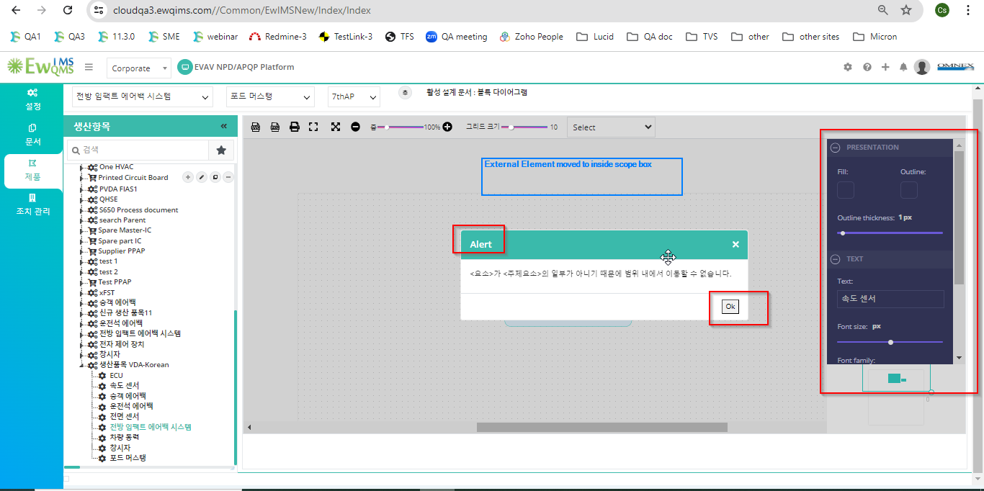
4. BD-Tool box and legend some text labels have not been converted. 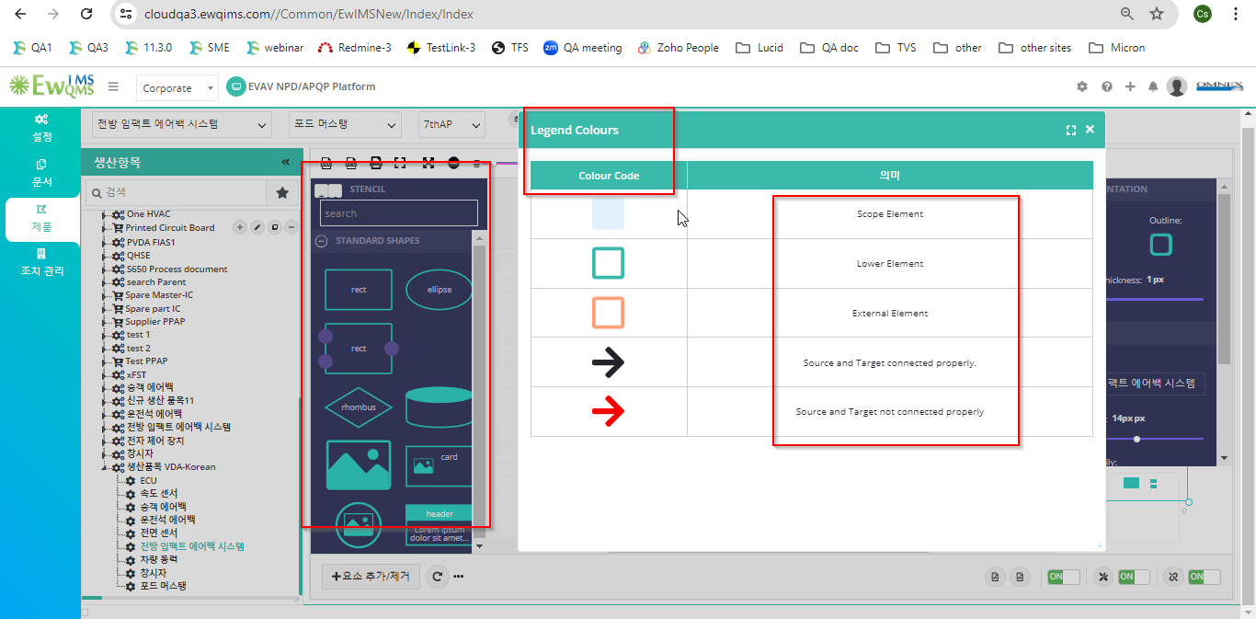
5. Interface line some text labels have not been converted. 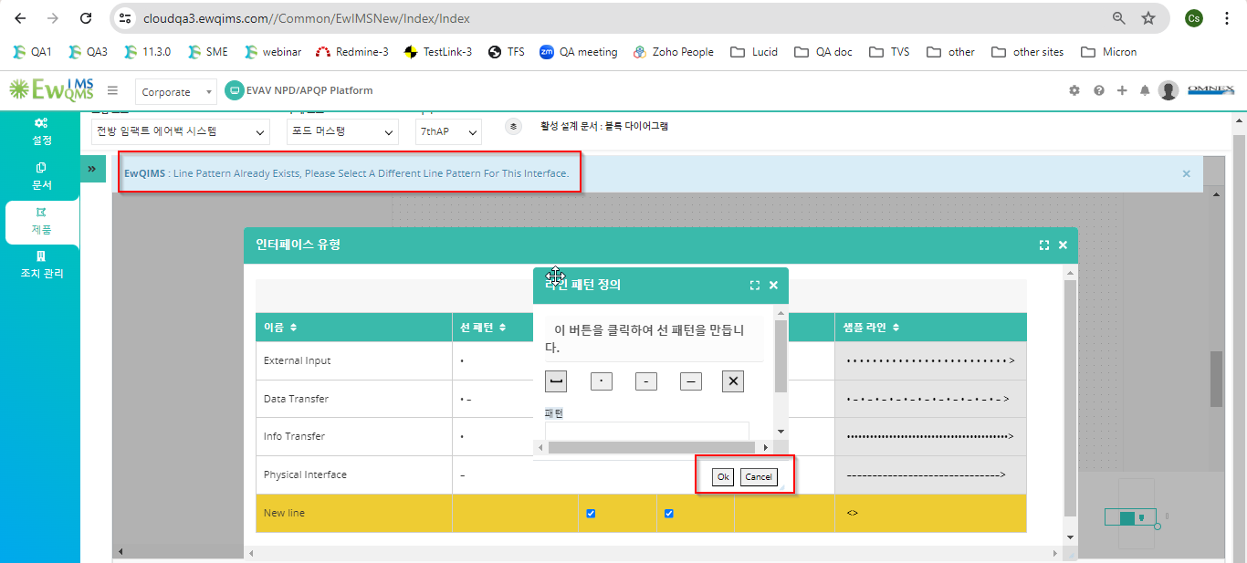
6. Published version some text labels have not been converted. 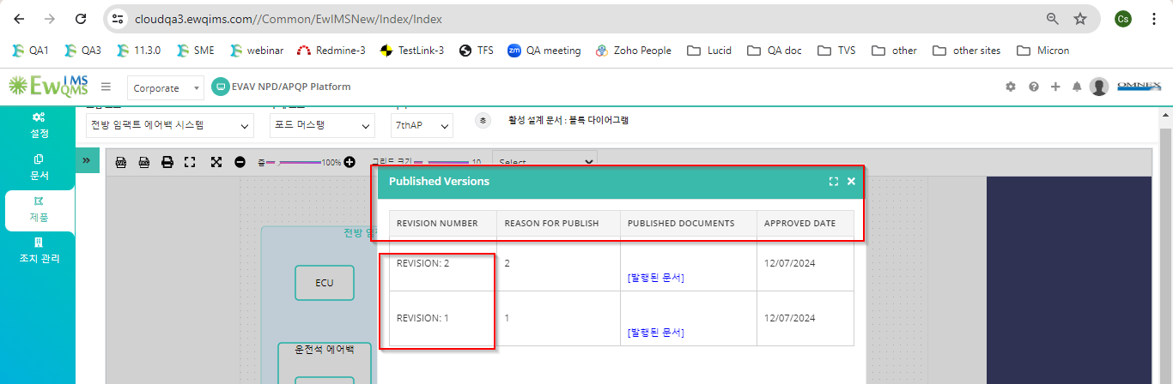
7. P-Diagram some text labels have not been converted. 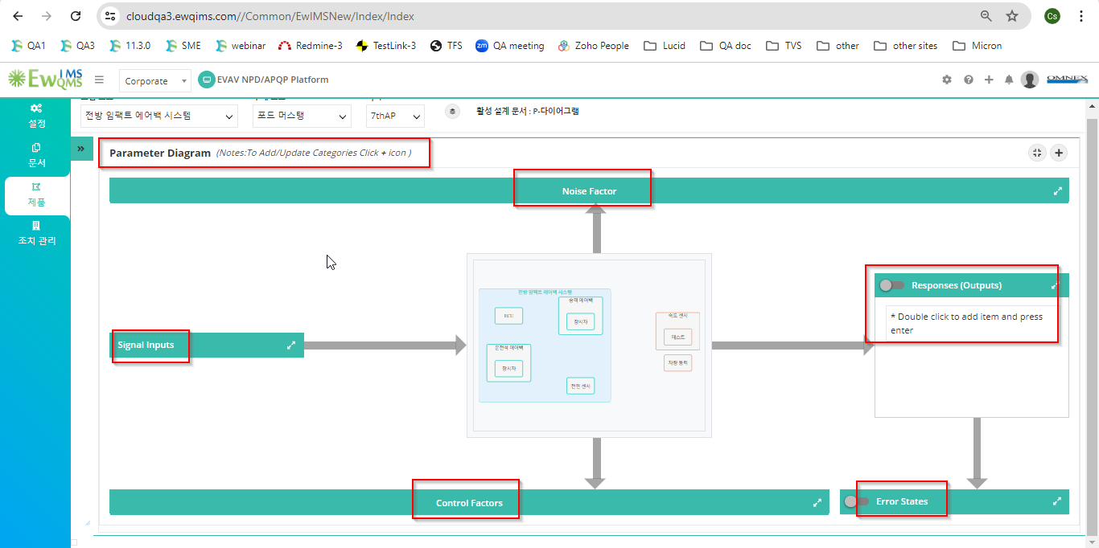
8. P-Diagram category some text labels have not been converted. 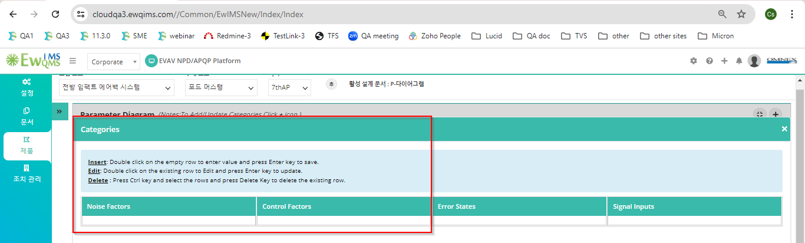
9. Delete category alert message not converted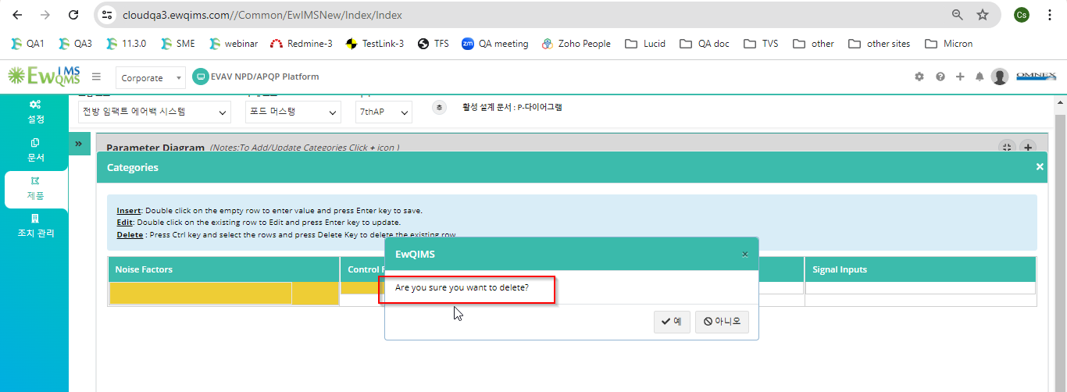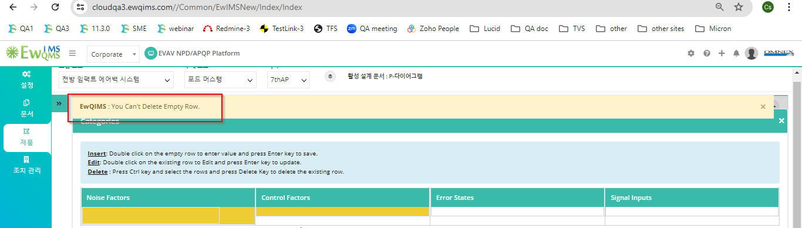

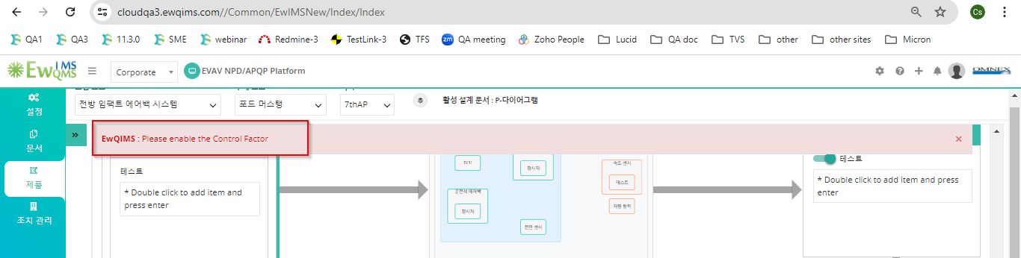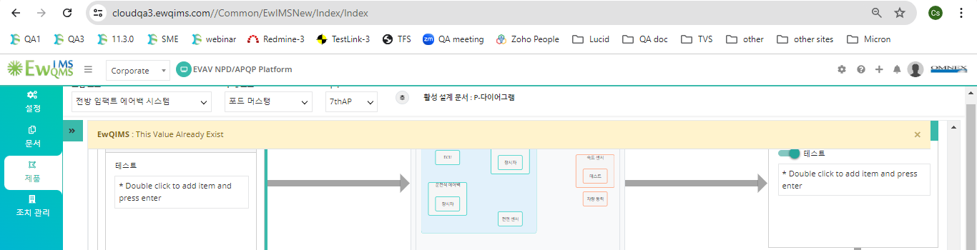

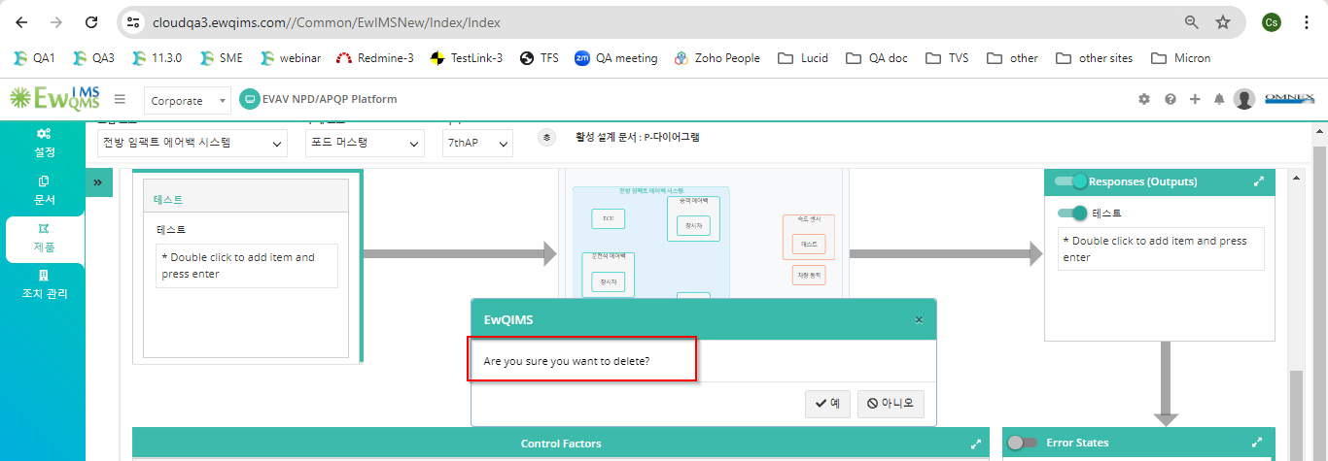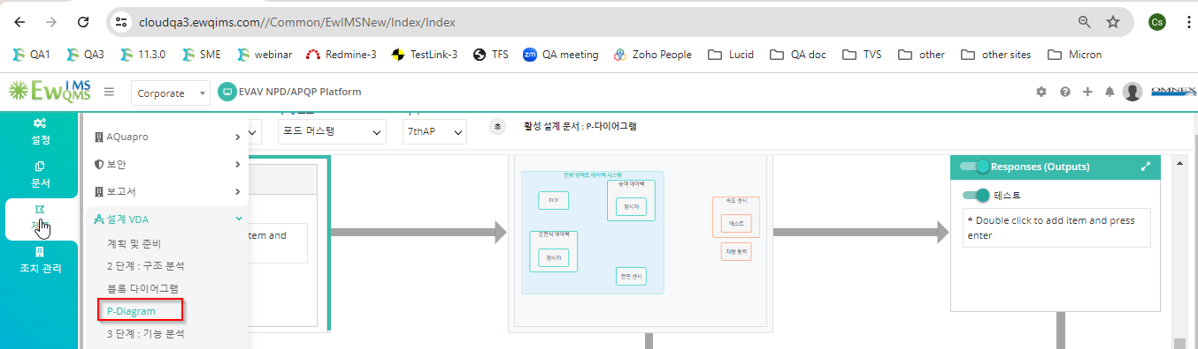

1. Function analysis some text labels have not been converted. 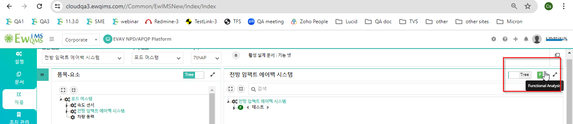
2. Add Function some text labels have not been converted. 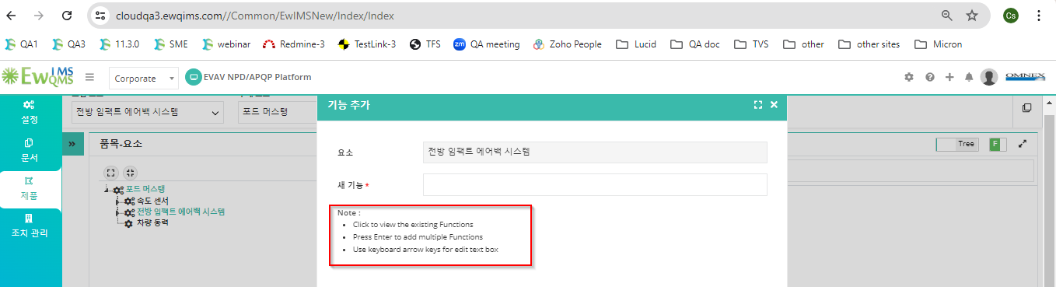
3. Delete flow up and down context menu not converted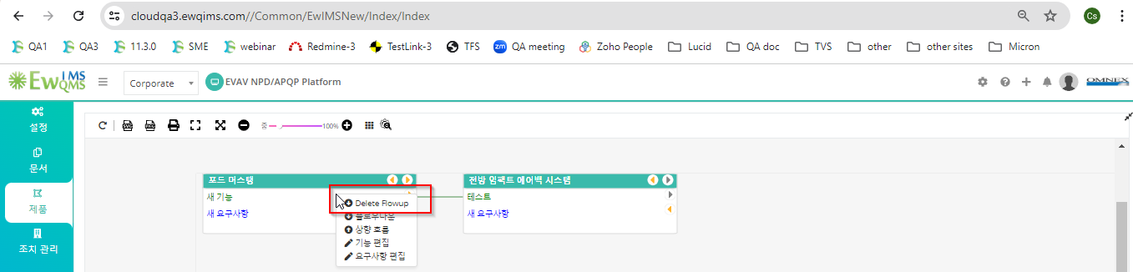
4. Flowup and down po up window some text labels have not been converted. 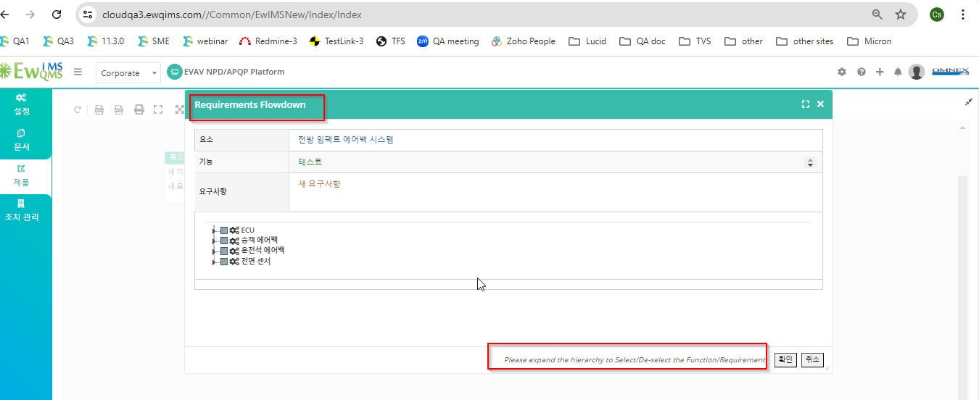
5. DFMEA Icon, Zoom in and out tool tip not converted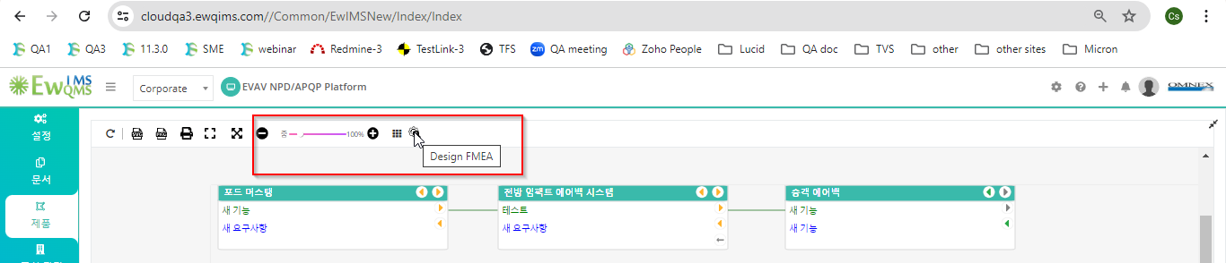
6. Rename BOM element context menu is not converted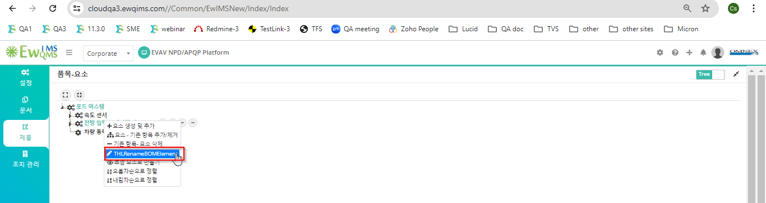
7. Rename pop up window some text labels have not been converted. 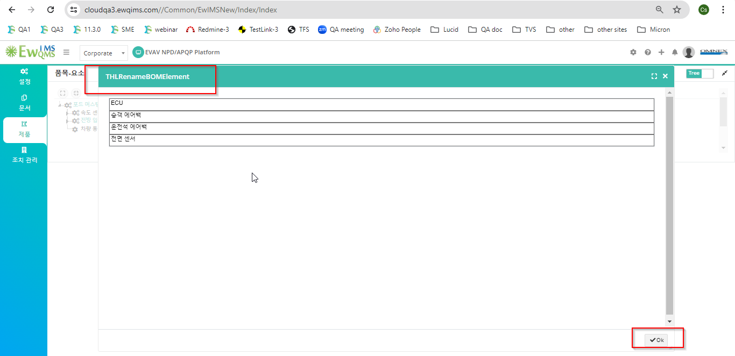
8. Rename BOM alert message not converted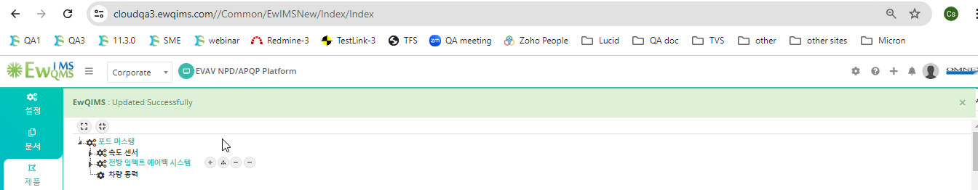
9. Make a child context element is not converted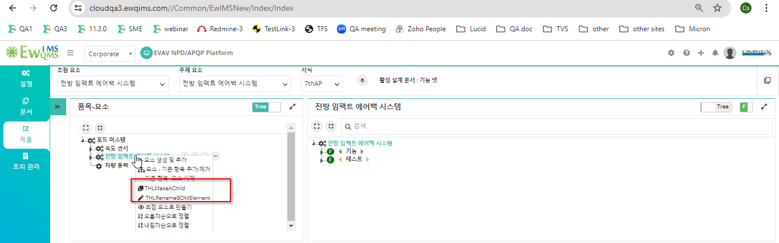
10. Make a child popup not converted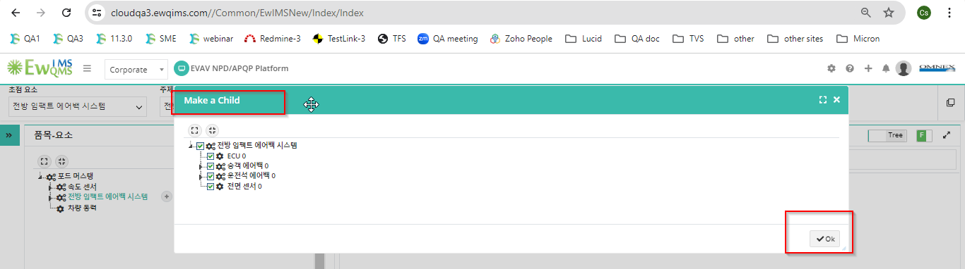
11. Alert message not converted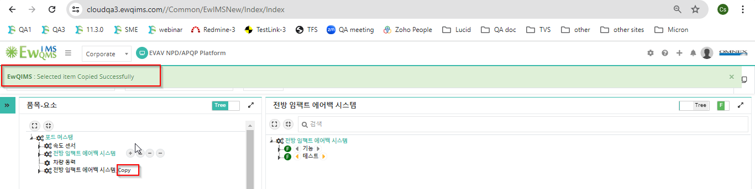
12. IFM context menu not converted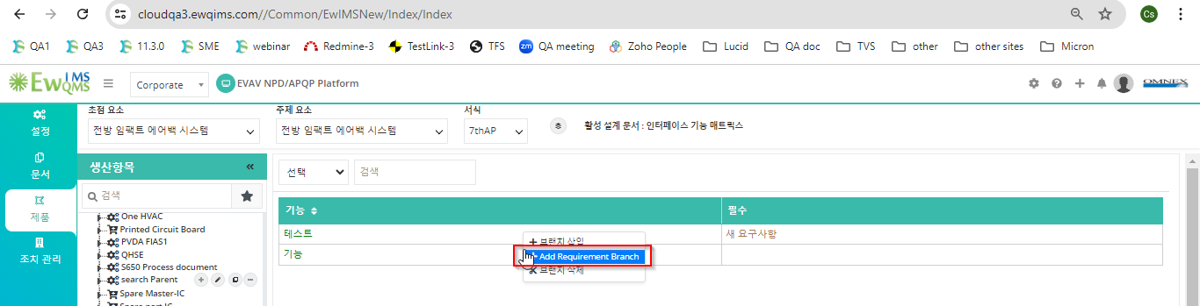
13. IFM alert message not converted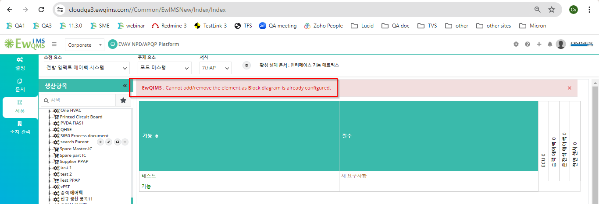
14. Pop up some text labels have not been converted. 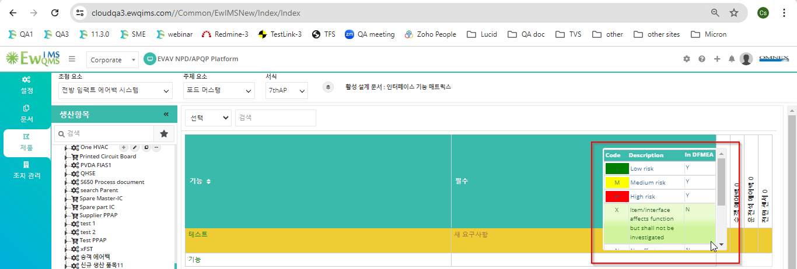
15. Publish alert message not converted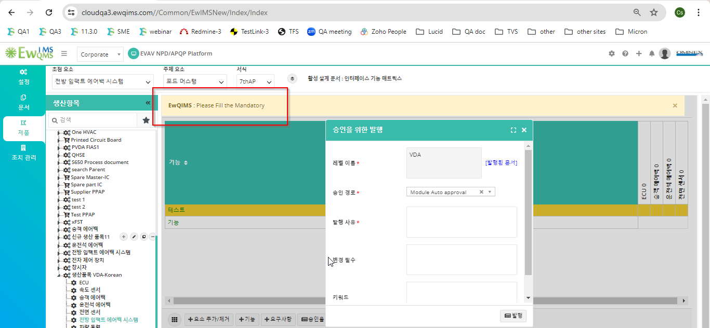
16. IFM Legend some text labels have not been converted. 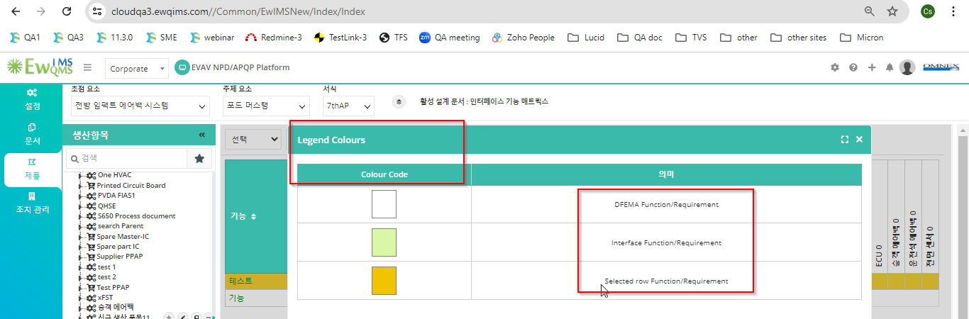
17. IFM Matrix pop up some text labels have not been converted. 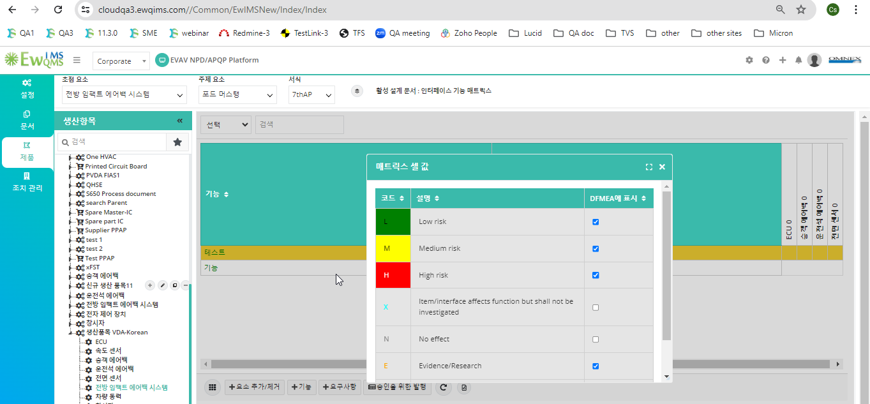
18. Add Failure some text labels have not been converted. 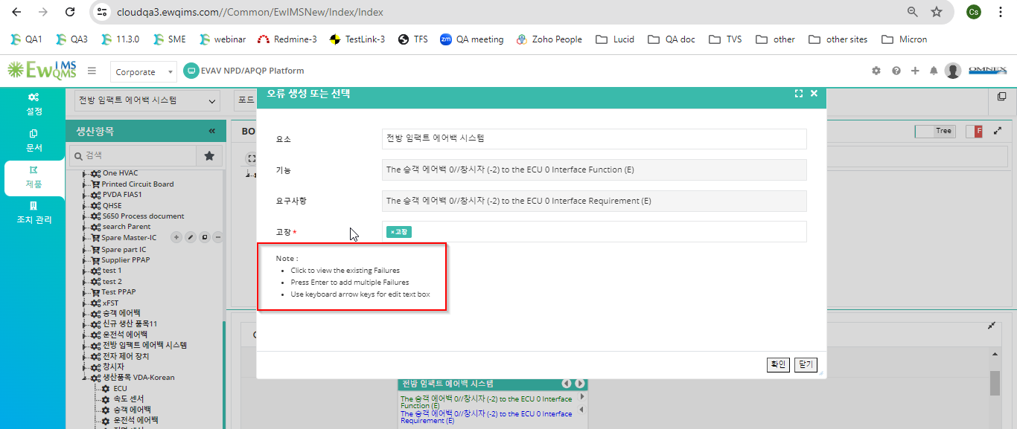
19. Add flowup failure and flowdown failure context menu not converted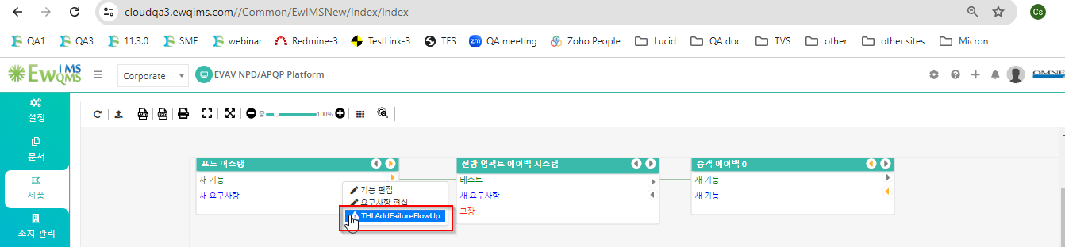
20. DFMEA Occurrence call out table some text labels have not been converted. 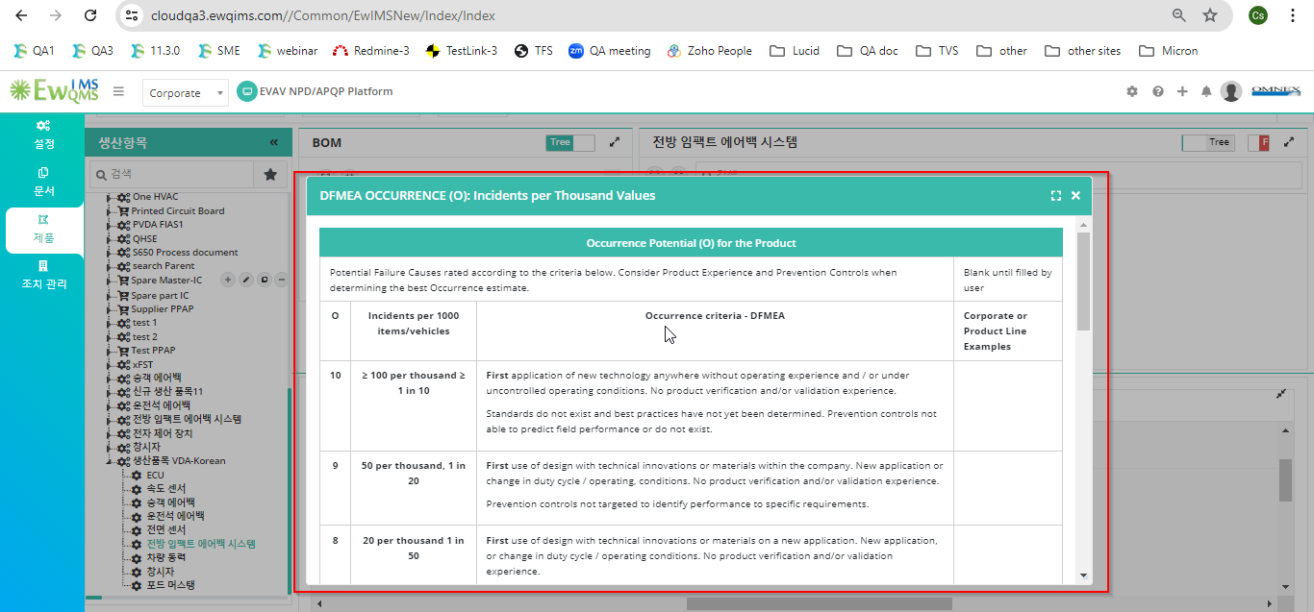
21. Add Risk some text labels have not been converted. 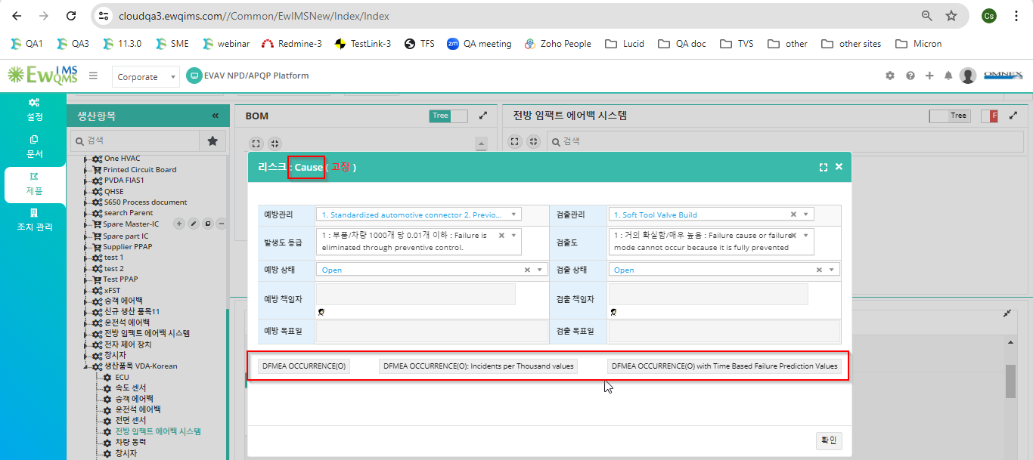
22. Alert message not converted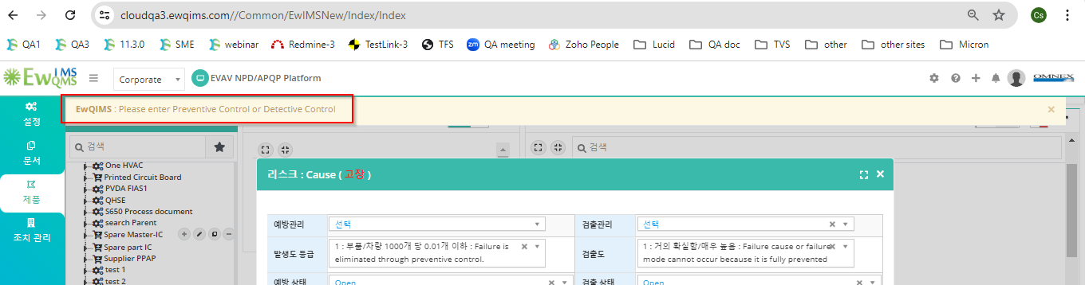
23. **Unable to add optimization - High**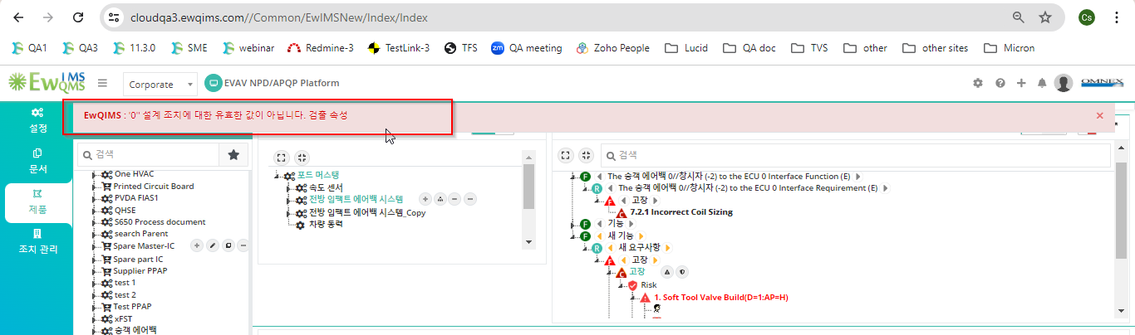
24. Step-7 not converted some text labels have not been converted. 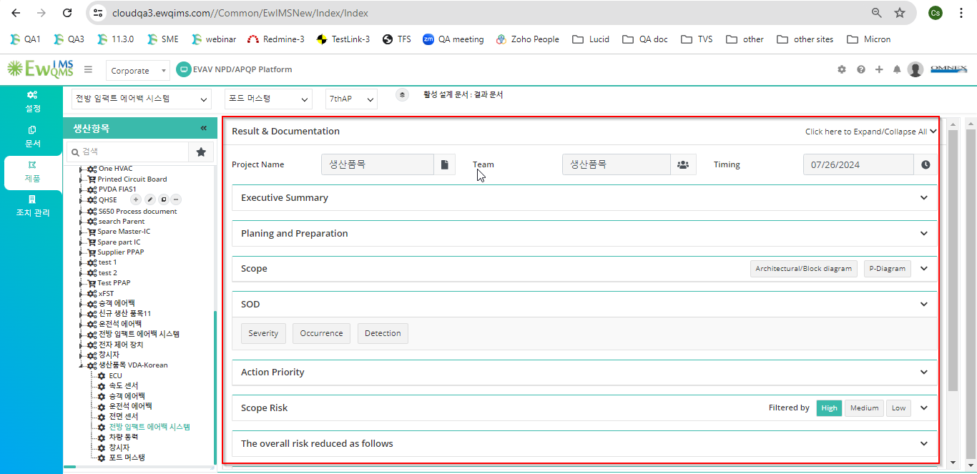
25. Consolidated DFMEA not converted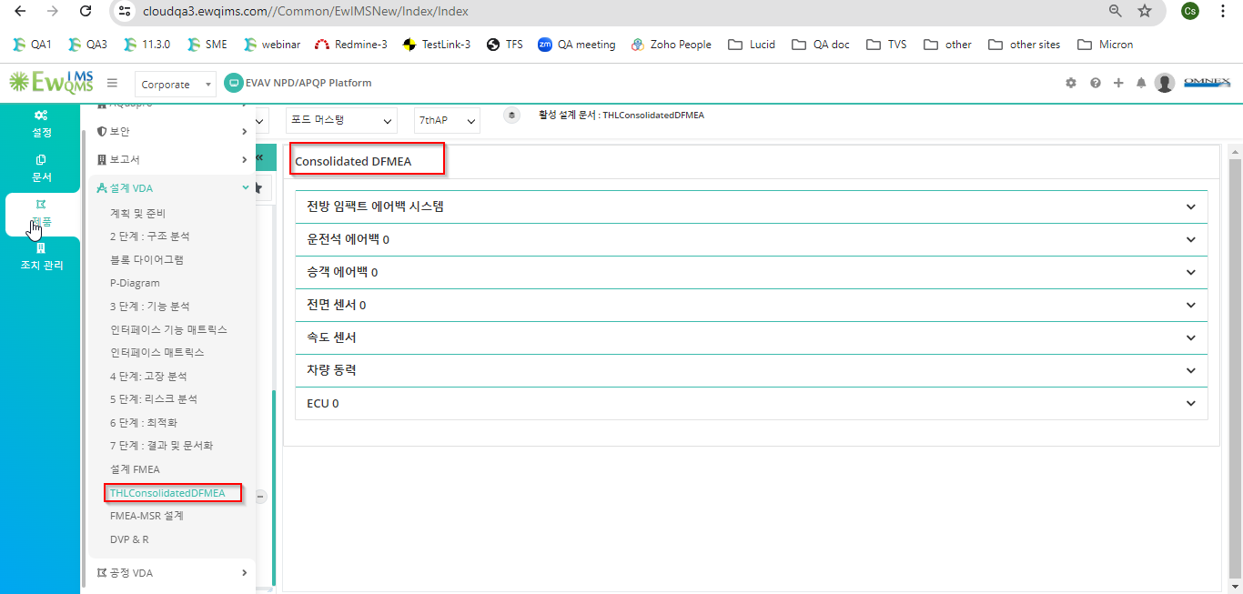
26. Publish some text labels have not been converted. 