**SP 11.3.0 AIAG VDA Korean language Verification**

**URL:** [**https://cloudqa3.ewqims.com/**](https://cloudqa3.ewqims.com/)

**AIAG Process VDA:**

1. Edit Process segment some text labels have not been converted. 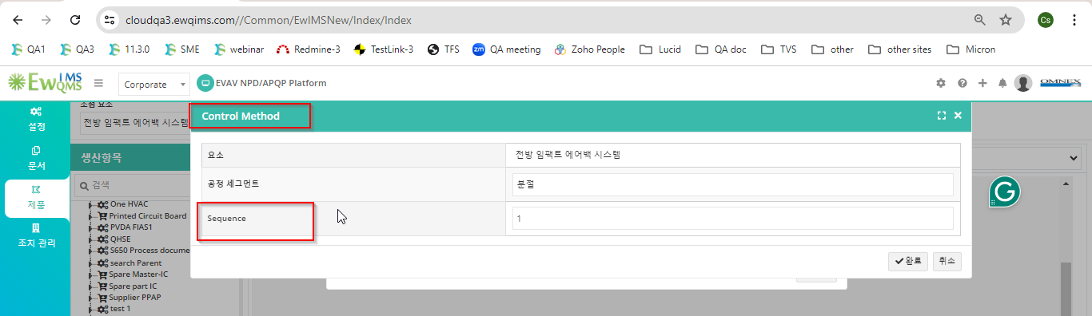
2. Create Operation Category some text labels have not been converted. 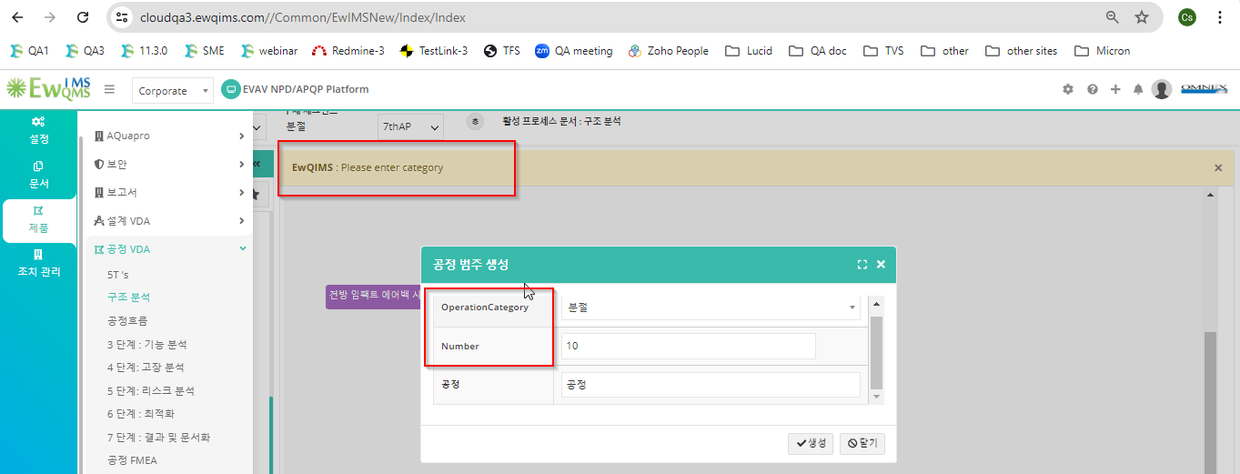
3. Fourm category alert message not converted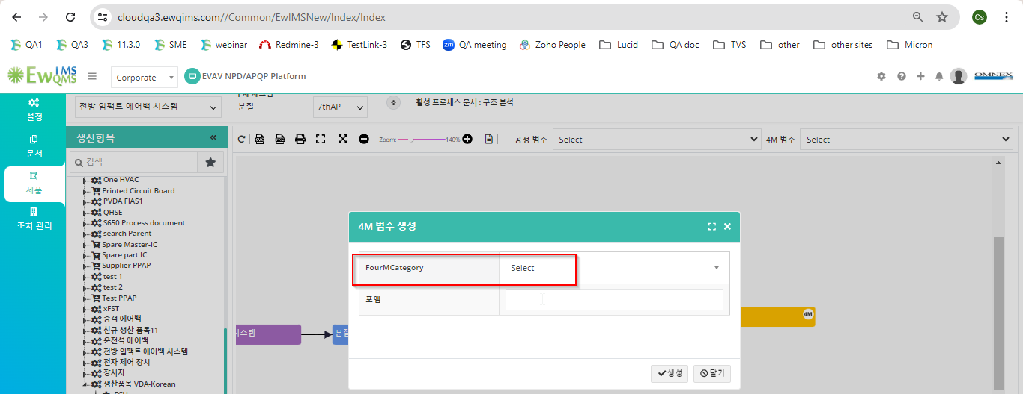
4. Delete FourM Alert message not converted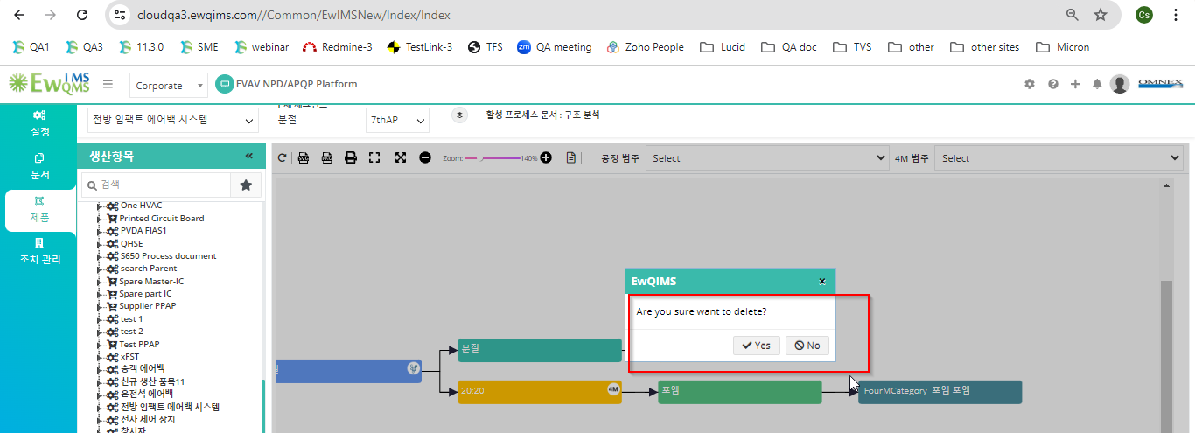
5. Delete Fourm category alert message not converted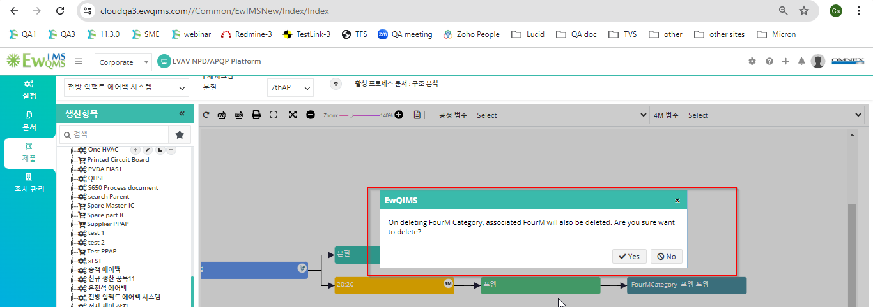
6. Delete Operation category alert message not converted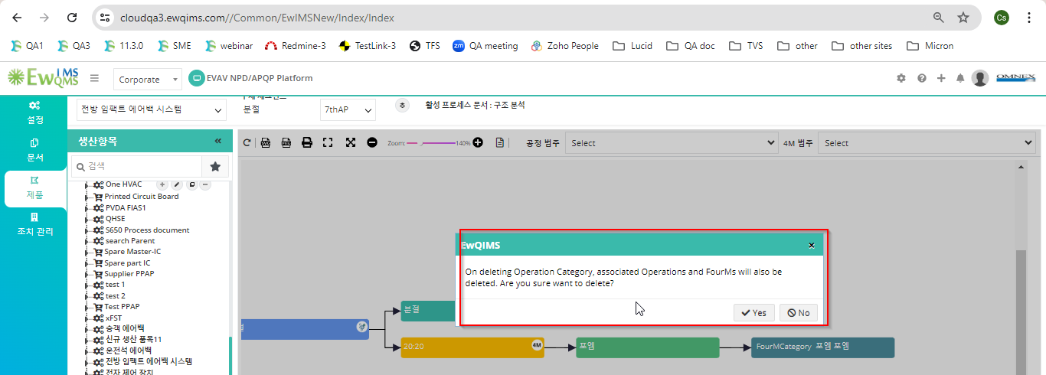
7. Delete Operation alert message not converted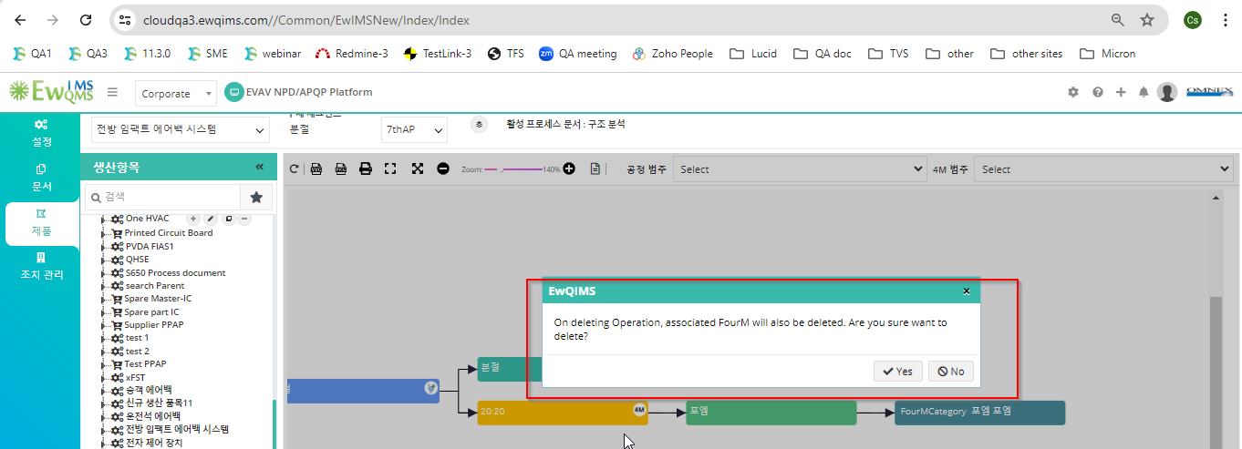
8. Color Legend some text labels have not been converted. 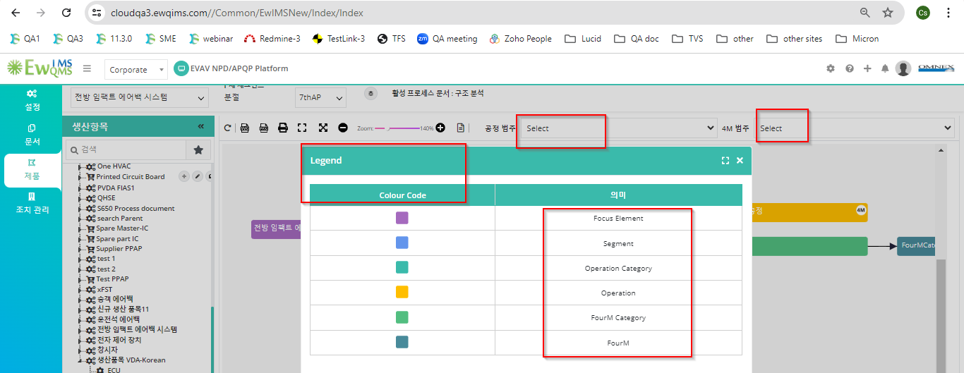
9. Save Image notes not converted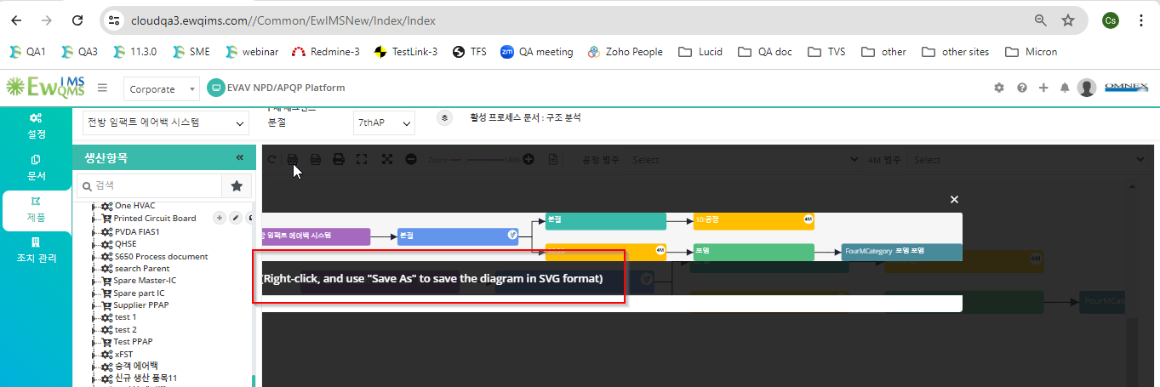
10. Tool Tip not converted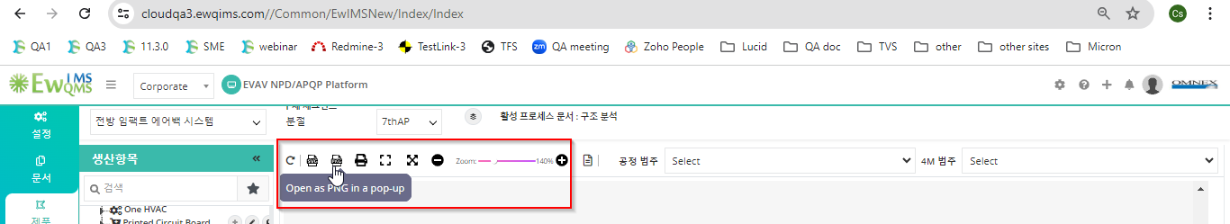
11. Create Character pop-up some text labels have not been converted. 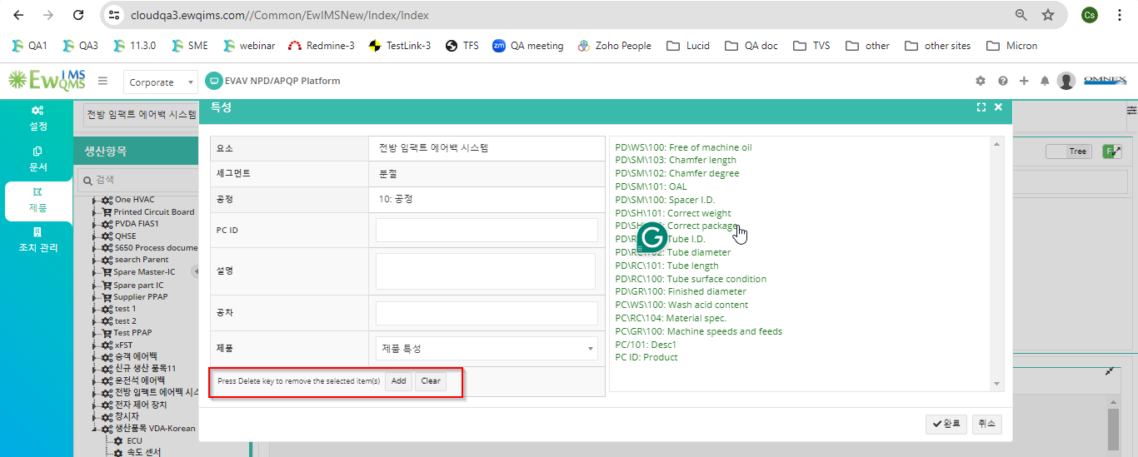
12. Change character some text labels have not been converted. 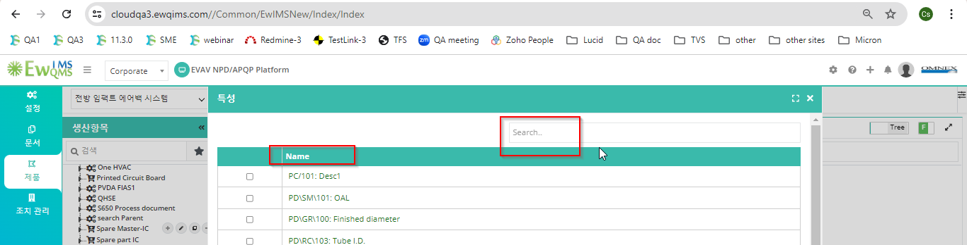
13. Map 4m some text labels have not been converted. 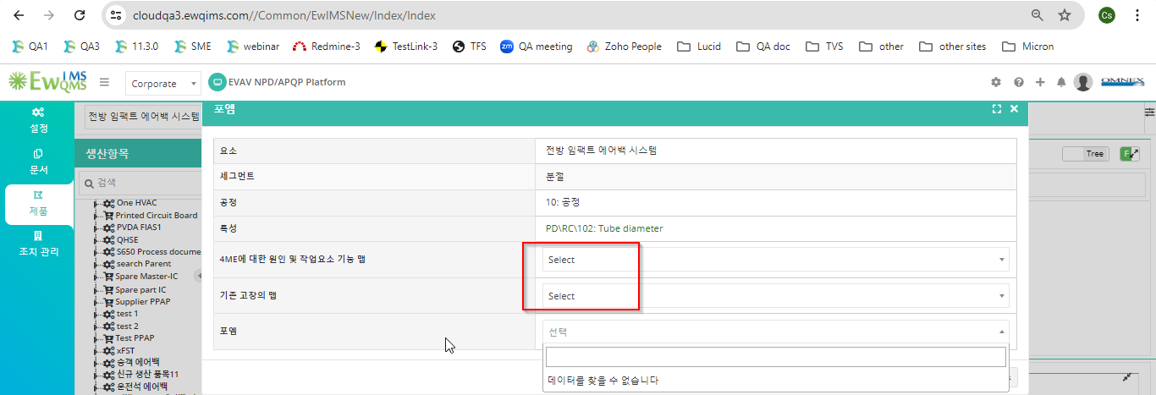
14. Tables not converted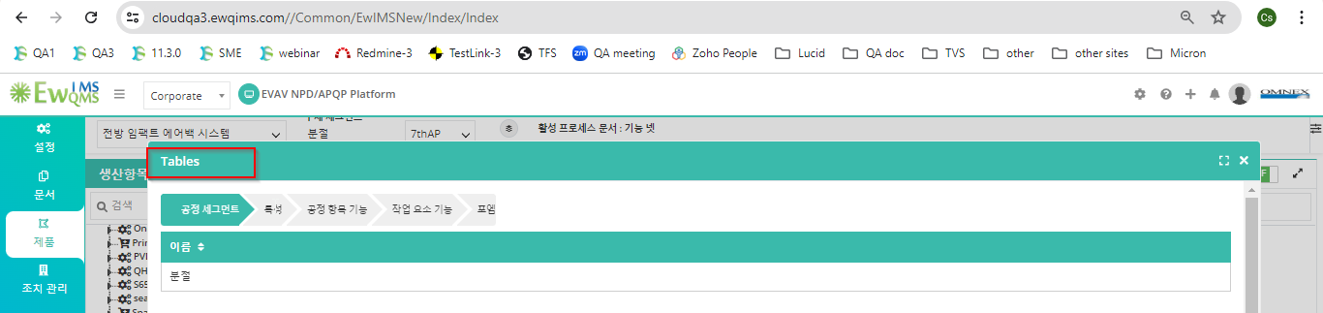
15. Change failure some text labels have not been converted. 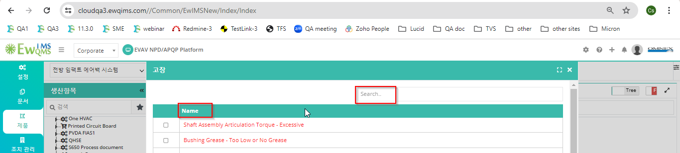
16. Add Cause some text labels have not been converted. 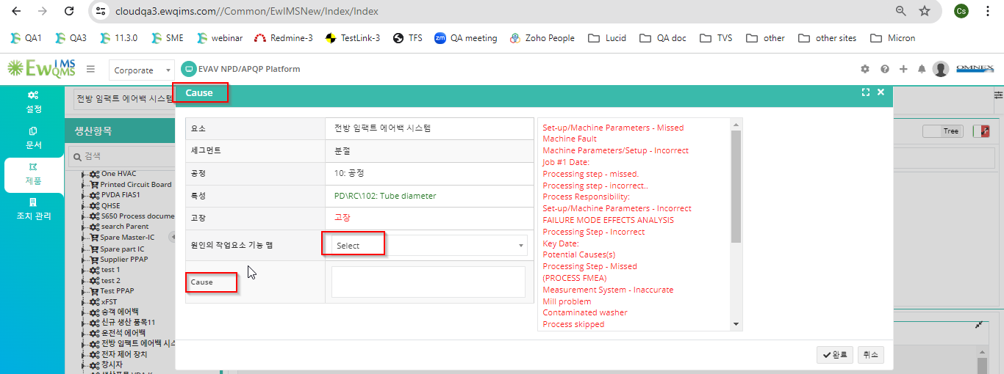
17. Change Cause some text labels have not been converted. 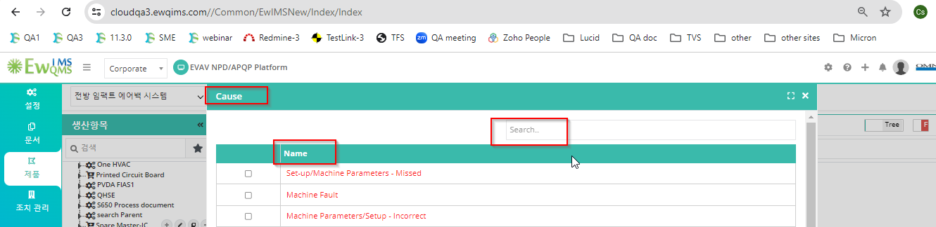
18. Unable to add risk in Korean language text- High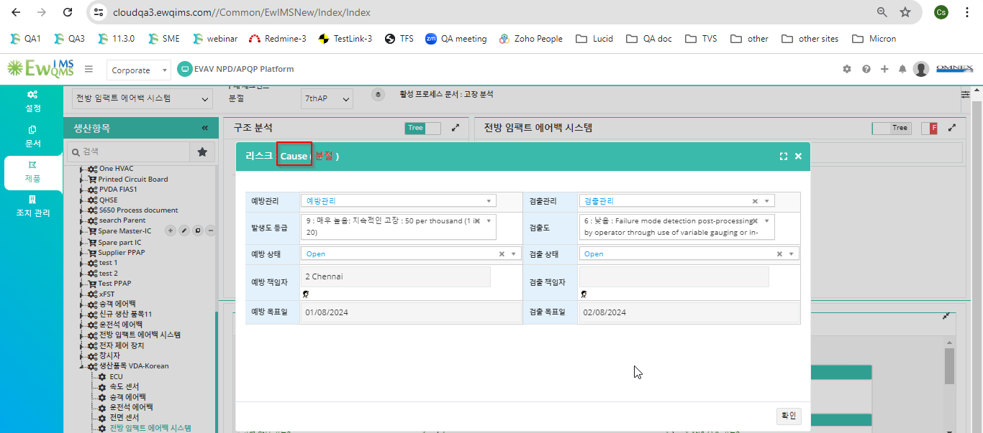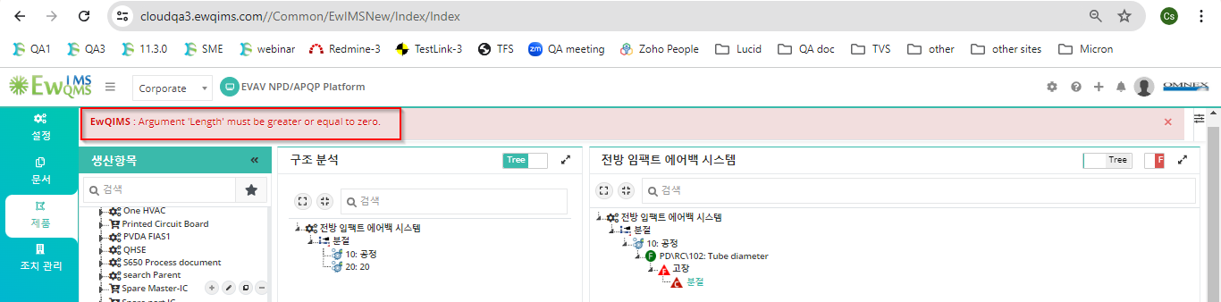
19. Add optimization some text labels have not been converted. 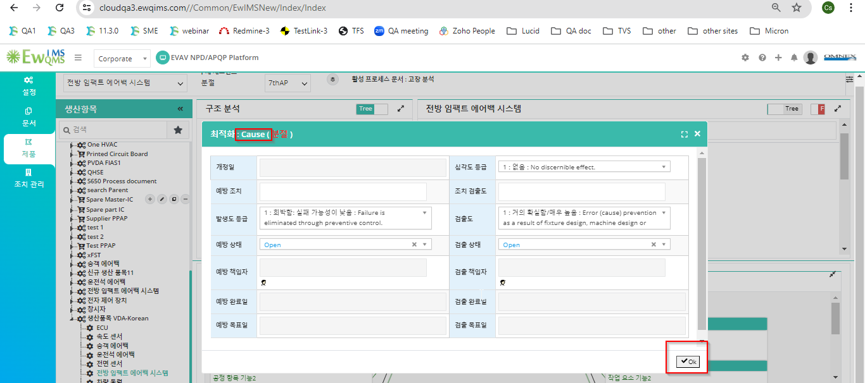
20. Delete Branch alert message not converted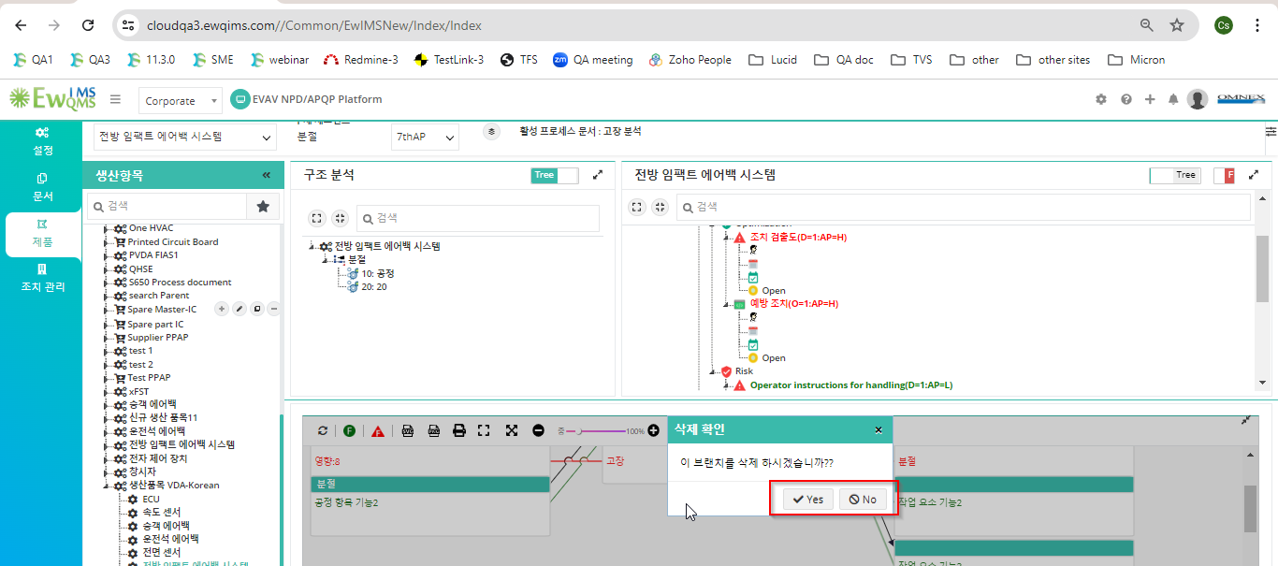
21. Step-7 some text labels have not been converted. 