1. Create Production Item Pop-up.

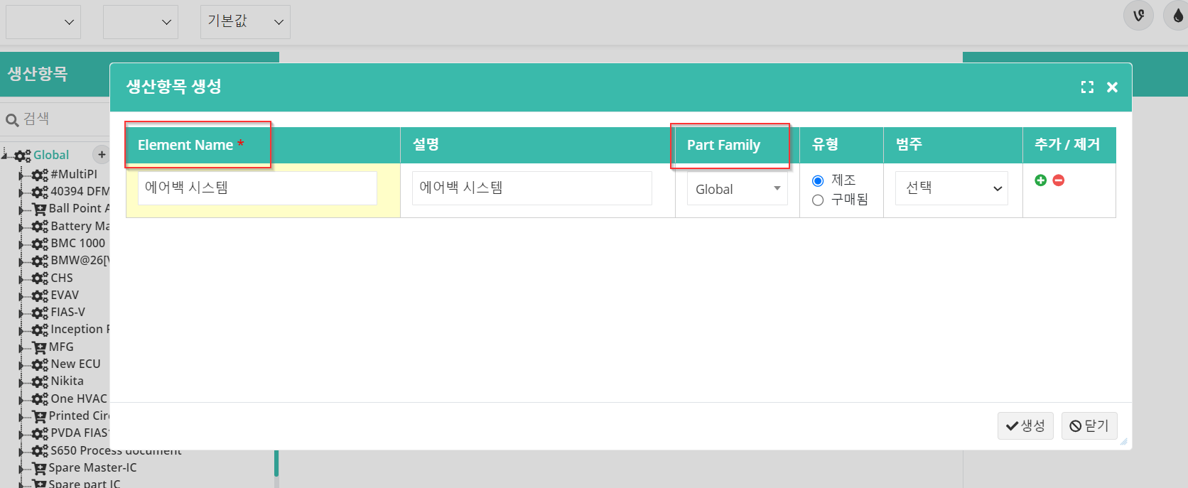

1. Part Family Dropdown is not working,
2. Header for Requirements Documents and Send for Review and Notes.

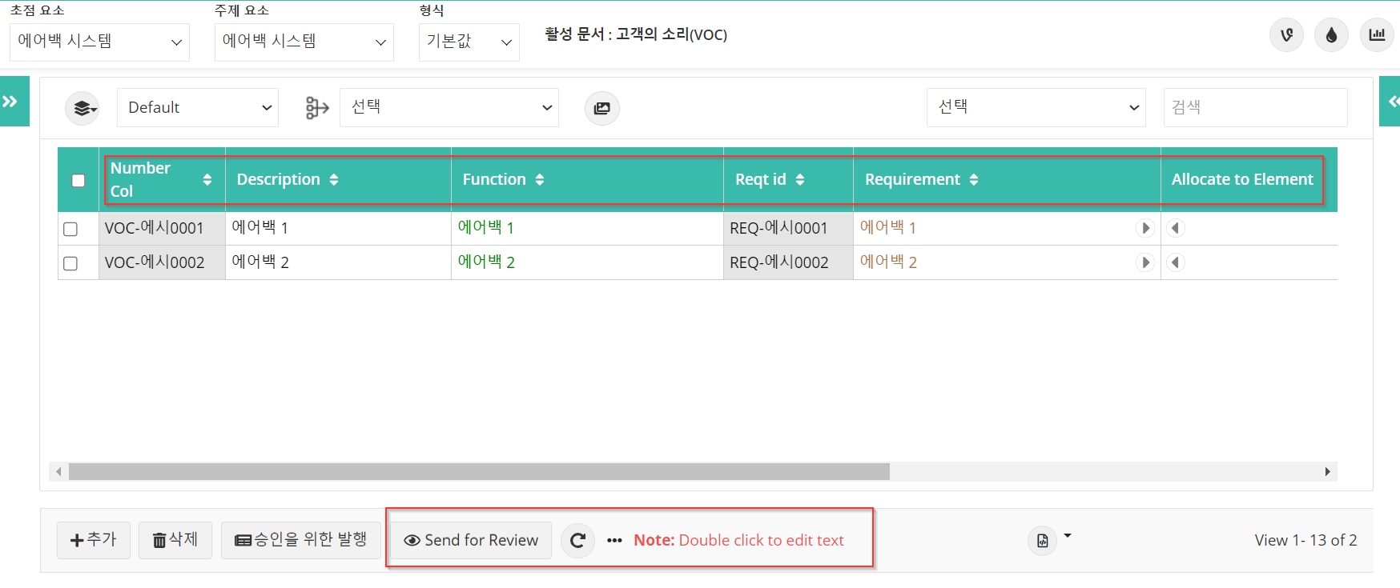

1. Requirements Document - Alert message for Edit Default Format.

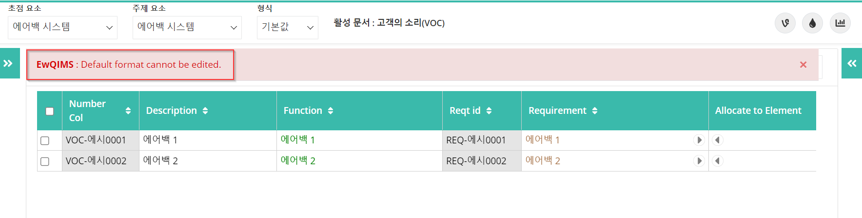

1. Requirements Document - Alert message for Delete Default Format.

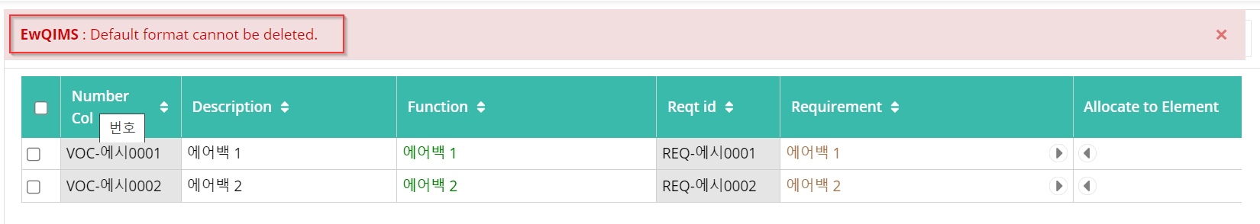

1. Save Format dropdown.

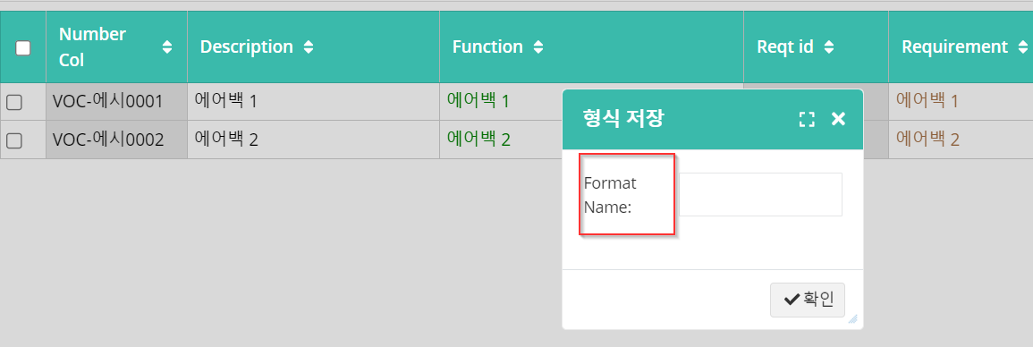

1. Make Default Formats.

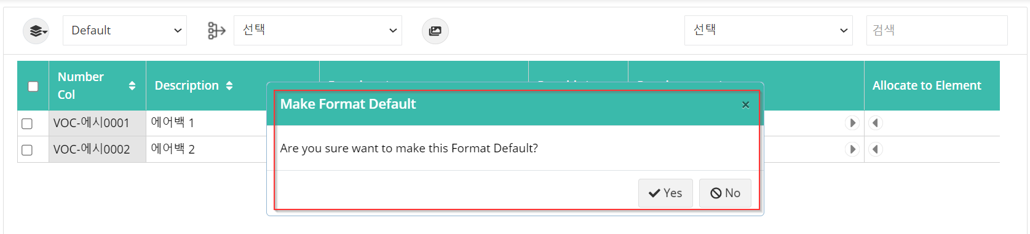

1. Requirement Type Filter.

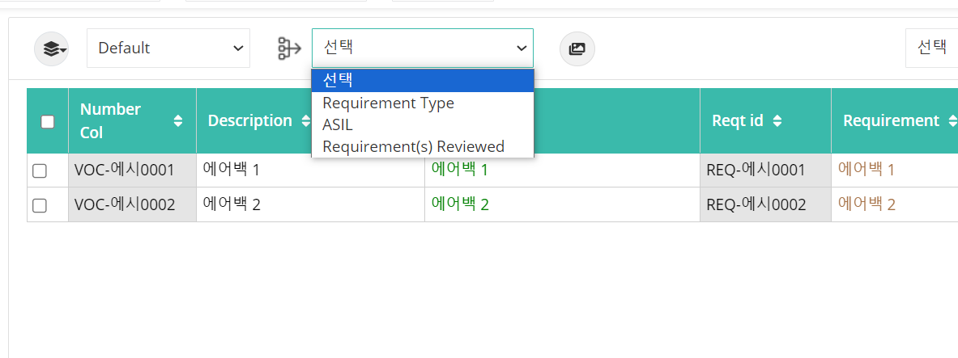

1. VOC Document view popup.

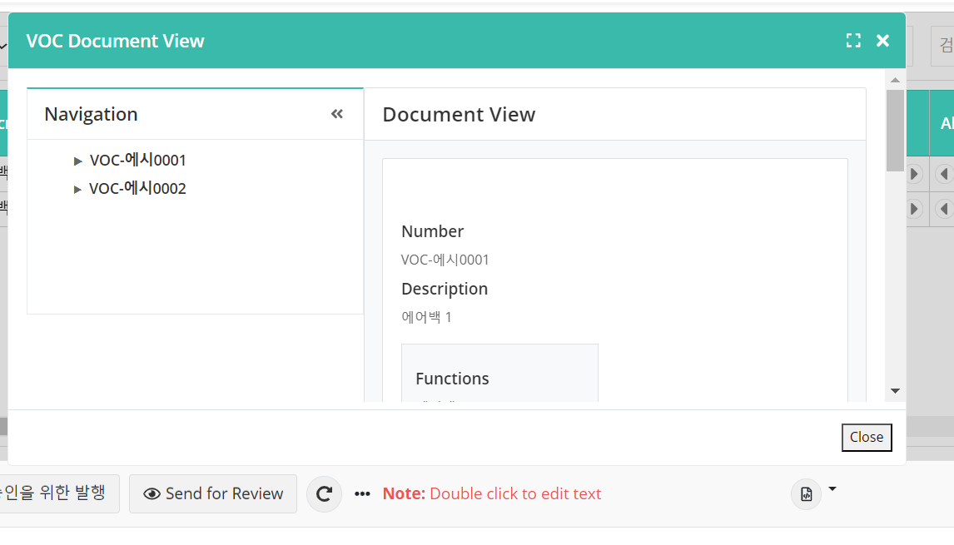

1. Legend

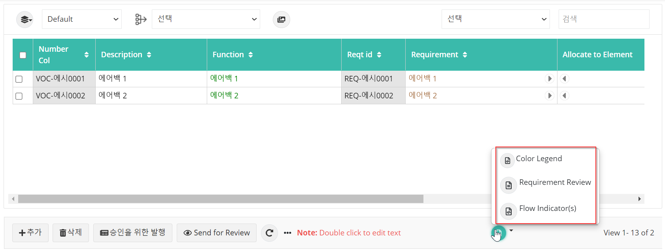

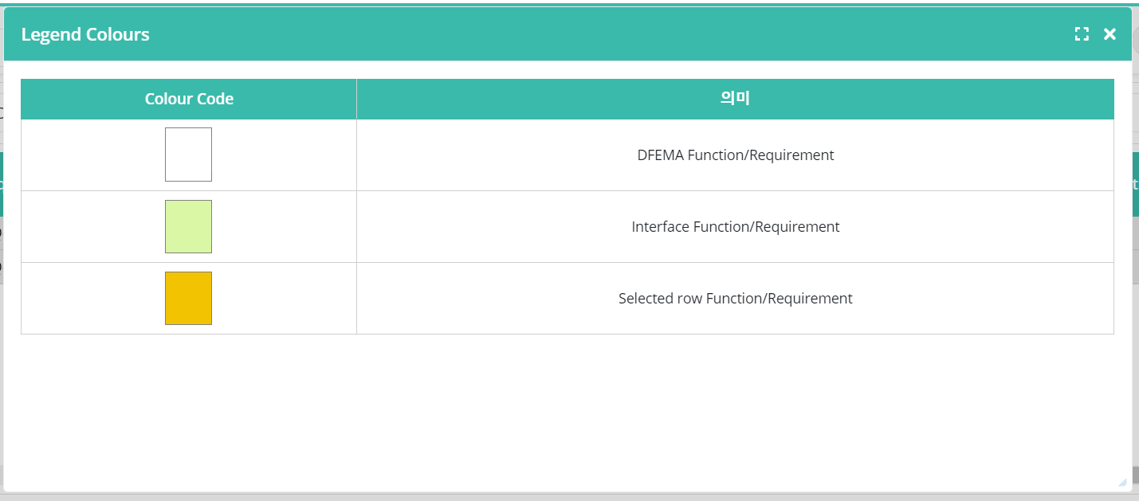

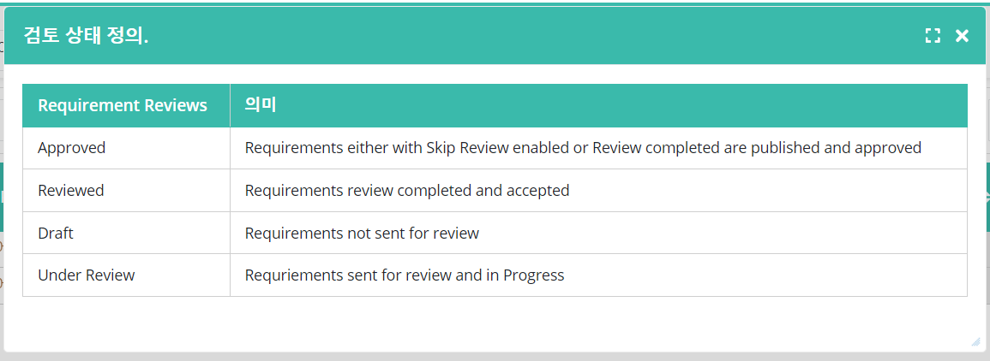

1. Send for Review popup.

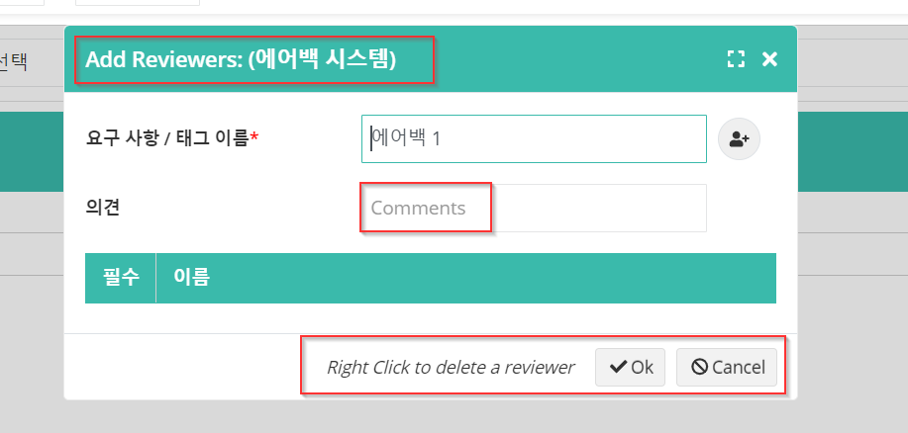

1. Configure Reviewer popup.

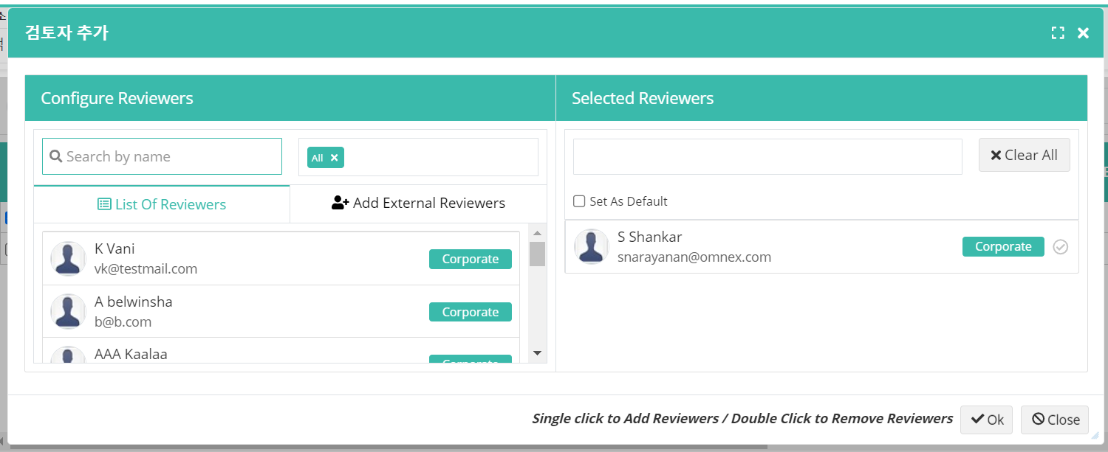

1. Reviewer status popup

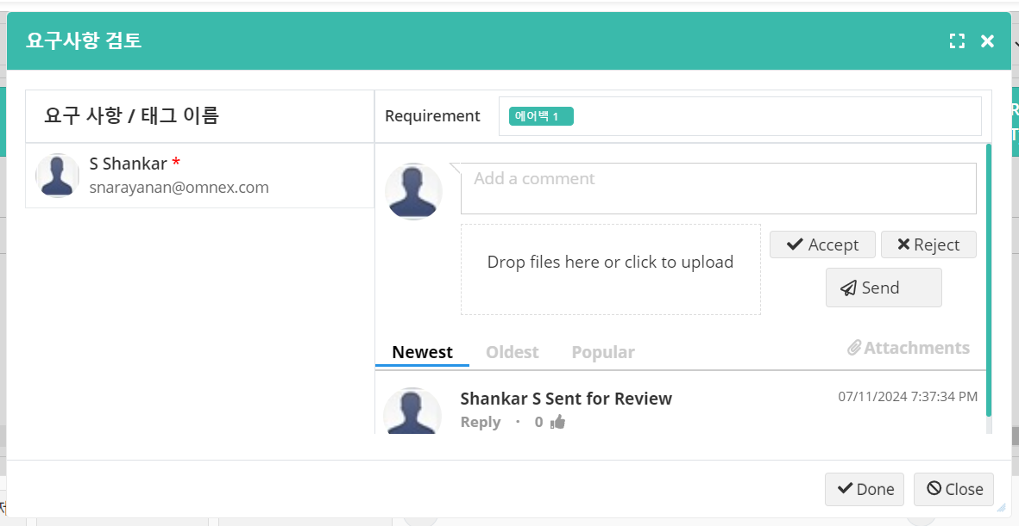

1. Create Column popup.

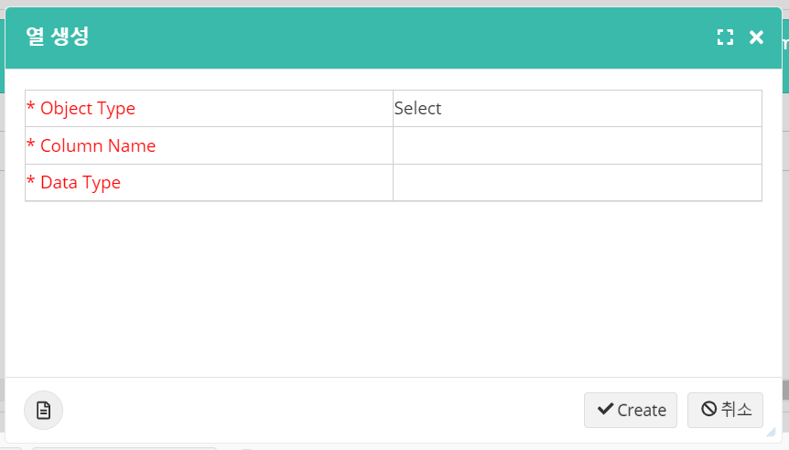

1. Object type and Data type popup shows blank.

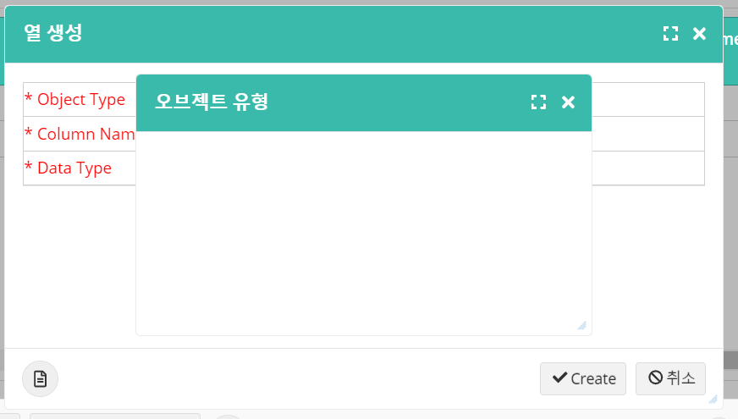

1. Create column Indicators popup.

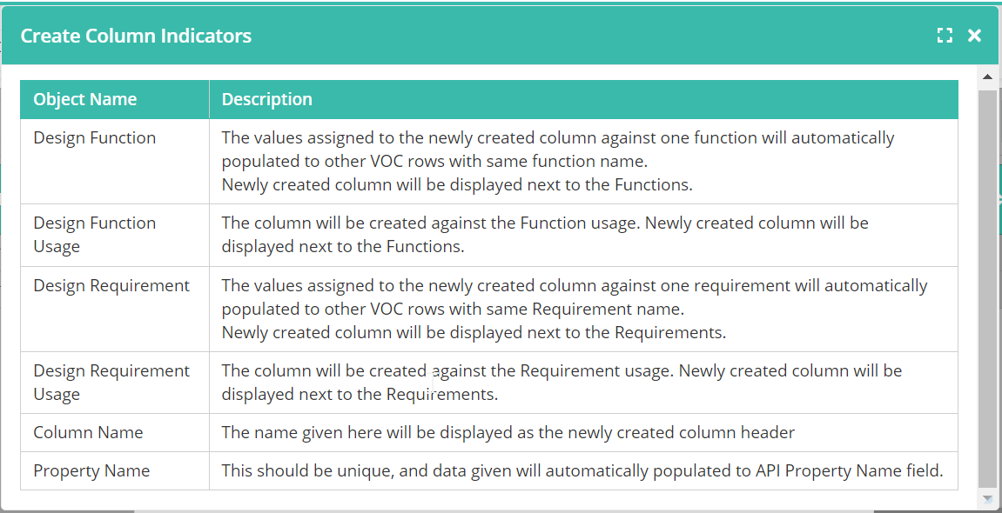

1. Context menu on the Header.

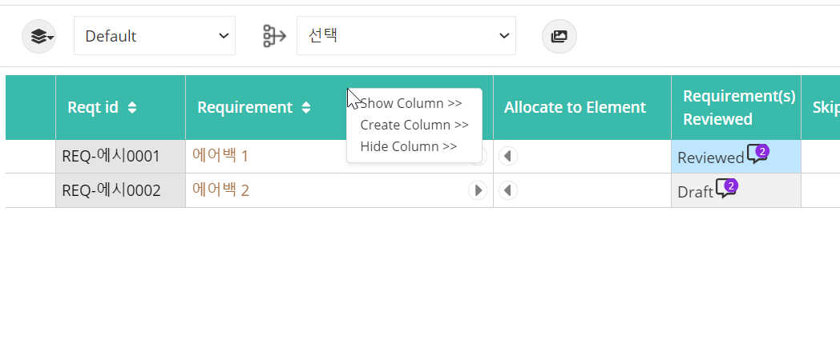

1. Close button in the Show Column popup.

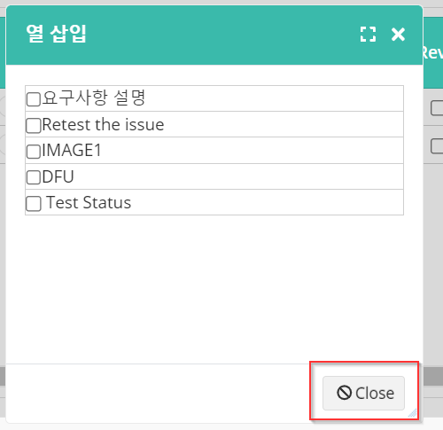

1. Insert Image popup

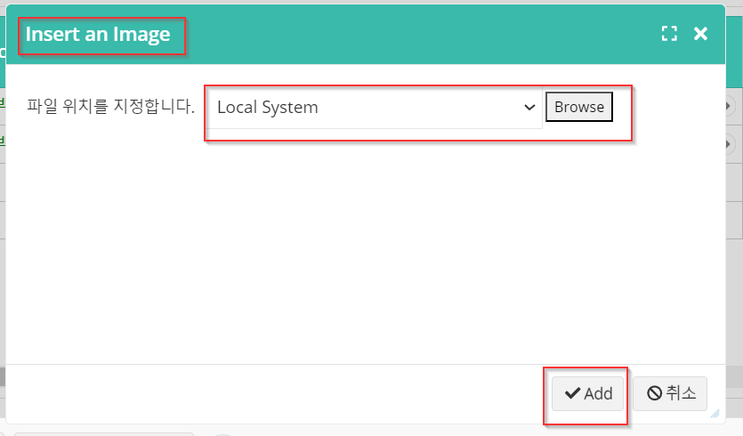

1. Requirements column context menu.

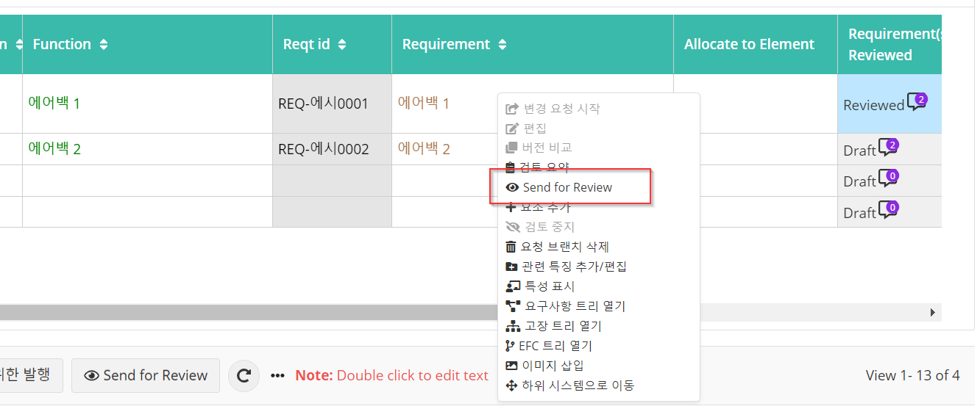

1. Tooltip for all columns shows in English.

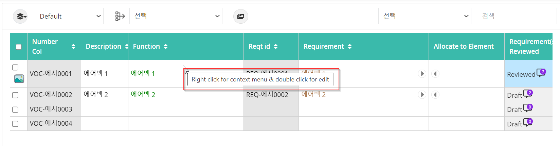

1. Import from PDF

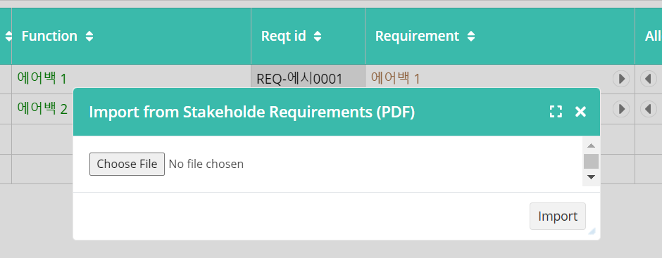

1. Functions Master table: Delete alert without selection.

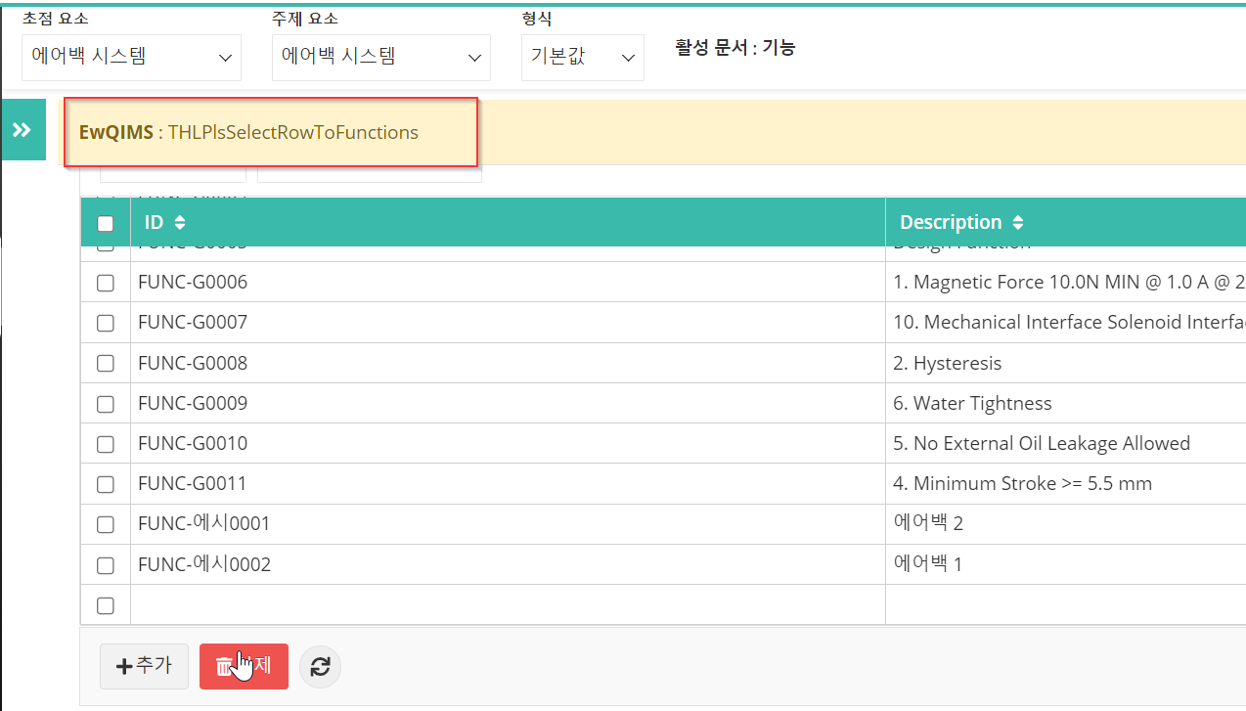

1. Delete confirmation and Search dropdown.

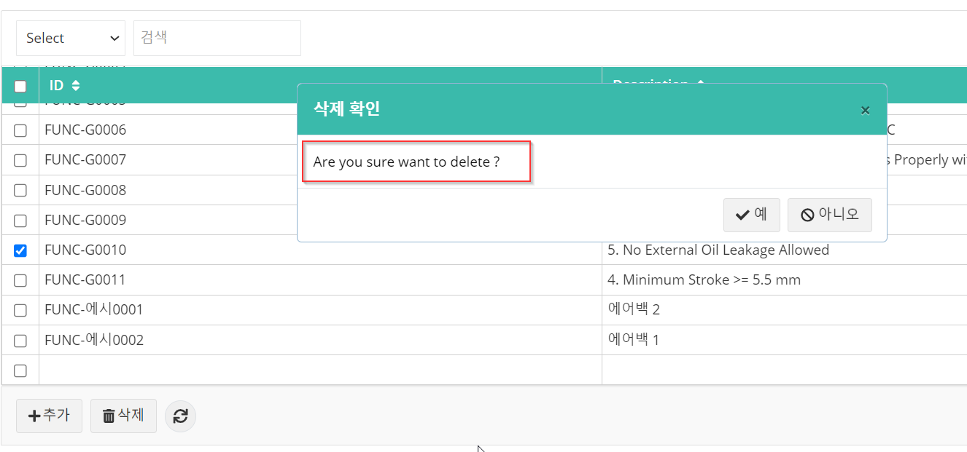

1. Testplan- Tooltip for Open Aqua Pro and Test plan and Window

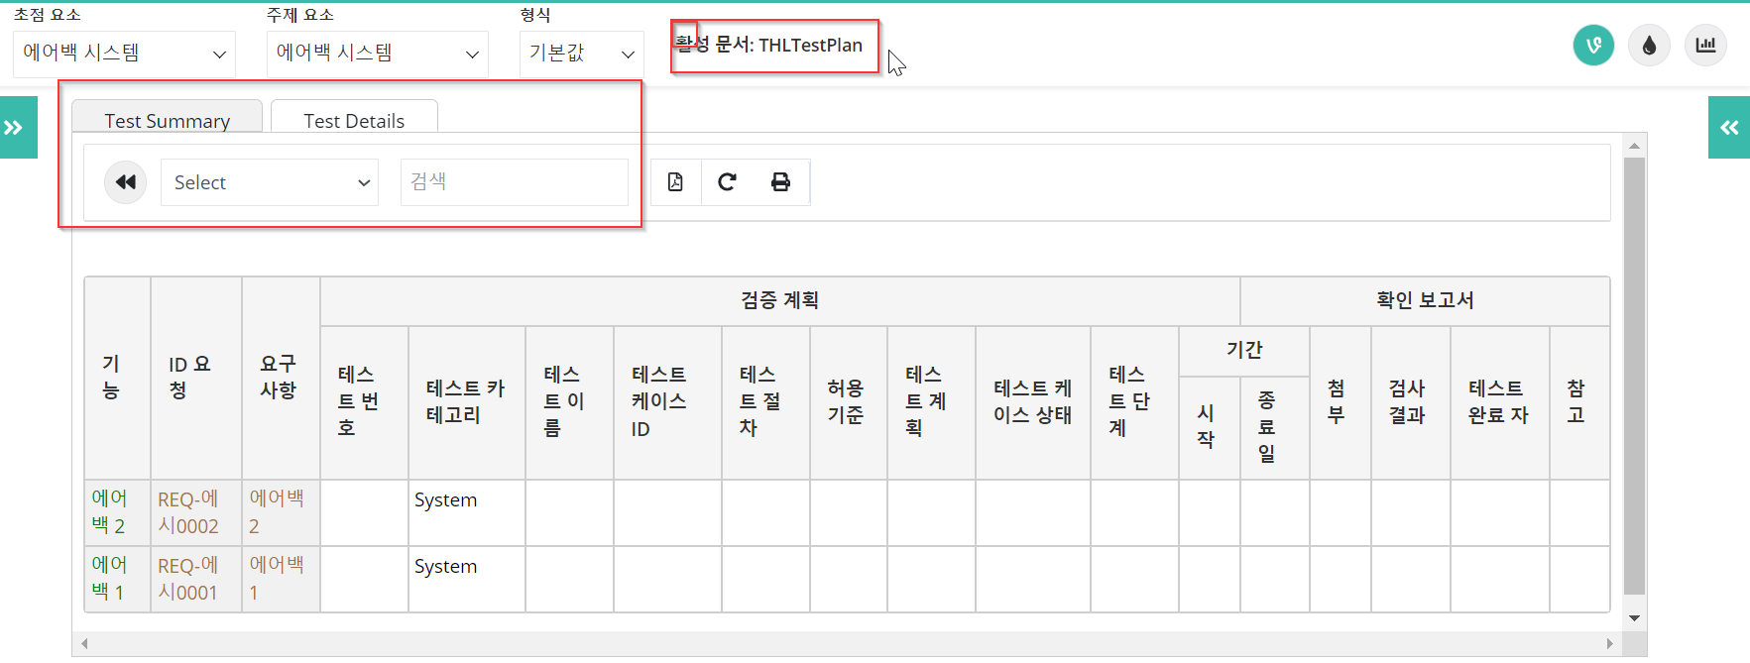

1. Failure Mode

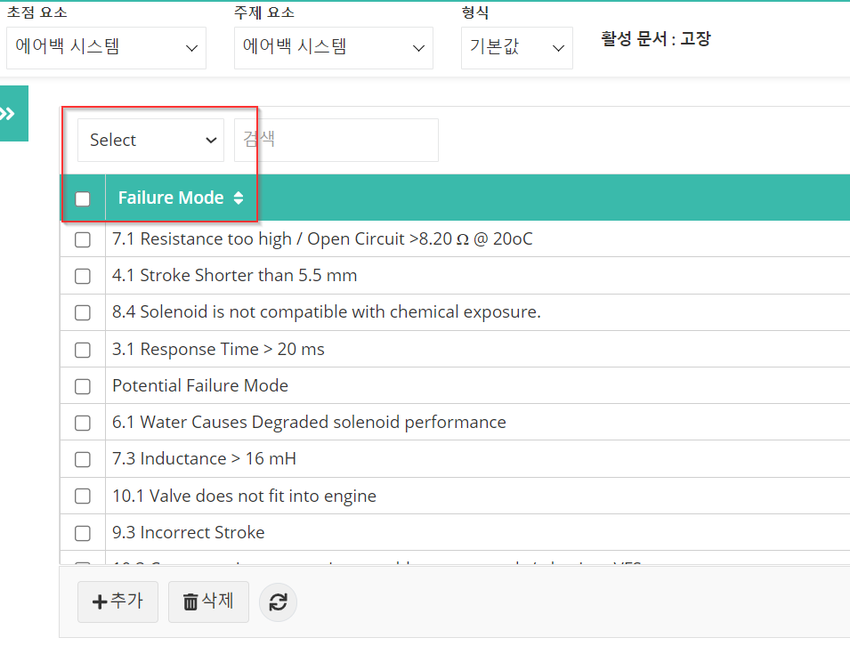

1. Failures Master table: Delete alert without selection

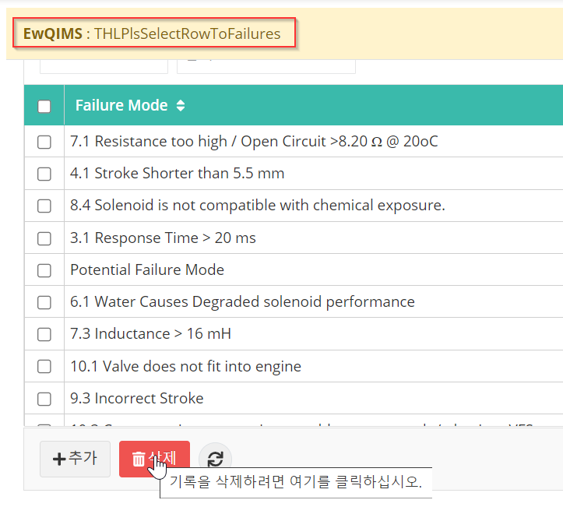

1. Export to PNG and SVG options

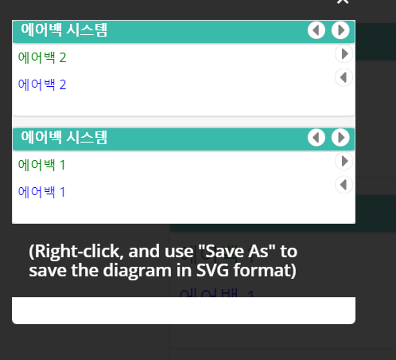

1. Tooltip for Zoom in and Zoom out options.

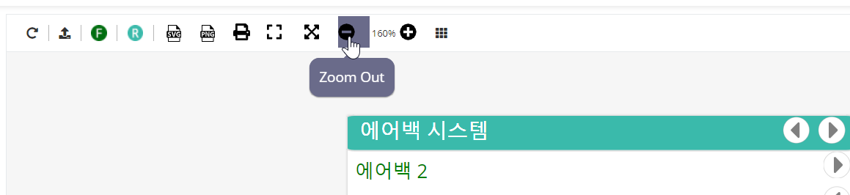

1. Flowdown and Flowup popup window.

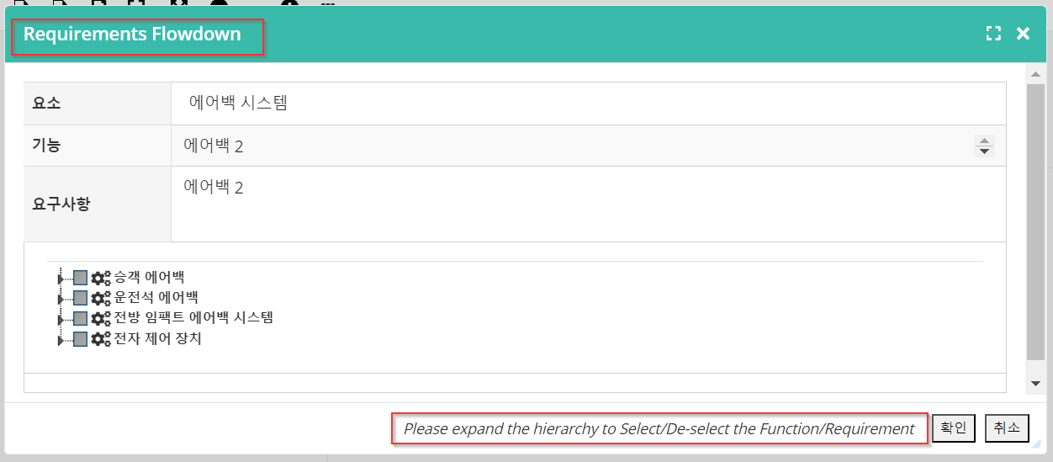

1. Consolidated FMEA menu.

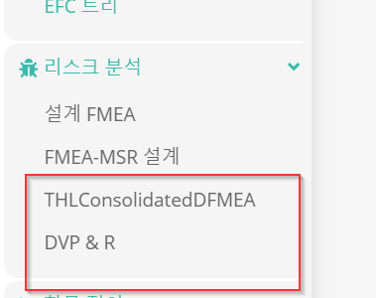

1. Item Details

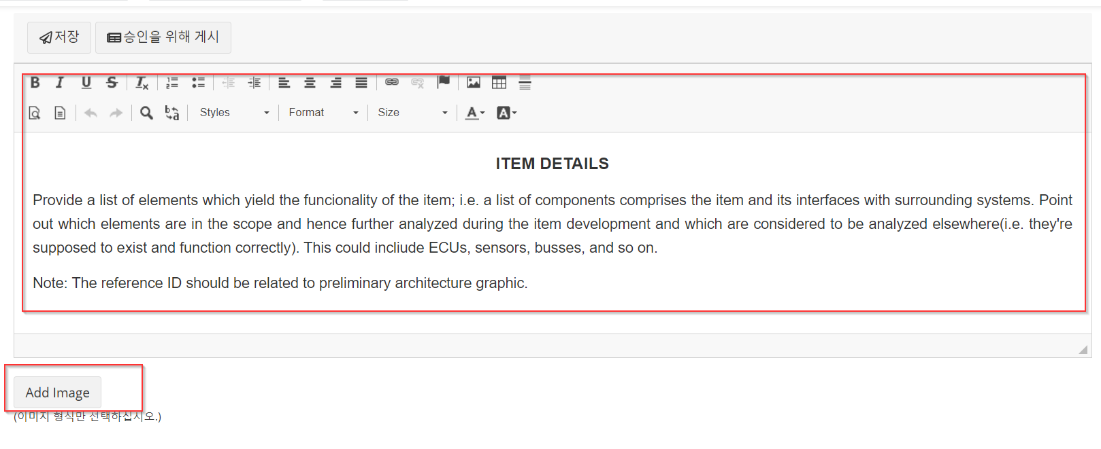

1. Insert image popup

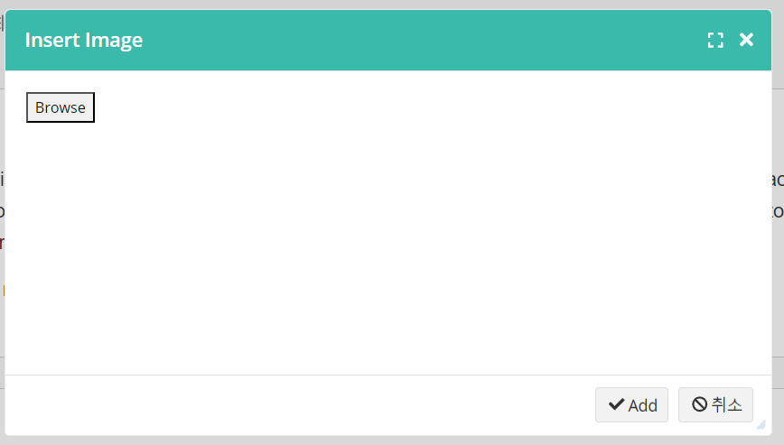

1. View Edit box and Toolbox for Block diagram.

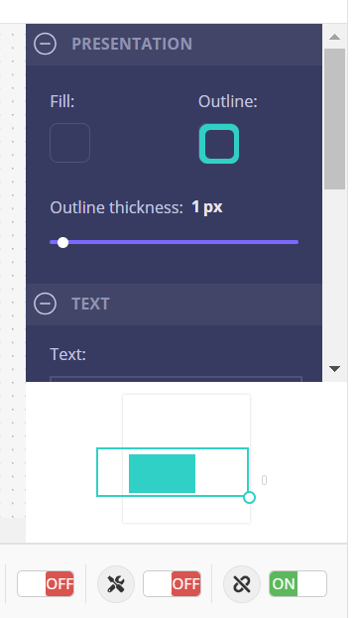

1. Publish alert.

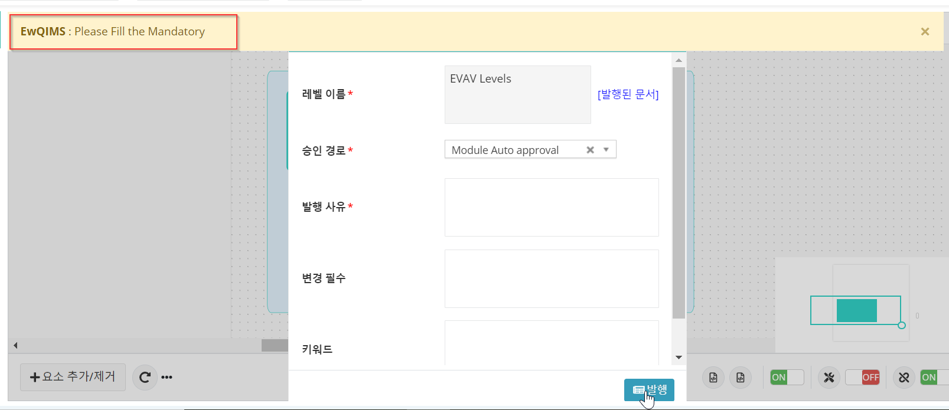

1. Color Legend for Block Diagram.

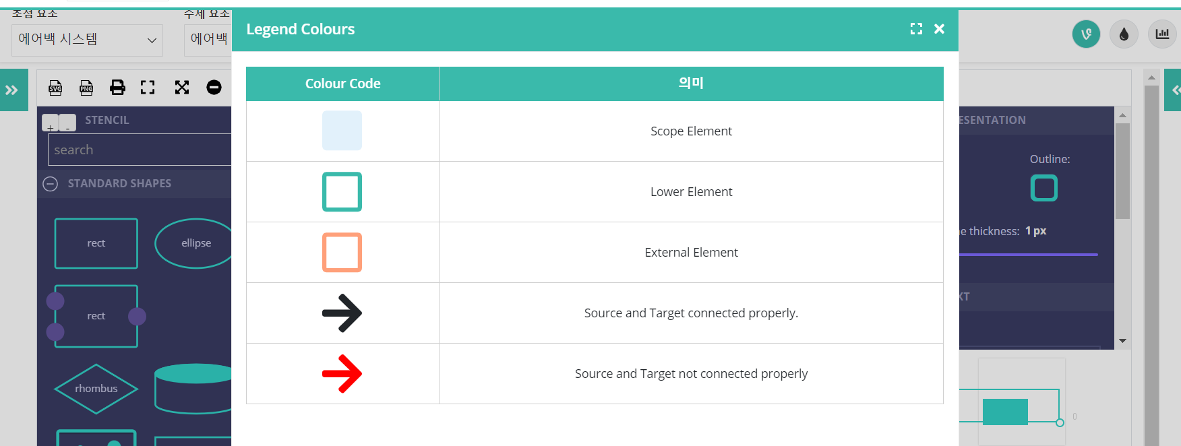

1. Published Version.

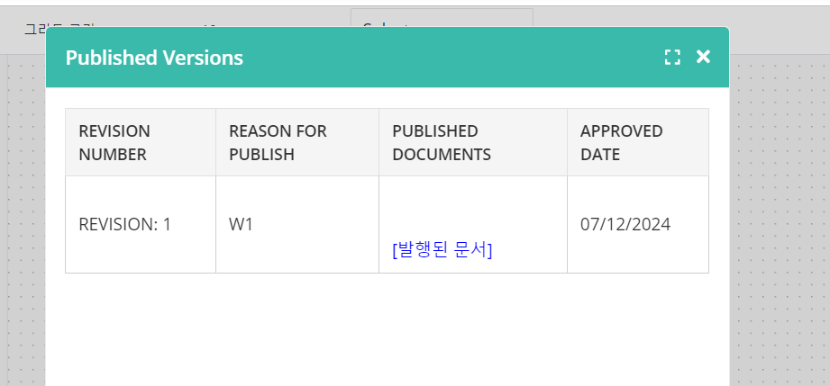

1. Risk value popup.

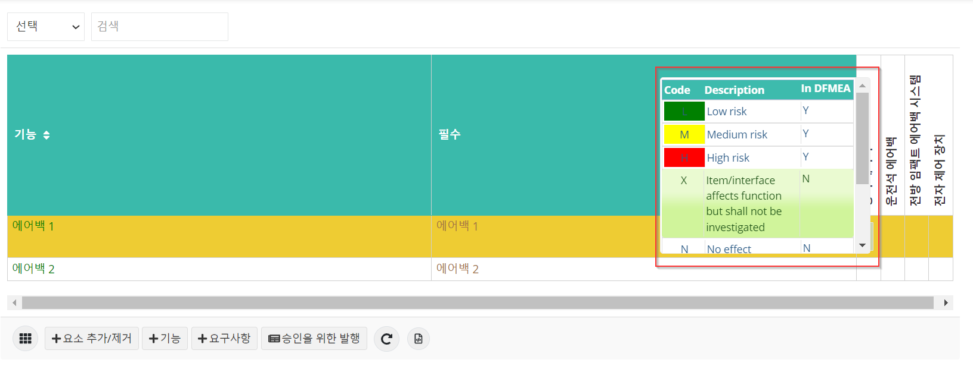

1. Deallocate option in IFM cells.

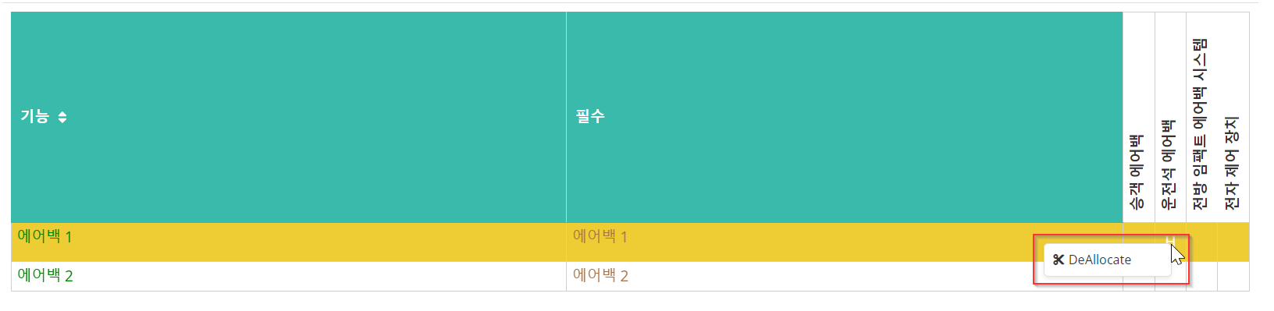

1. Insert Requirement branch.

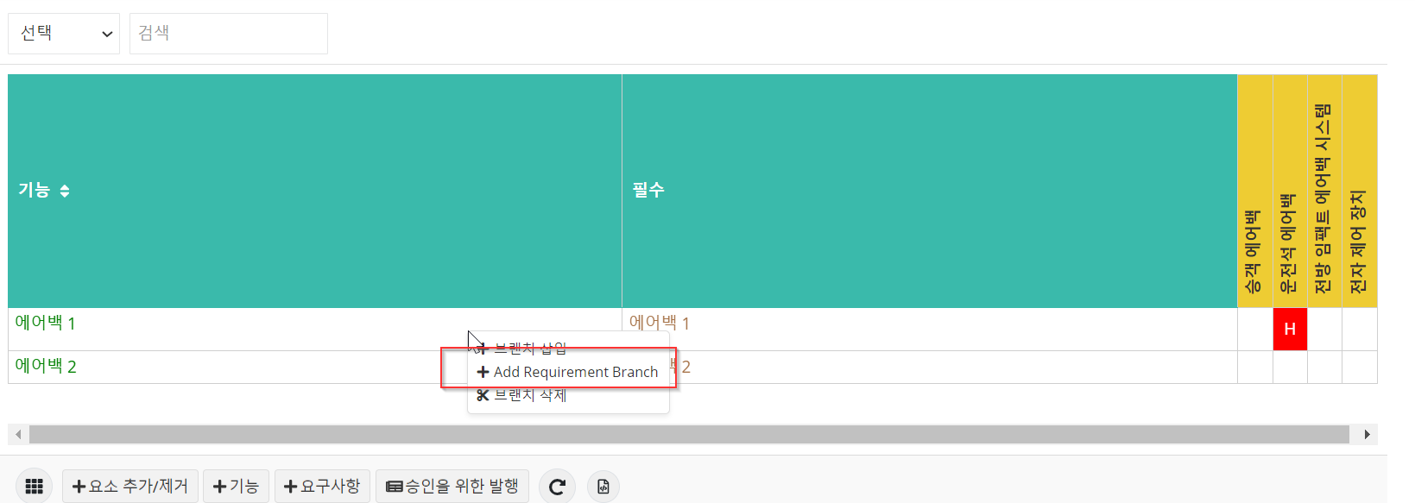

1. Color legend in IFM.

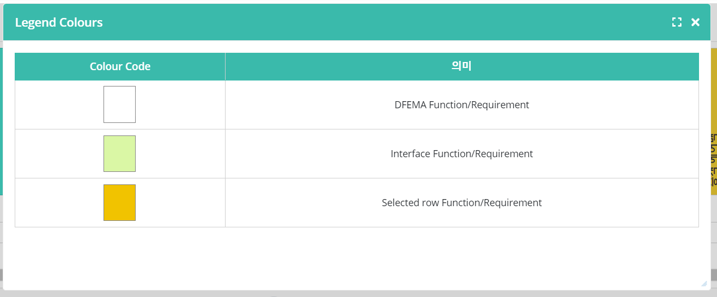

1. Risk Legend in IFM.

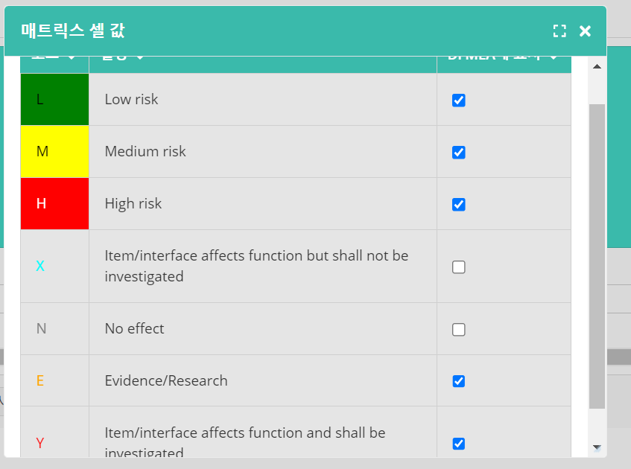

1. Interface Matrix Tooltip

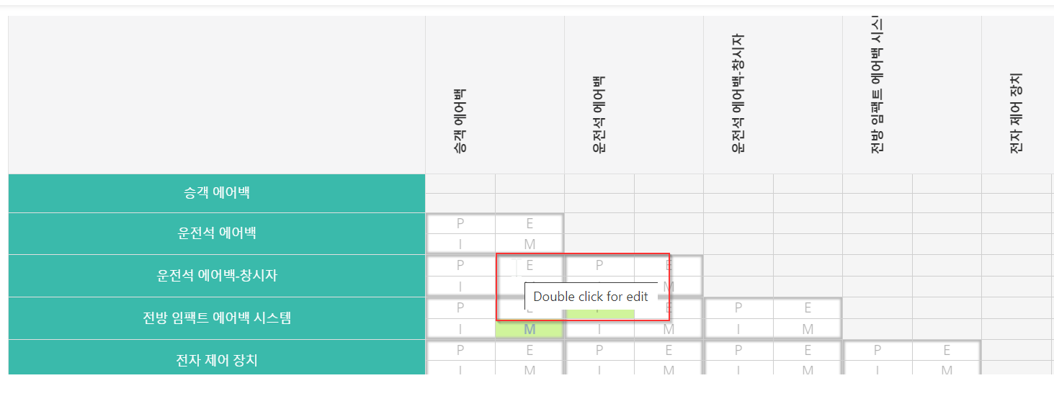

1. P-Diagram

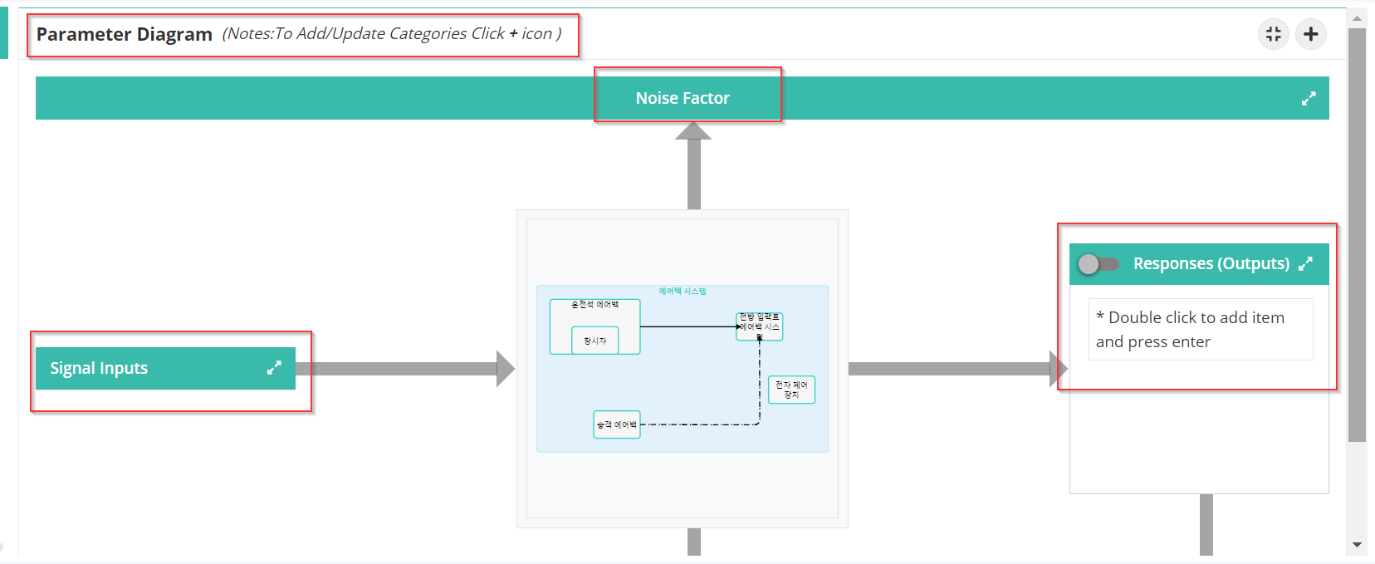

1. Categories popup and Tooltips for add Categories.

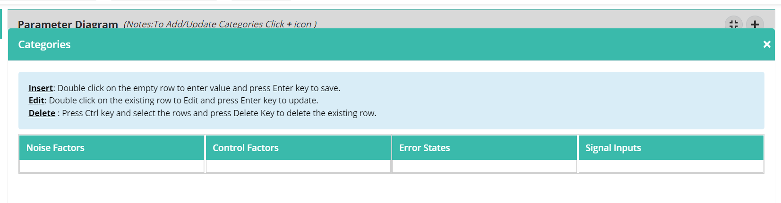

1. Actions tabs.

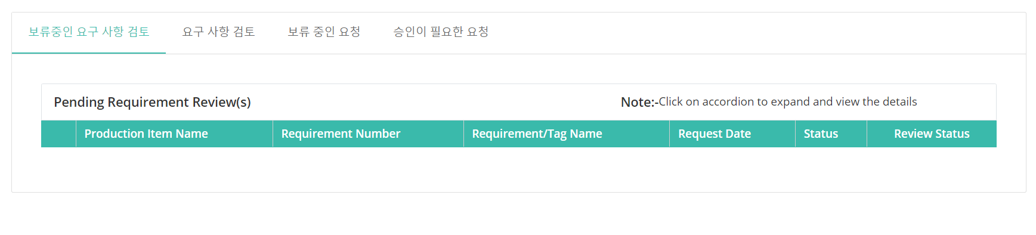

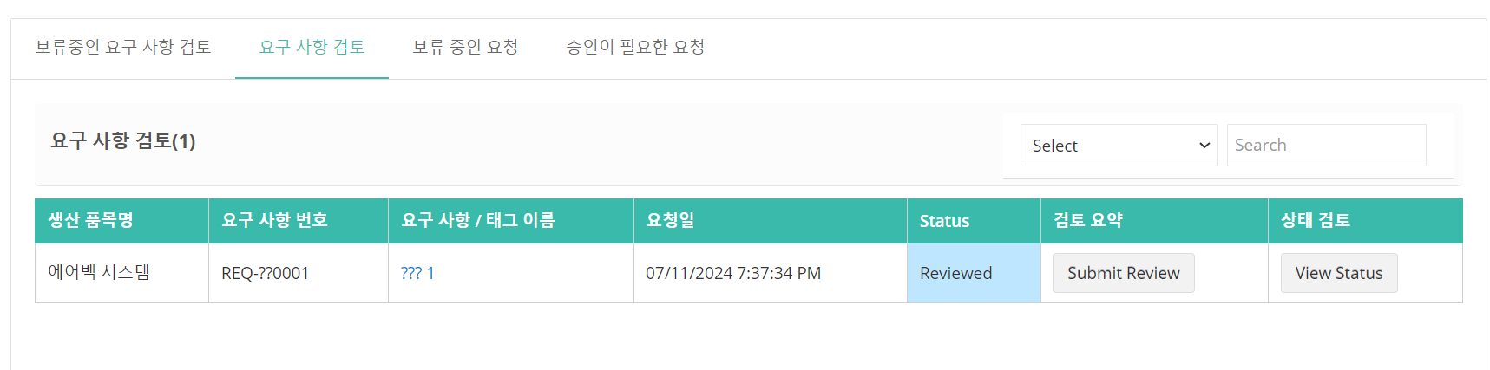

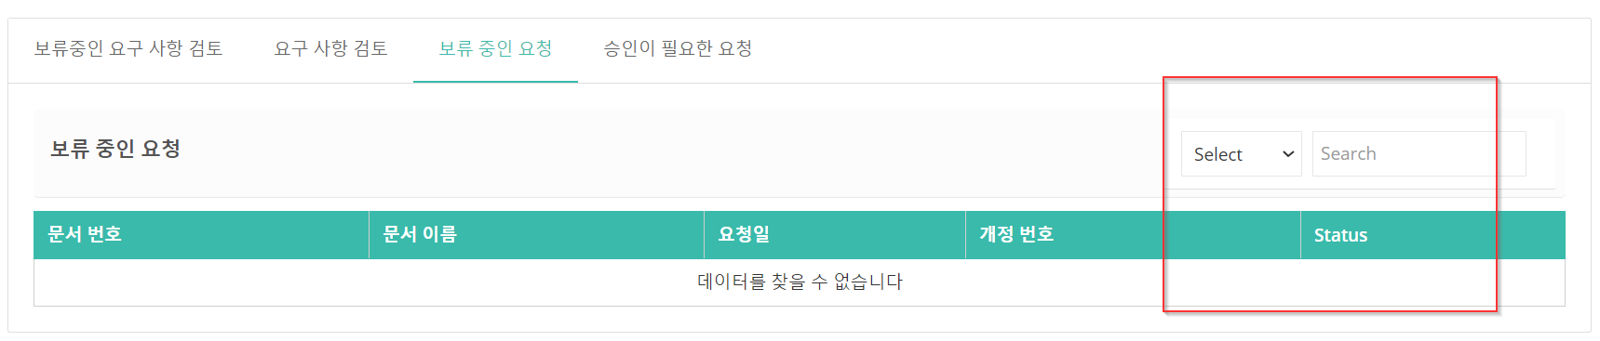

1. Element types tooltip

