1.Setup🡪Business Rule

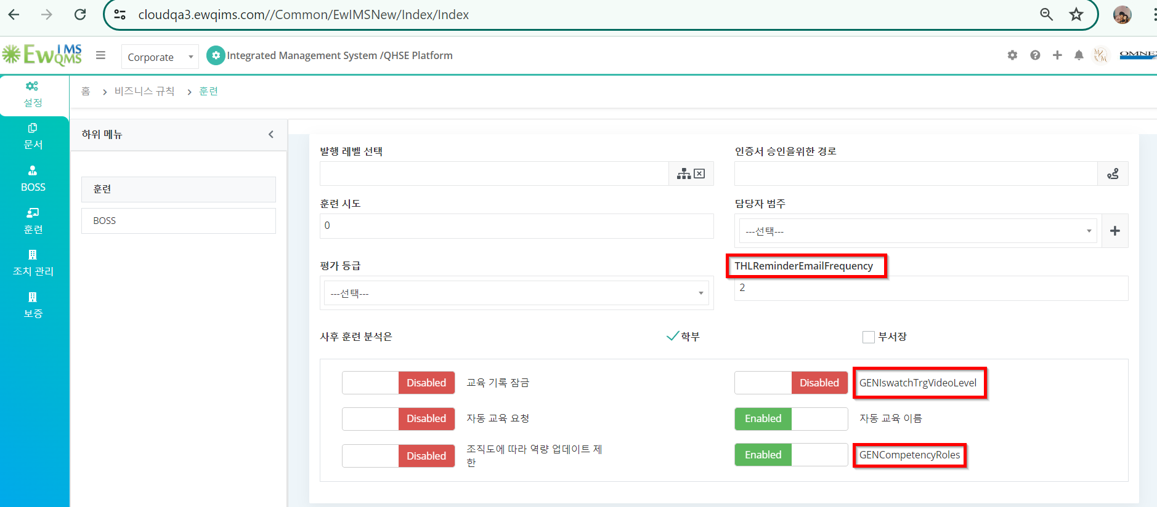

2. Competency Criteria

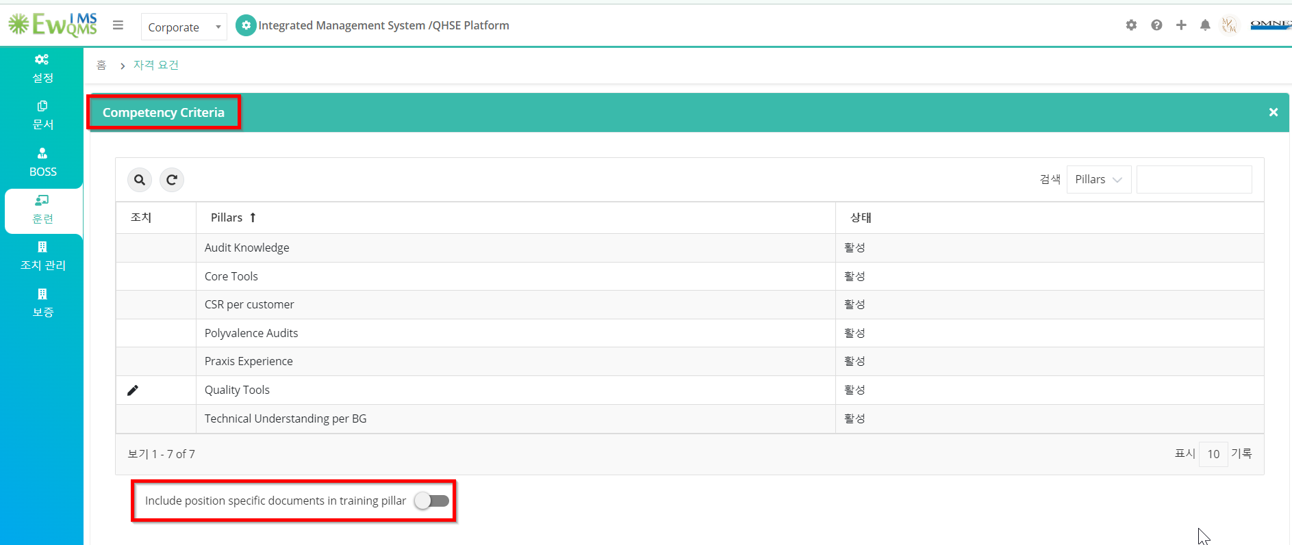

3. Job Requirement page

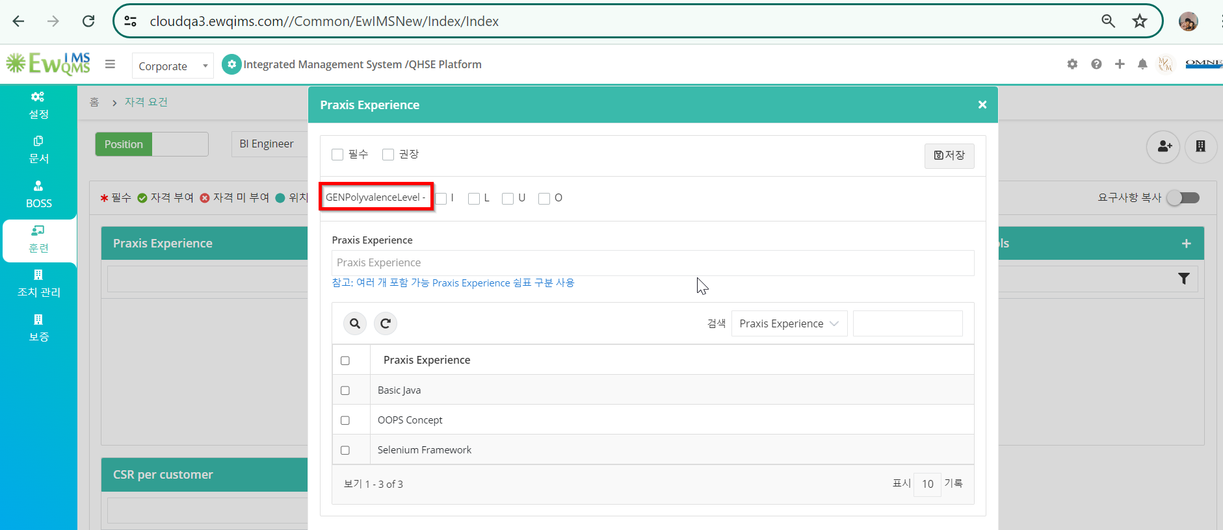

4.Competency Evaluation

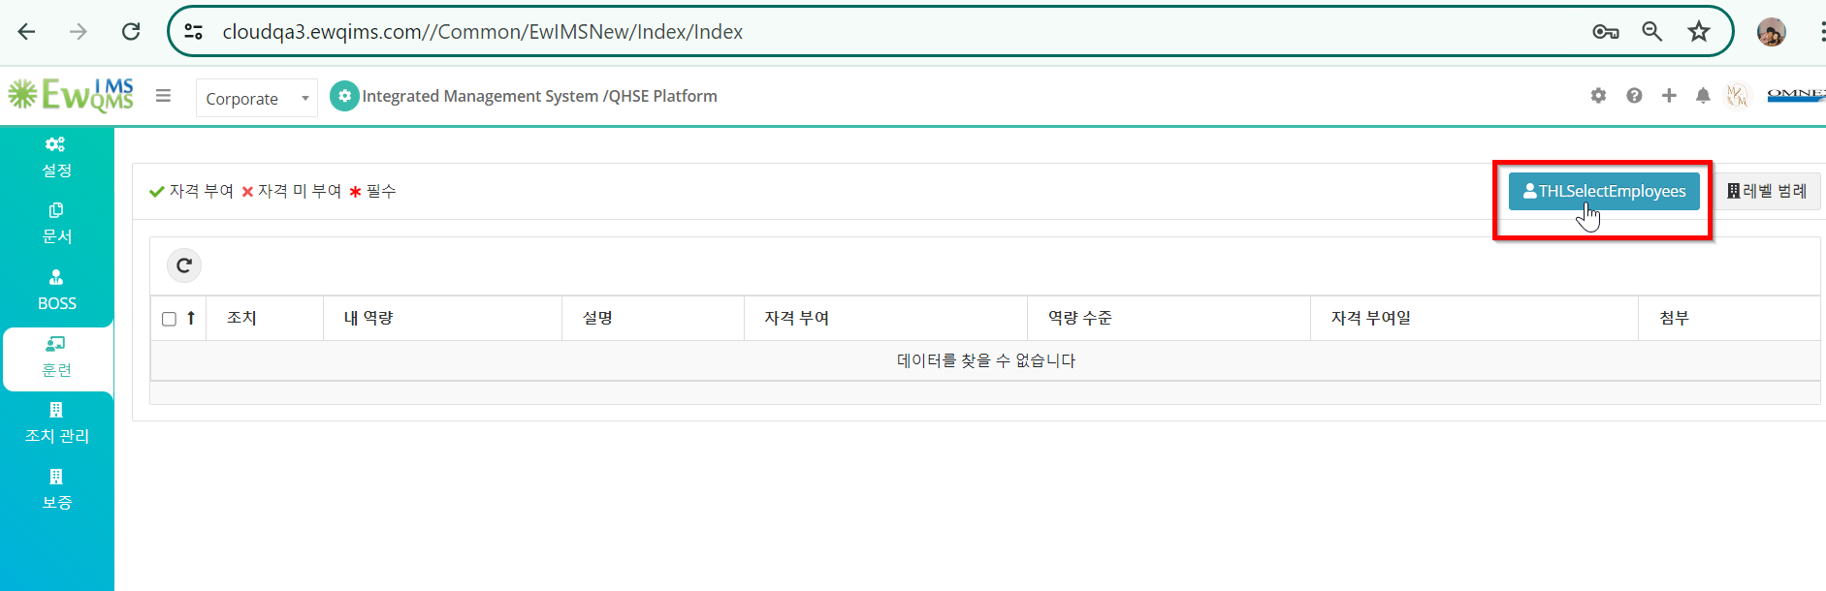

5. My certifications

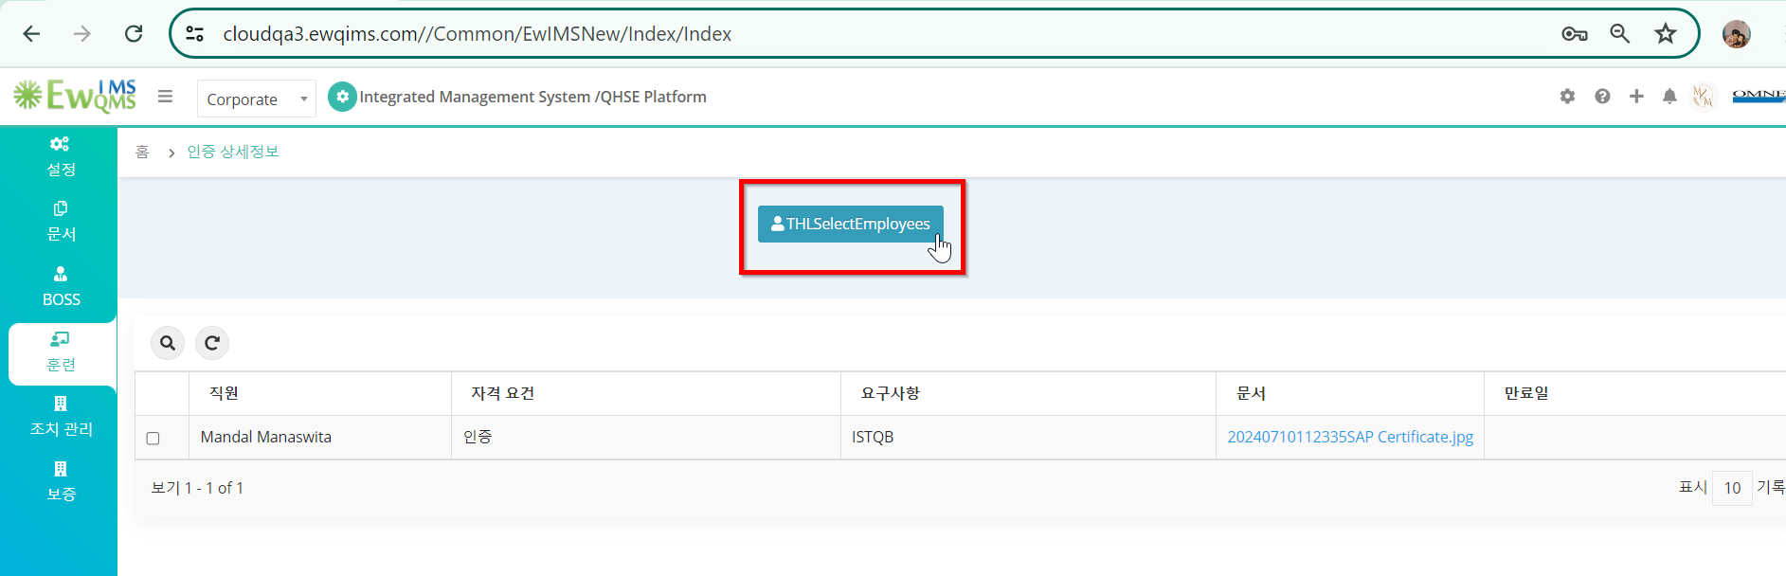

6.Competency Criteria

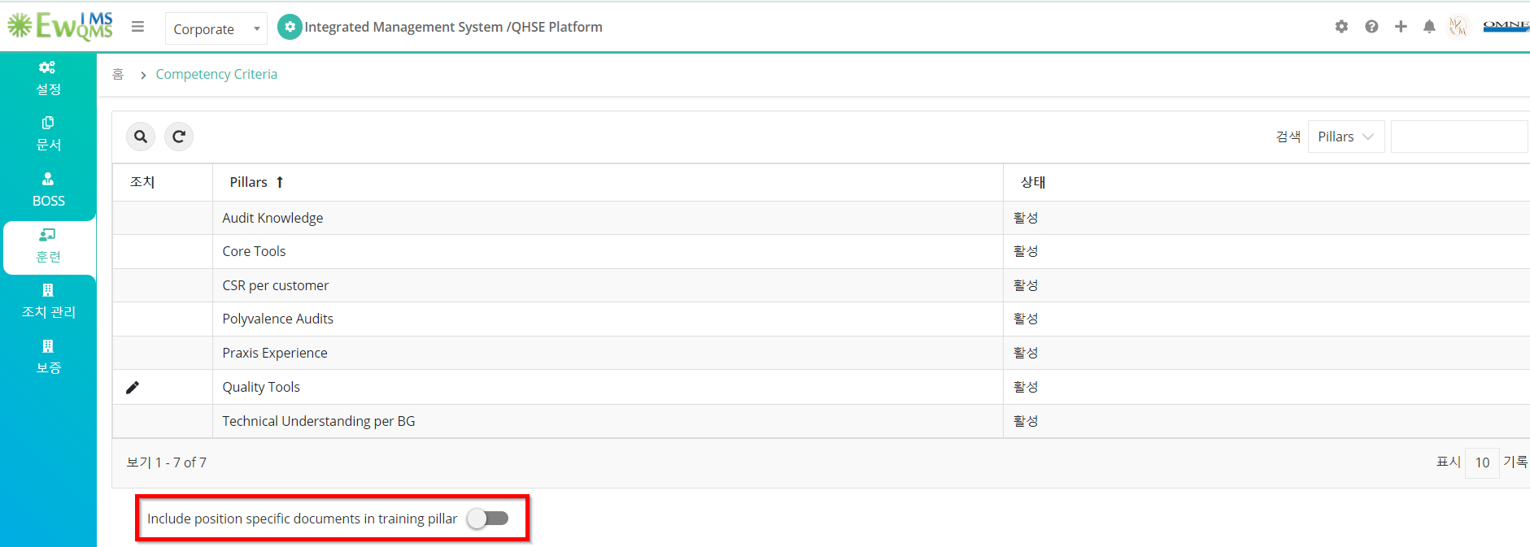

7. Trainings

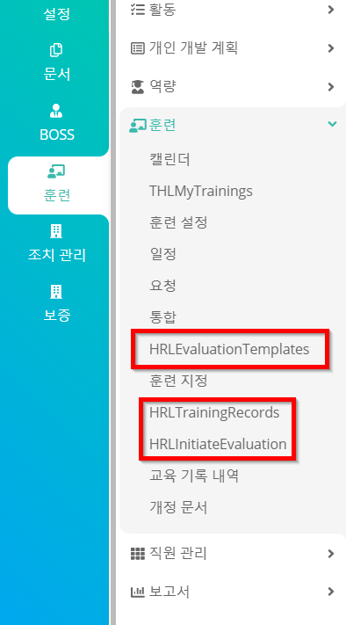

8. My Trainings

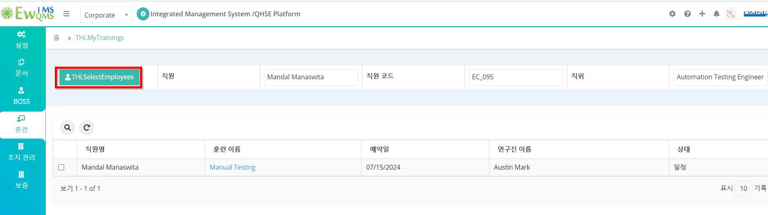

9.Initiate Evaluation

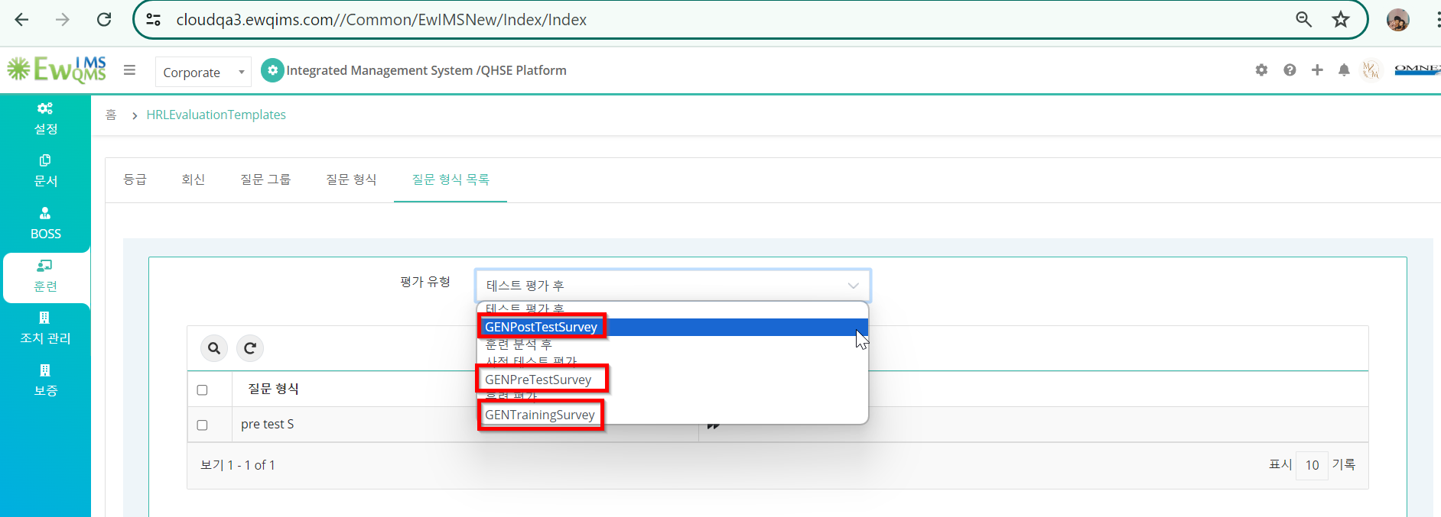

10. Training Records

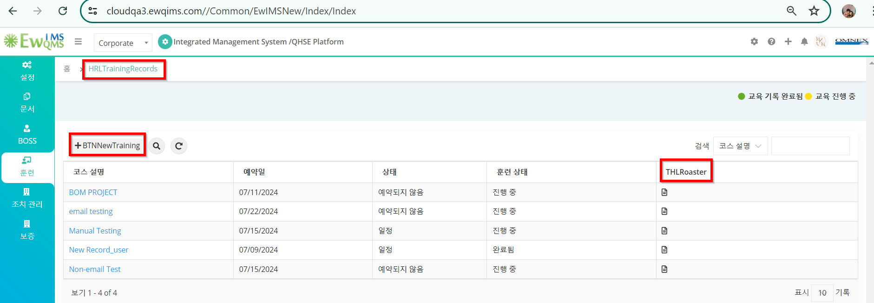

11. Training Records🡪New Training

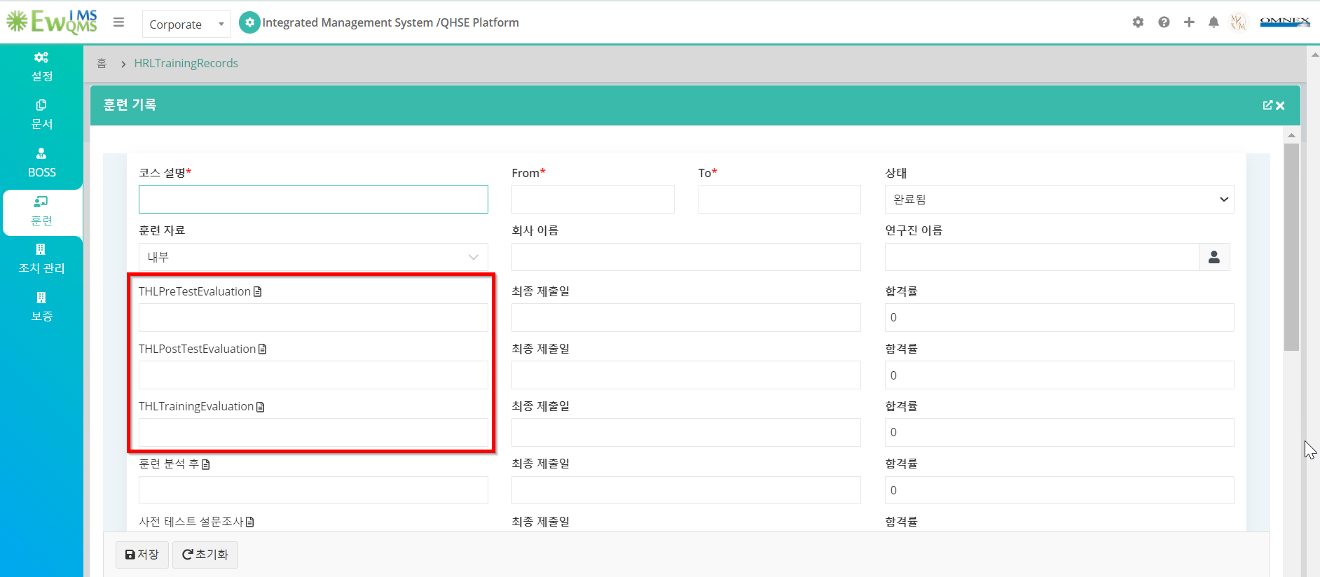

12.Training Records🡪New Training🡪Add nonemail

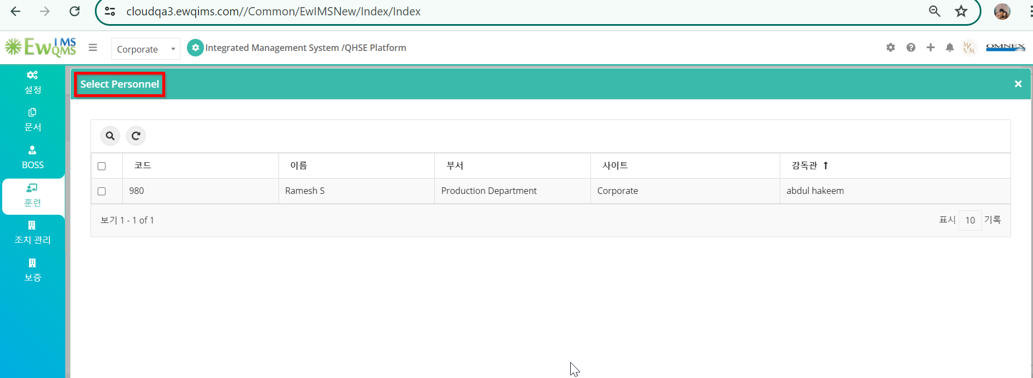

13. Initiate Evaluation

