1.Warranty Setup

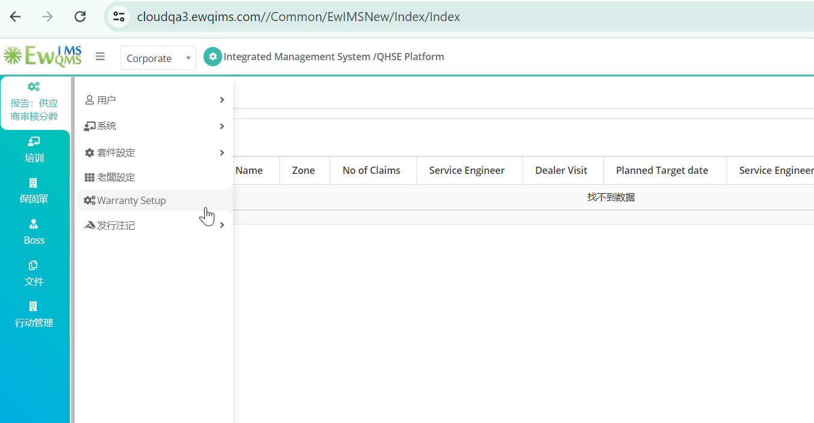

2. Warranty

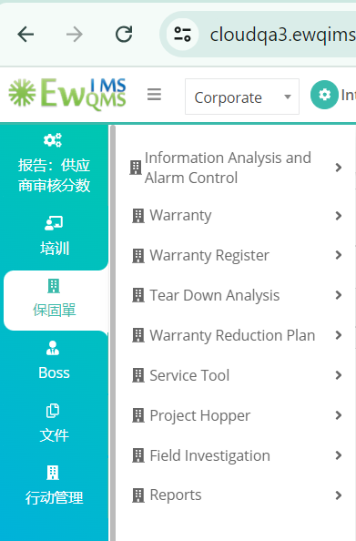

3.IAAC

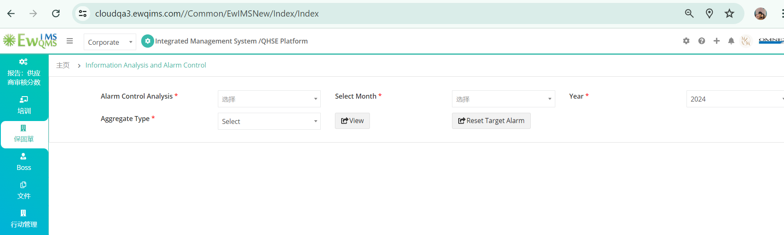

4.Customer Feedback

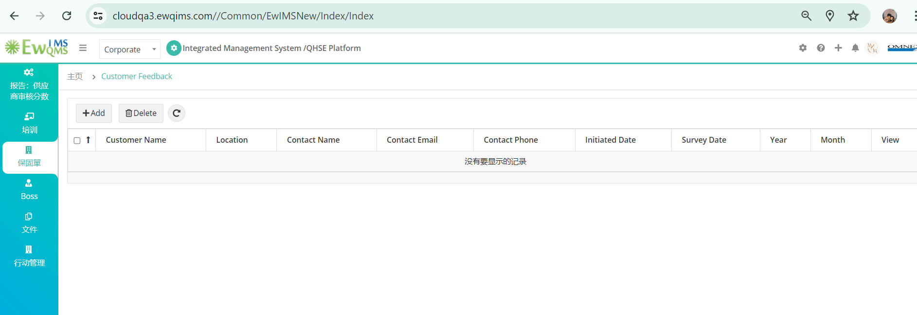

5. NPD

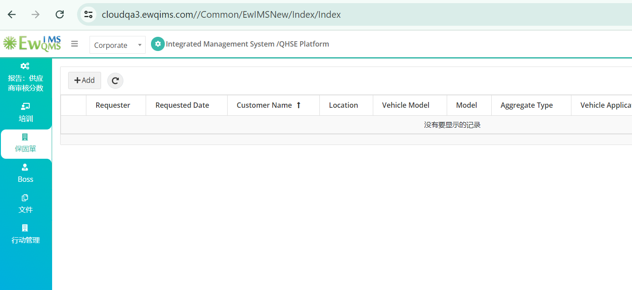

6.Deeler Feedback

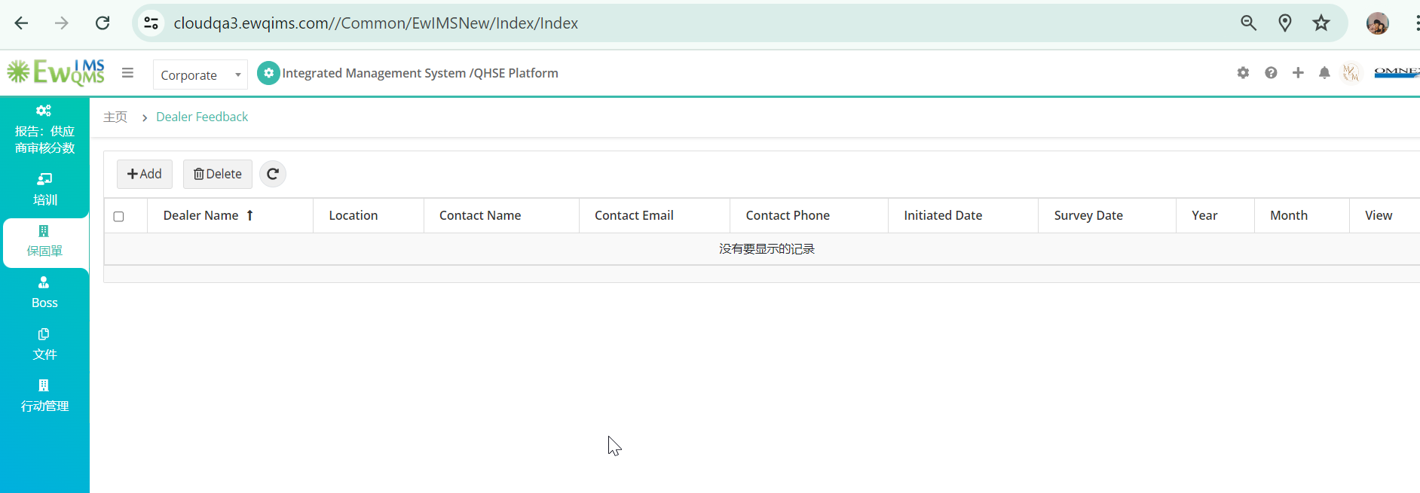

7.Warranty Claim Entry

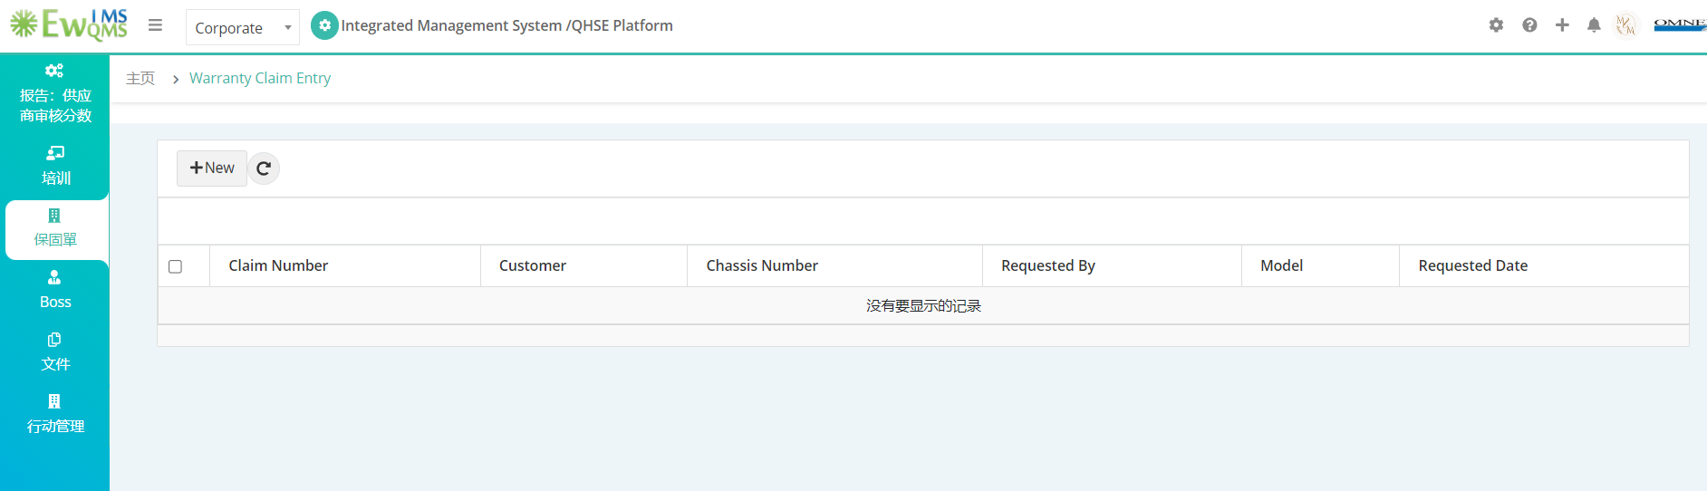

8.Warranty Claim Analysis

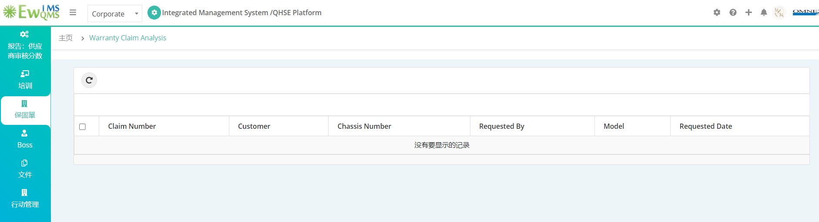

9.Warranty Import

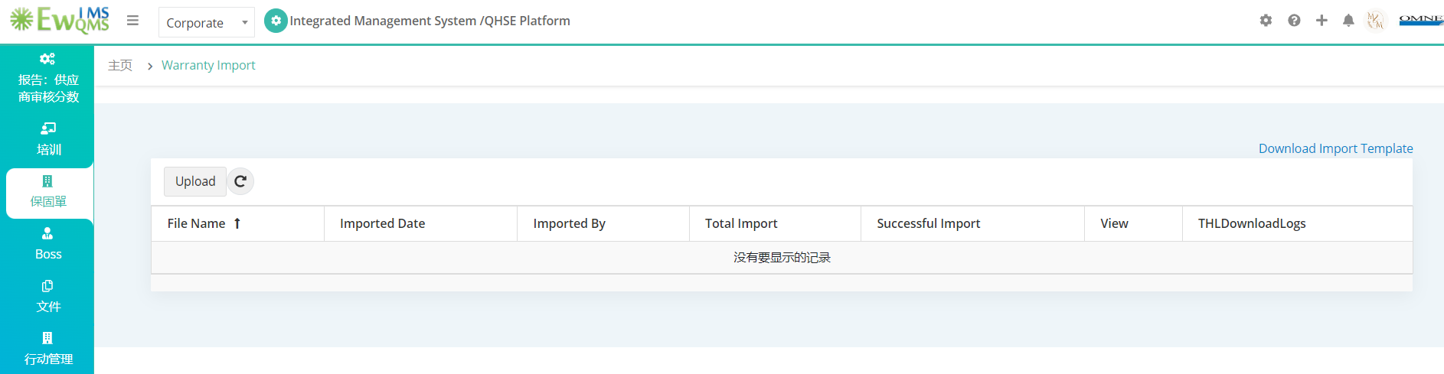

10. Accepted and Rejected Claims

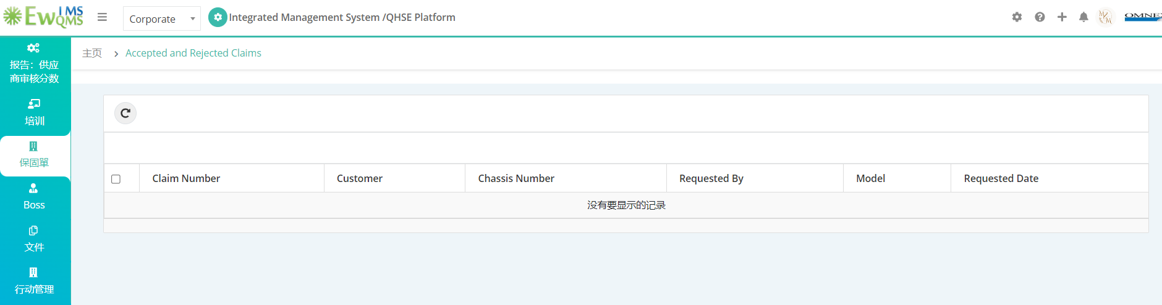

11. Customer Portal

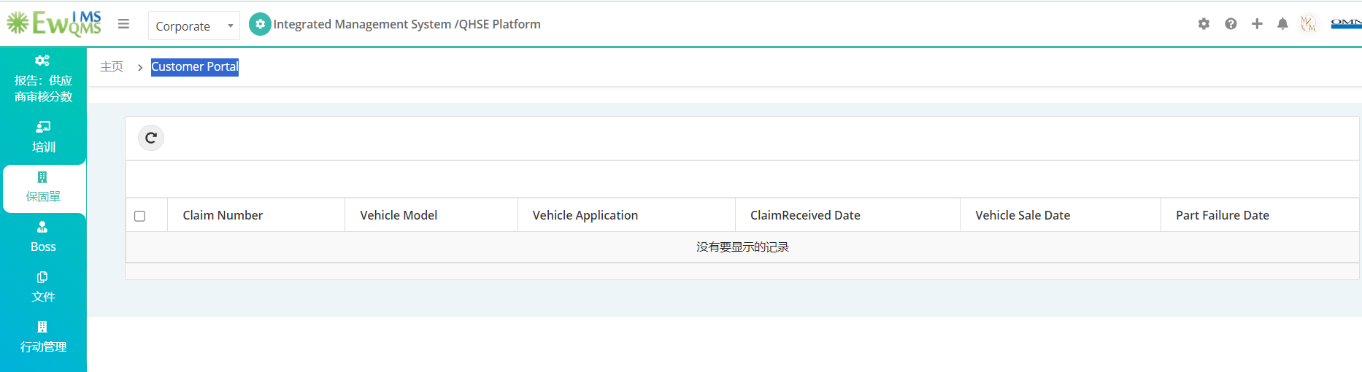

12. Tear Down Analysis

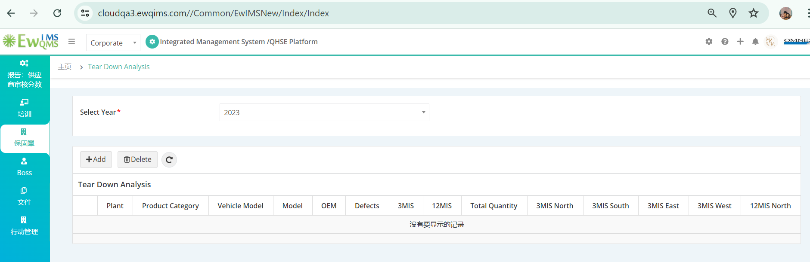

13. Project Creation

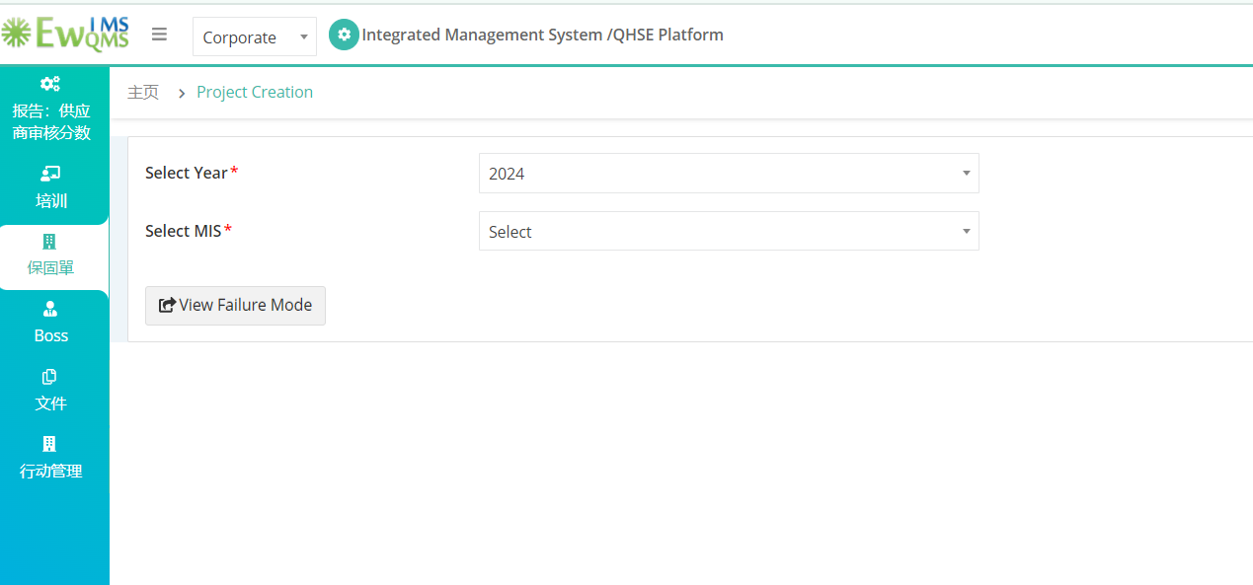

14. Project Hopper

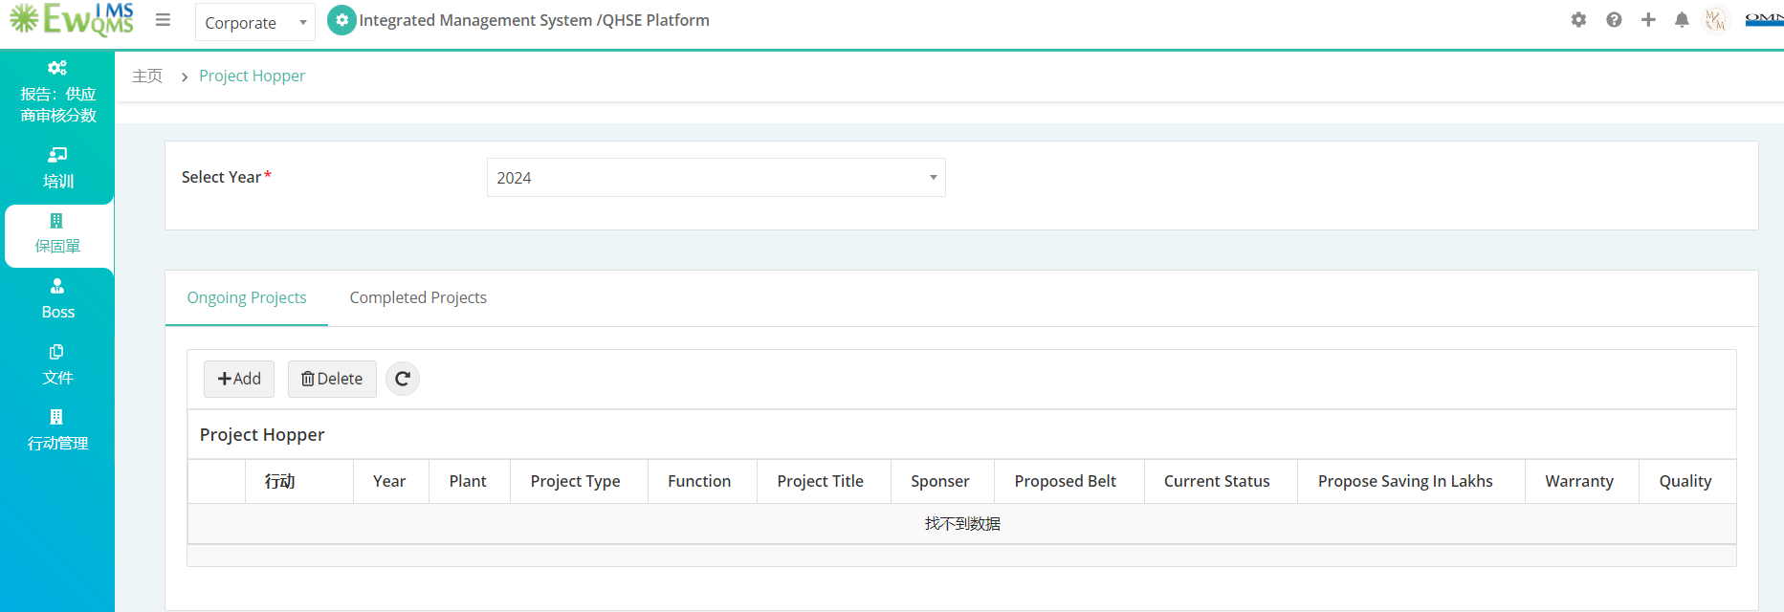

15. Field Investigation by Service Engineer

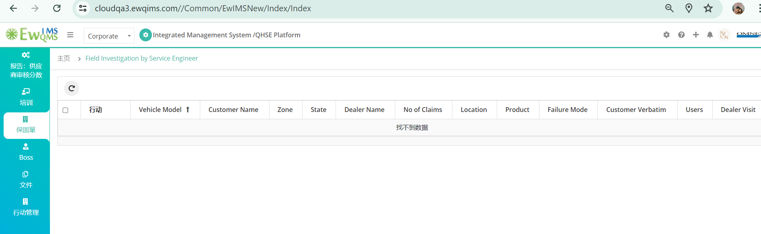

16. Dealer Visit

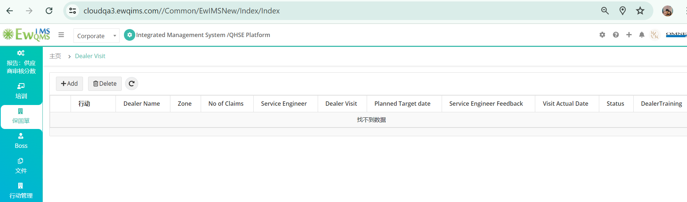

17. Dealer Visit Training

