1.HRPRo🡪Trainings

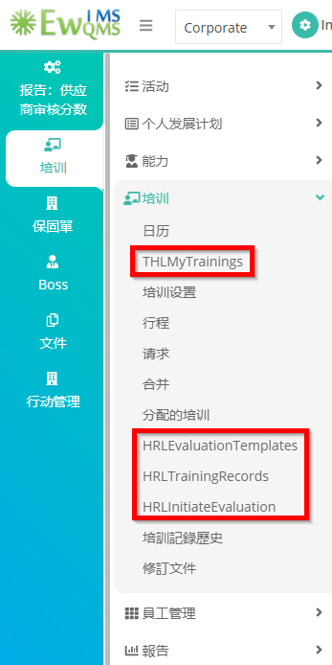

2. Job Requirements

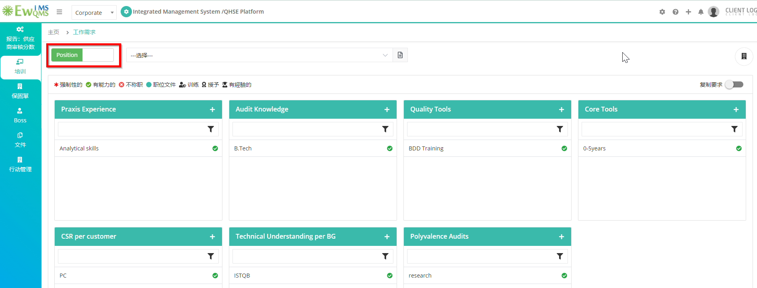

3. Competency Evaluation

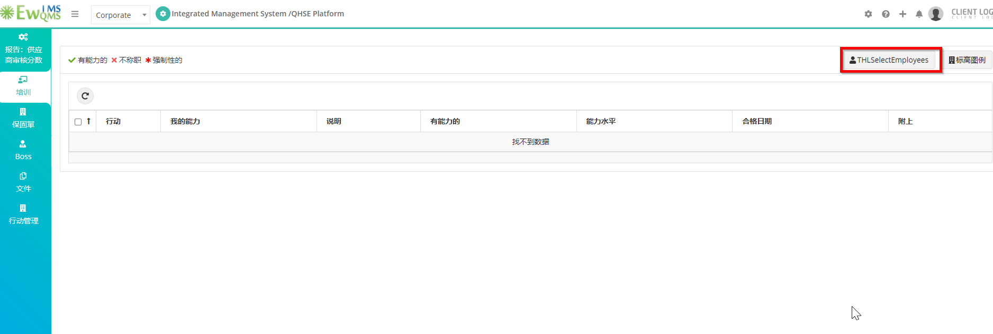

4.Certification Details

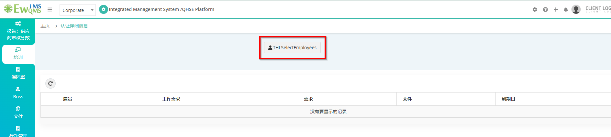

5. Competency criteria

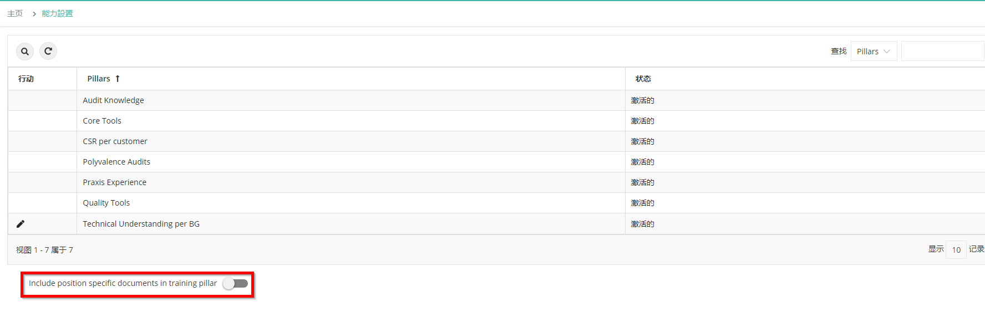

6.

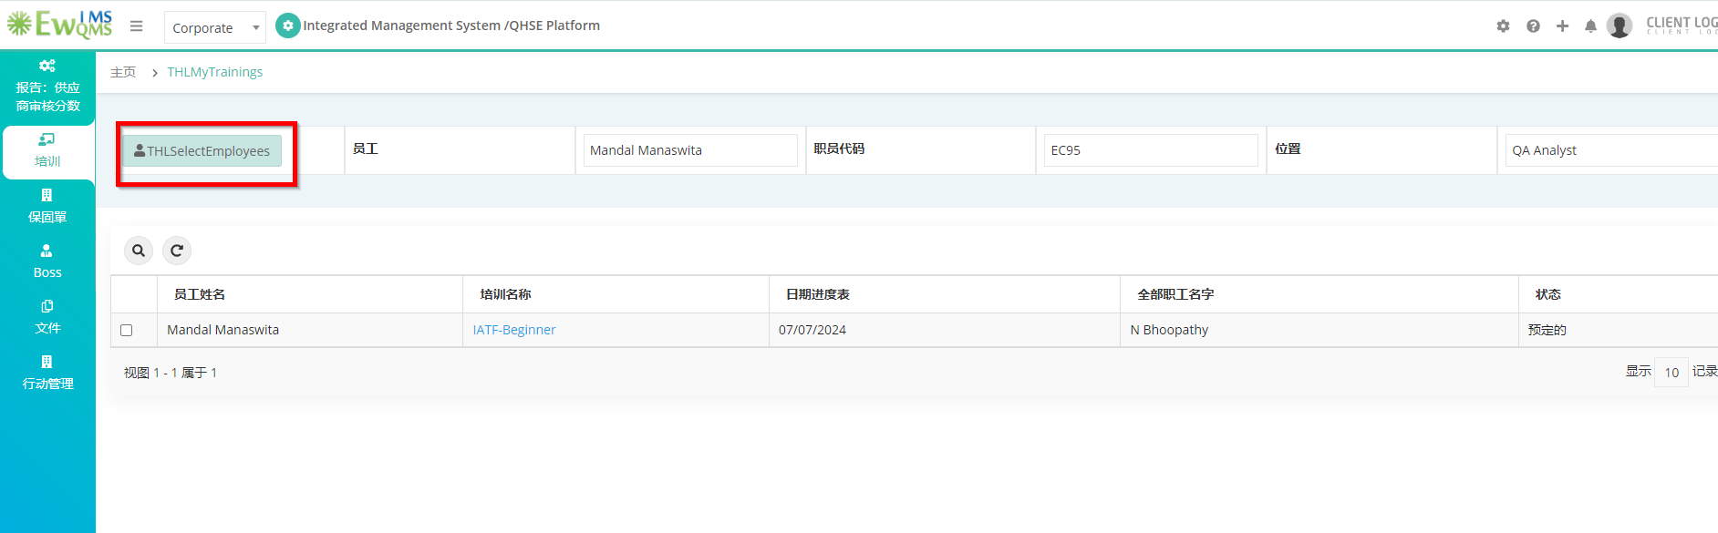

7. Initiate Evaluation

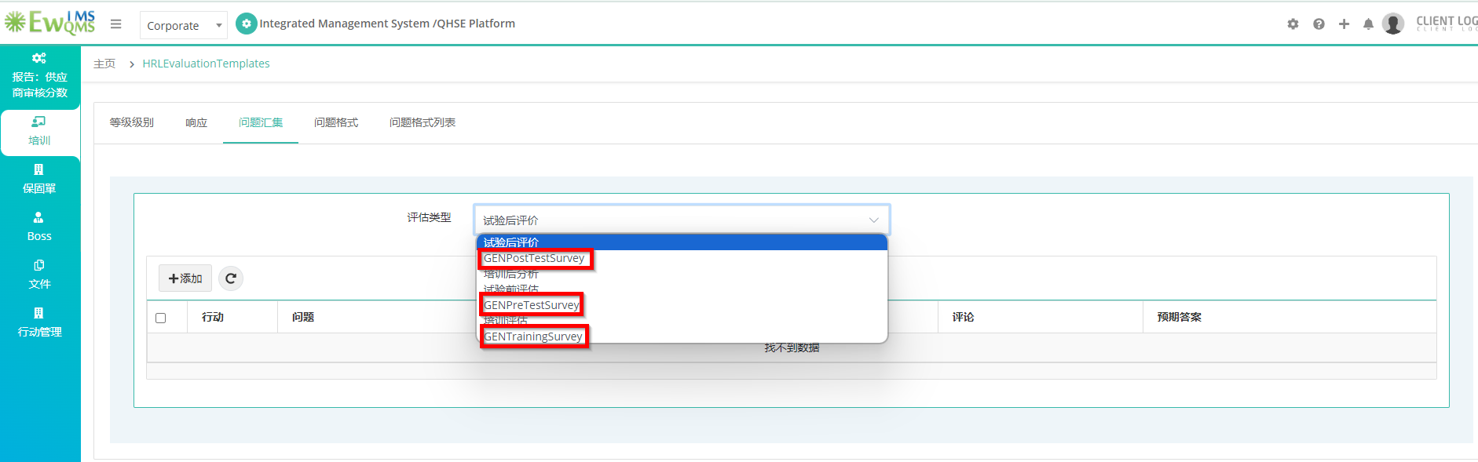

8. Records🡪New Trainings

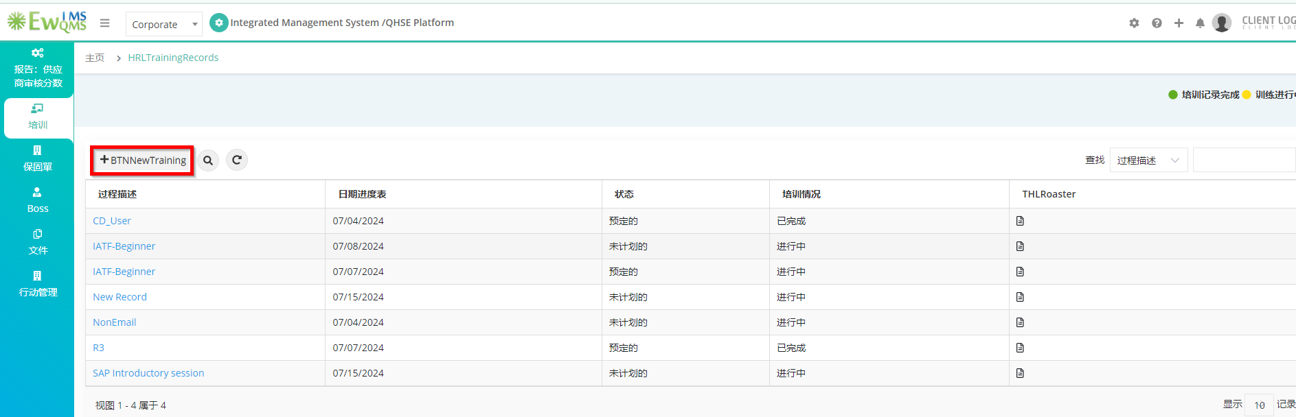

9.Records🡪New records

