Only one user is selected during the project creation.

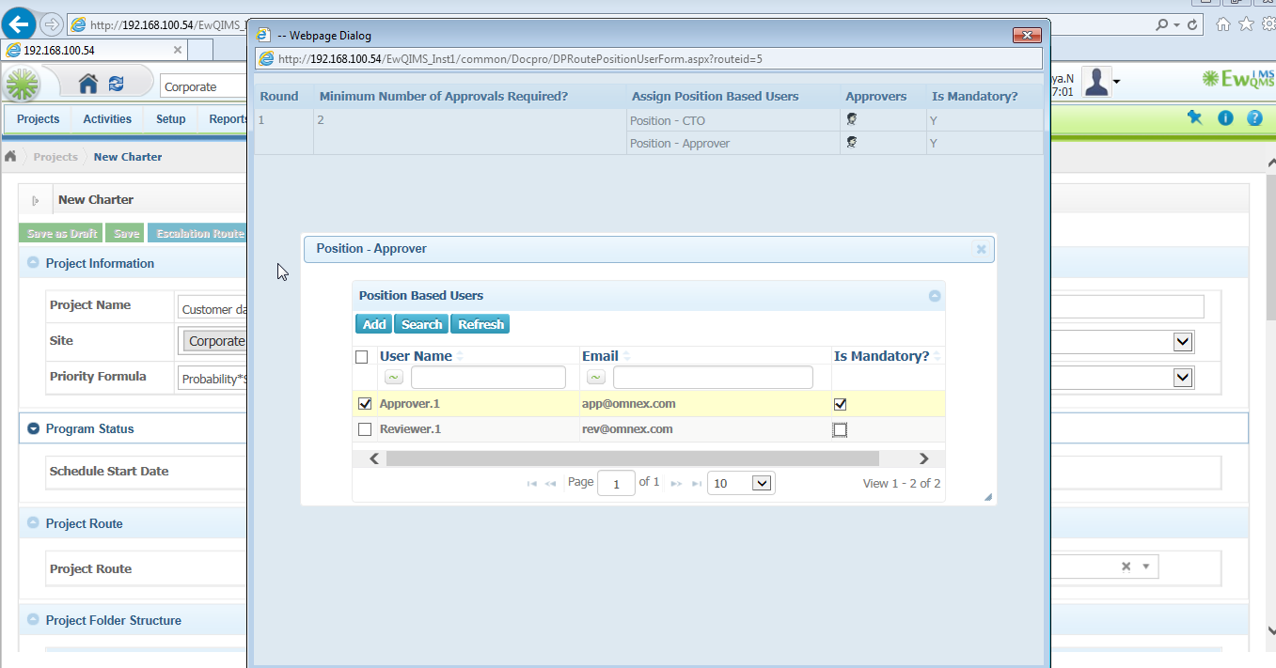

But in the action page it displays the details of unselected user also

