FST SP710 issues:

These issues are particularly occurring in following Scenario:

1. Click on FSR

2. Add a function A1and requirement R1 for a safety goal

3. Decompose A1 to A2 and R2

4. Decompose A2 to A3 and R3

Add the Same function to other safety goal.

1) Add a requirement to function A2 in any one safety goal. System is alternatively adding the requirement in Function A1.

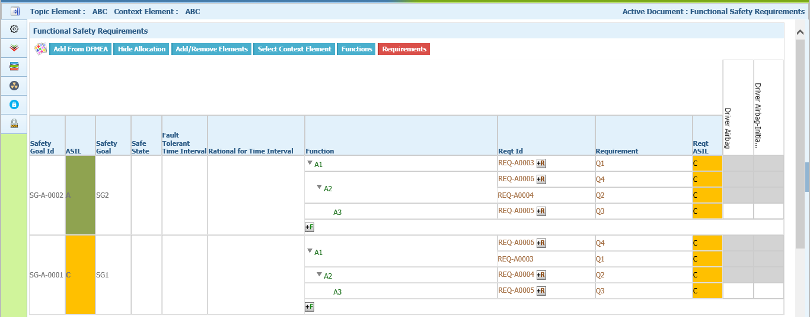

So while deleting that requirement in any one safety goal, system is deleting only in that safety goal.

2) After allocate ASIL Is done for an element, there is no Deallocate when right click on the element.

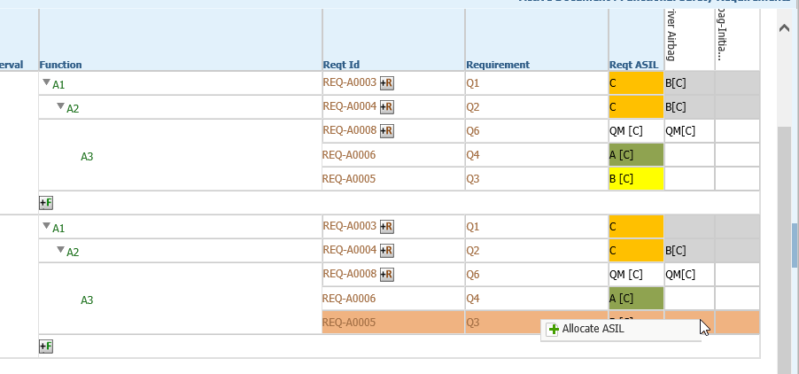3) Add requirement to A3 and Add ASIL.

Now Add requirement to A2 in any one safety goal.(Also Refresh Issue)

Here system is adding the requirement only in that safety goal. Also leaving a white space in Reqt ASIL column.

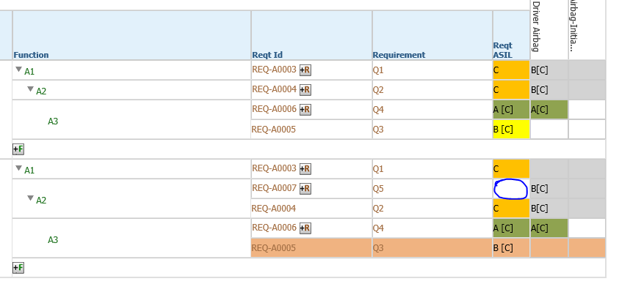

4) After this scenario when doing Add ASIL, system displays a blank window.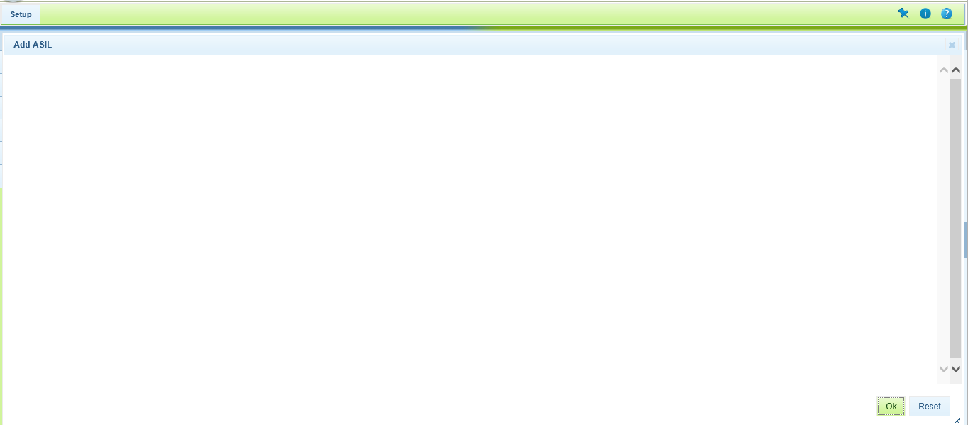

5) In VOC the symbol is not displayed for the allocated element.

