FSR Issue on 27-09-17

While Decomposing more than 3rd level function, following issues occurs.

1. Add one function and requirement to in each level.

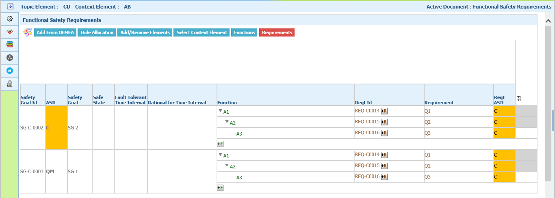

2. Add one or more requirement for A3 function.

Here +R button appears for each requirement. But cannot able to add a requirement by clicking on +R icon except top most +R icon.

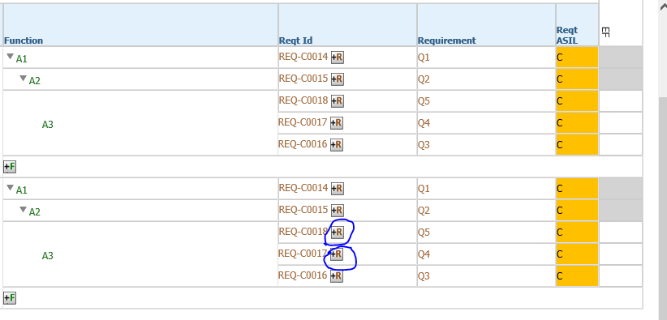

3. Click add ASIL for A3.

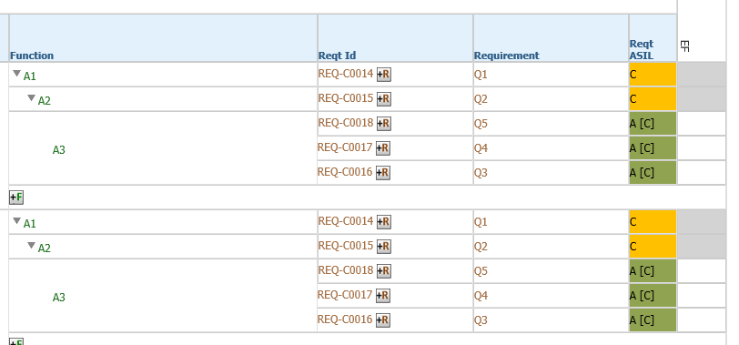

4. Decompose A3 to A4.

Observe the changes in both the safety goals.

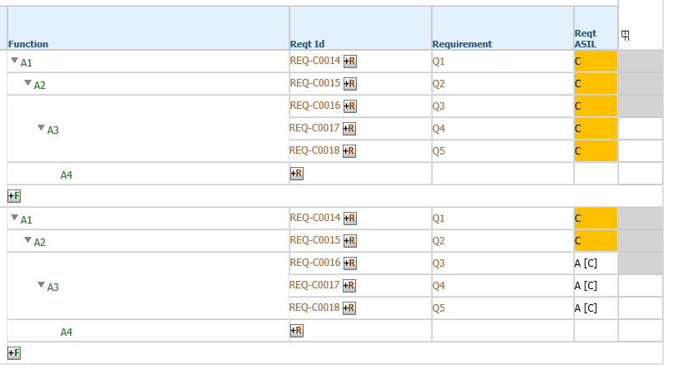

5. Add a requirement to A4.

Here cannot able to do Add ASIL. System resets the ASIL.

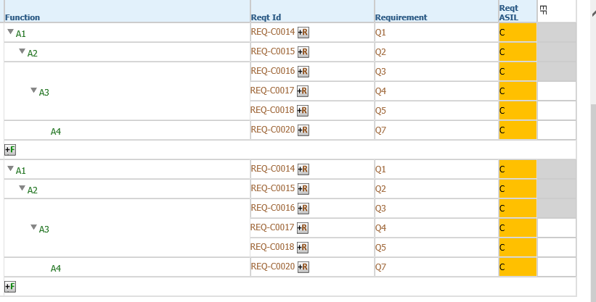

6. Delete A4.

Here system deletes all the requirements of A3 also and displays the requirement of A1.

