TPM

SPOTFIRE REPORTS VERIFICATION:-

1. TPM Break down Analysis:-

* Getting error Message while opening report

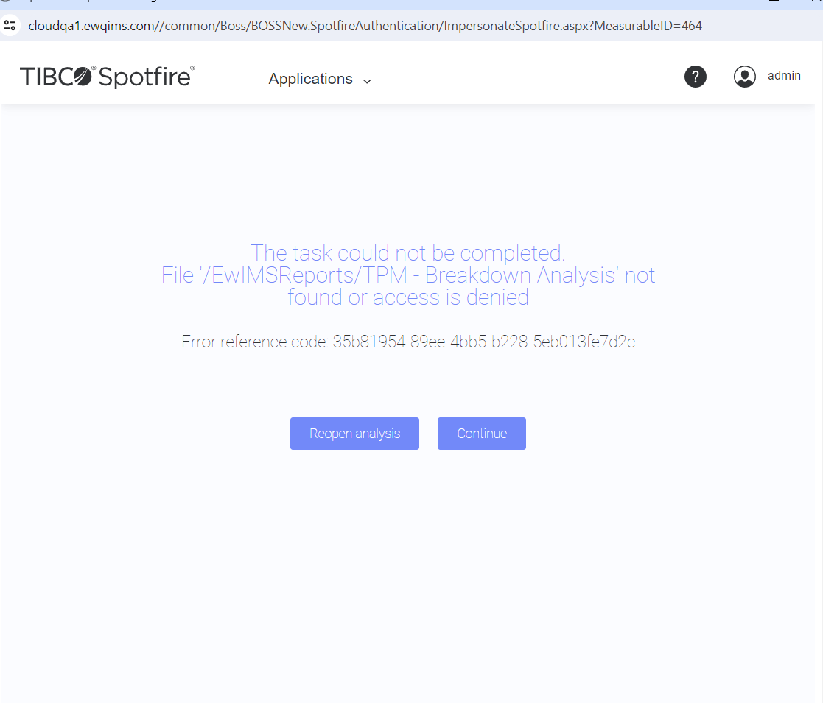

2. Tpm Equipment breaks Down:-

* Getting some interrupted errors

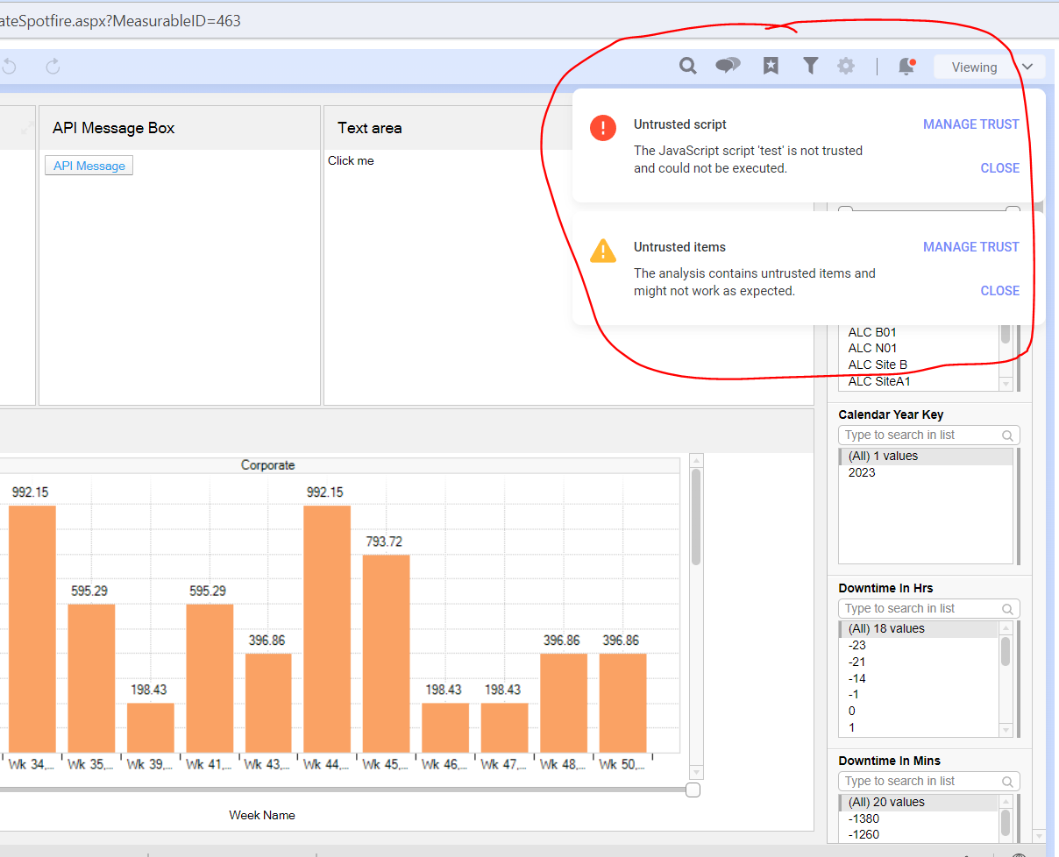

3. History card sub report:-

* All the flters are working as expected
* While clicking type as [UBM] It is highlighting as red colour this behaviour is not showing other work orders.

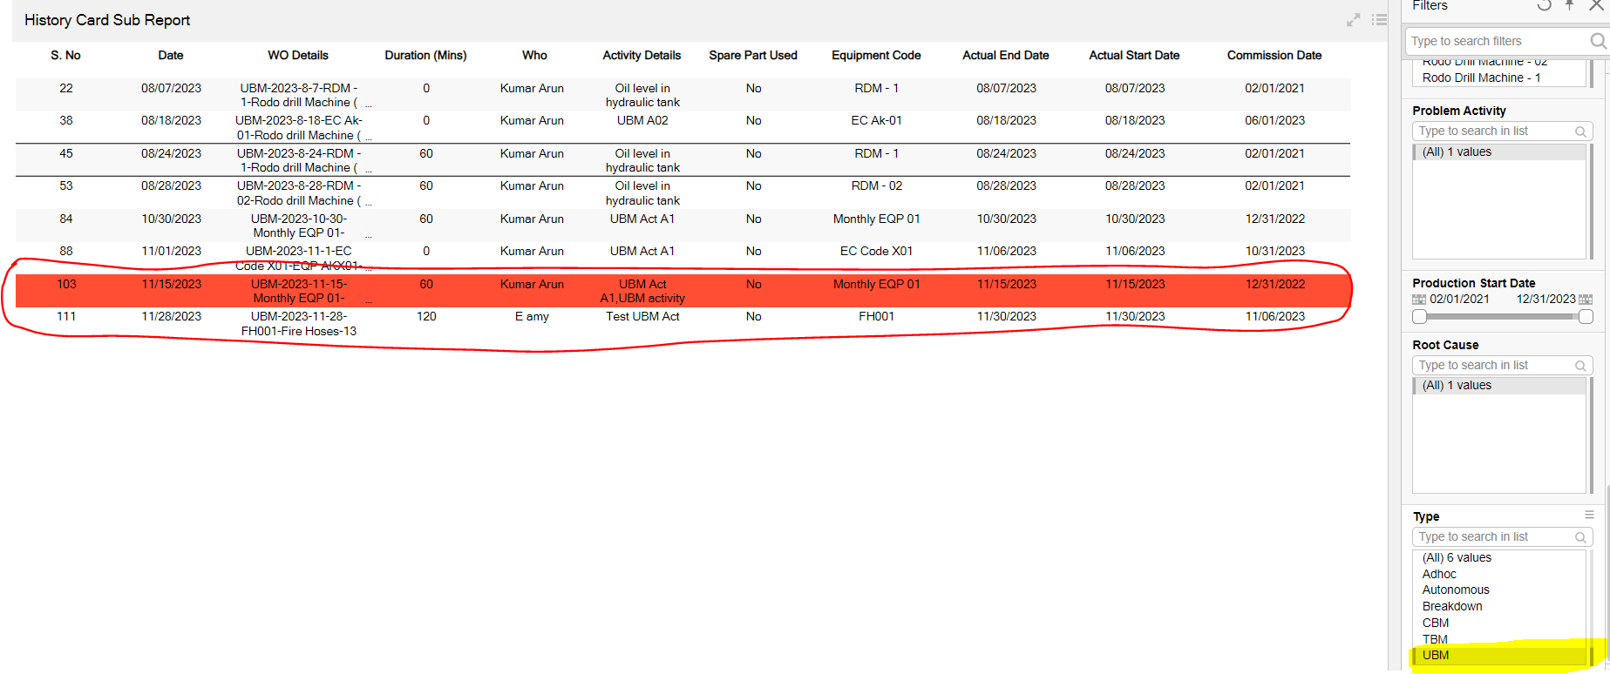

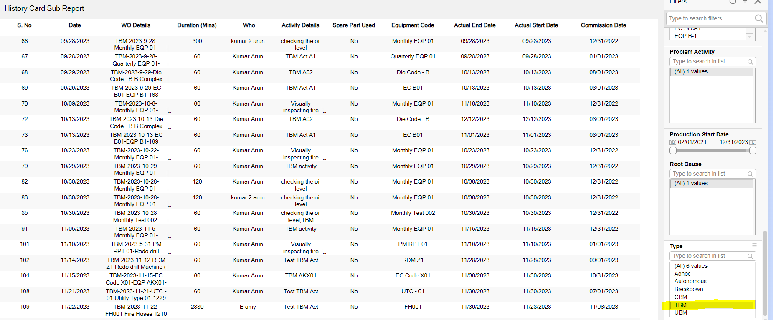

4. History card sub report BD:-

* **Please change NAME Filter as Equipment code**

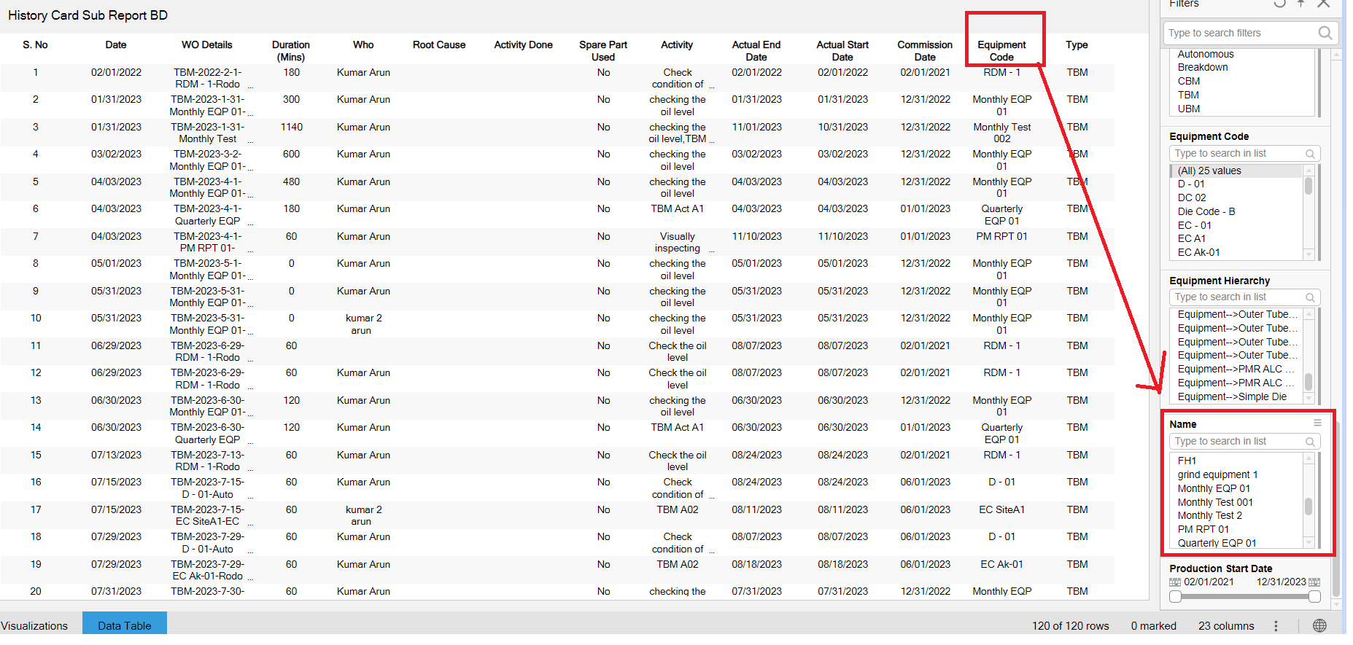

* **In filters the root cause details are listing clearly while seeing root Cause column data screen the details are not listing clearly it will make confusion**

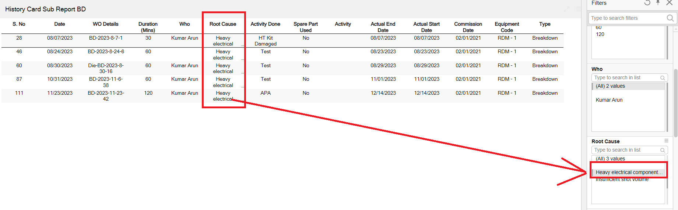

5. TPM - Inventory Analysis:-

**Getting error alert**

6. TPM - KEs Efficiency

**[i] Site wise KE Efficiency**

**[ii] Site production equipment wise**

* **Month name filter :- Months are not listing order wise like [Jan ,Feb., ] as the same way the months data are not listing order wise.**
* **Remove calendar year key**

**1990 year**

* **On the Graph IN Week Word “w” is not all looking good its low colour**

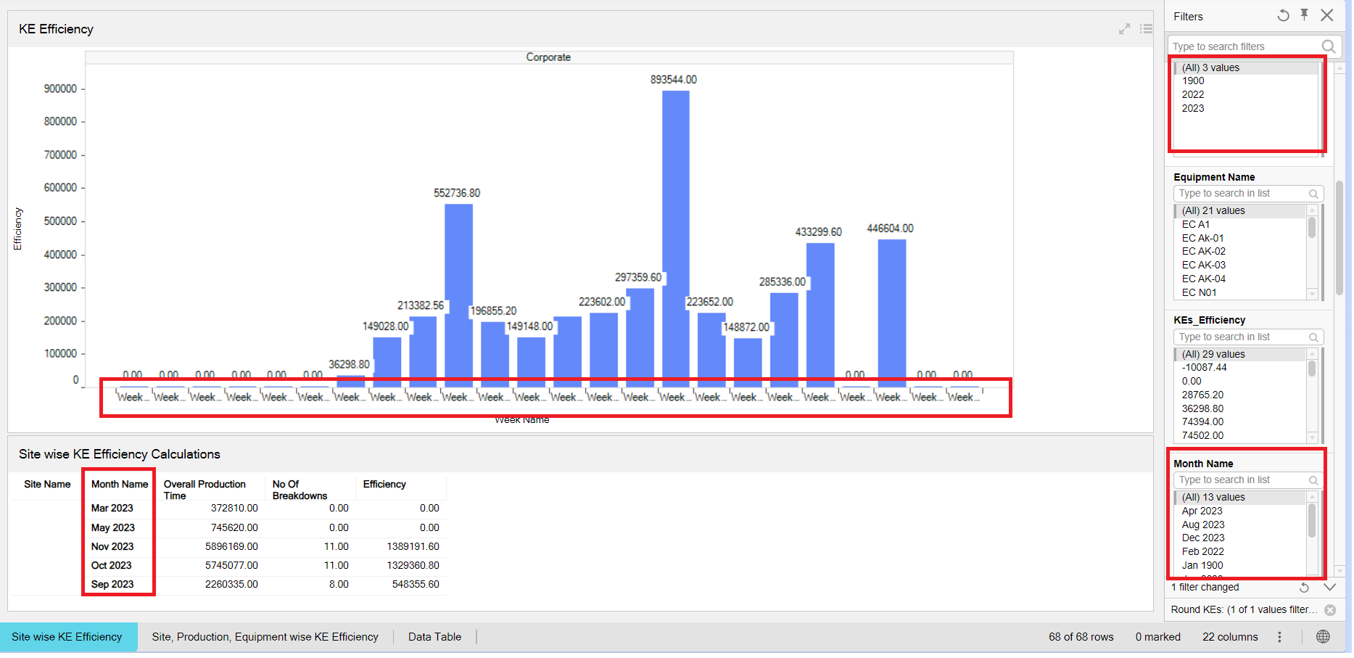

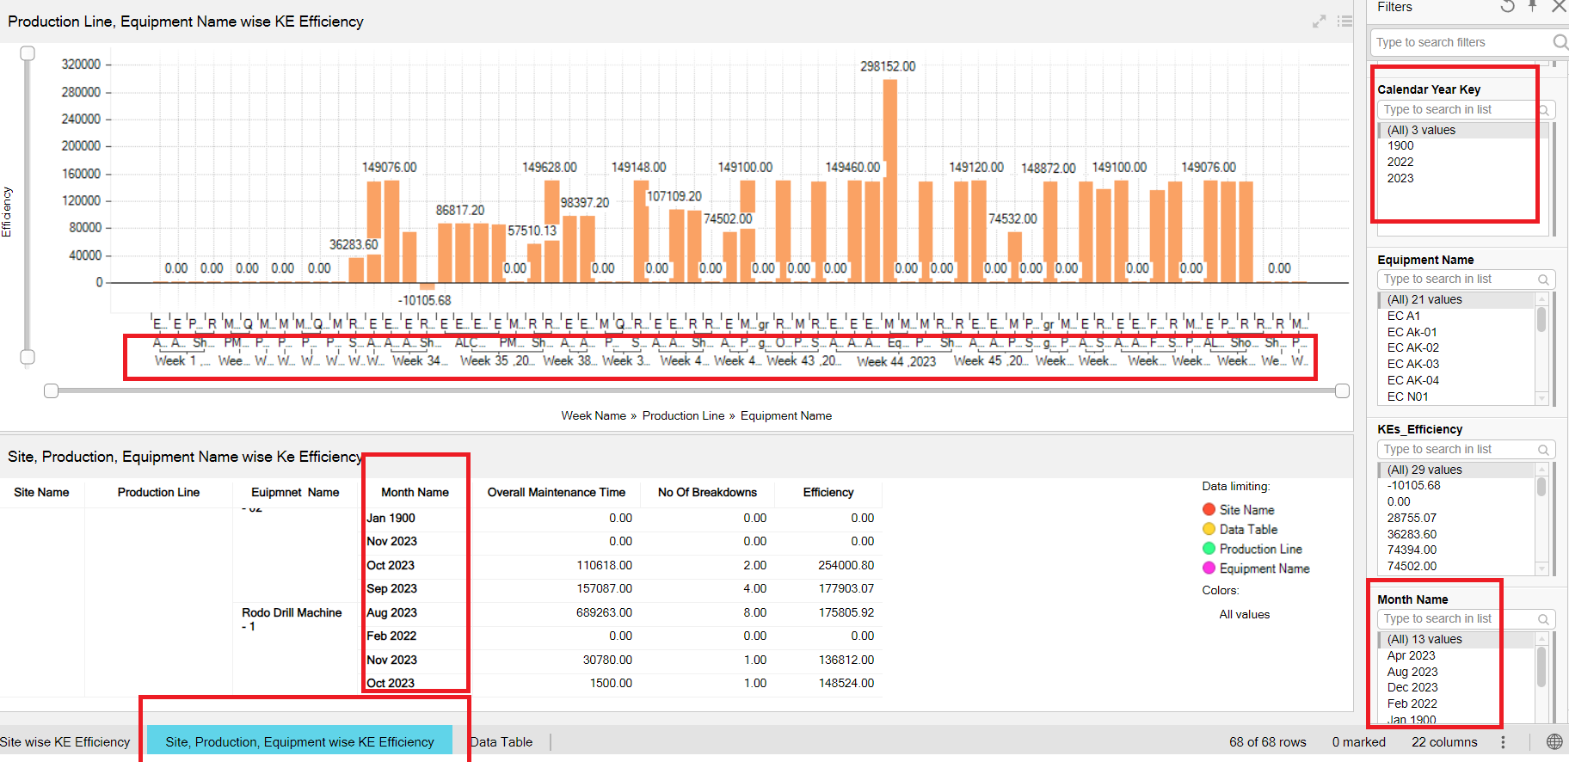

**7.** TPM – MTBF:-

[i] Equipment wise MTBF

* **The column heading and data is not all good to see its showing like merged [ change the bold colour]**

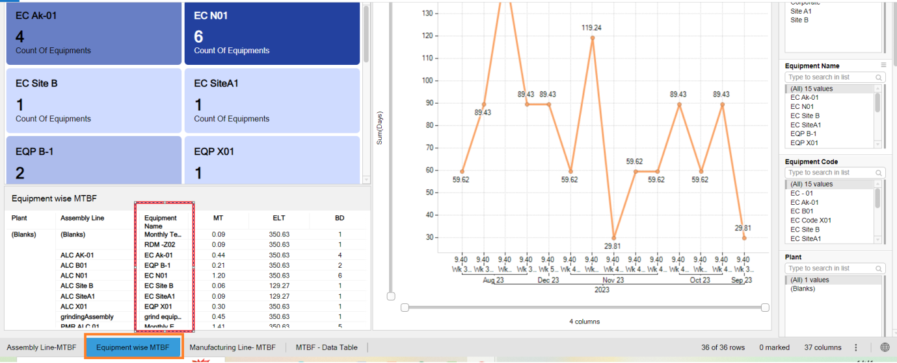

**[ii] MTBF DATA -TABLE**

* **Problem description column :- its showing same data for all the existing records ..the data seems to be irrelevant and also prblm description column shows irrelevant.**

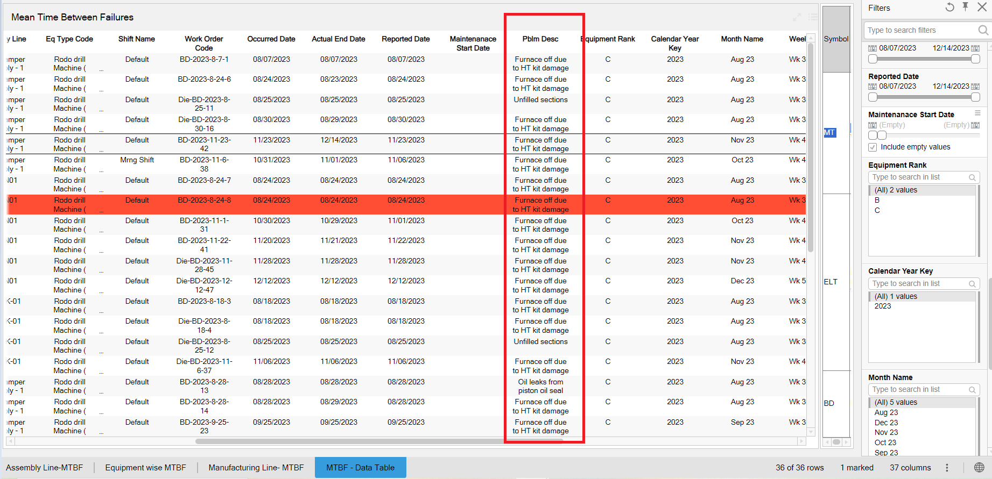

**8. MTTR:-**

**[I] MTTR DATA TABLE:-**

* **Calendar monthly key and week key :- those data is not understandable**

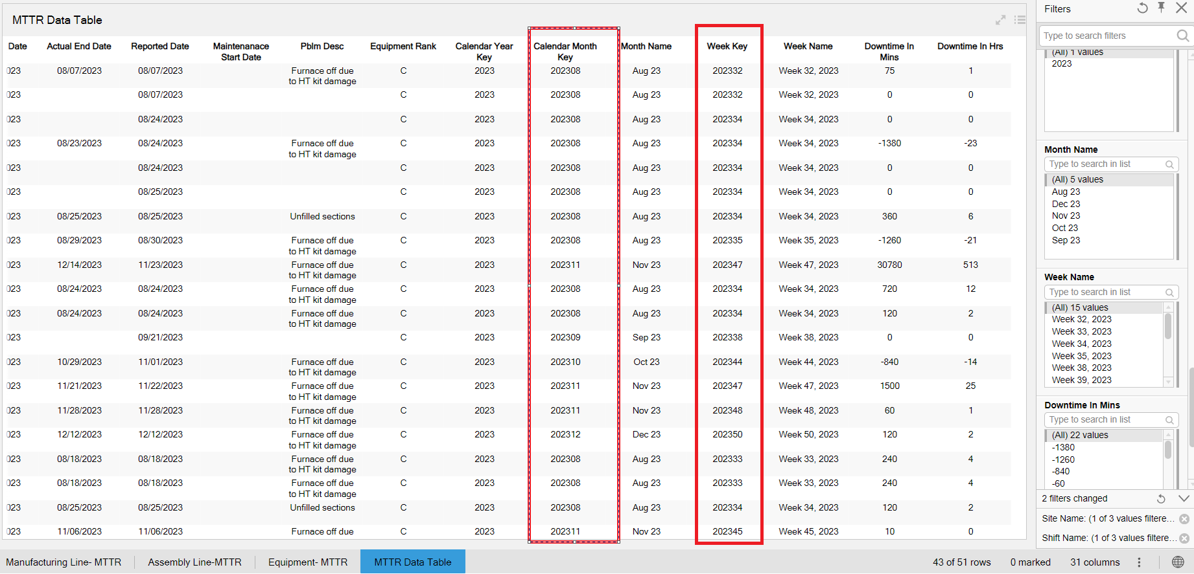

9. Preventive Maintenance:-

Data table:-

* Remove 1990 year from calendar year key
* Month name filter:- **arrange months in proper order**

