[Actions->Documents->Approve Request](file:///C:\Users\Omnex\Documents\TEST_Report_1\APQP\APQP.xlsx#Sheet12!A1)

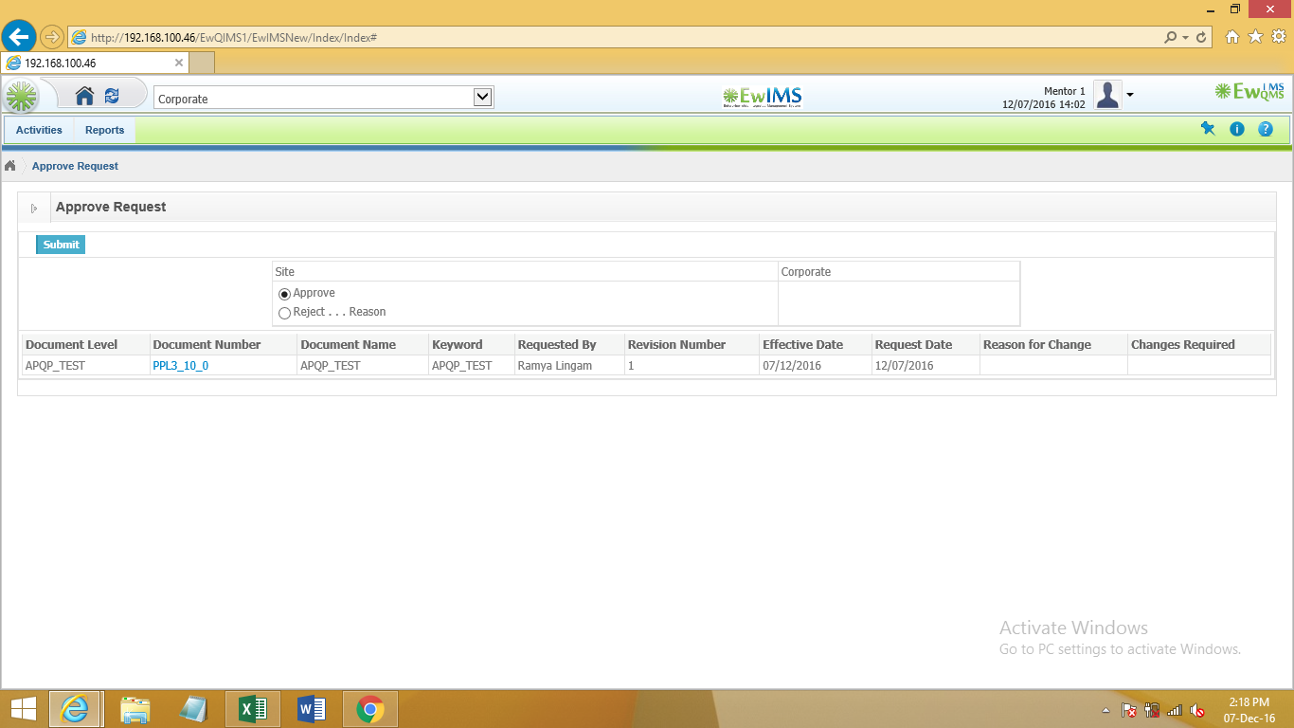

Actions->Documents->Request Details

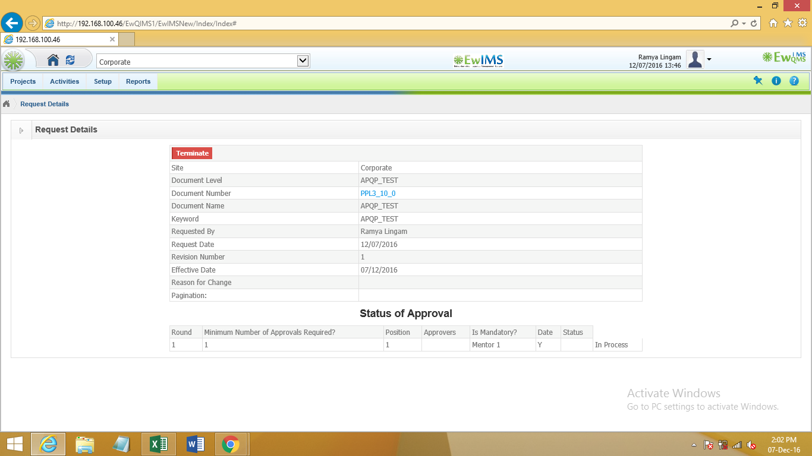

Routes

