1. Added categories and added subcategories before refresh, after refreshing all the added subcategories vanished.

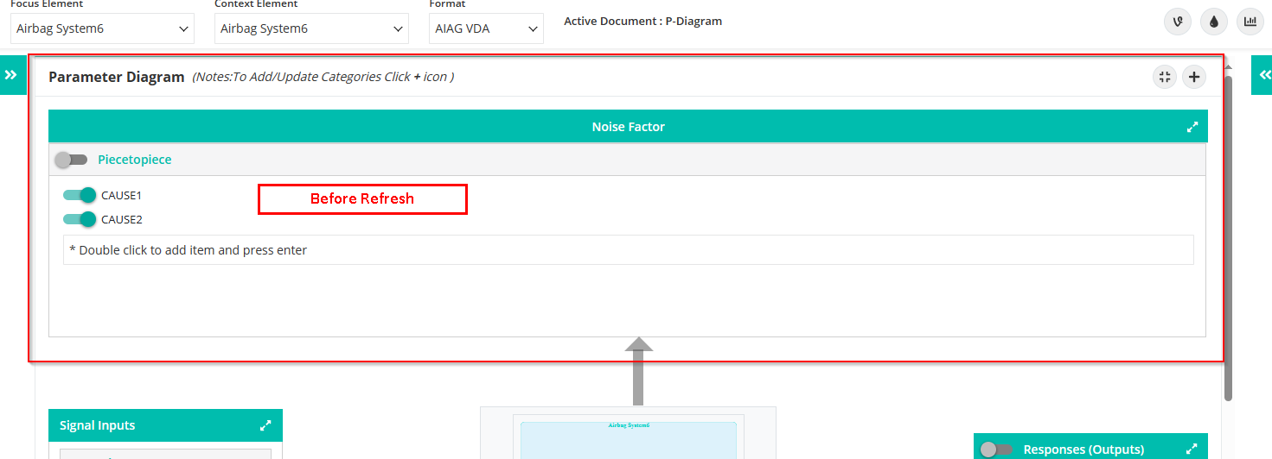

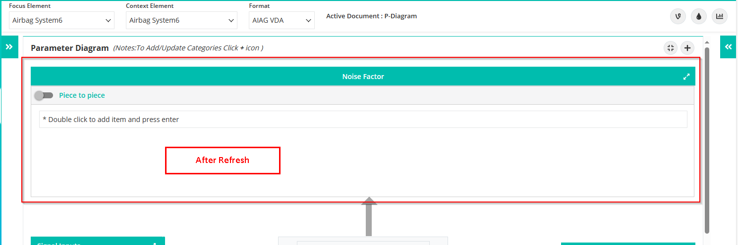

(Added categories refreshed and added subcategories – working fine)

1. While adding the categories hit the Enter key to add the data after refresh all the added categories are duplicated.

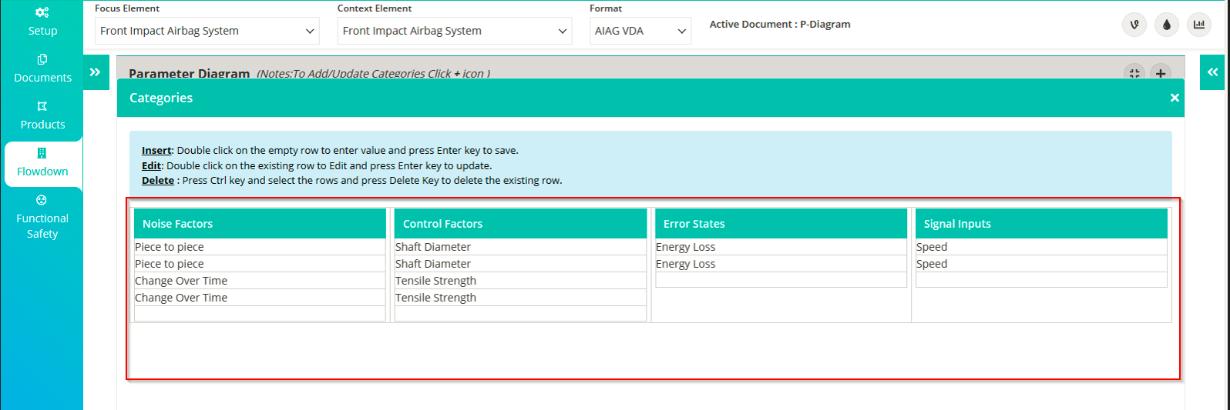

1. The Undefined is showing while adding a new Function in the Response output.

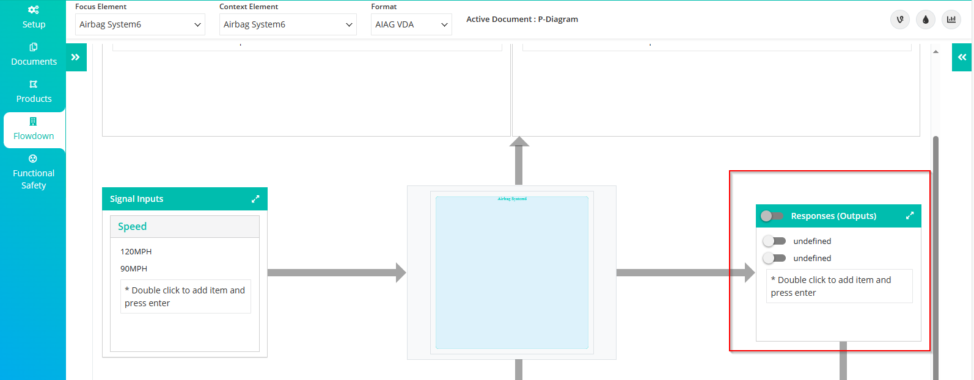

1. Add a new Error state category and before refresh add new and existing Failures, showing Undefined.

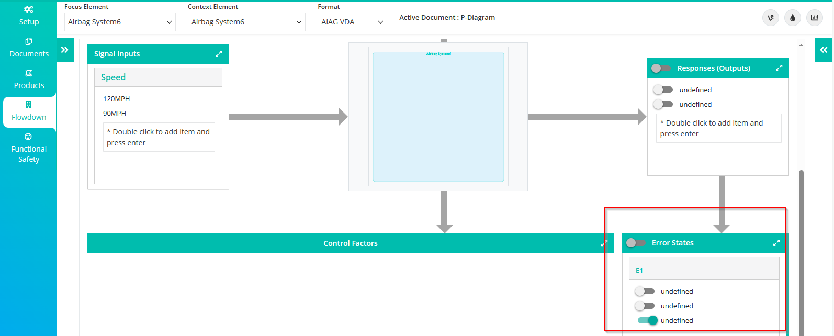

1. Not able to delete the added Signal input subcategories.

