After editing the risk value, then changing the risk value in the edit dropdown popup, and then editing the risk value again, the data is not updated after refreshing; instead, it displays the old data.

**Issue 1: The Edit risk value is not updated in the below scenario**

Step 1: Add a Risk value against cause

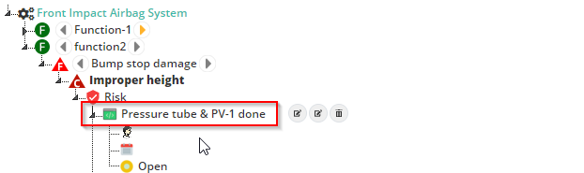

Step 2: Edit the risk value

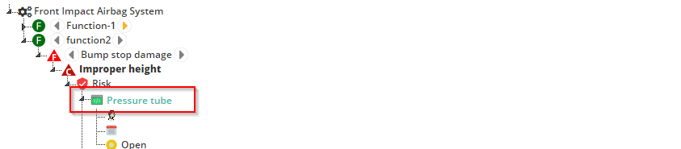

Step 3: changing the risk value in the edit dropdown popup

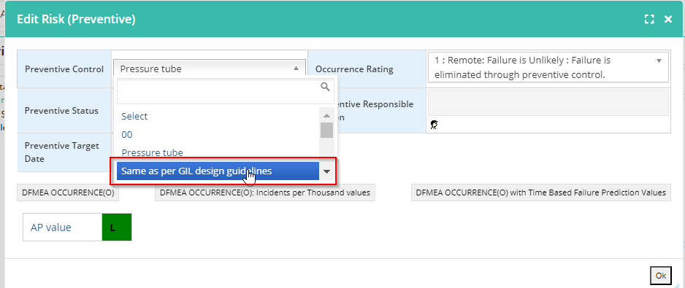

Step 4: then editing the risk value again

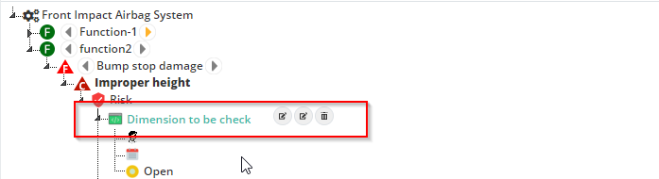

Step 5: data is not updated after refreshing, instead, it displays the old data.

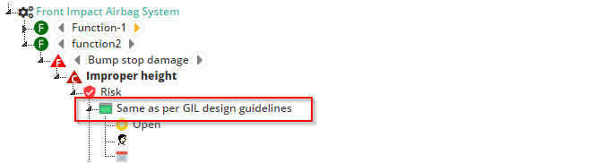

**Issue 2:** When I enter empty data into the Edit Risk text box, it displays undefined.

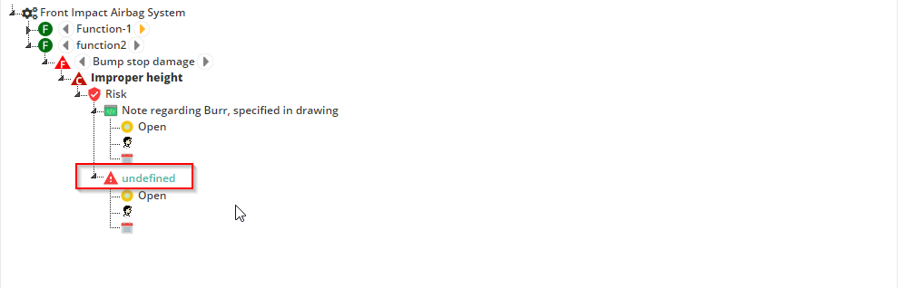

After refreshing, it displays old data