AIAG VDA-Flow up and flow down issues

1. While performing flow down, without expanding nodes, the system displayed an incorrect alert message. - not fixed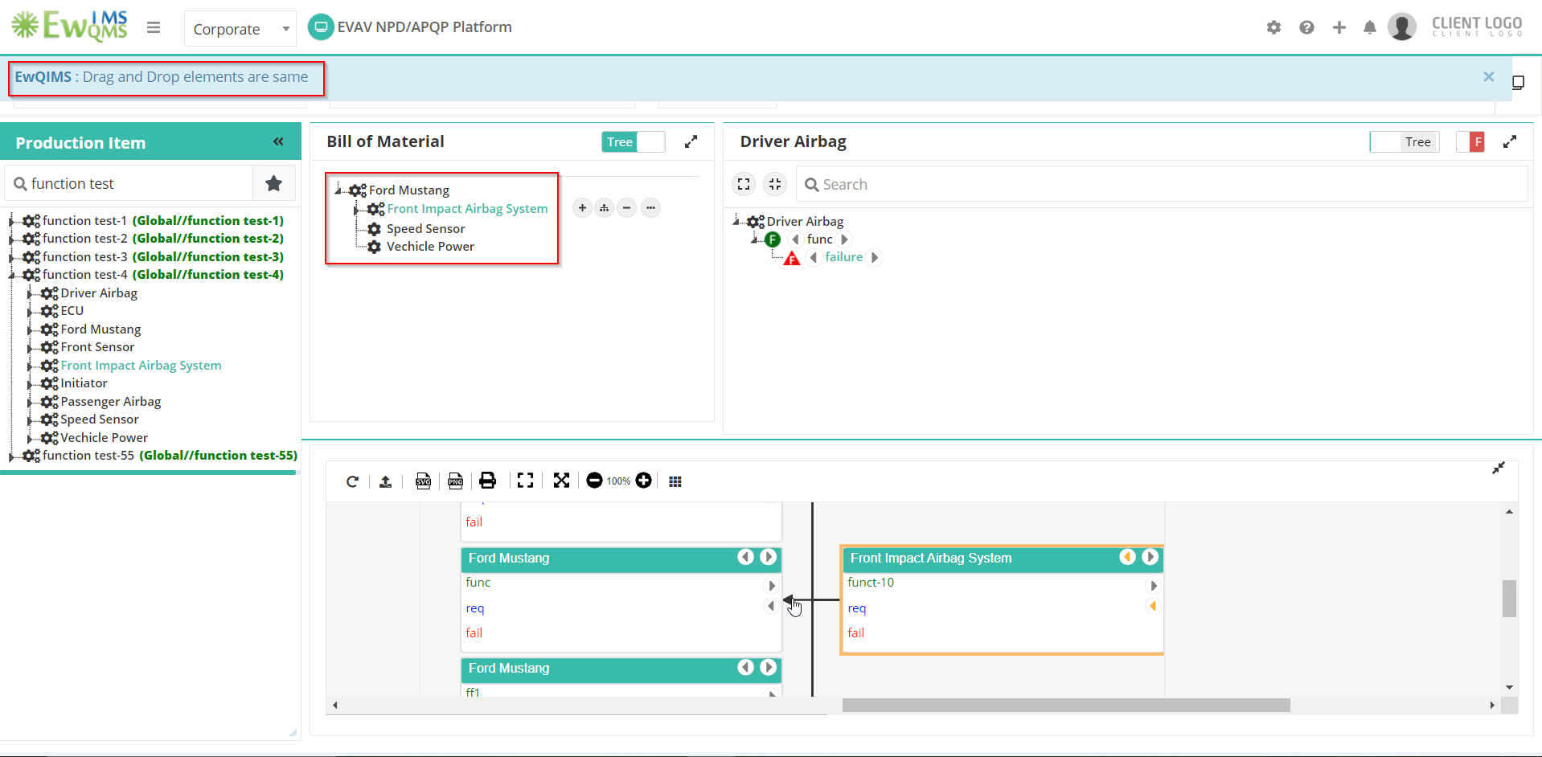
2. Alignment for the diagrammatic view is not in the middle.

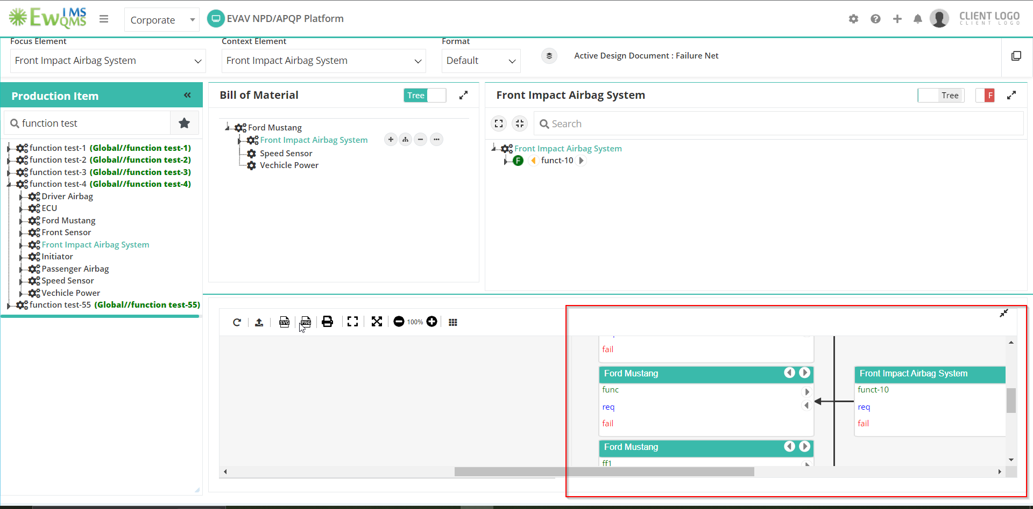

1. While adding Failure directly, it is displayed in Function level

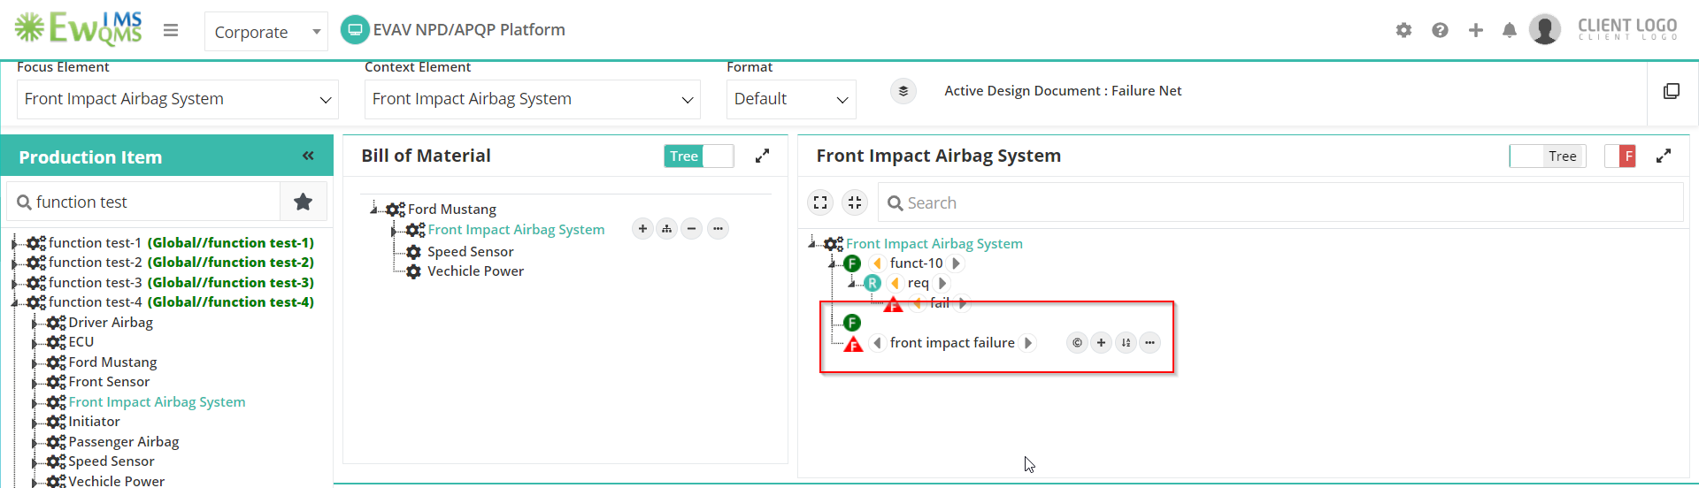

1. Failure flow up/down duplication

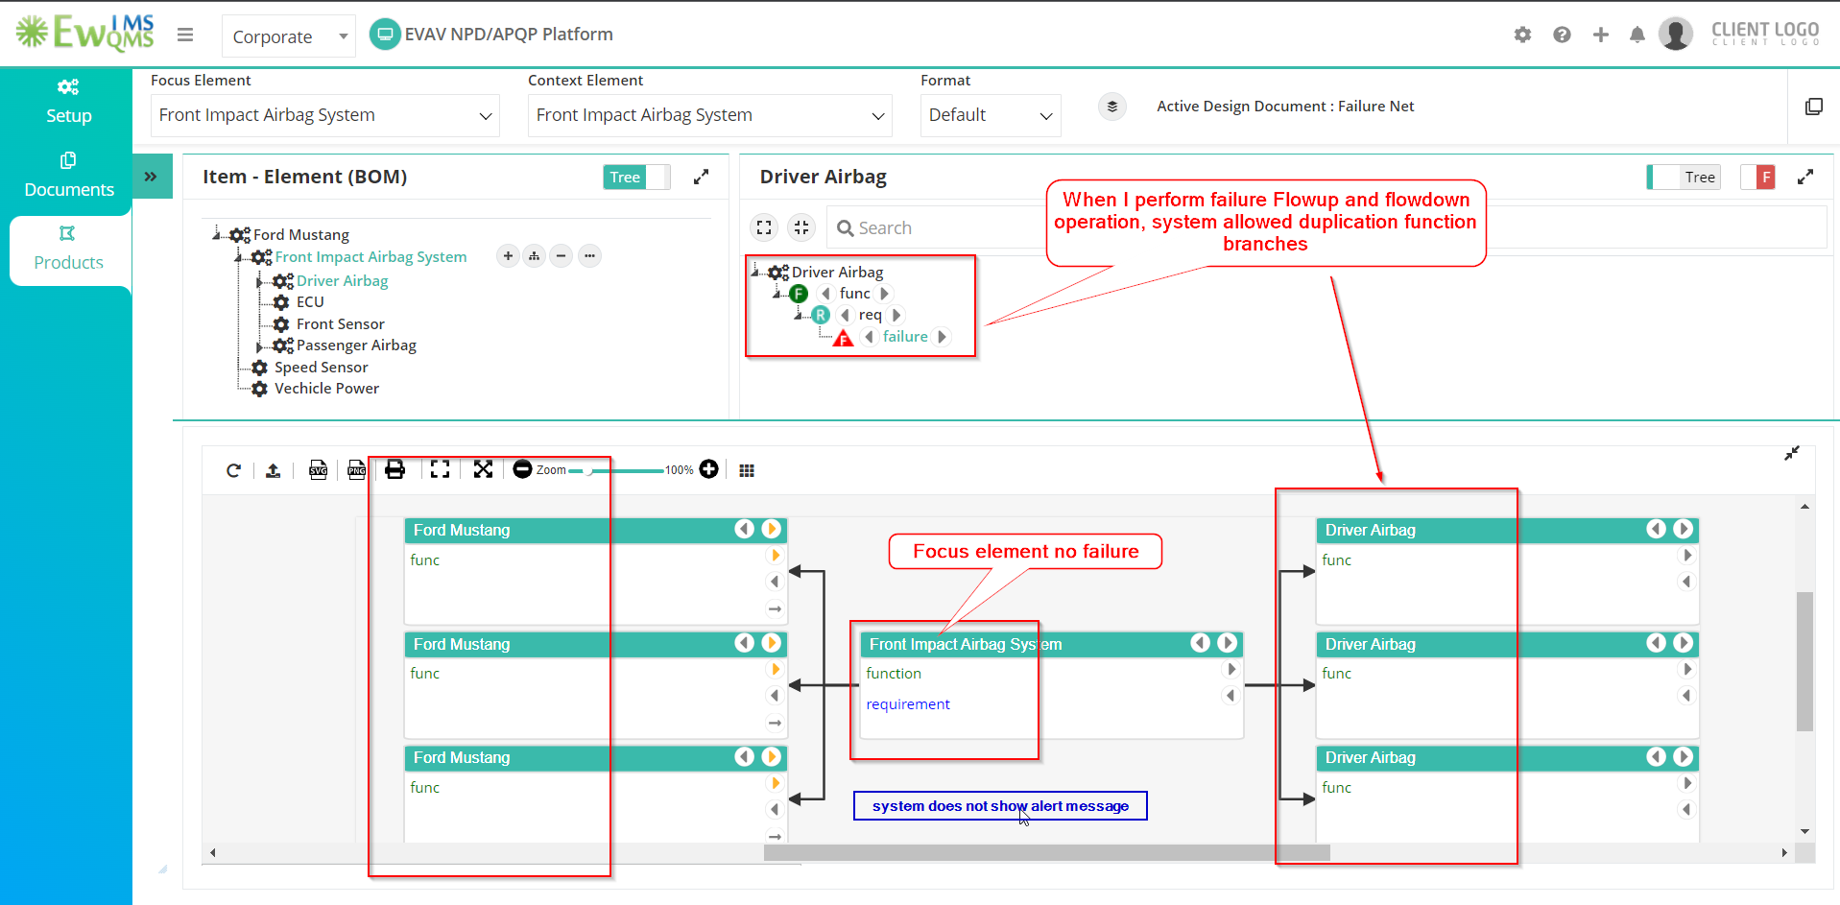

1. Diagrammatic view-Flow up function hide icon displayed, when click hide icon diagrammatic view branches displaced 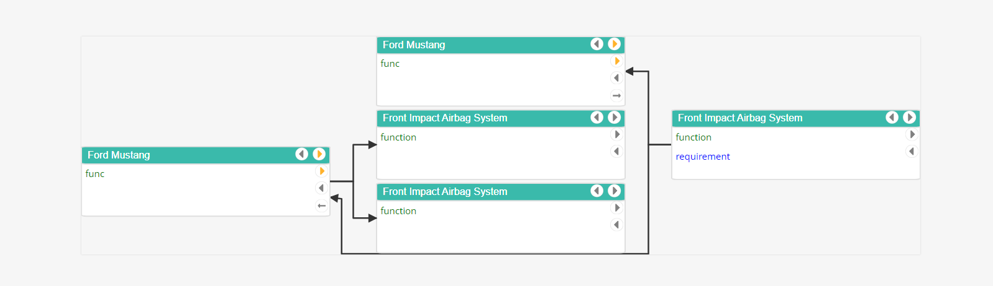
2. When the number lock is enabled on the keyboard, Edit function, Requirement, and failure in diagrammatic view, the text box duplicates. Then close the window, select another option, and the system freezes. 