Parker Chineese lang issues- THL

1. Session Alert popup

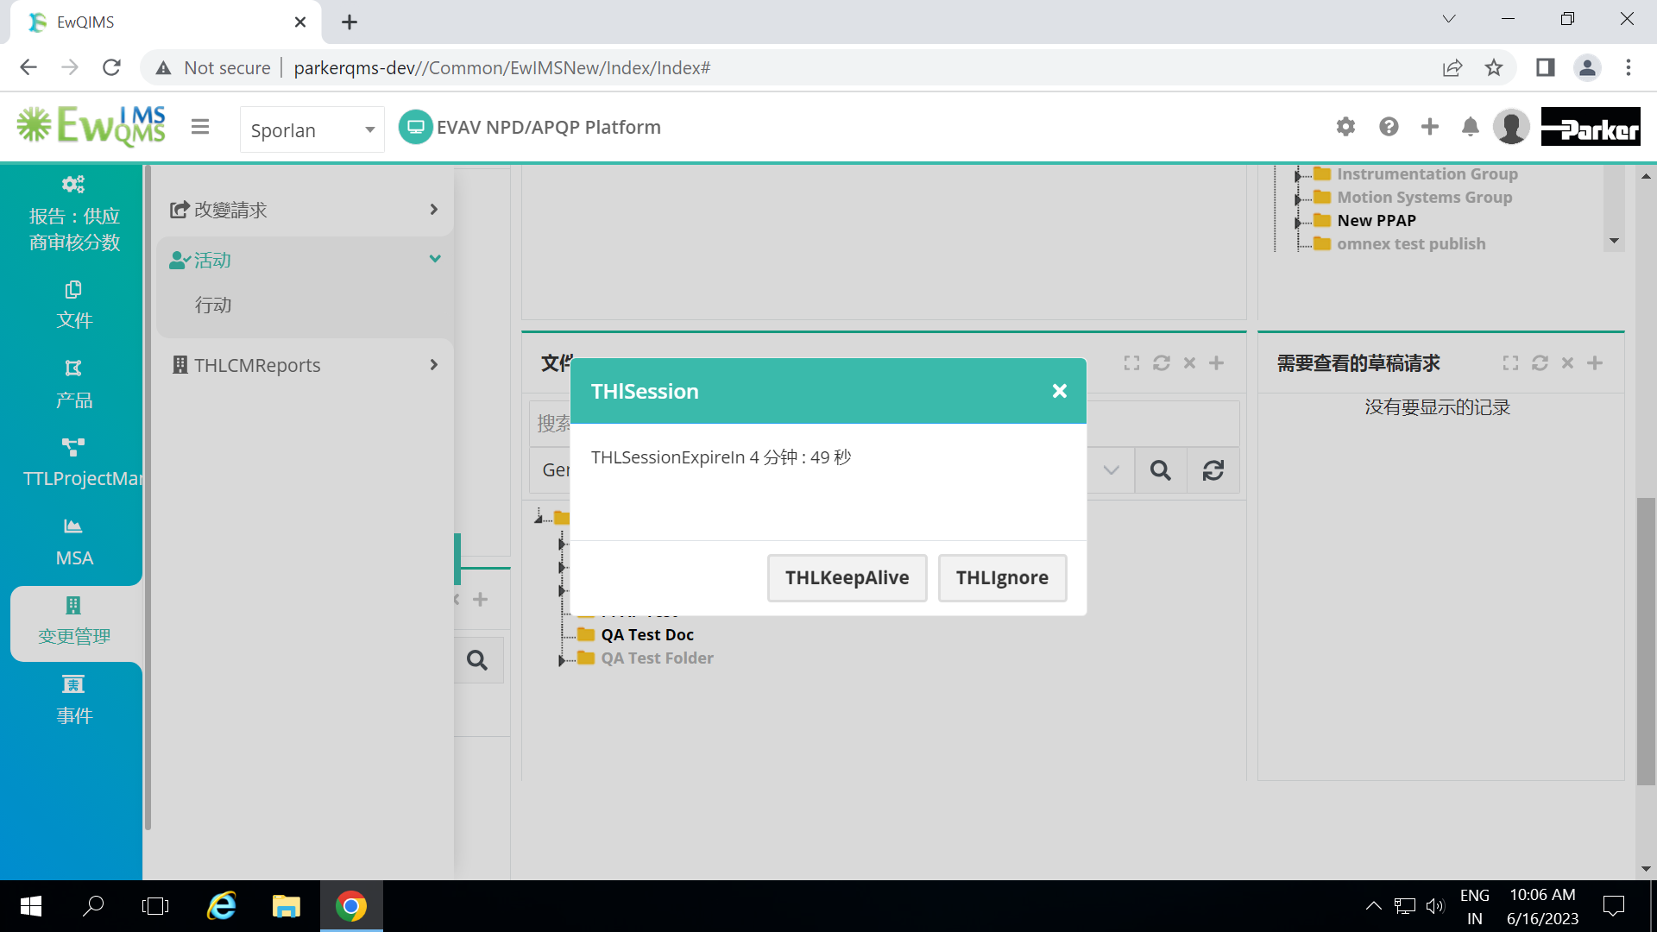

1. APQP- Gantt page Right Click, Buffer icon text

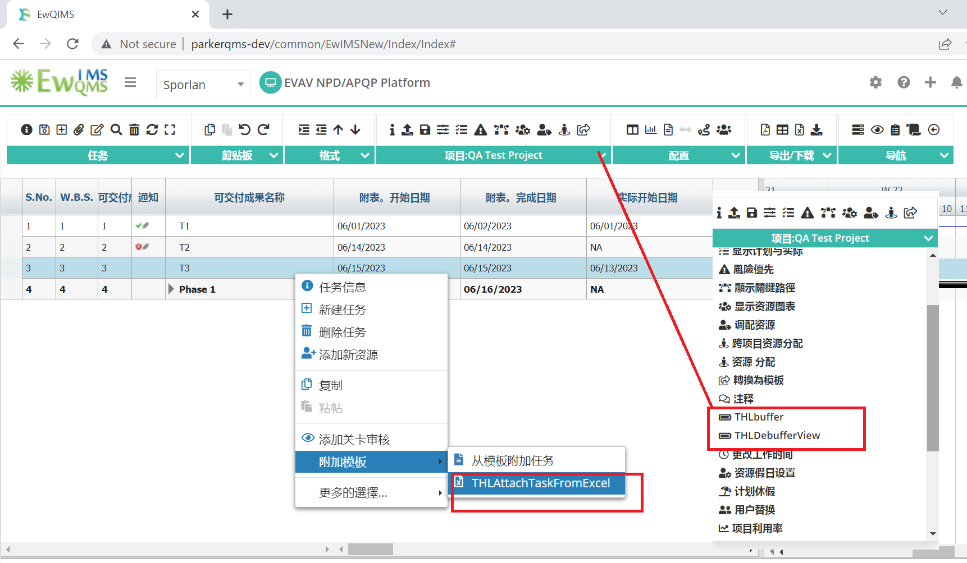

1. Gantt Column headers, Configuration task name

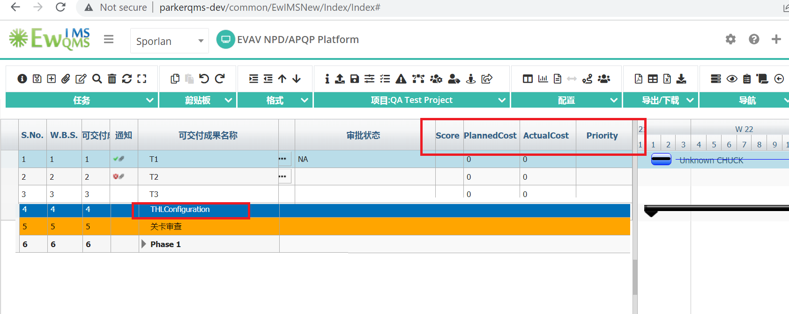

1. Download documents option popup -> Right click-> Attach Documents – Not converted

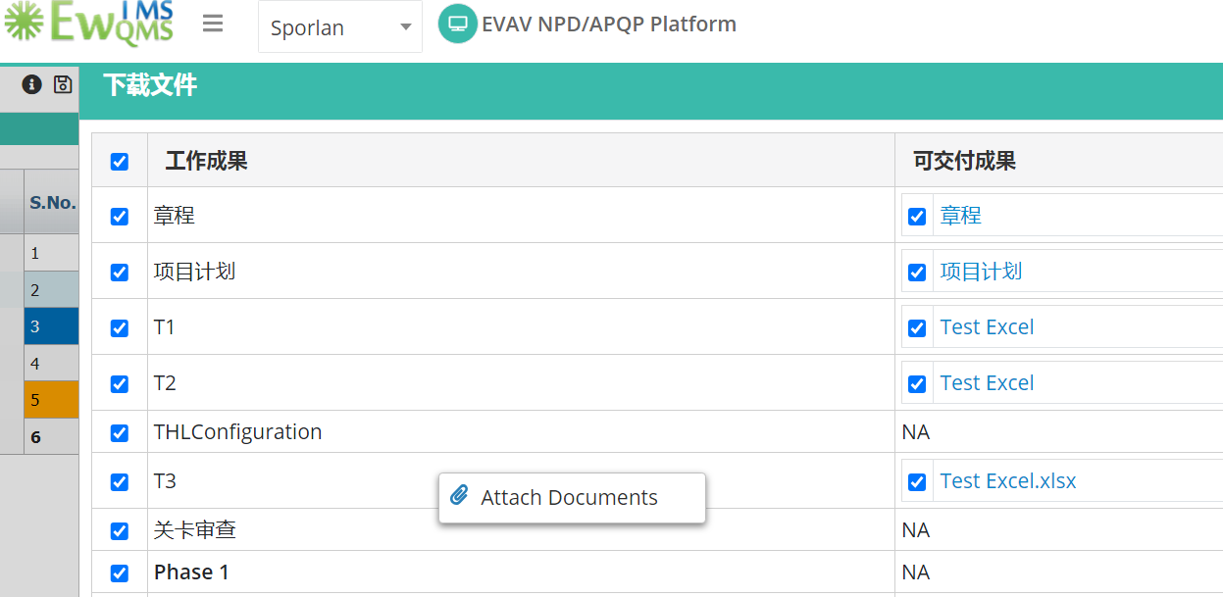

1. Review Page Search column( Project listing-> Select Project-> Click on review)

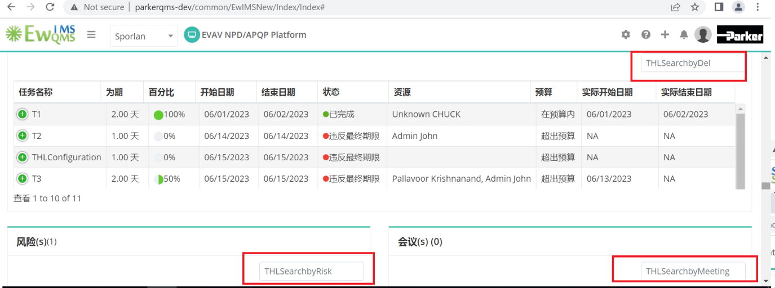

1. Project Set-up->Task Rating menu

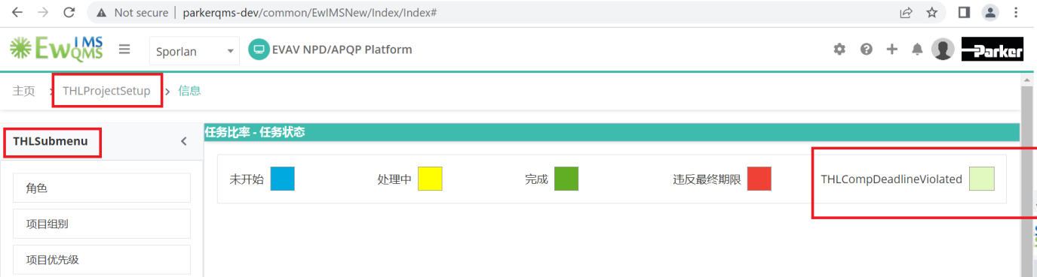

1. Suite-> main menus

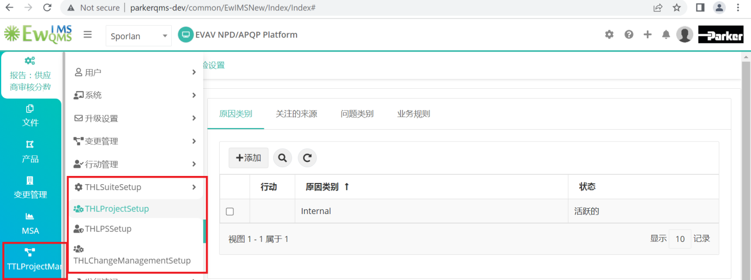

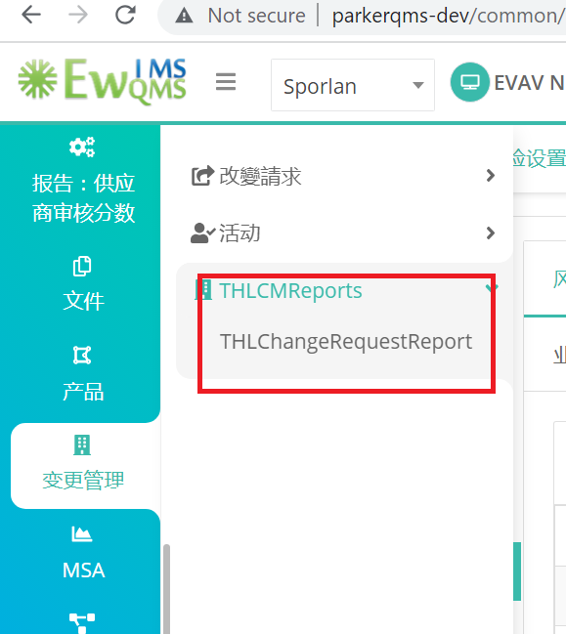

1. Business Rule > Configure tab

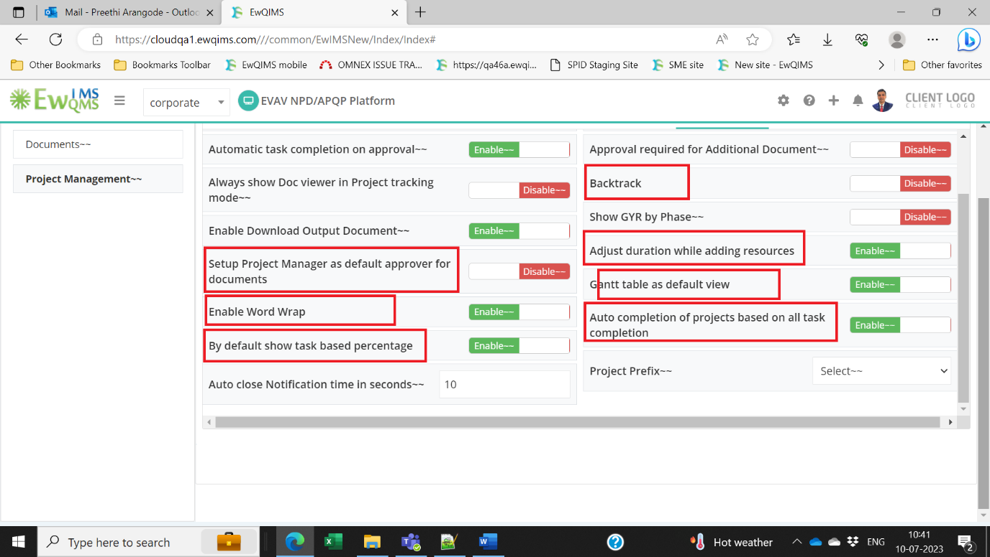

1. Business Rule > Gantt column configuration All Pillars text

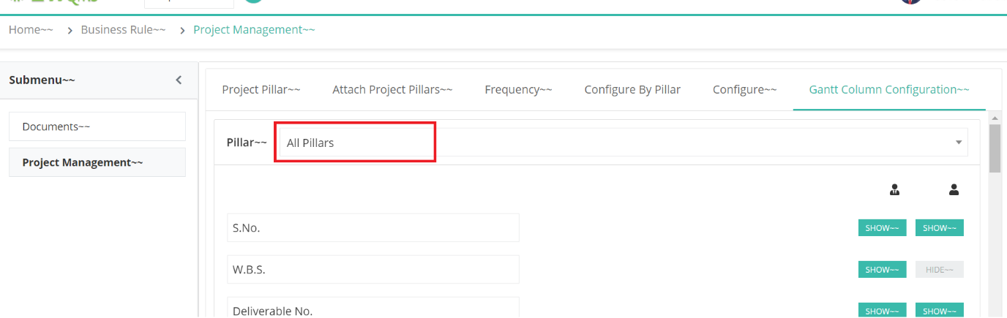

1. Project plan page Documents Needing Approval menu, Popup heading and tool tip too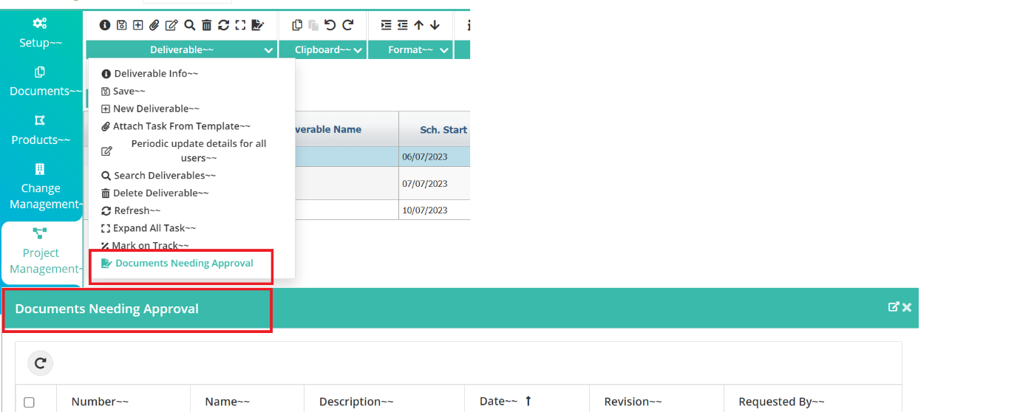
2. RASIC Popup including popup heading, content and Button copy from other project

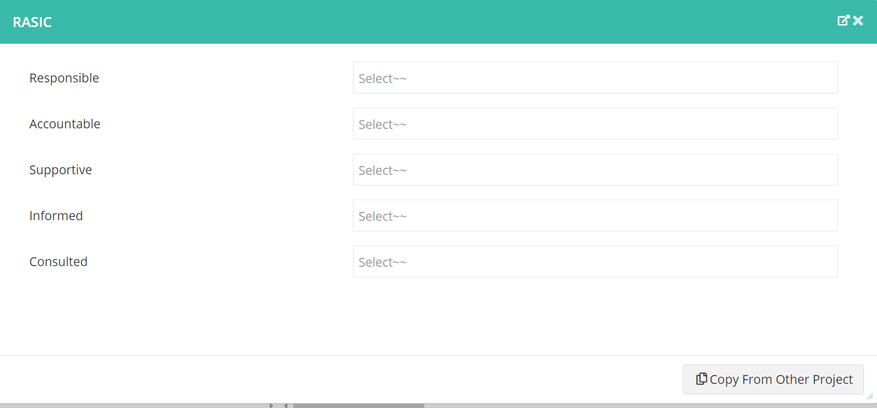

1. New menu items and tool tips also

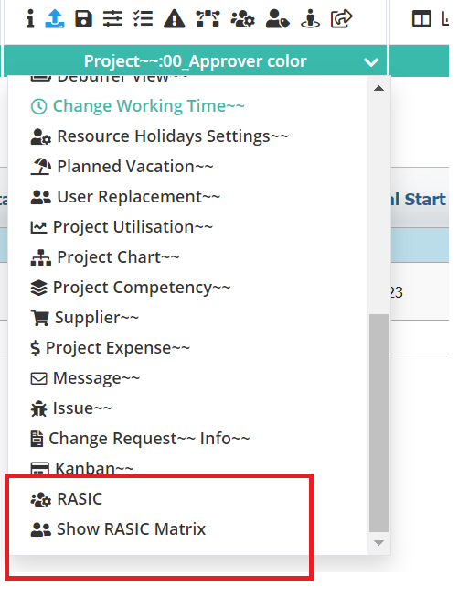

1. Show RASIC Matrix content and popup heading

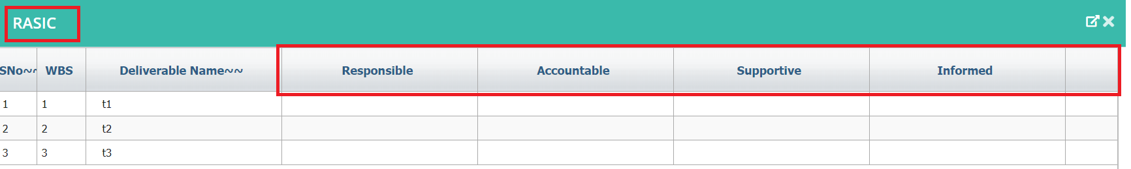

1. Switch Gantt View menu item and tool tip also

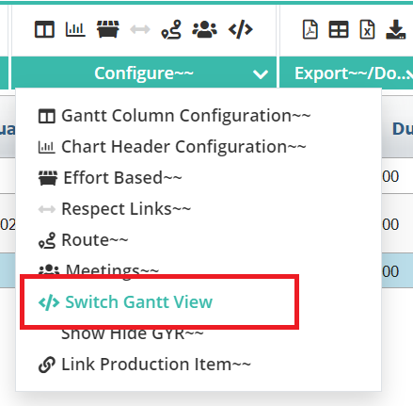

1. Convert to template/project menu item and tool tip also

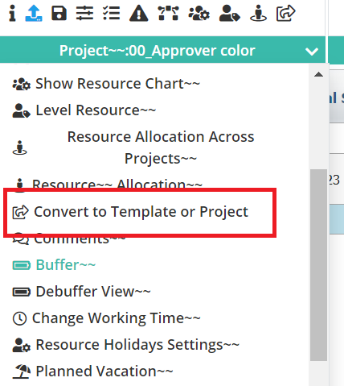

1. Approval status in Gantt page

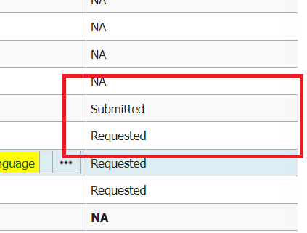

1. While saving Template and Checklist page alert message without ~~ is showing

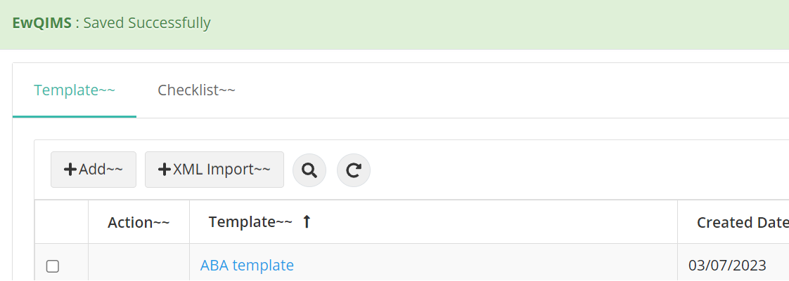

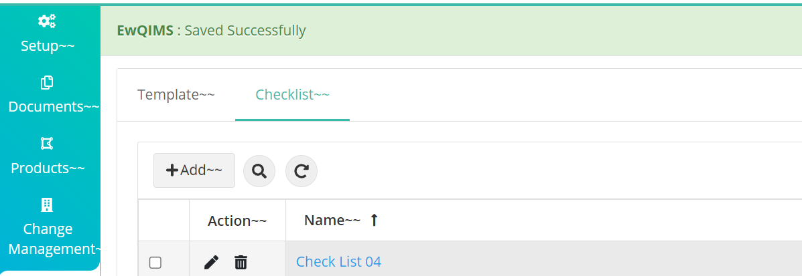

1. Deleting Template alert showing without ~~

