1. Structure Analysis – Save as SVG and PNG is not converted.

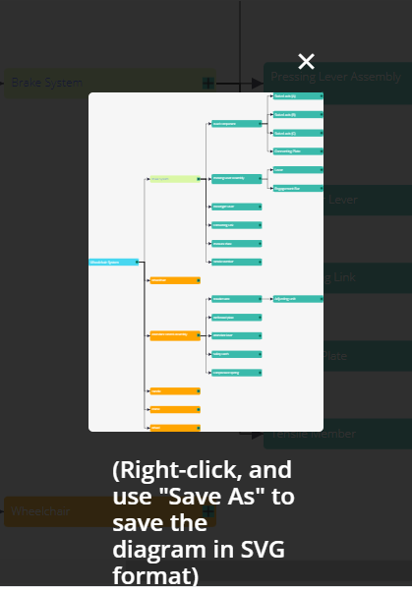

1. Color Legend for Structure Analysis is not converted.

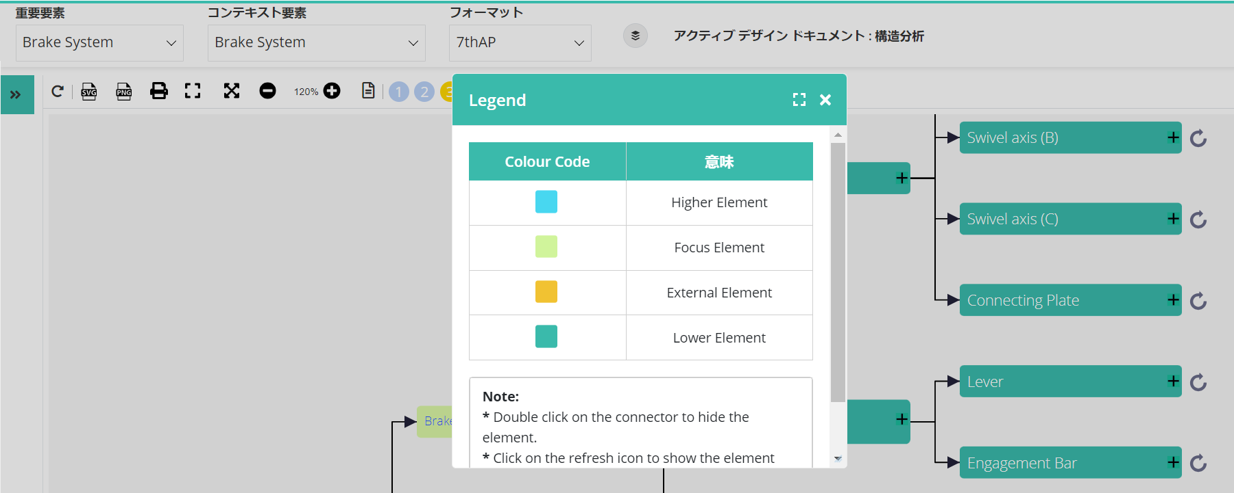

1. Create Production Item popup is not converted partially.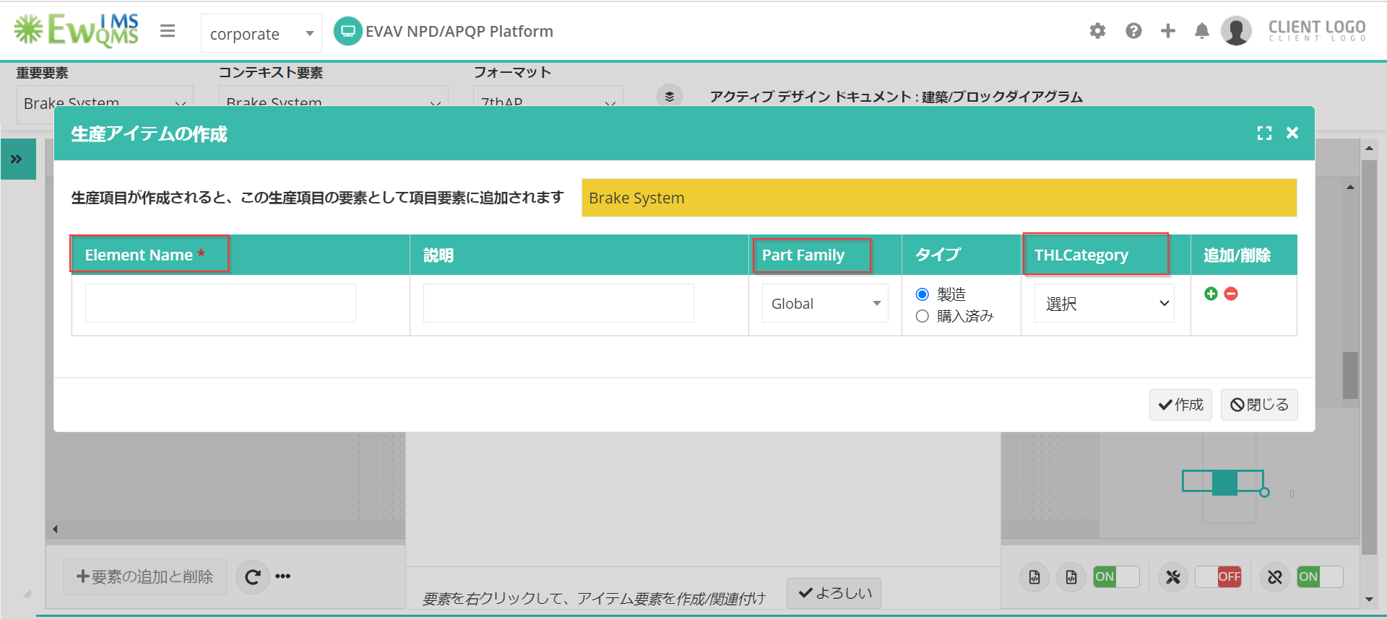
2. PI search is not working in PI tree.

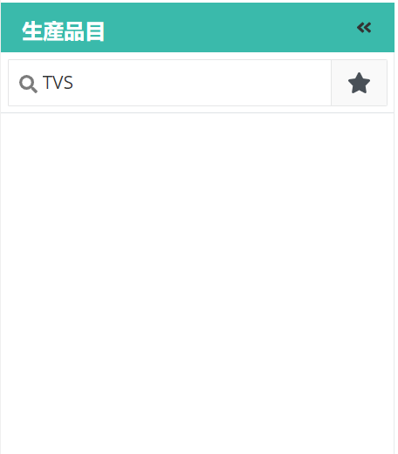

1. P- Diagram

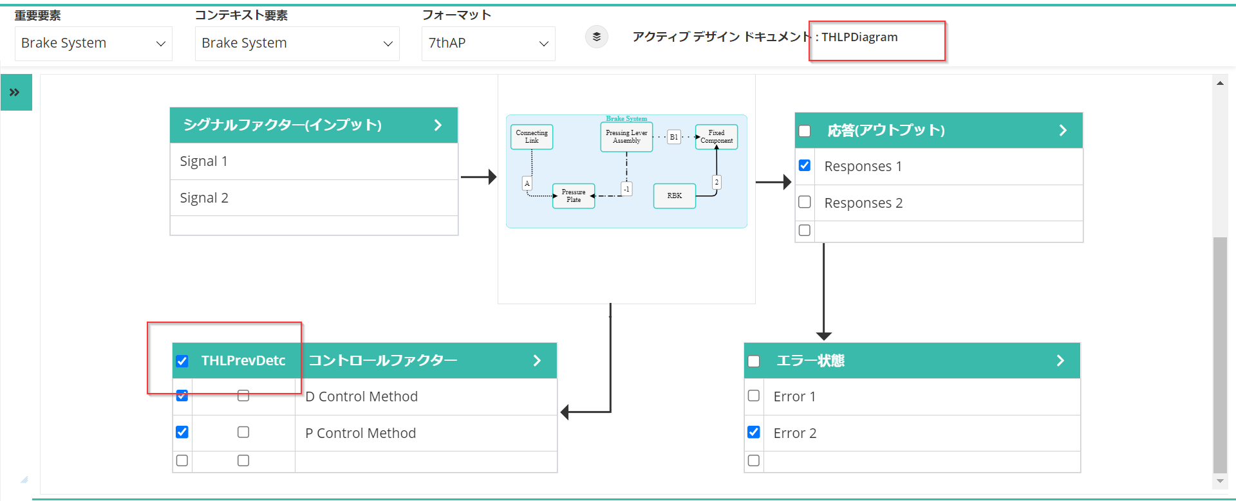

1. Add Function/Requirement/Failure options in Functional/Failure Analysis.

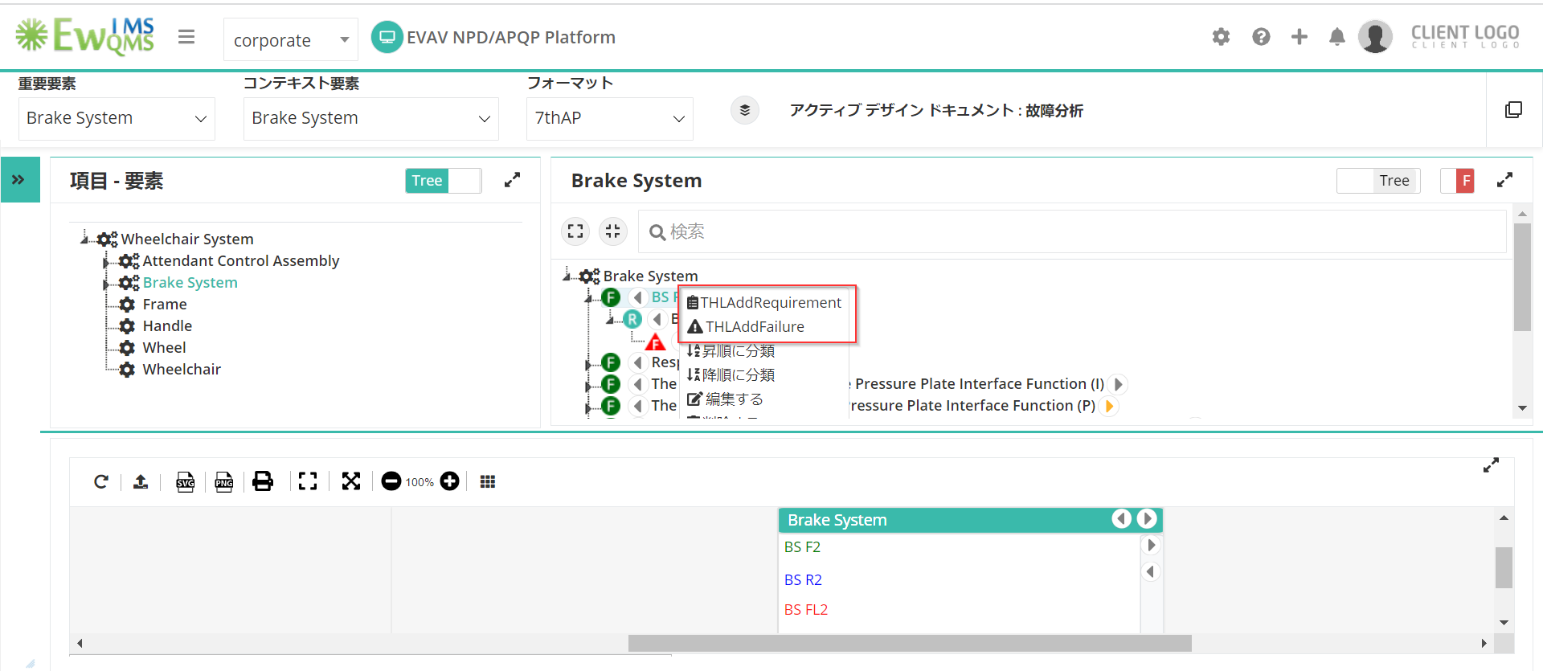

1. Header and Notes in Add Function/Requirement/Failure popup is not converted.

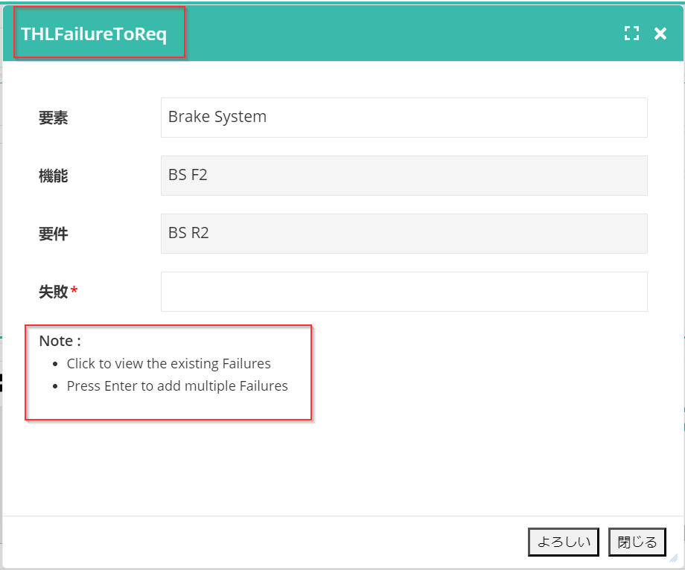

1. Session expires message.

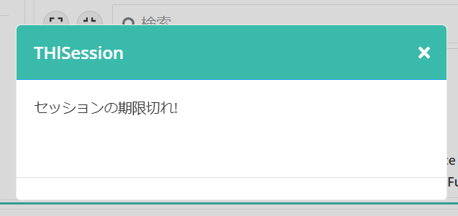

1. Edit Function/Edit Requirement in diagrammatic view.

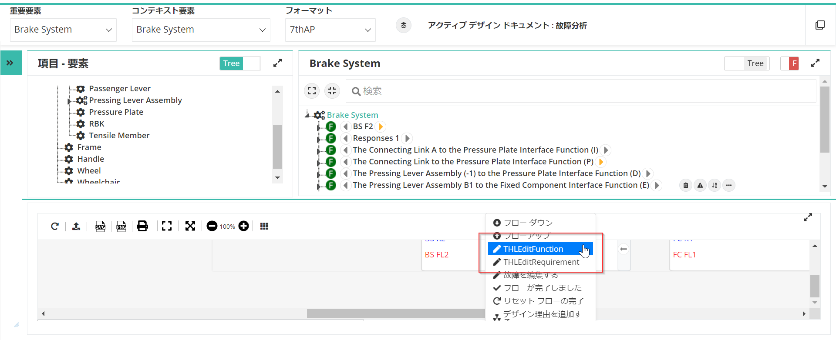

1. All 3 call out tables in Risk and Optimization popup.

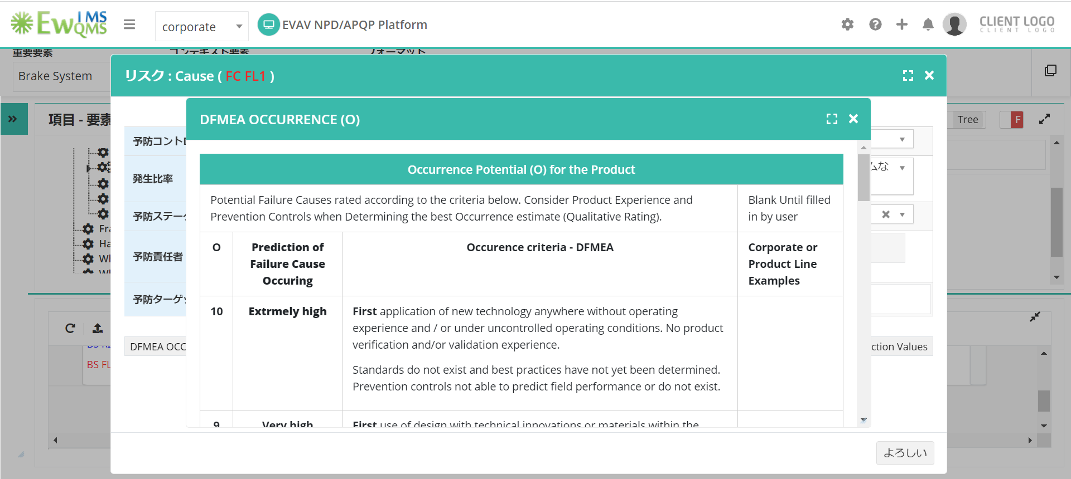

1. Clear option in Calendar.

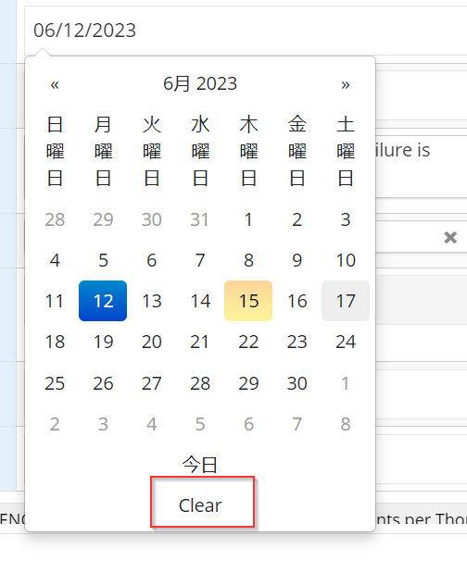

1. Added optimization is not displayed in Design VDA.
2. IFM search field

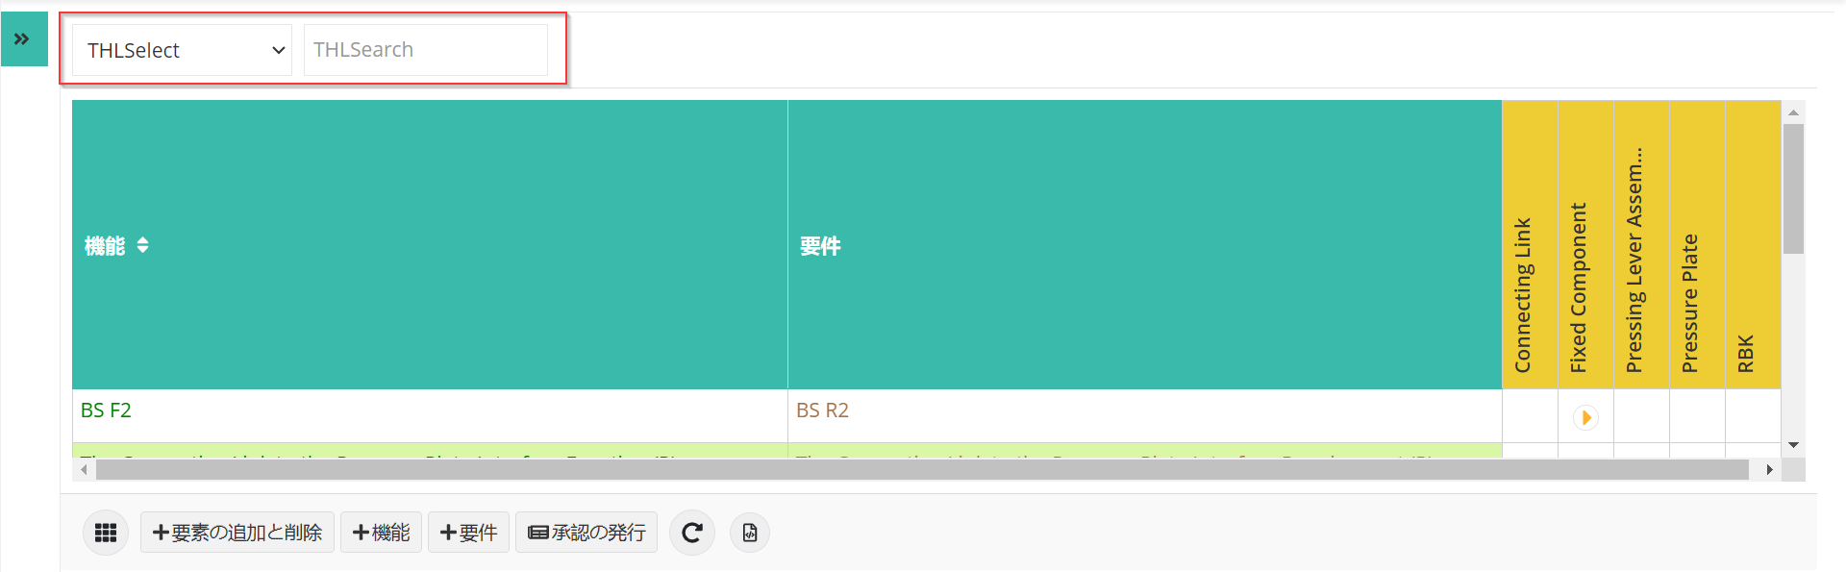

1. IFM – Risk legend.

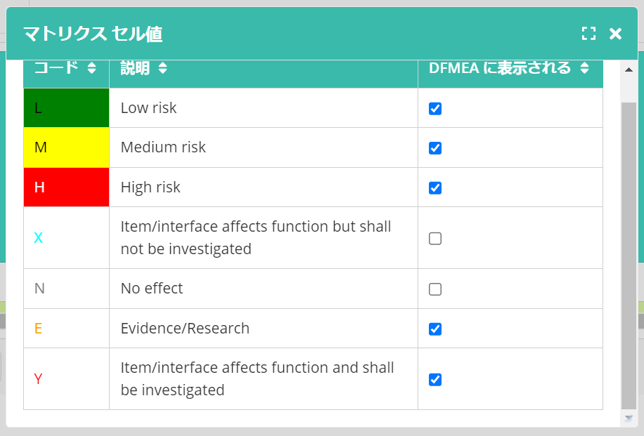

1. IFM – Color code legend

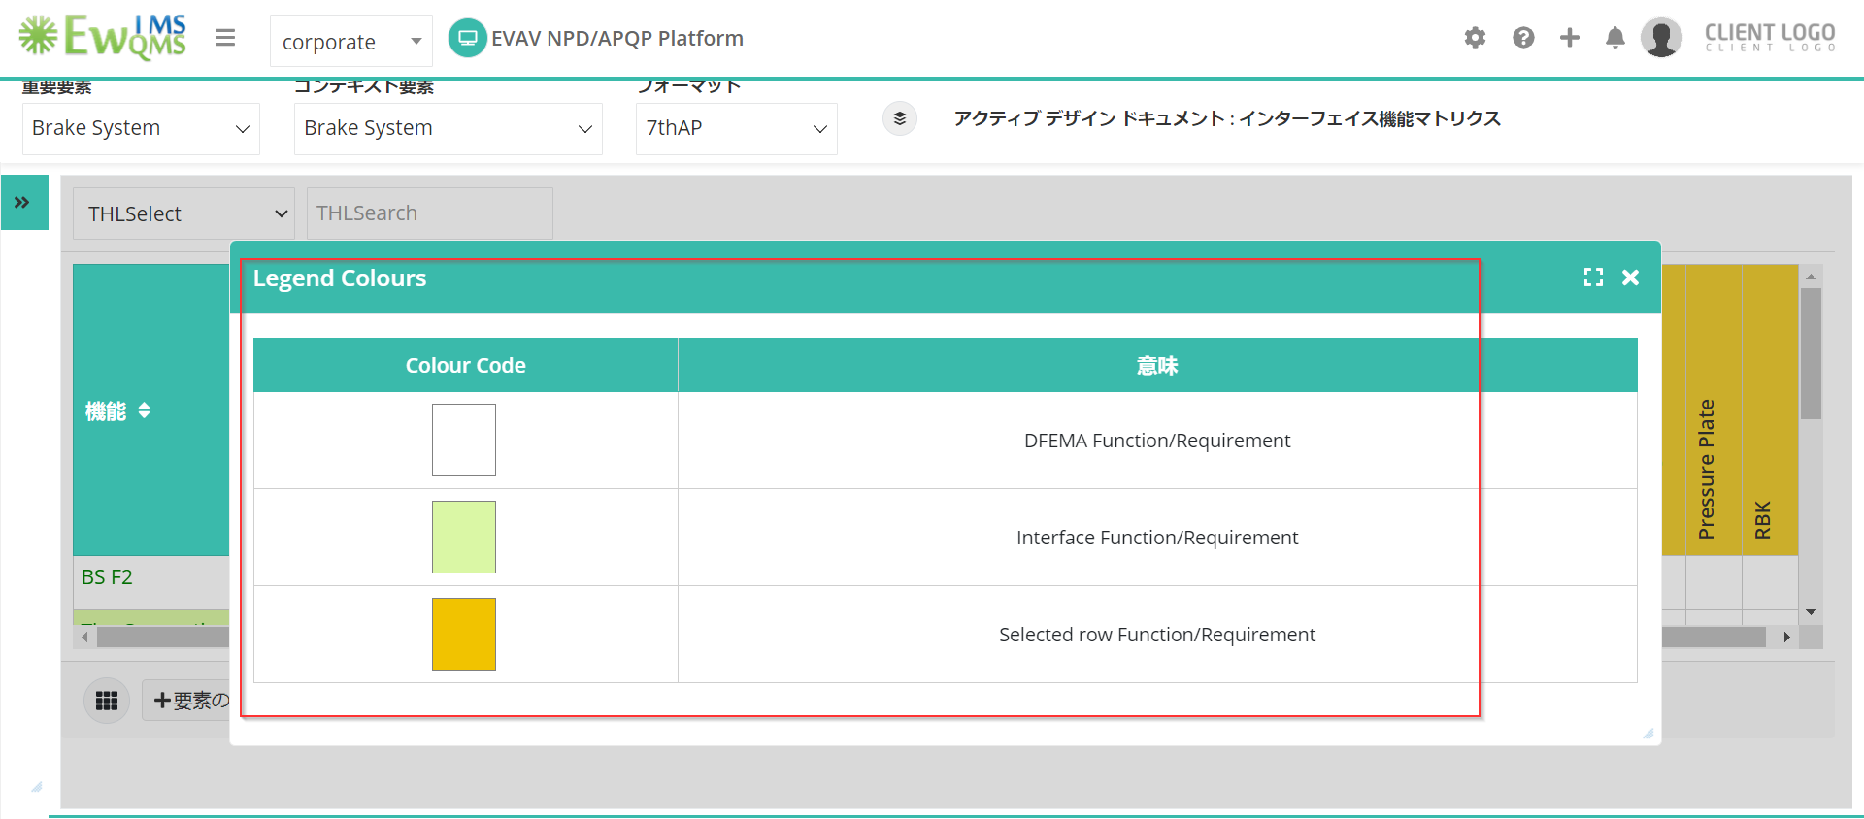

1. IFM –Functions/Requirements master table search option.

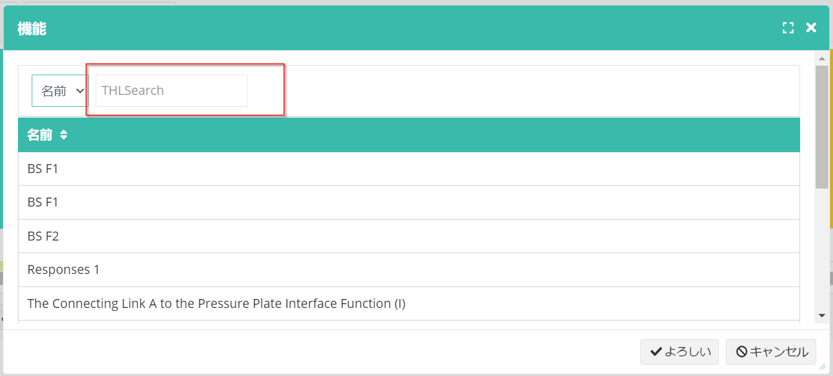

1. IFM - Add Requirement branch.

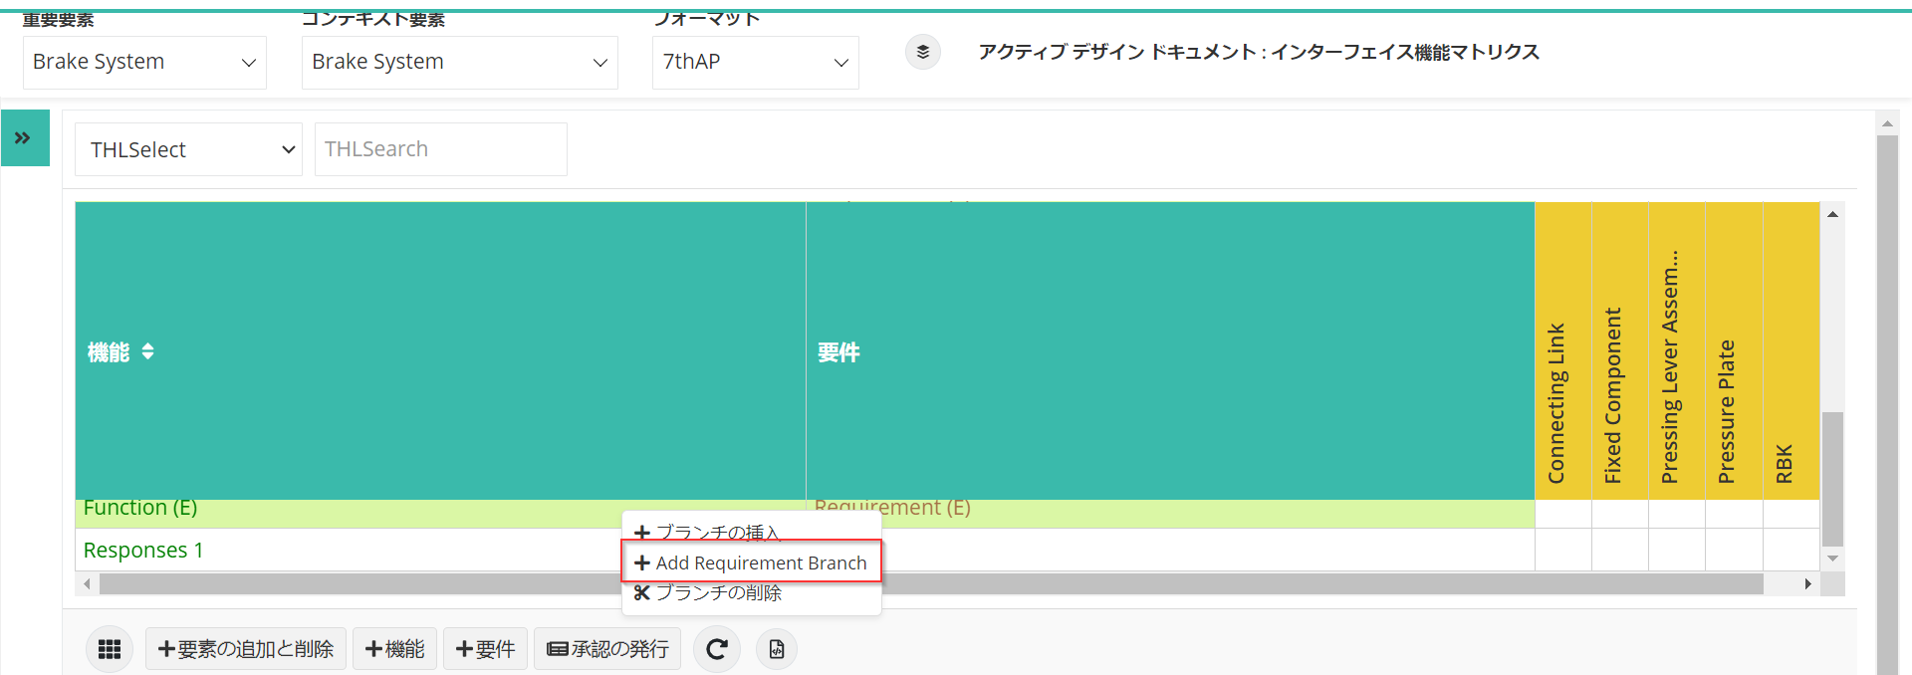

1. Risk allocation popup.

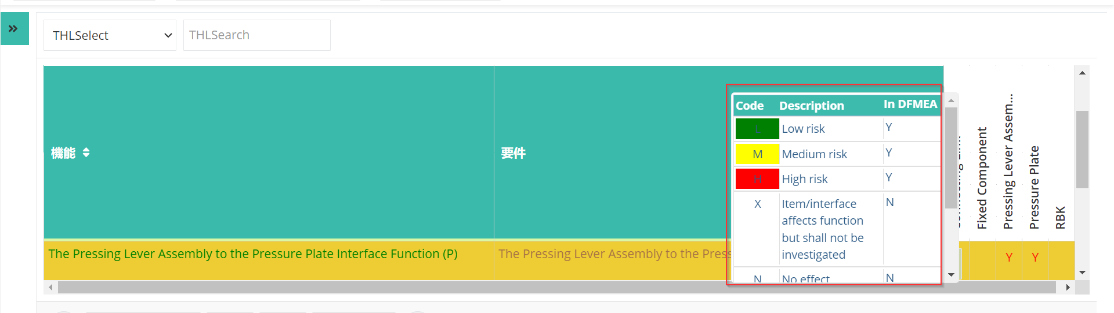

1. Interface Matrix – Legend

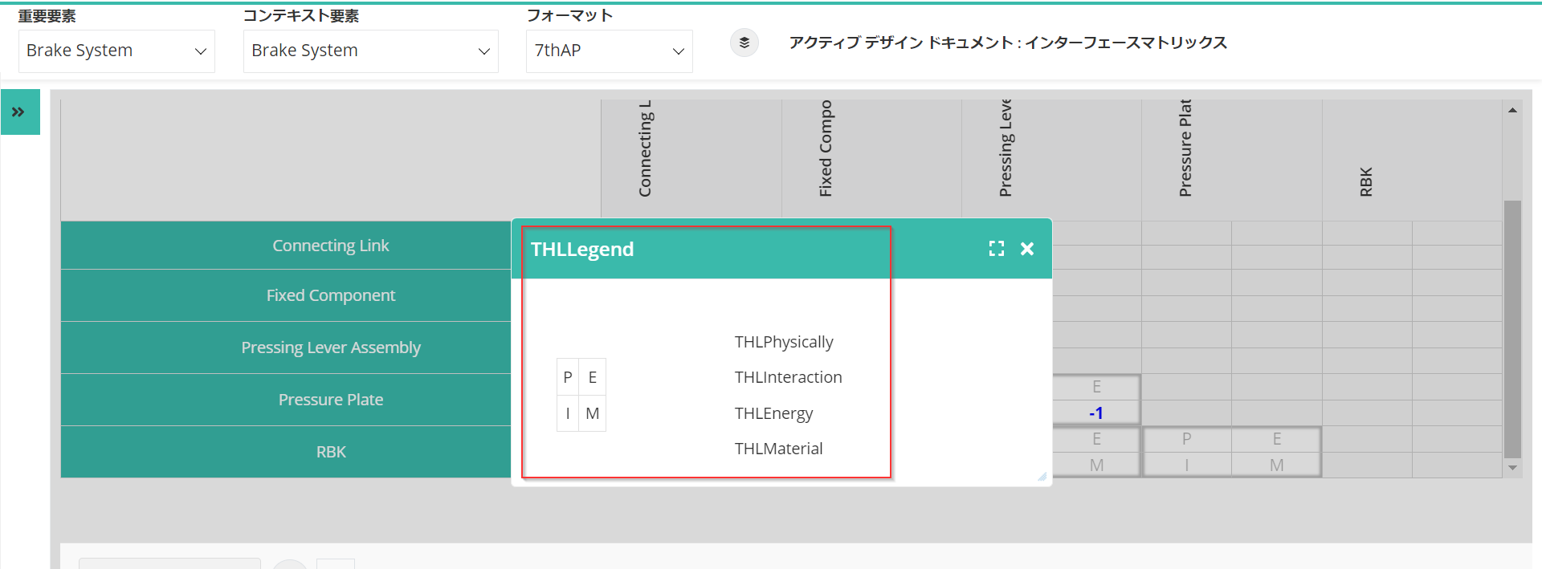

1. Alert message before selecting a PI.

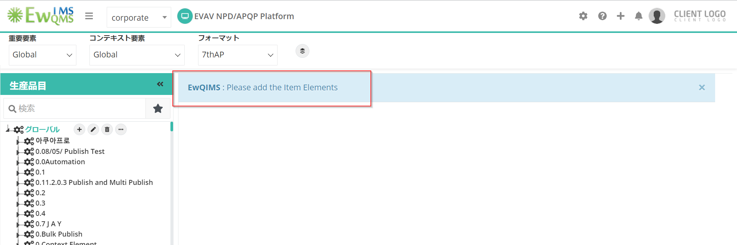

1. Select dropdown in Assign Severity rating popup.

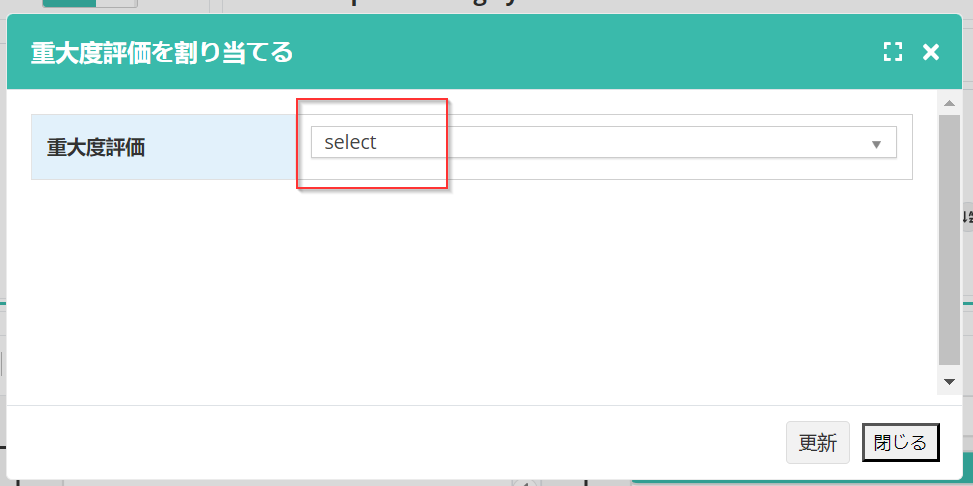

1. MSR DFMEA is not converted.

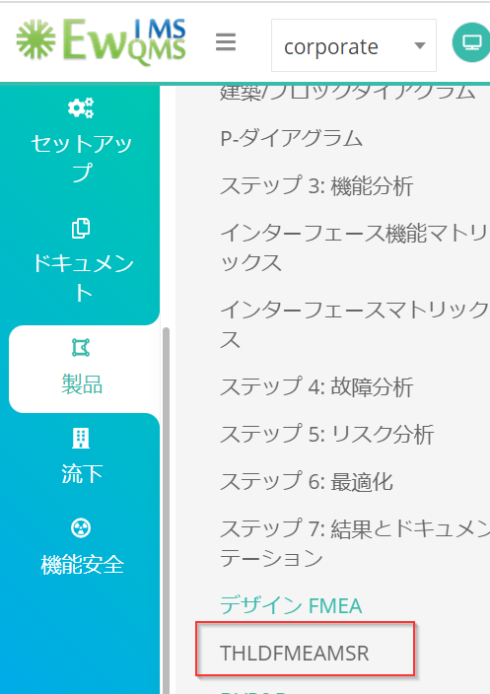

1. Complete step 7- Results & Documentation is not converted.

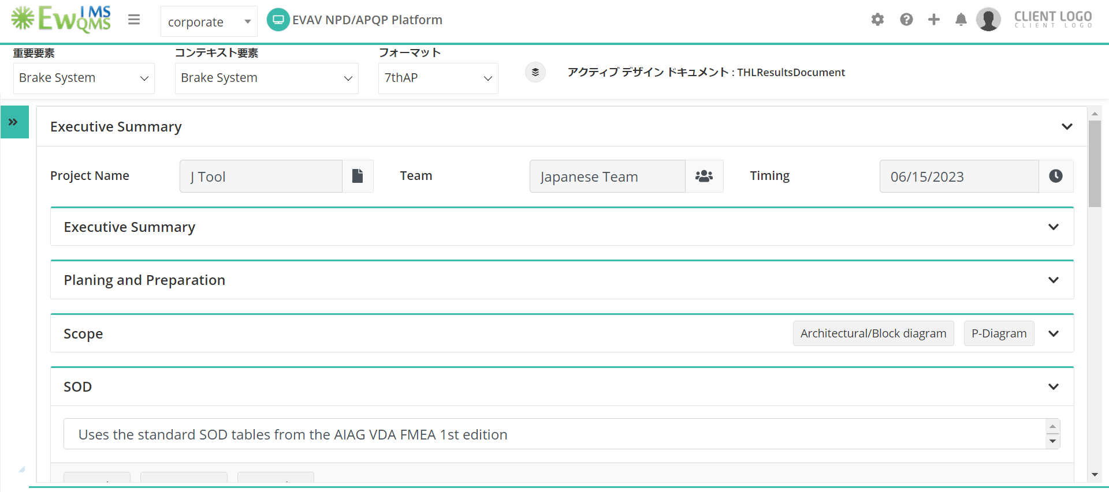

1. Percentage Allocation

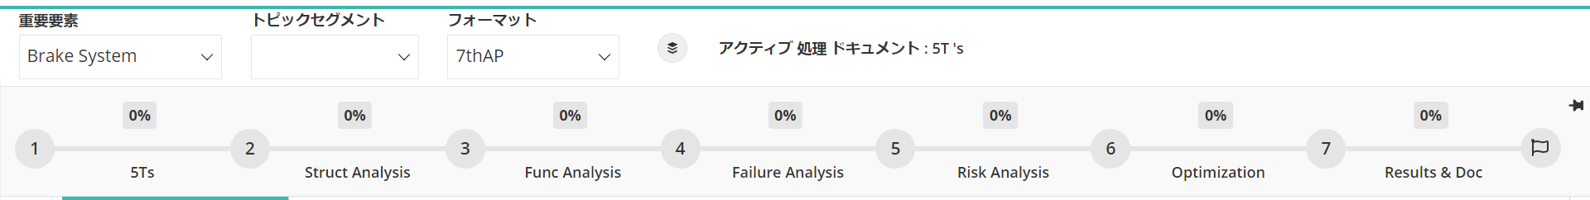

**Process VDA:**

1. Create Operation, Create Operation Category and create 4M category popup

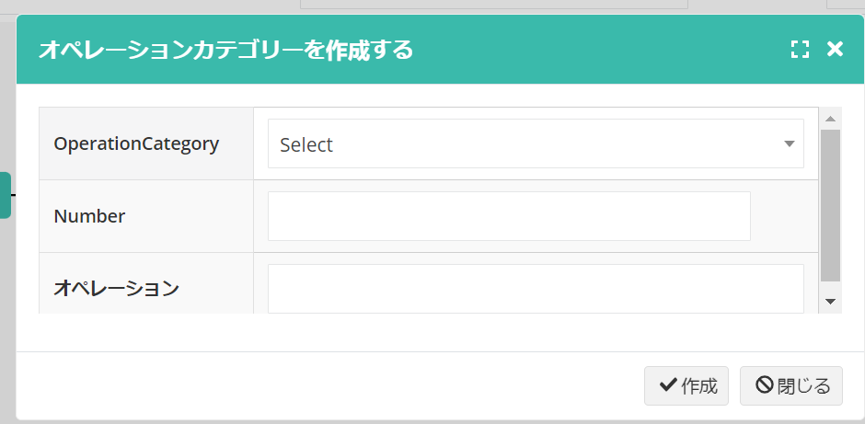

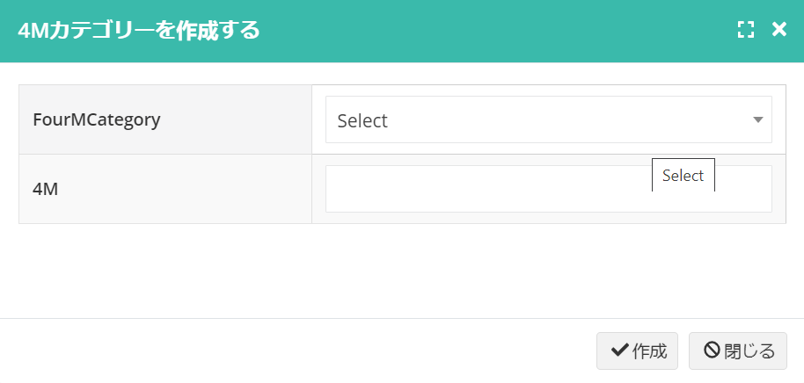

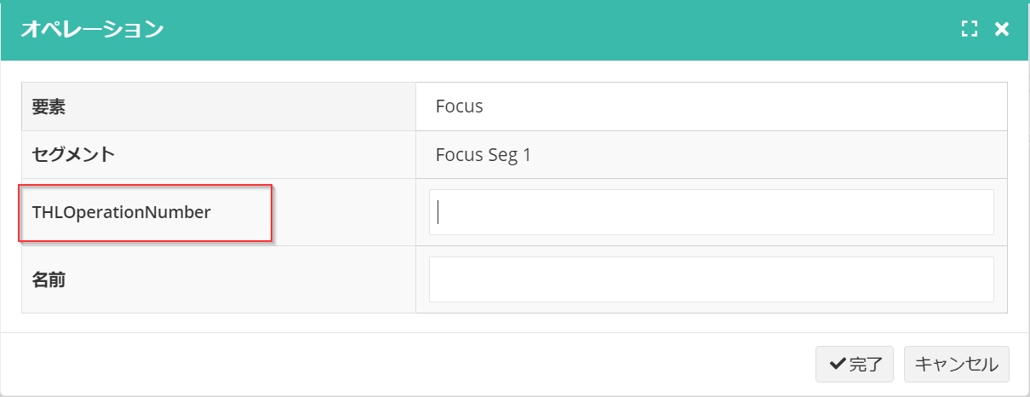

1. Save as SVG and PNG options are not converted.

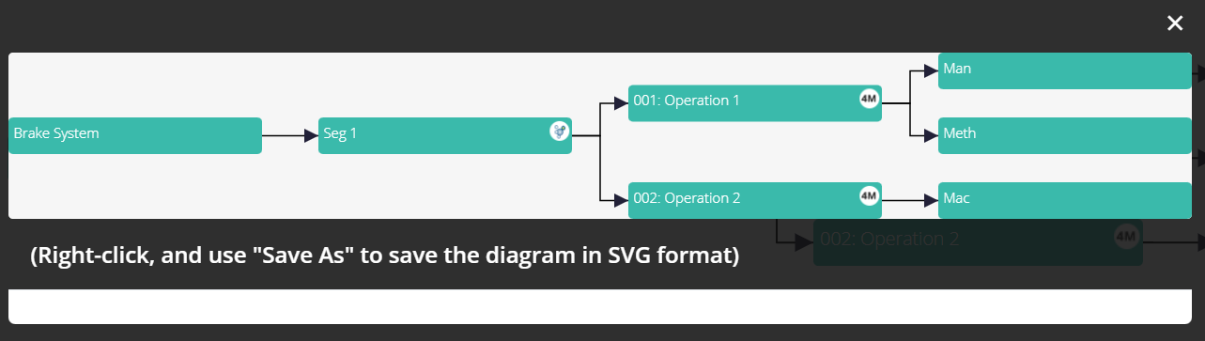

1. Operation and 4M category dropdown select option.

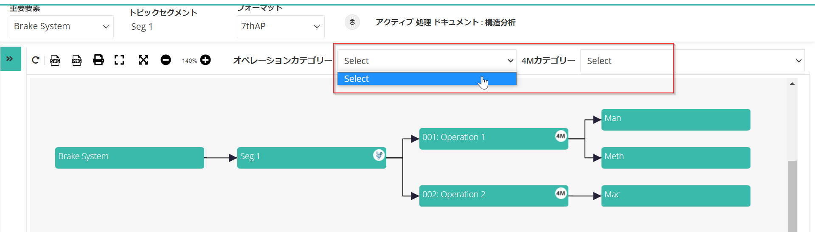

1. Process Flow Diagram
2. RHS view: Change Characteristics option in context menu.

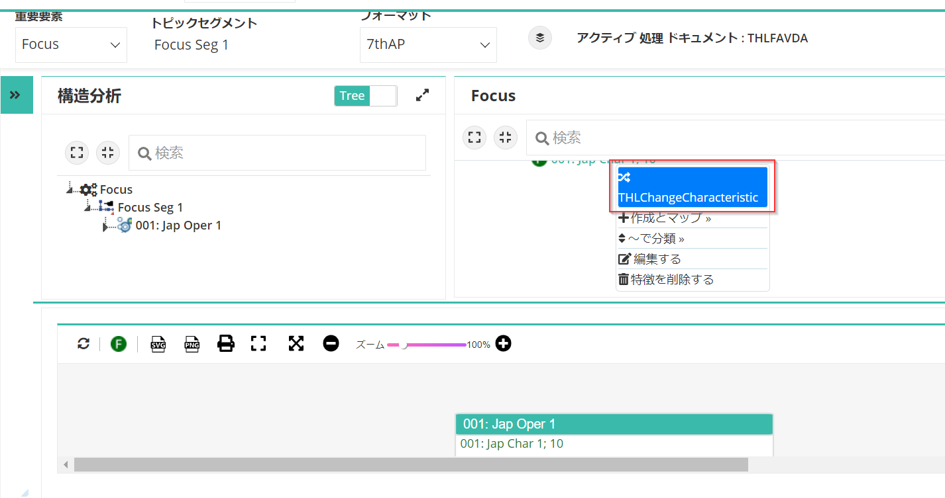

1. Map 4M option in context menu.

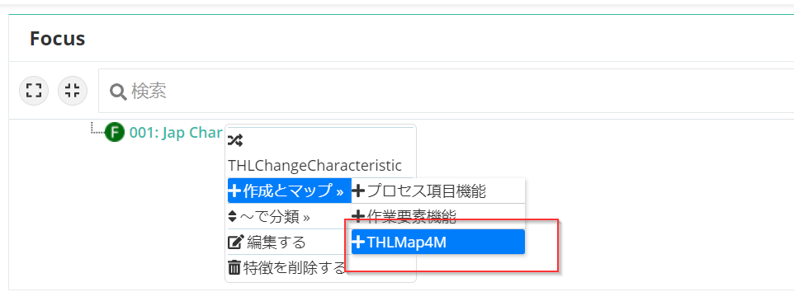

1. Results & Documentation

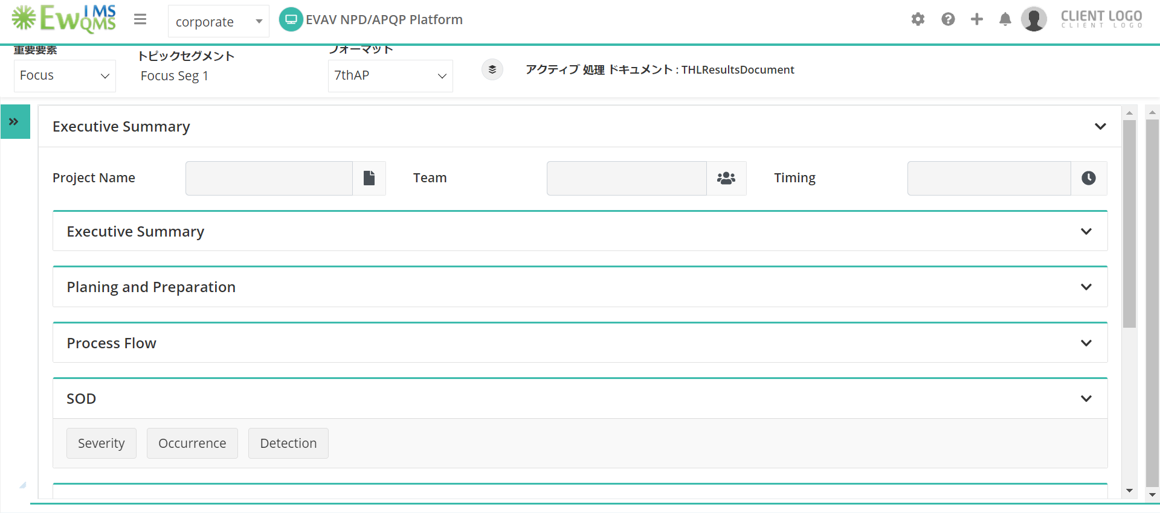

**Common Issues in Multi-Language:**

1. PI created in other languages are not displayed in English.
2. Data added in Other Languages are displayed blank in English.
3. Interface lines drawn in Block Diagram for other languages are not displayed when changing to English.
4. Added Risk is not updated in Process VDA.