1. Alert Messages All languages:

Change request deletion confirmation, Deleted alert

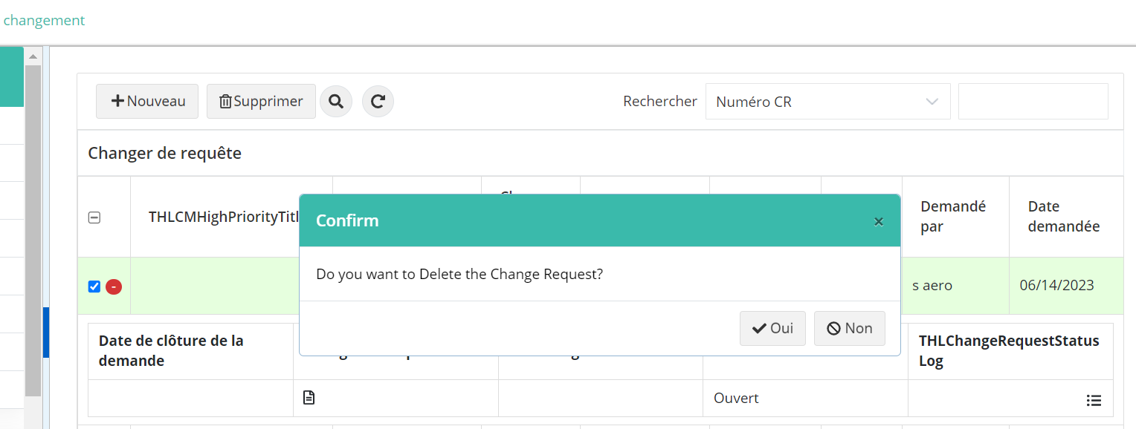

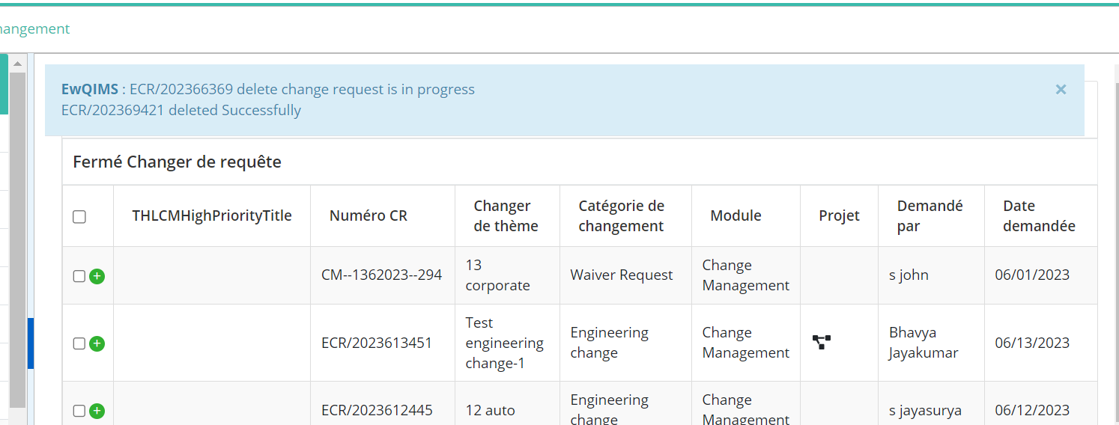

1. Change form mapping

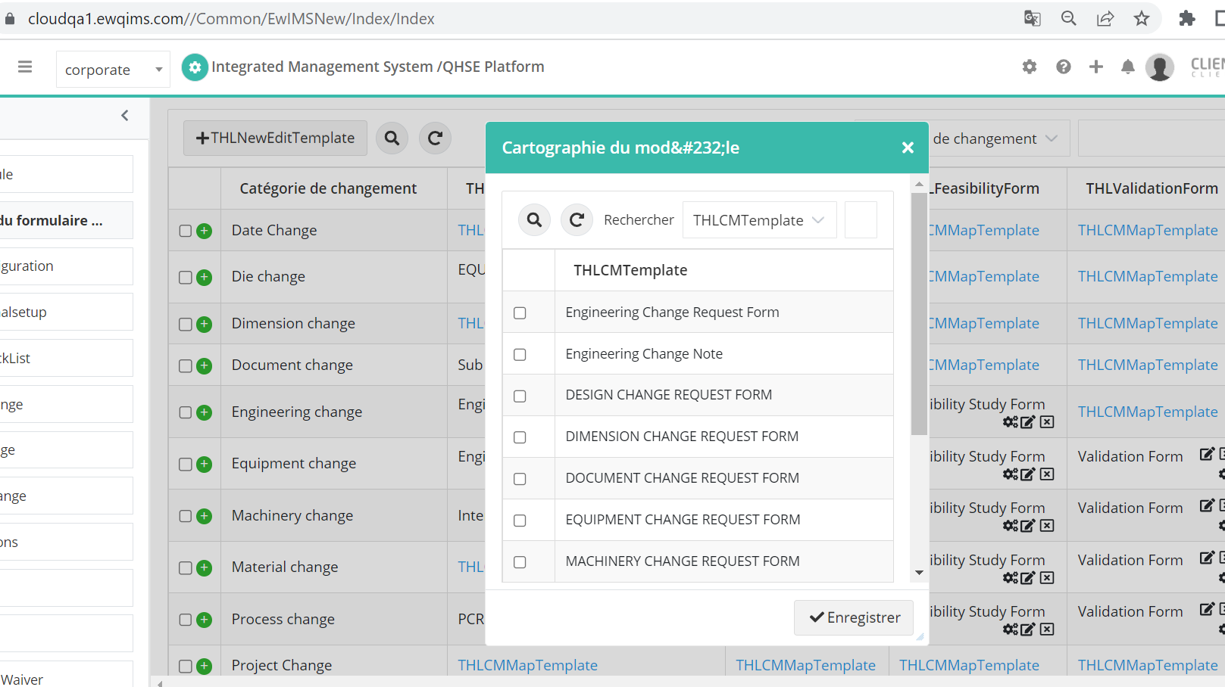

1. Initiate Change request

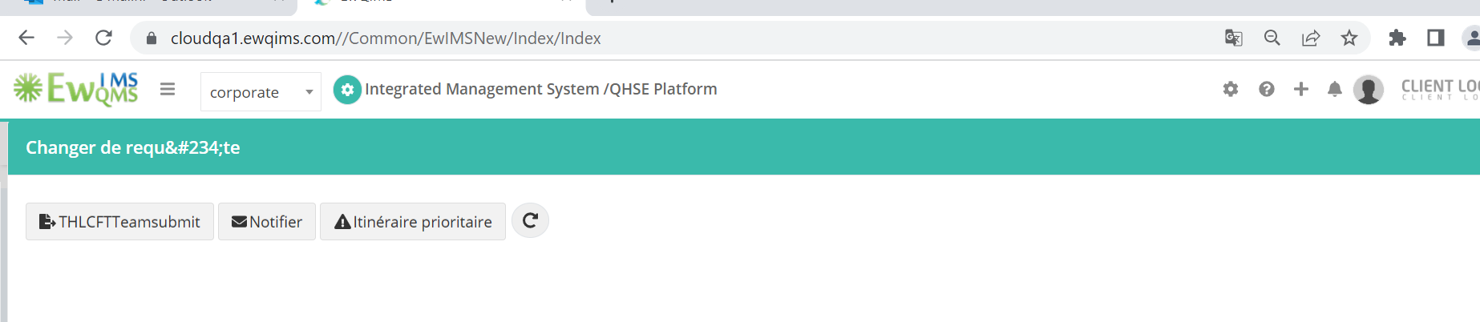

1. Mandatory Alert-> Applicable for set up page , types of proposal,Consideration page etc

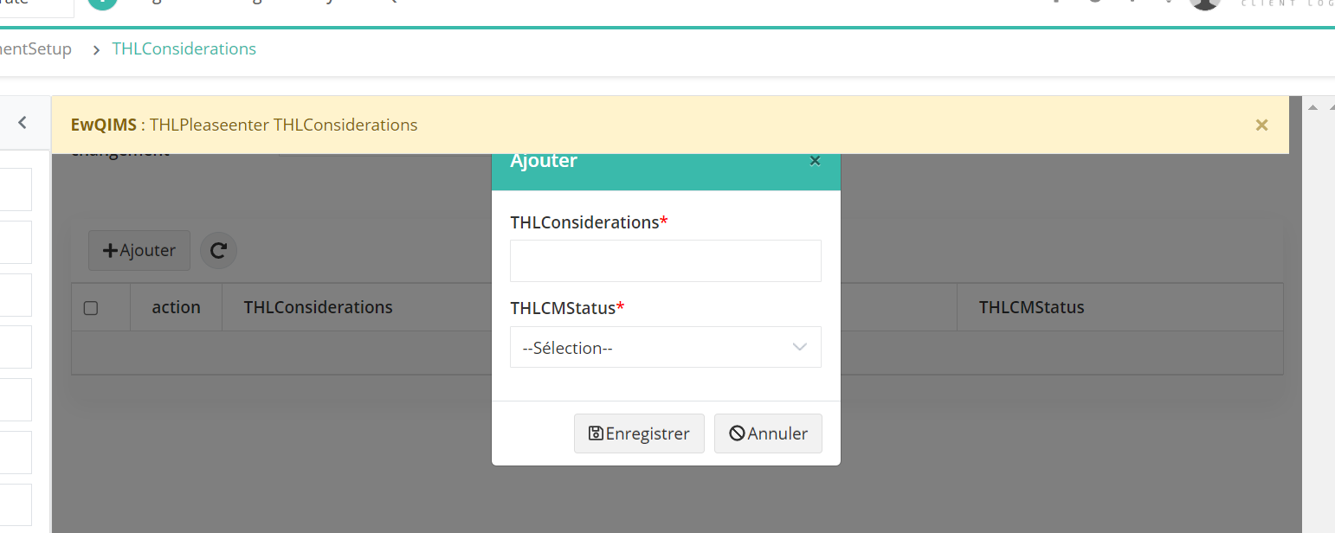

1. Process change alert

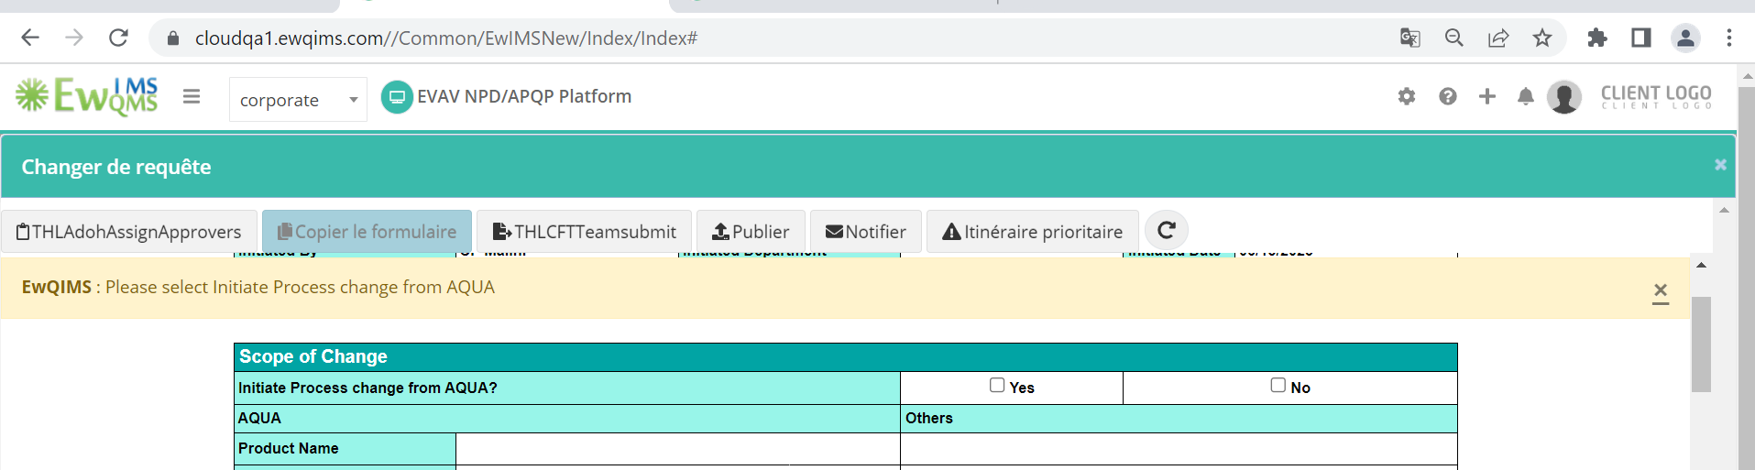

1. Submit Waiver-> Process change

