1.Customize Email Messages

On/Off is not Converted

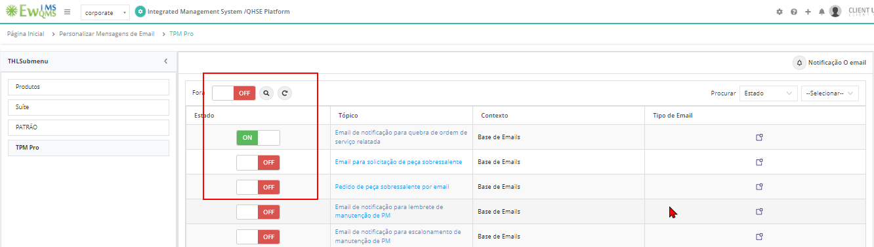

2.Trade

Labels are not converted  
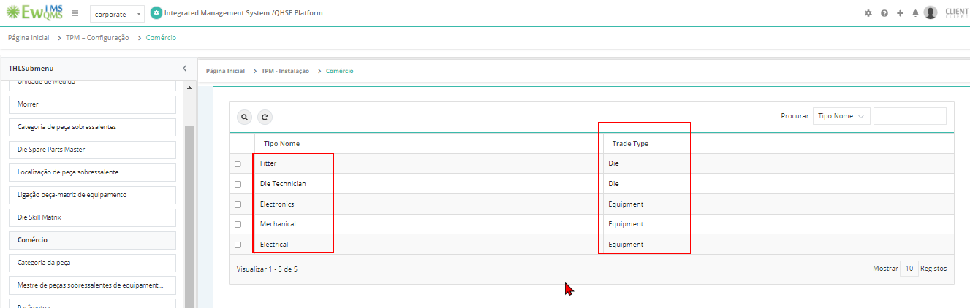

3.Equipment  
Click on criticality & edit criticality ->Saved successfully alert is not converted  
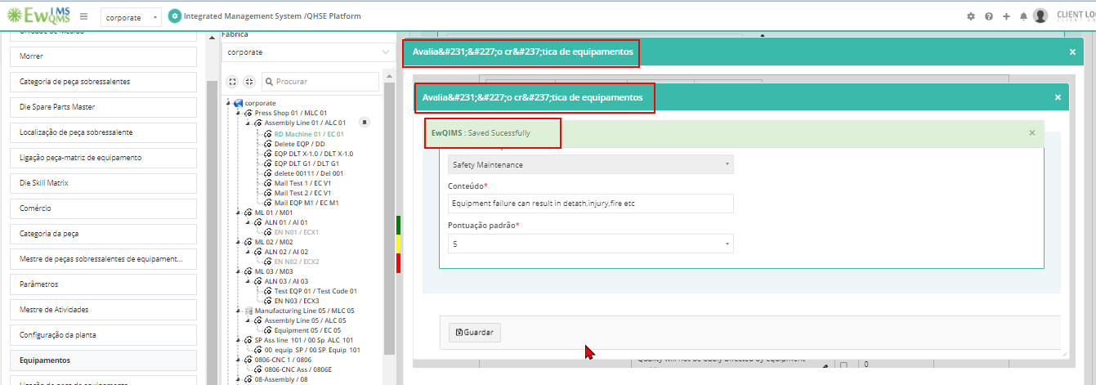

4.Cause - Causes list label is not converted  
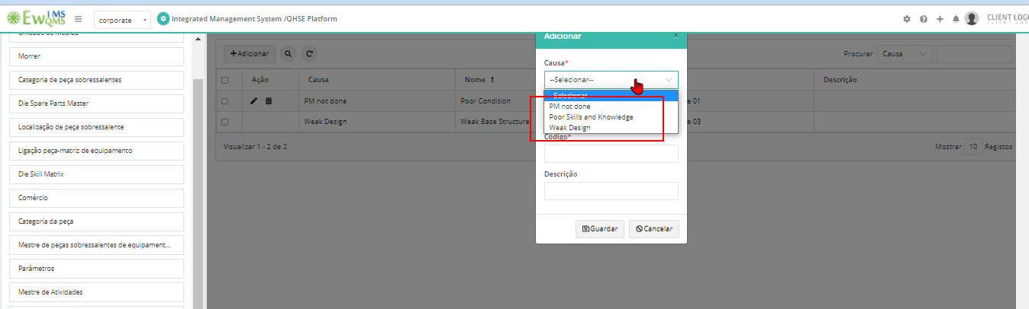

5. Problem Master label & Root cause category list label is not converted  
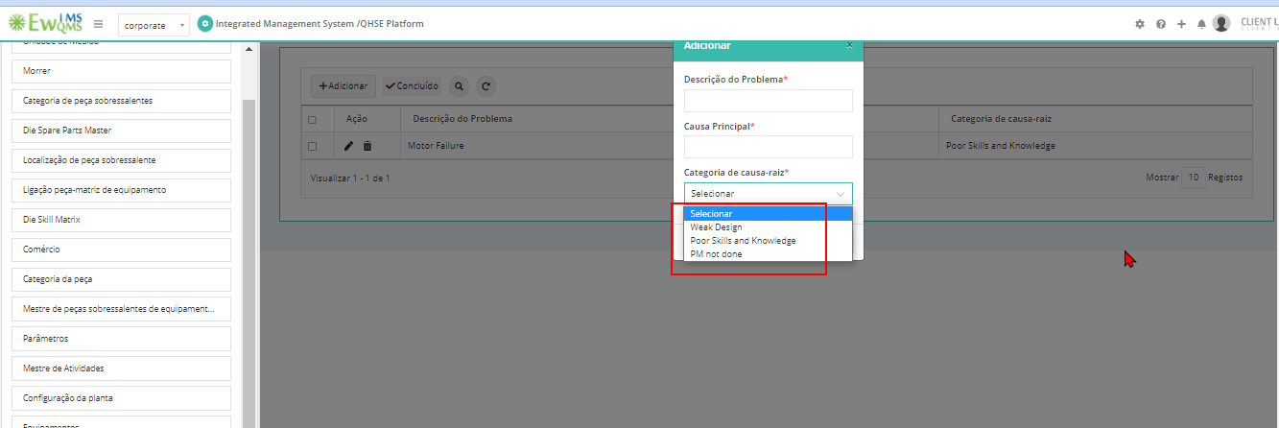

6.Equipment Skill Matrix and Die Skill matrix - Trade List label is not converted   
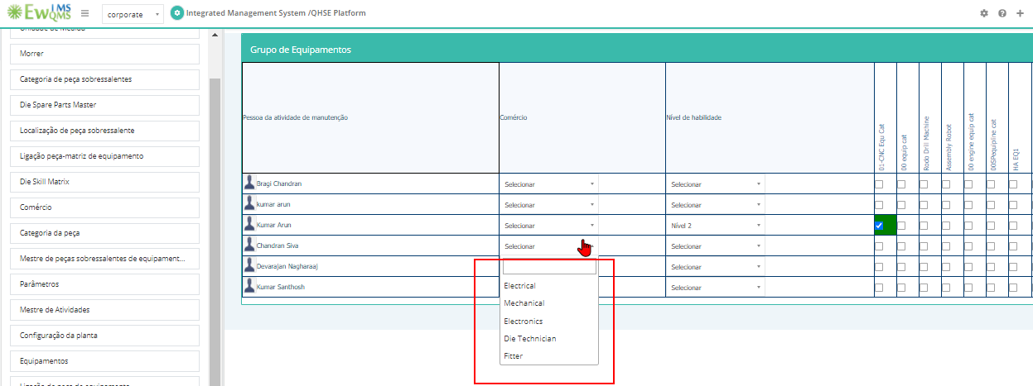

7.PM Calendar – Activity – Edit – Alert messages are not Converted  
