1.Groups

Header is showing Unwanted Data

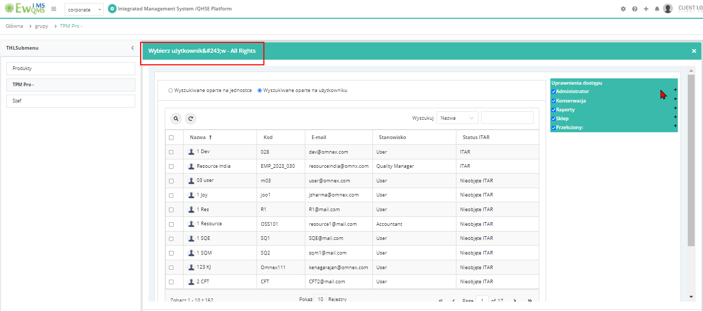

2.Customize Email Messages

On/Off is not Converted

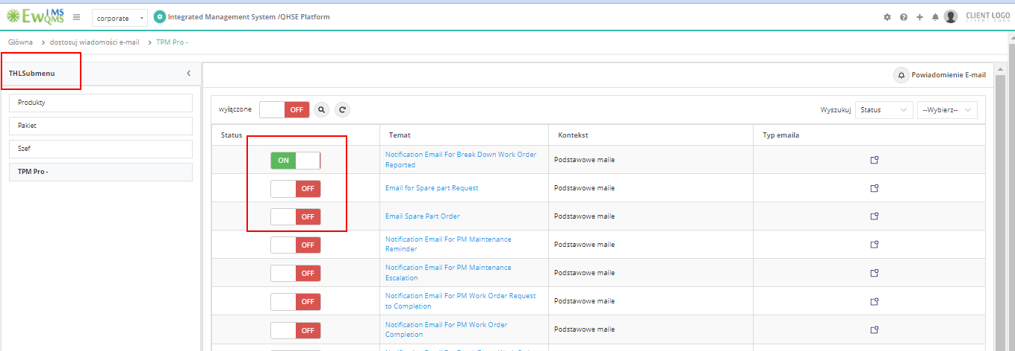

3.Trade

Labels are not converted  
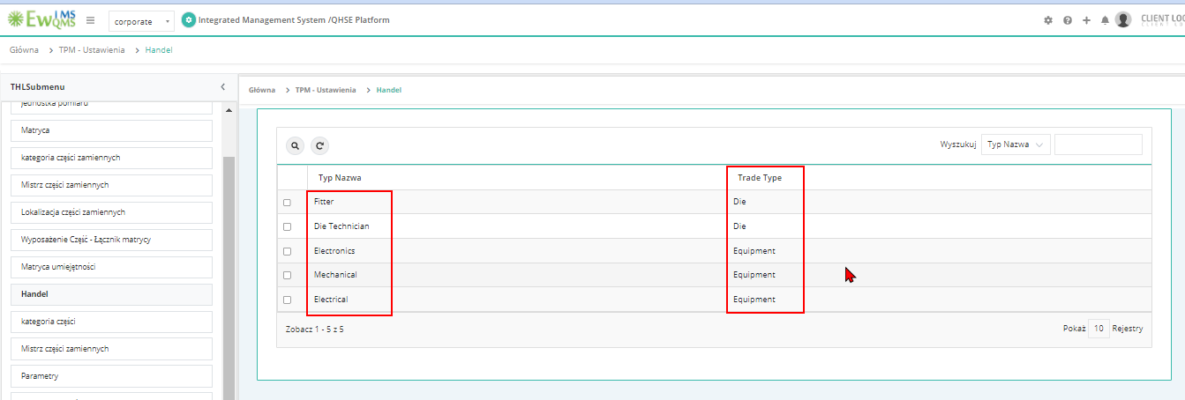

4.Equipment  
Click on criticality & edit criticality ->Saved successfully alert is not converted  
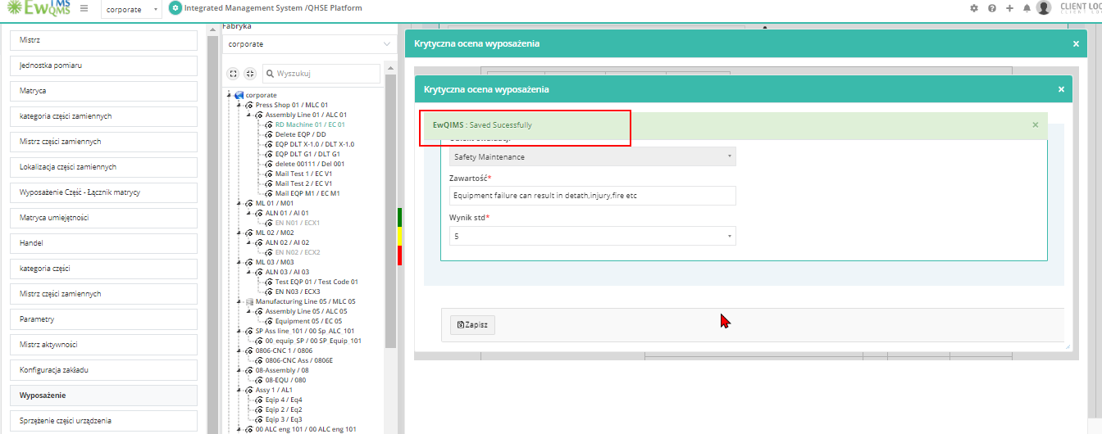

5.Cause - Causes list label is not converted  
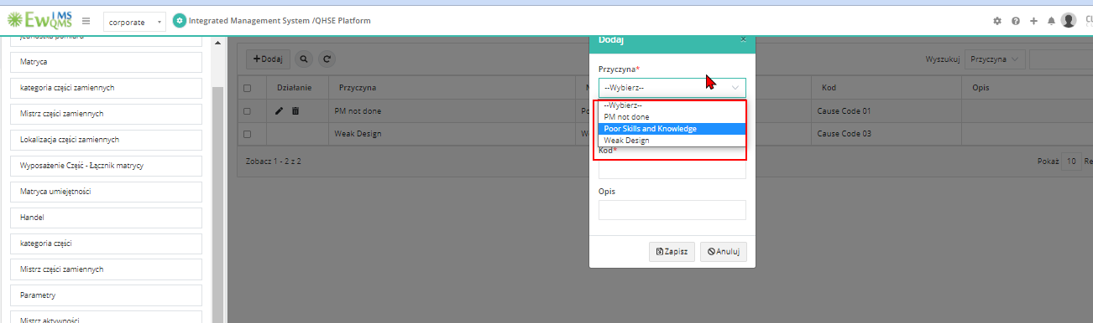

6. Problem Master label & Root cause category list label is not converted  
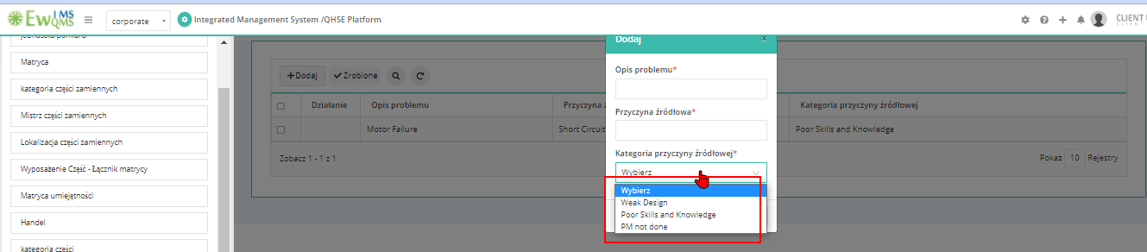

7.Equipment Skill Matrix and Die Skill matrix - Trade List label is not converted   
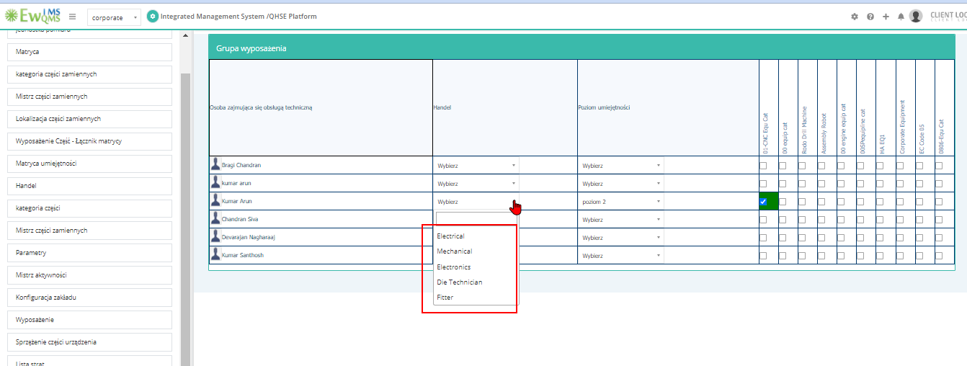  
  
8.PM Calendar – Activity – Edit – Alert messages are not Converted

