1.Group – Add Users  
Add user pop up header showing unwanted data and Maintenance label is not converted   
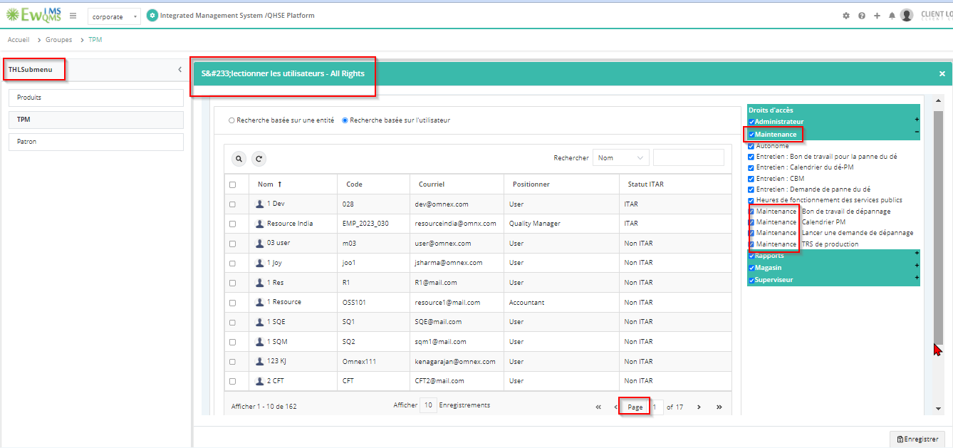

2.Share Rights -   
Select user pop up header & Done label showing unwanted data

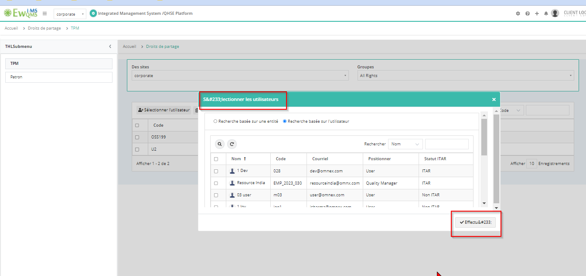

3. Customize Email Messages  
On & OFF label not converted

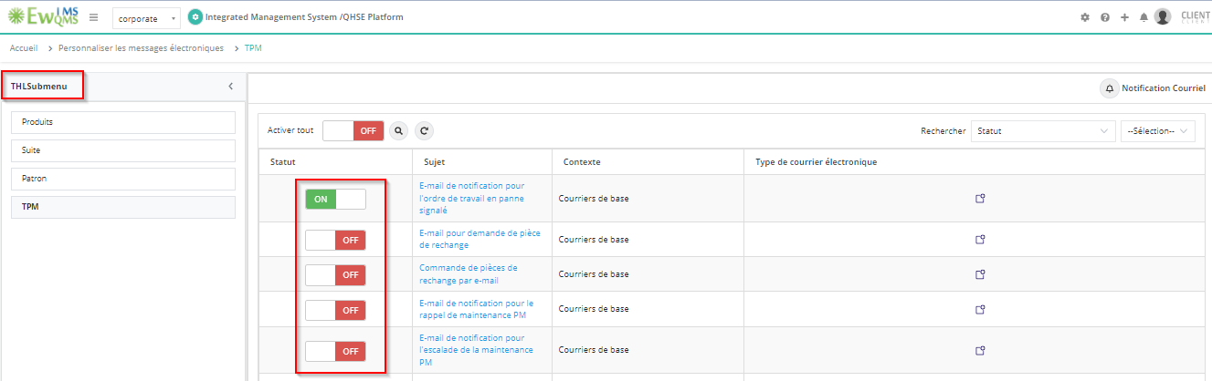

4. **Business Rule Settings->Basic Settings**

Production OEE label is not converted

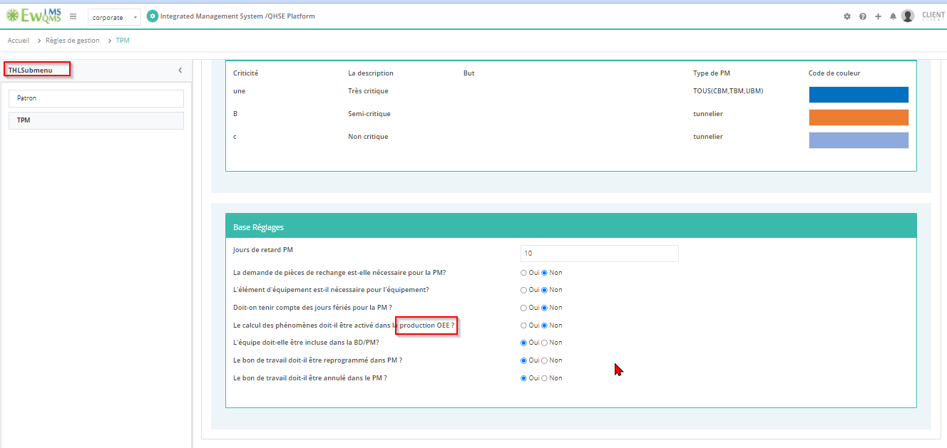

5. **Trade**Trade name & type list is not converted  
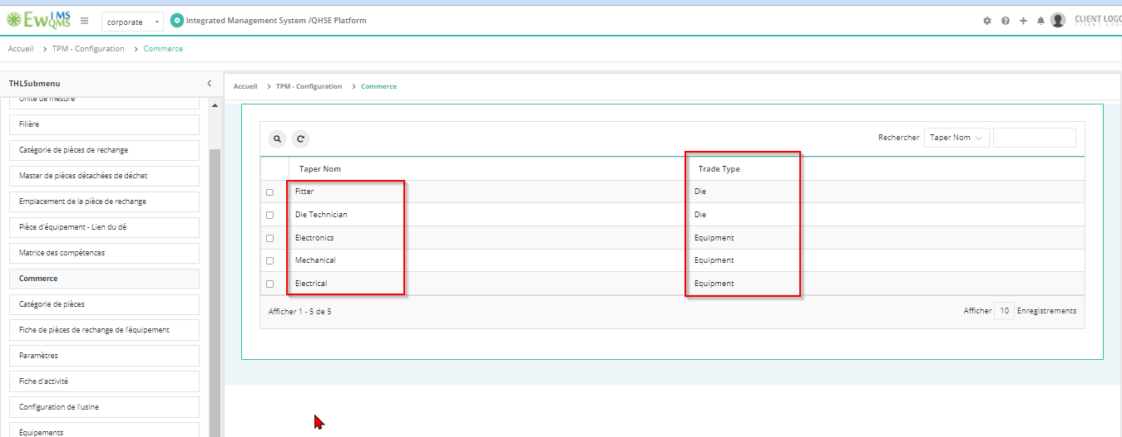

6. **Equipments**

Alert not converted

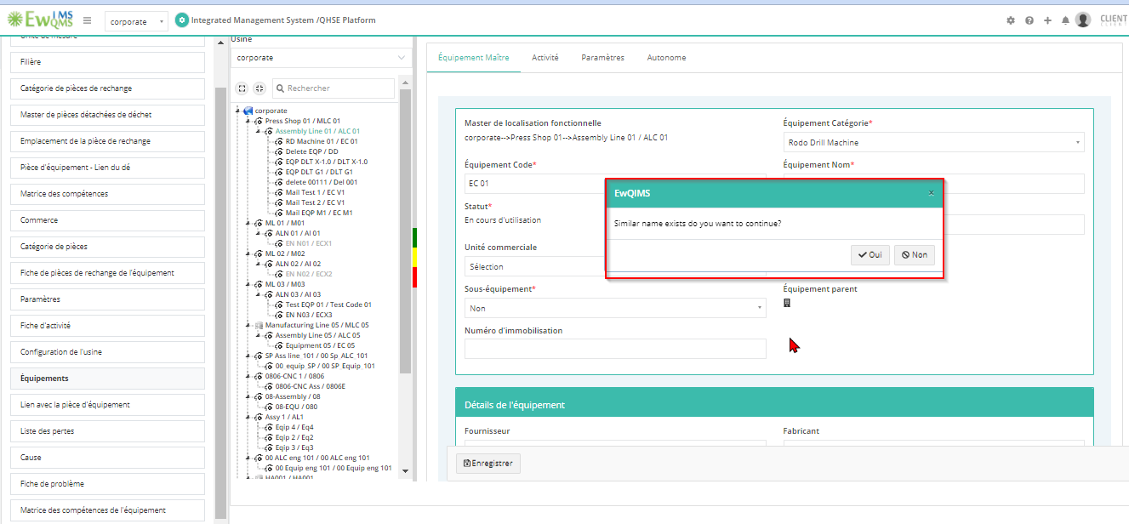

7. **Problem Master**Root cause category list not converted   
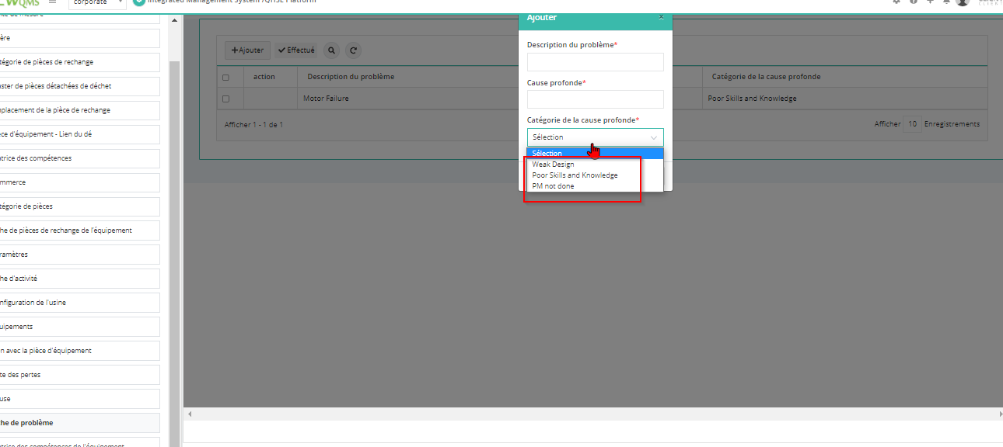

8. PM calendar ->TBM-Select Activity ->Click on done ->Observe the alert->Alert label is not converted  
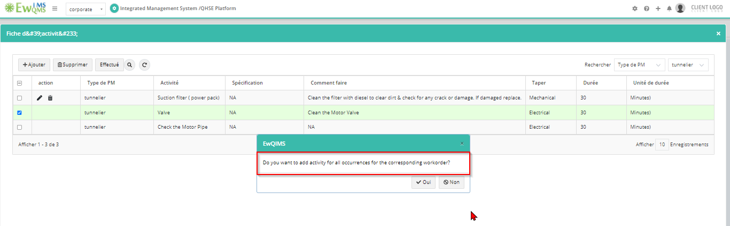

9. **Utility Running Hours**

Alert not converted  
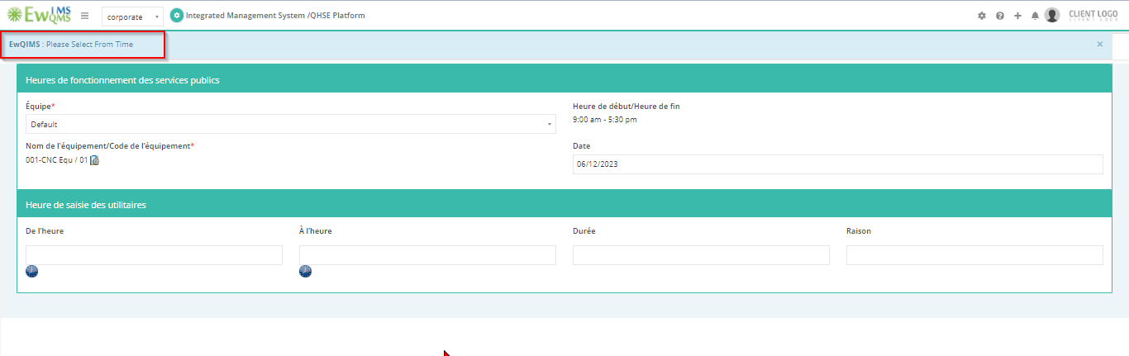

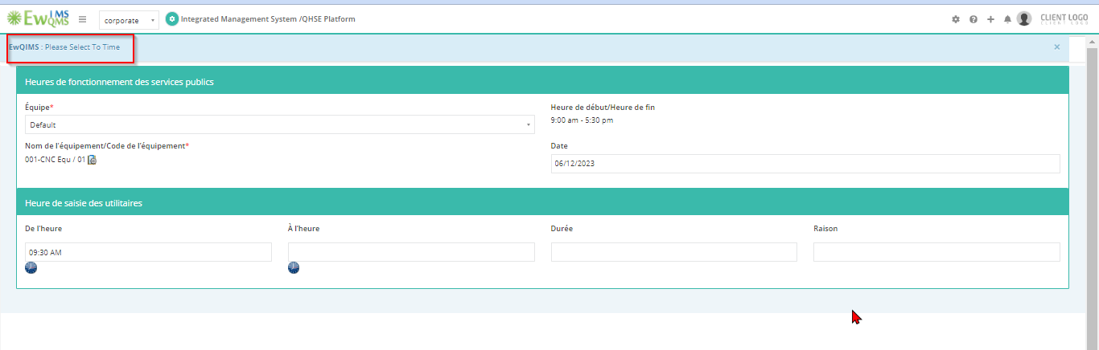

10. PM supervisor calendar ->Select Activity-> Alert not converted

