1. Bread Crumb for Project Setup

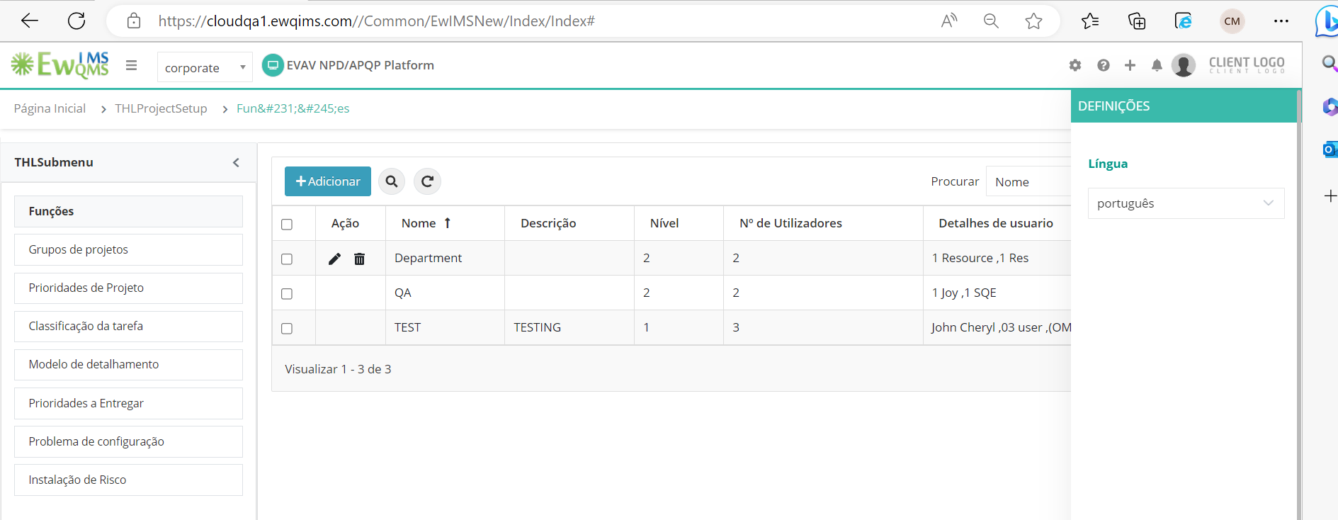

1. Project Actions are not showing the action names

Suite->Action Management -> Actions and Project Management- >Activities-> Actions

