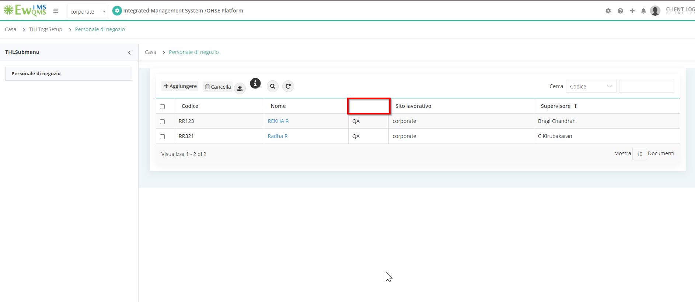

Trainings🡪Targetsetup🡪non-email users

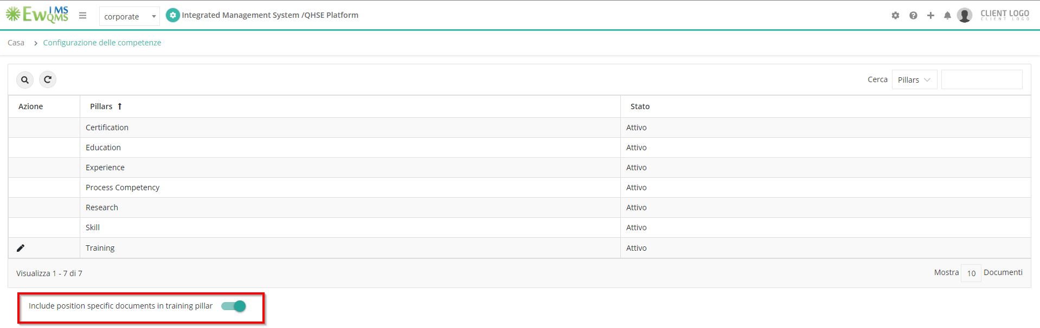

Competency Management🡪Competency Setup

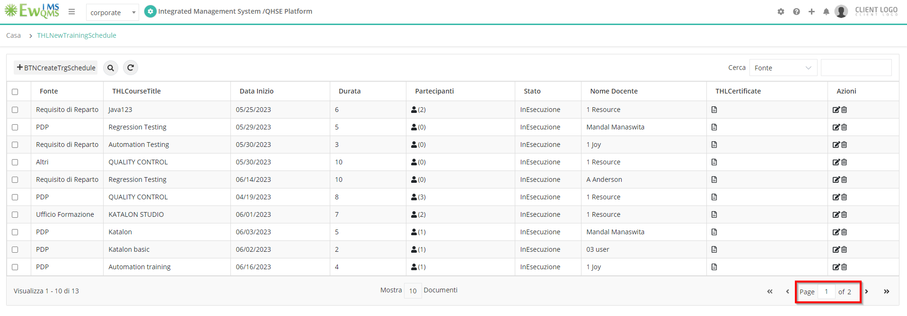

Trainings🡪Training🡪Training schedule

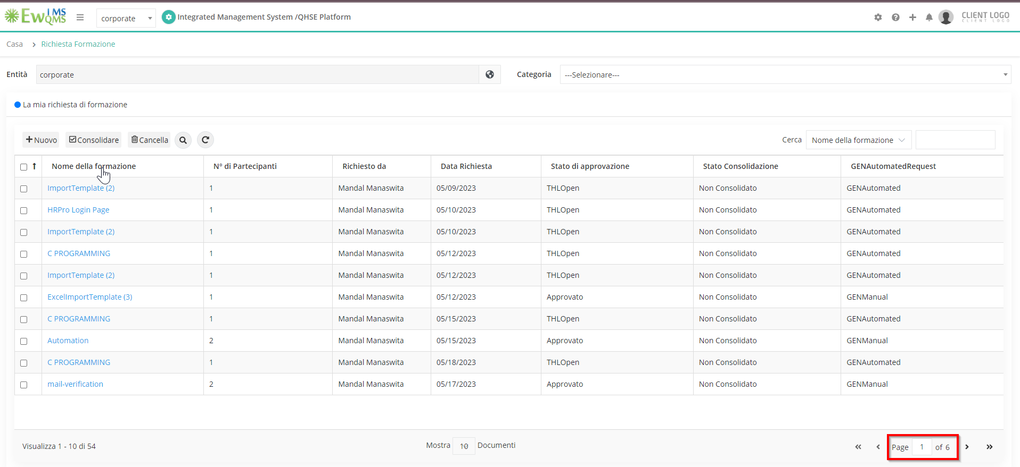

Trainings🡪Training

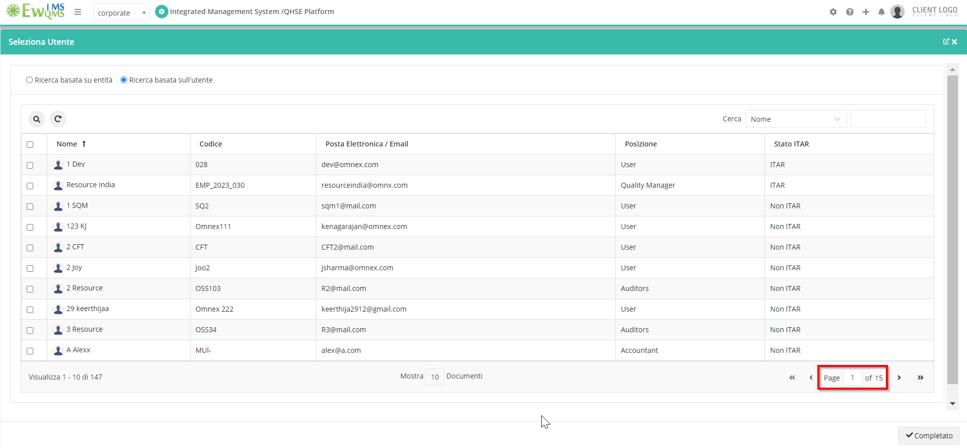

Trainings—>Training🡪New🡪Add users

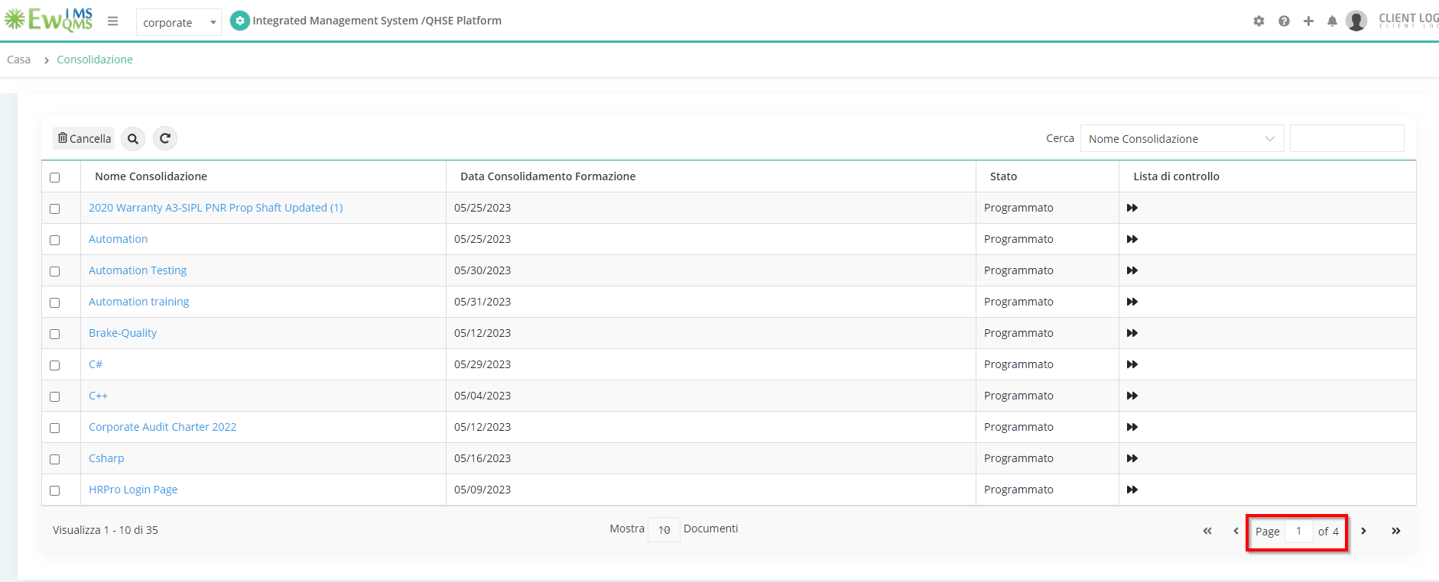

Trainings🡪Training🡪Confirmed trainings

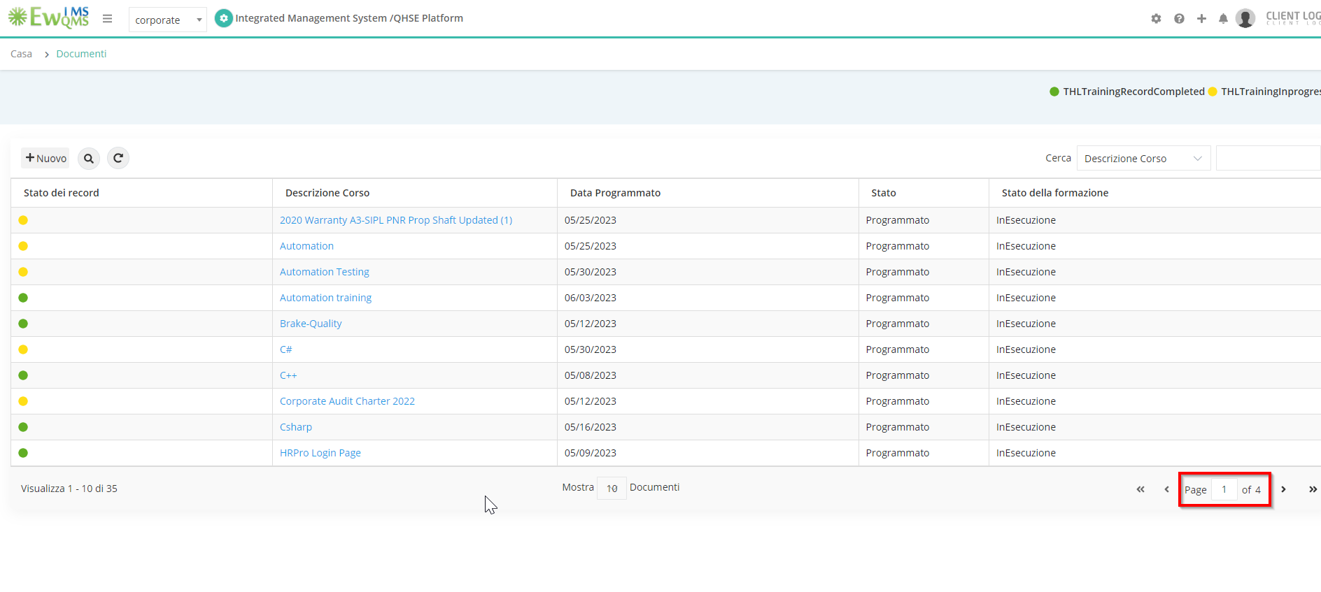

Trainings🡪Training🡪Records

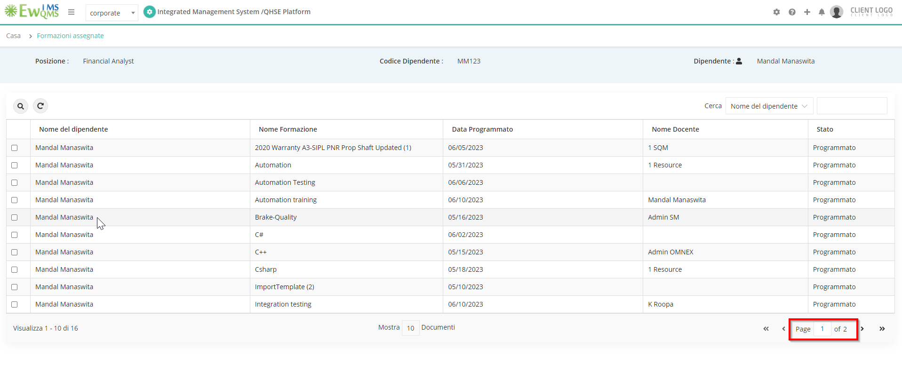

Trainings🡪Training🡪Training Details

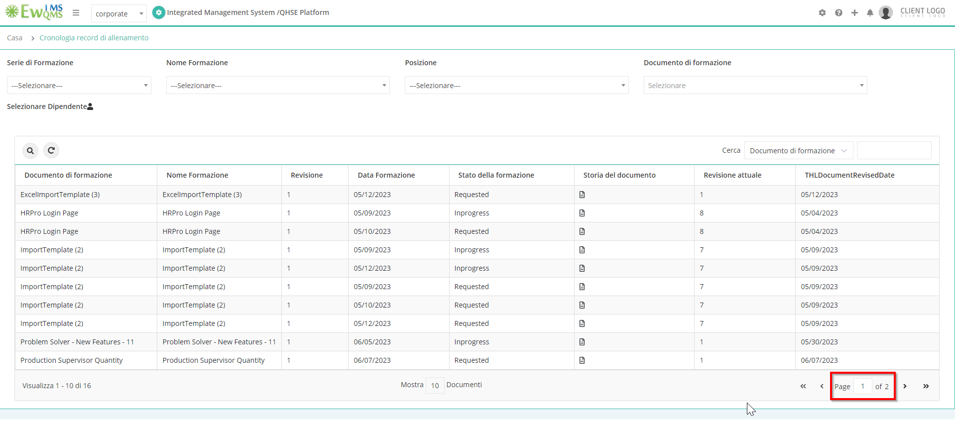

Trainings🡪Training🡪training record history

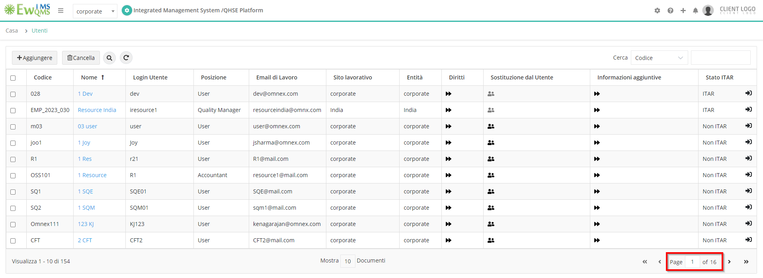

Employee Management🡪Employee details