Trainings🡪Competency Management🡪Job Requirements🡪Select Participants🡪Add users

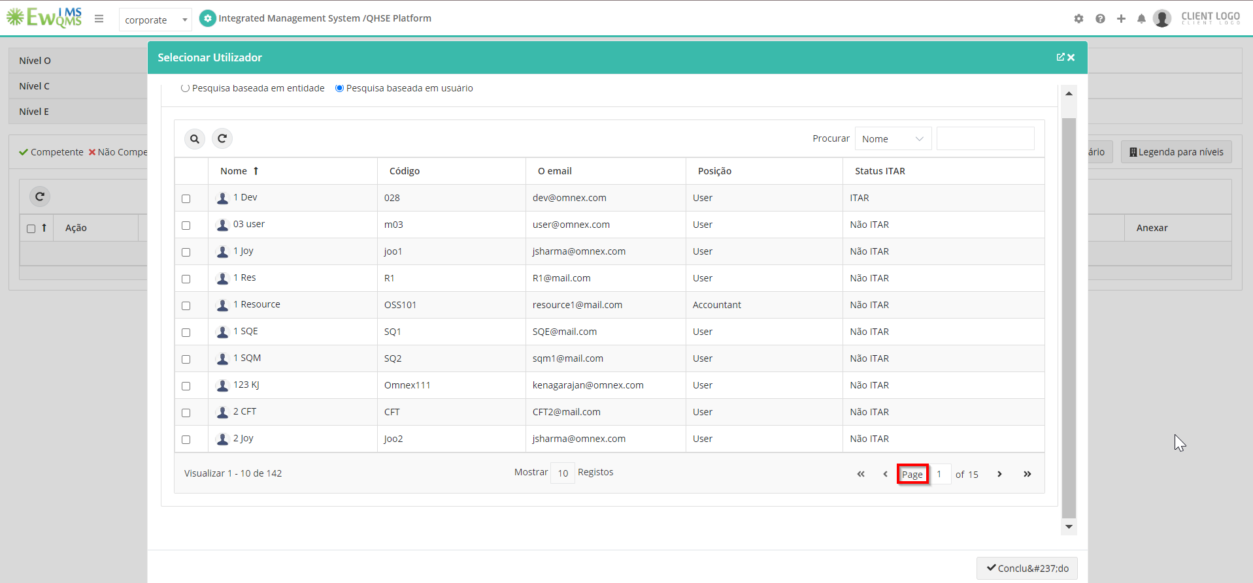

Trainings🡪Competency Management🡪Competency Setup

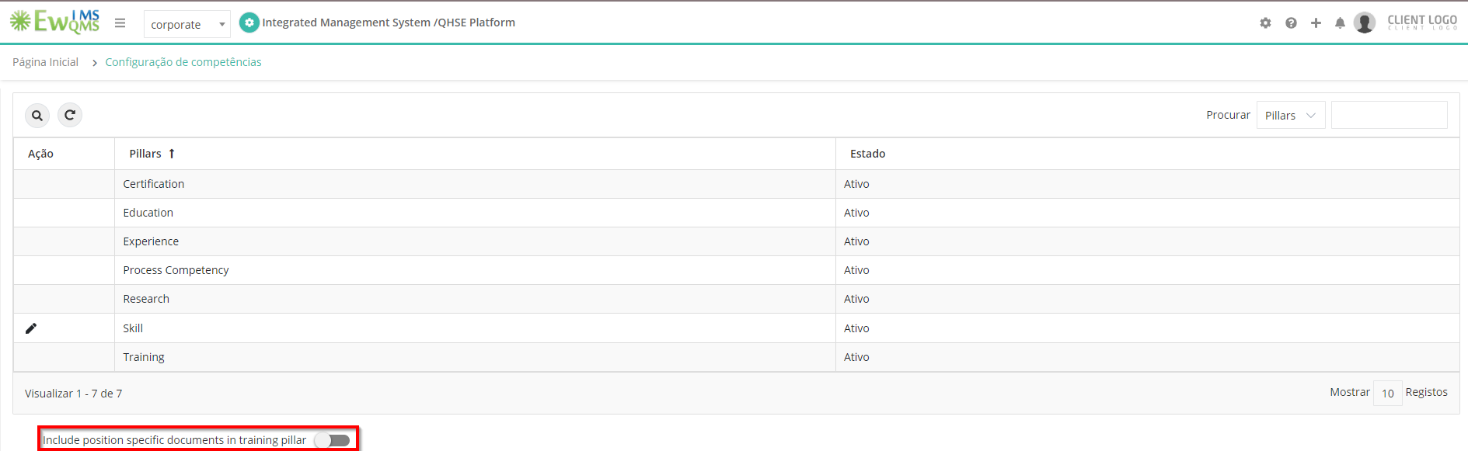

Trainings🡪Training🡪Request🡪Add Users

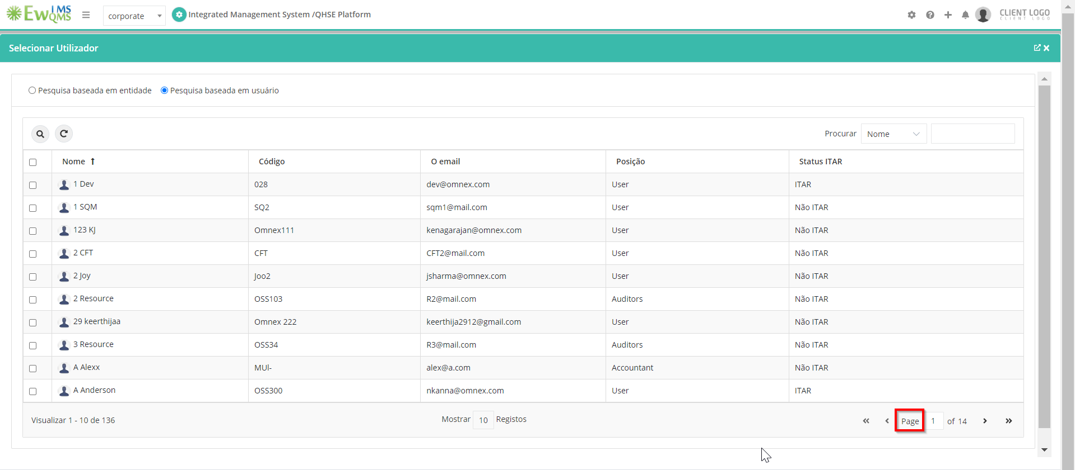

Trainings🡪Training🡪Confirmed trainings

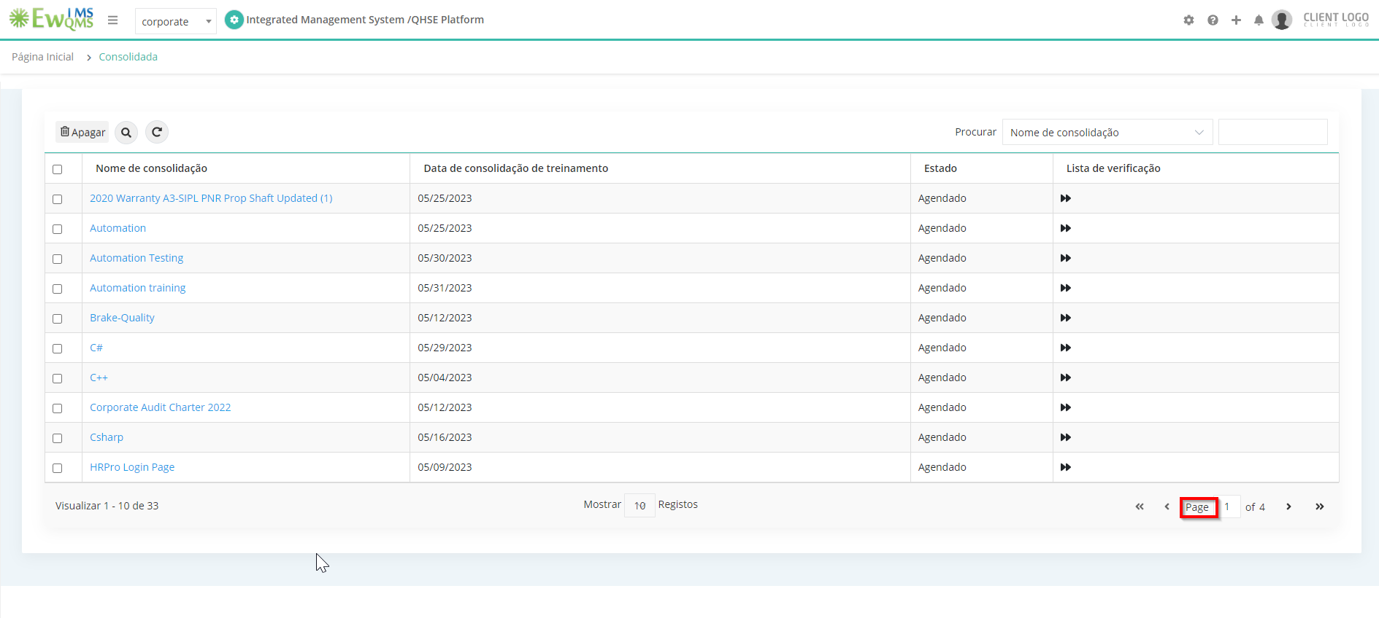

Trainings🡪Training🡪Training Assigned

