Japanese: HRPRO

1.Trainings🡪Competency Management🡪Competency setup

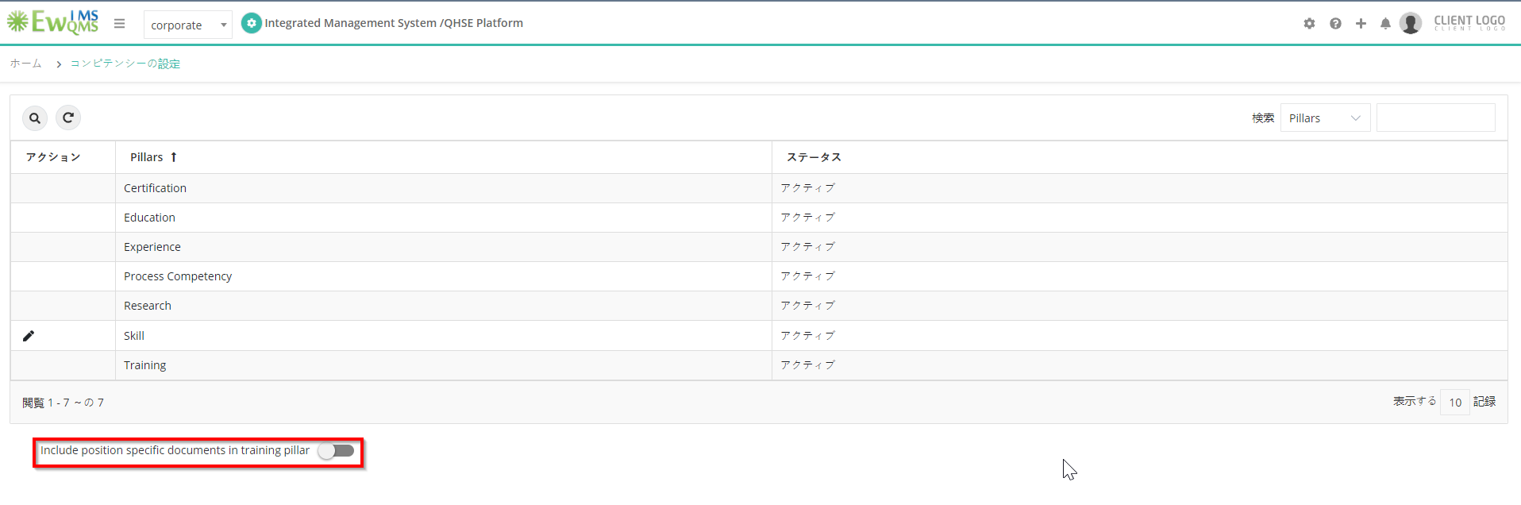

2.Trainings🡪Training🡪Request

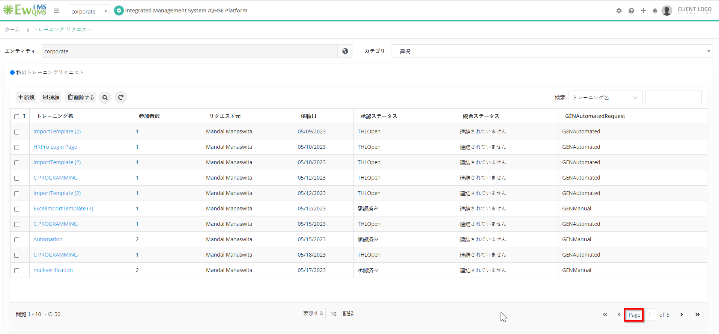

Training🡪Training🡪Confirmed Trainings

T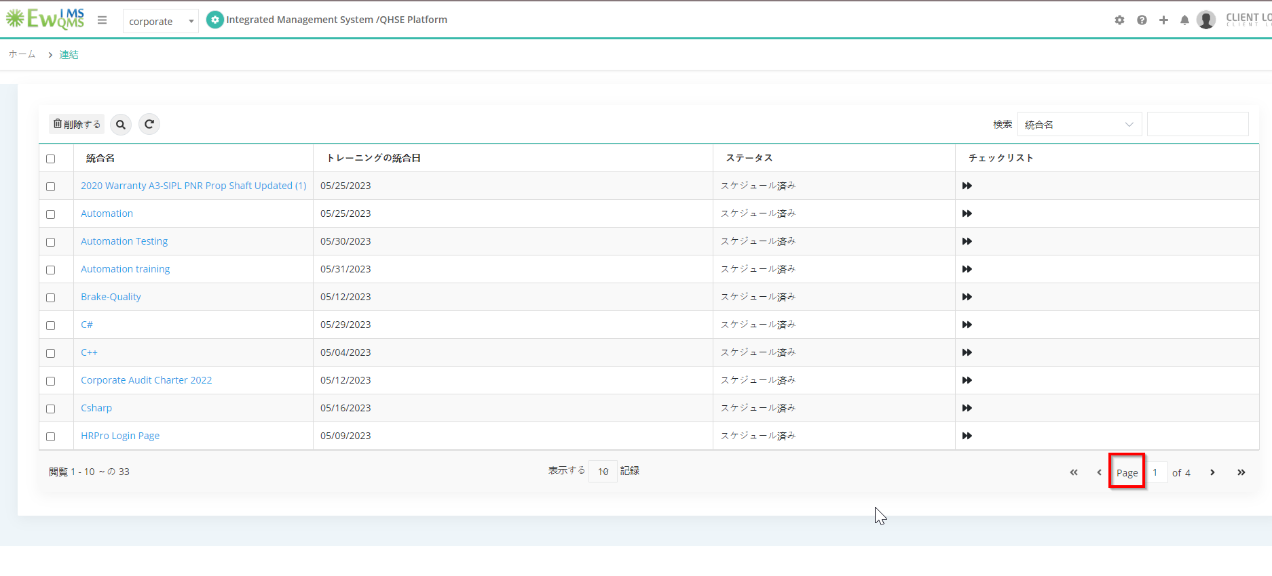

Trainings🡪Training🡪Records

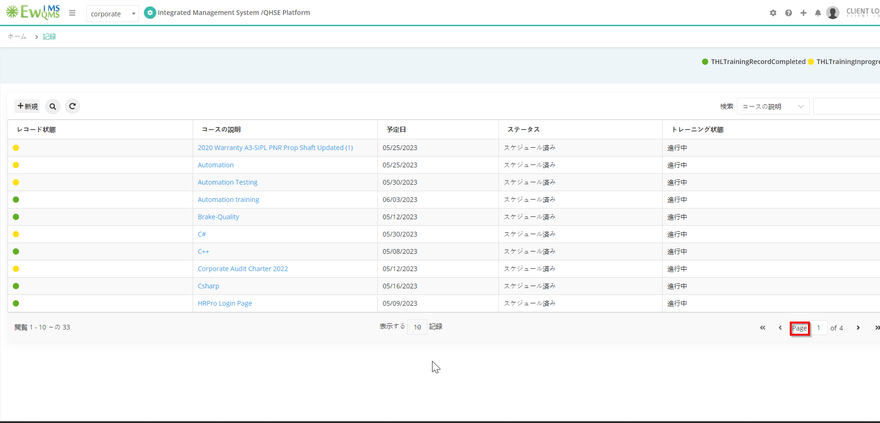

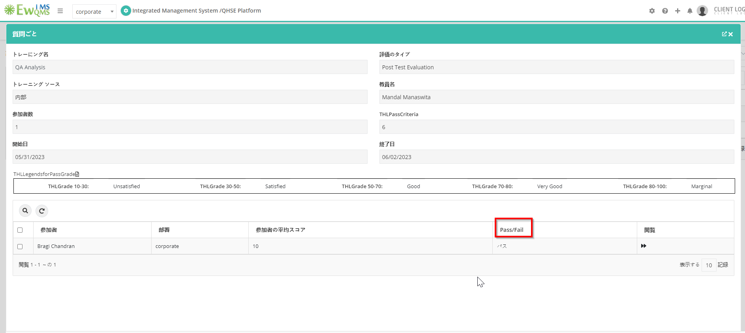

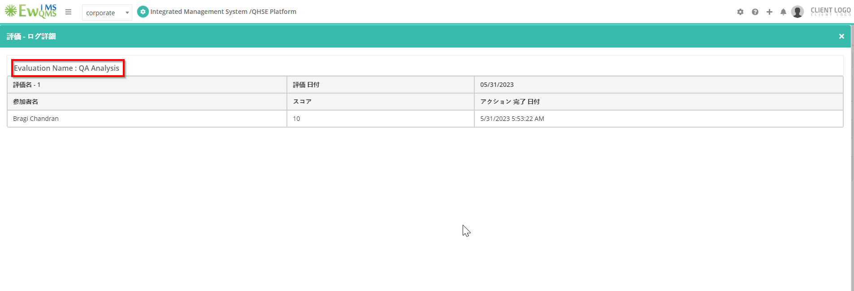

Trainings🡪Training🡪Trainings Assigned

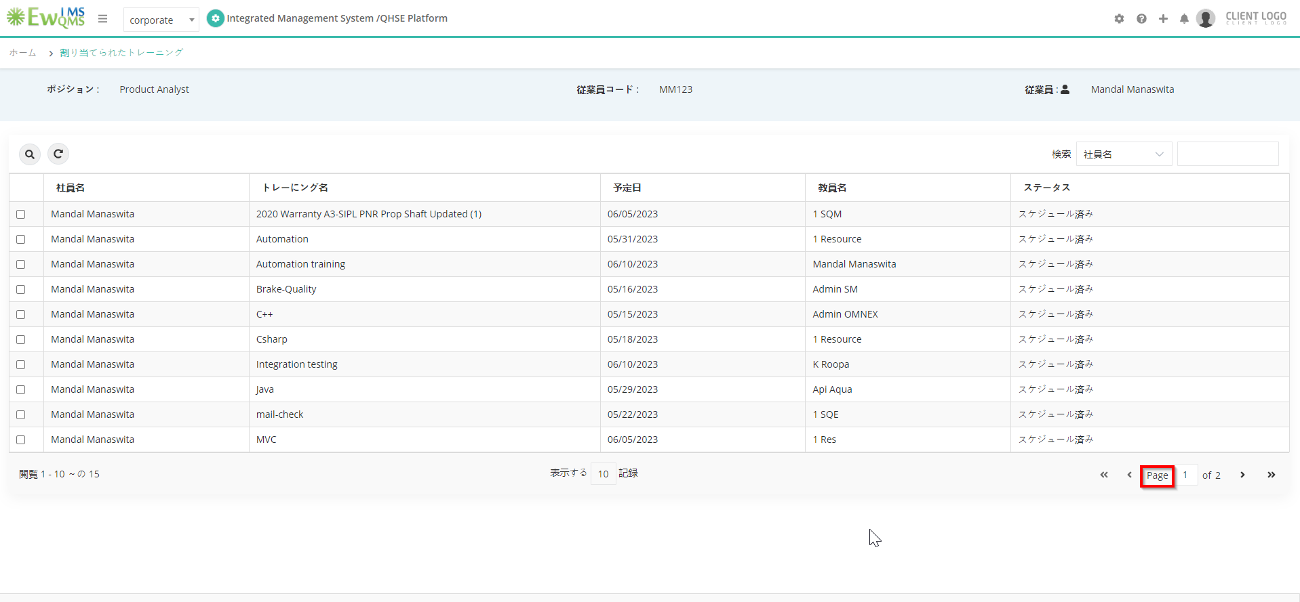

Trainings🡪Training🡪Training record history

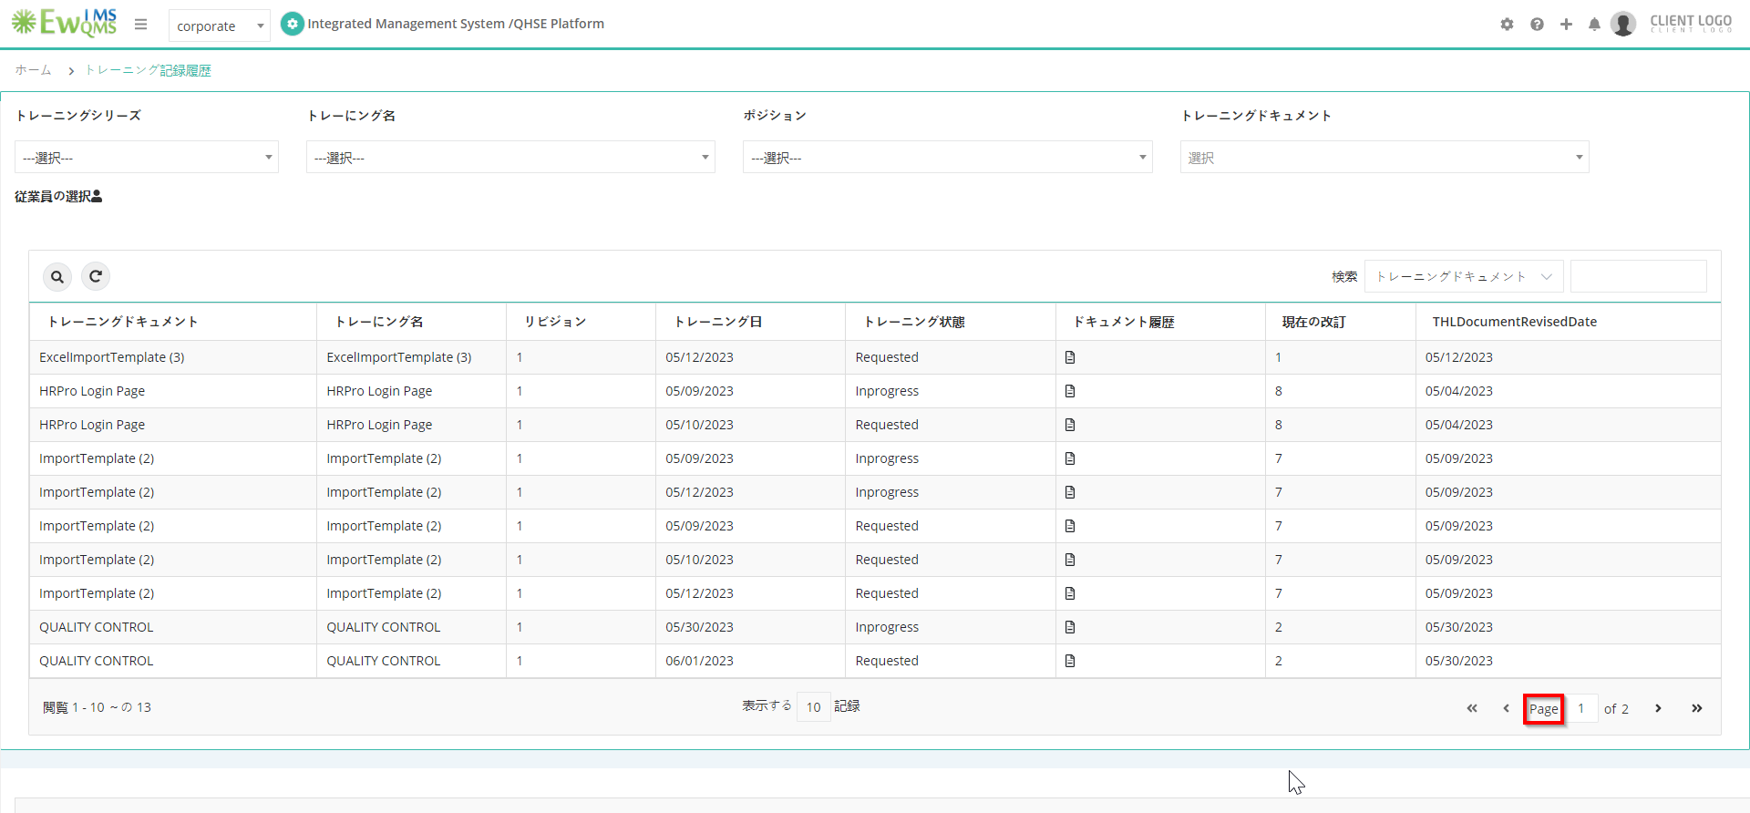

Trainings🡪Employee Management🡪Employee details

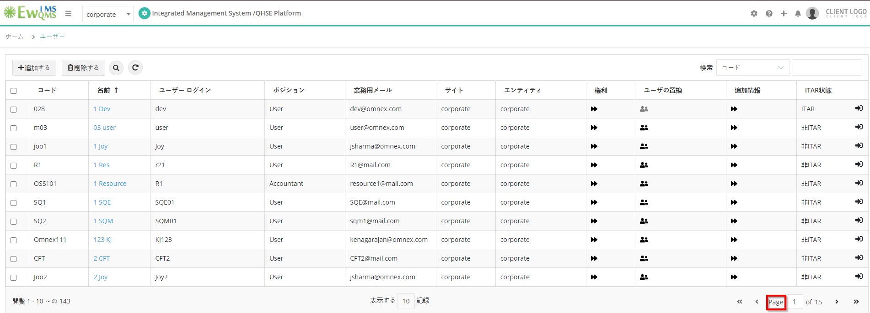

Setup🡪System🡪Positions

