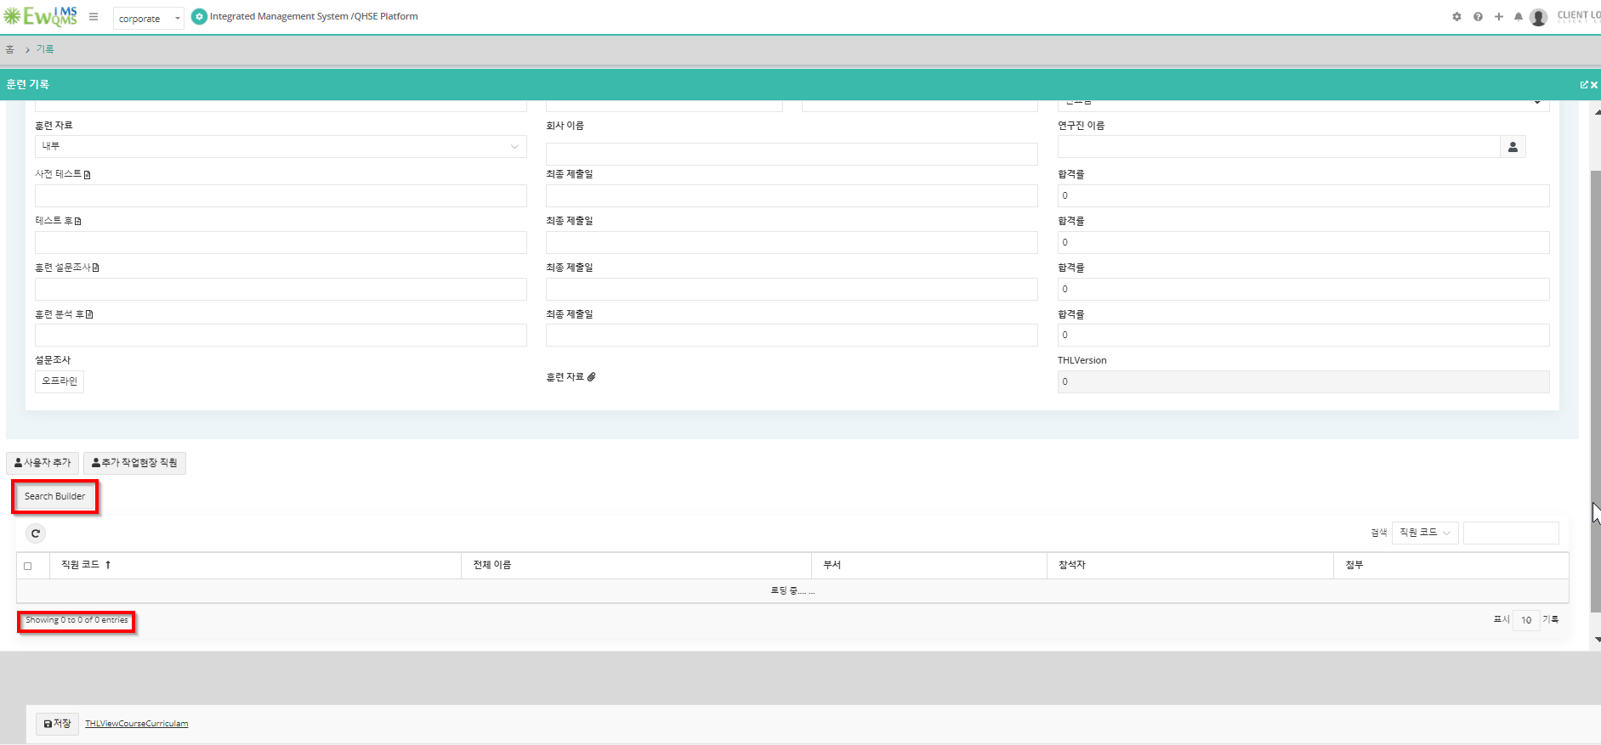

Training🡪records🡪new

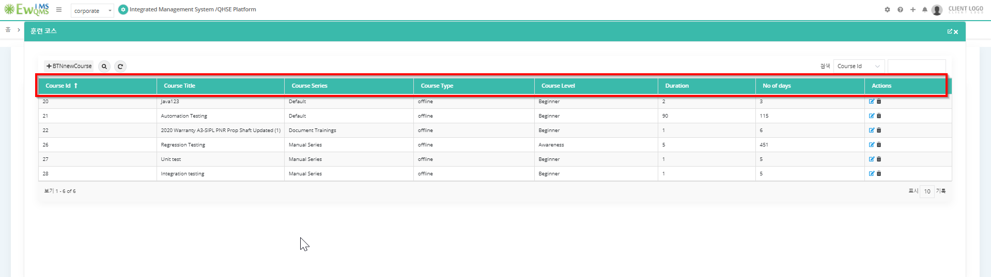

Training Request Setup🡪Select series🡪Add new course

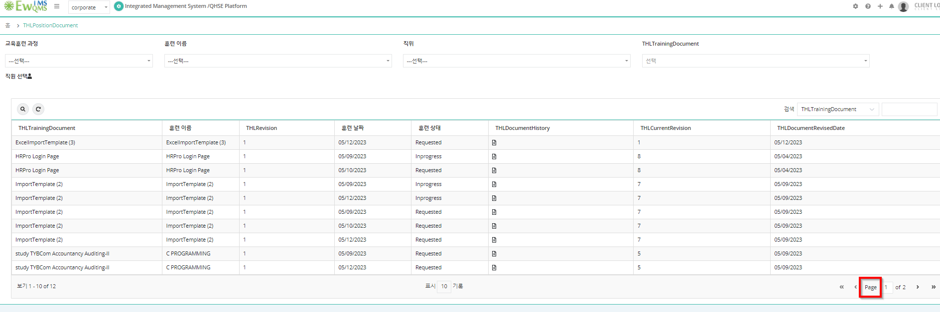

Training record history

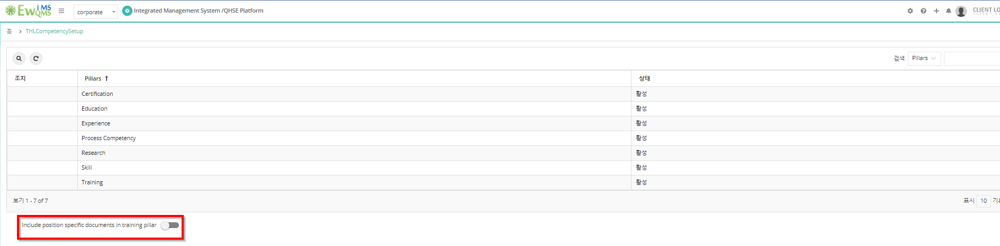

Competency setup