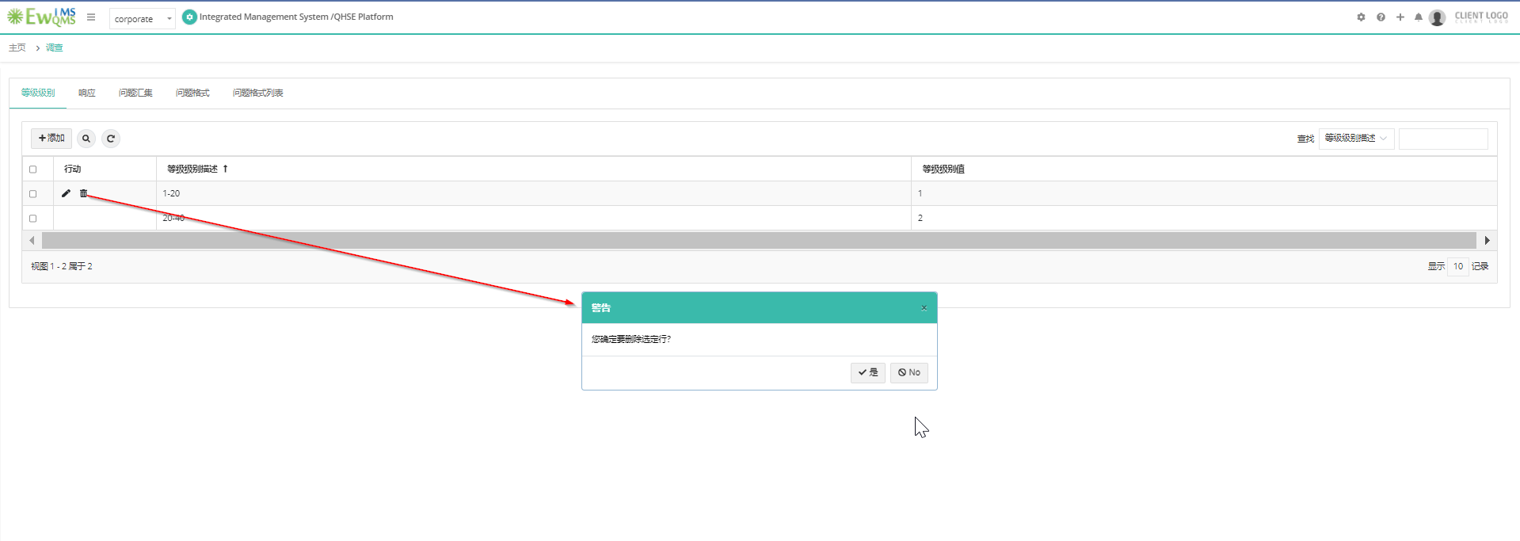

Survey 🡪 Click on Delete



New Training schedule🡪+New Training schedule

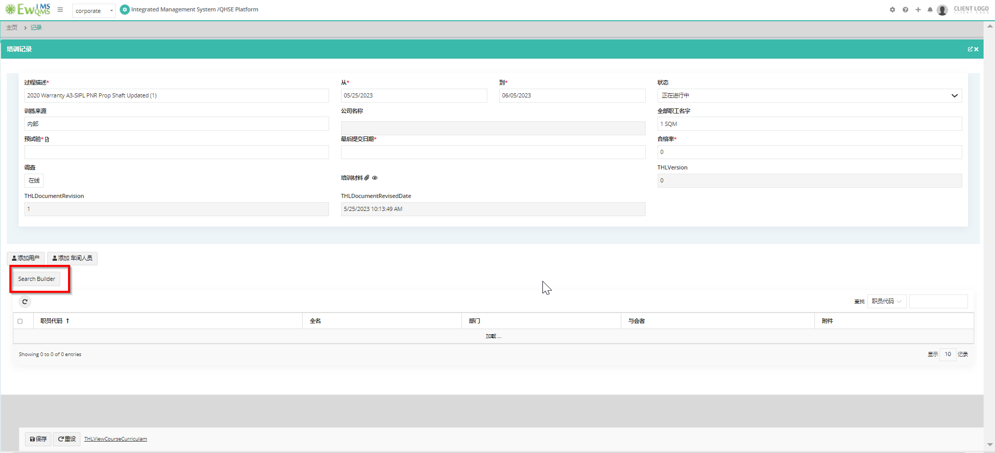

New Training Schedule🡪Add training schedule

Training🡪Record

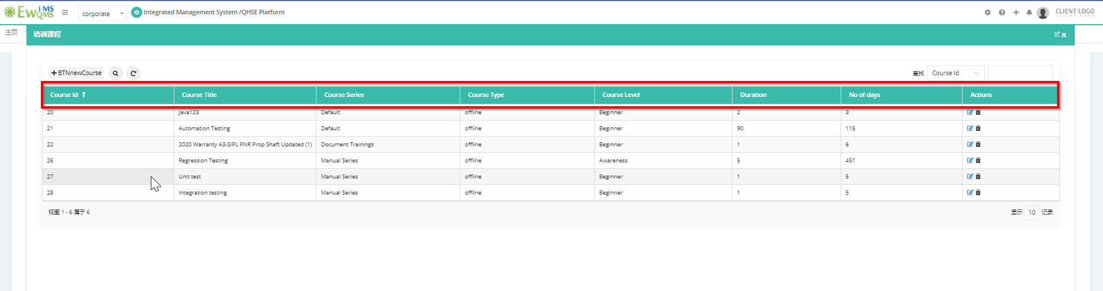

Training Request Setup🡪Click on training series—>

