1. In Reminder Settings – “Meeting Subject” Search and Sort is Not Working.

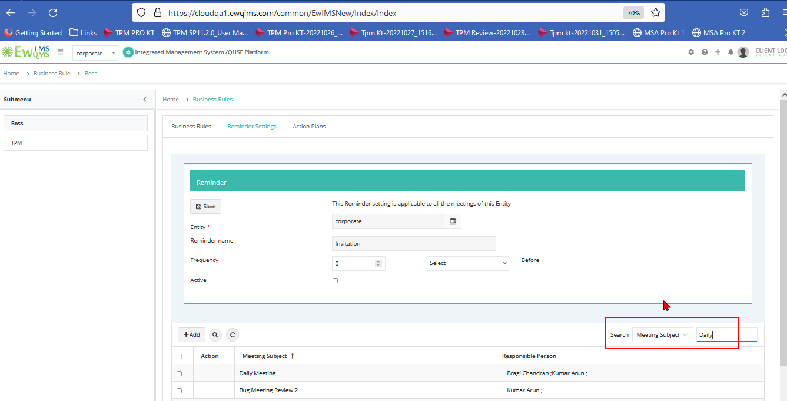

2.Action Plan – Sort is not working

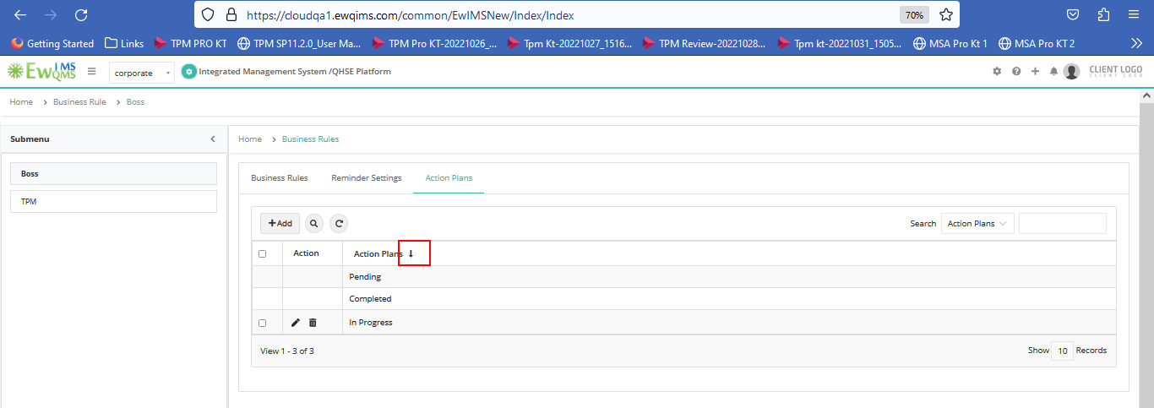

3.Business Planning Stratergy – Boss Setup – Click on a Interested Party Expectation Hyperlink - When we click on Sort icon in “Interested Party” and “Note”, All Datas are Hidden or Not Displayed. Then we need to close and Repoen the page to View it.

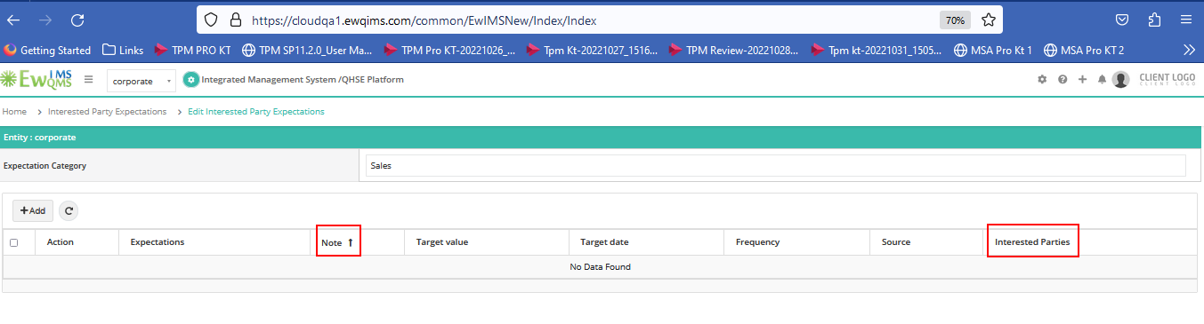

4.Benchmark - Short/Long Term Time Period Search is not working

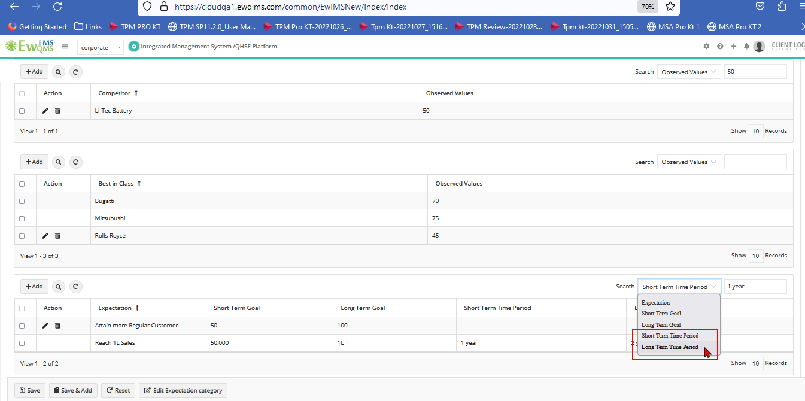

5. KPI – Sort icon is missing in Groups and Add|View



  
  
  
  