**Publish Issue**

1. On the Doc Pro module, published documents are being duplicated by different users.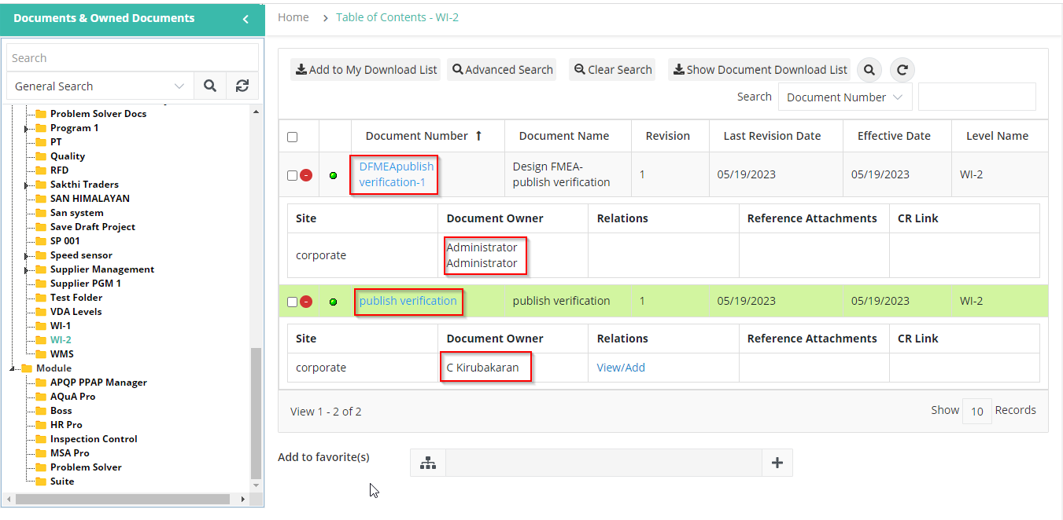
2. After published, the Add and Cancel buttons are hidden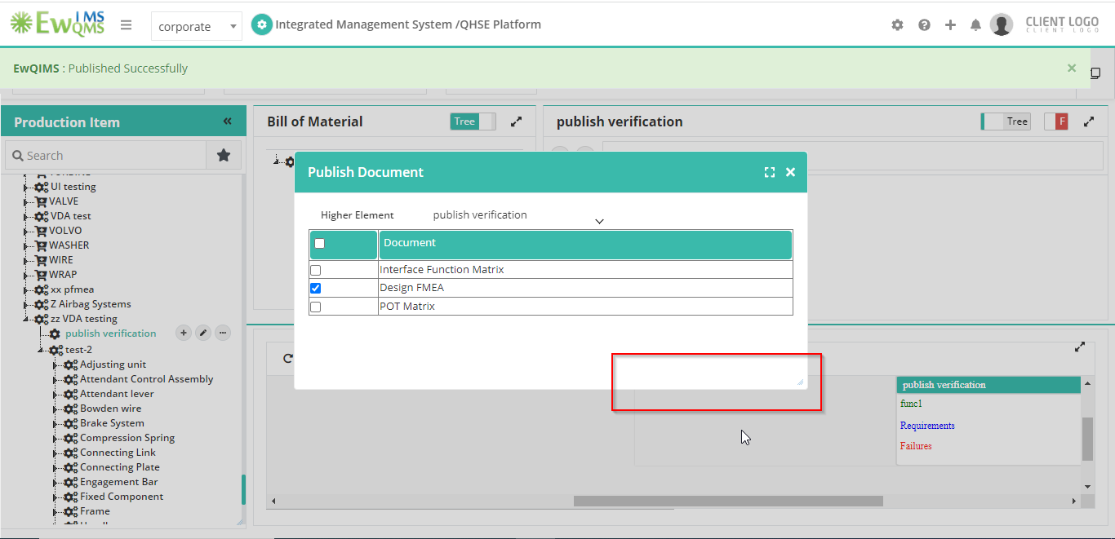
3. The blank page of a published document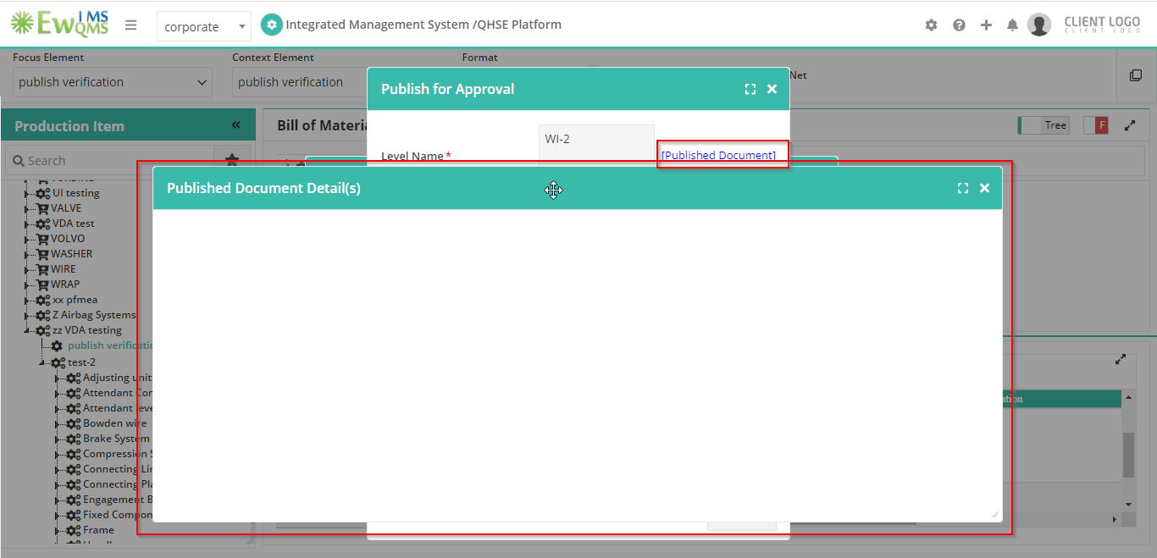
4. IFM first publish (cannot select level) and DFMEA second publish (both documents published at same level)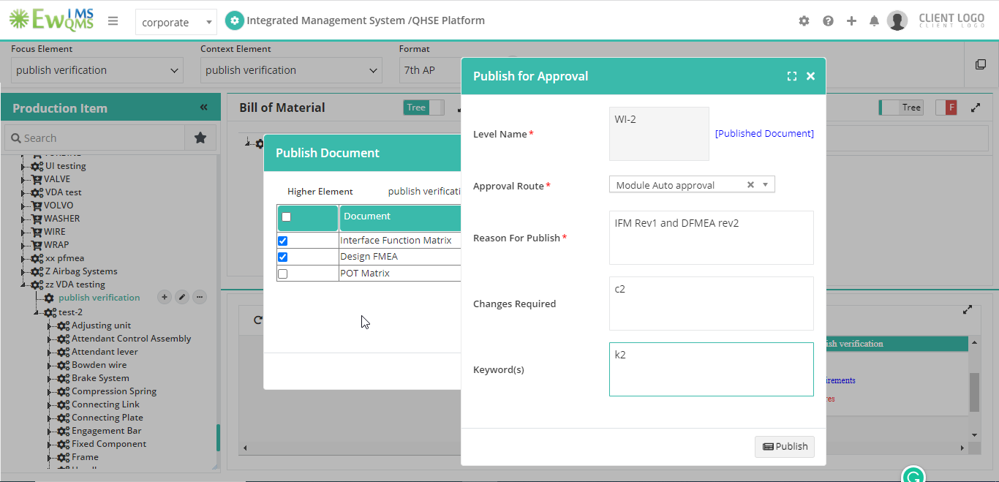
5. The IFM document was shown as Revision 2.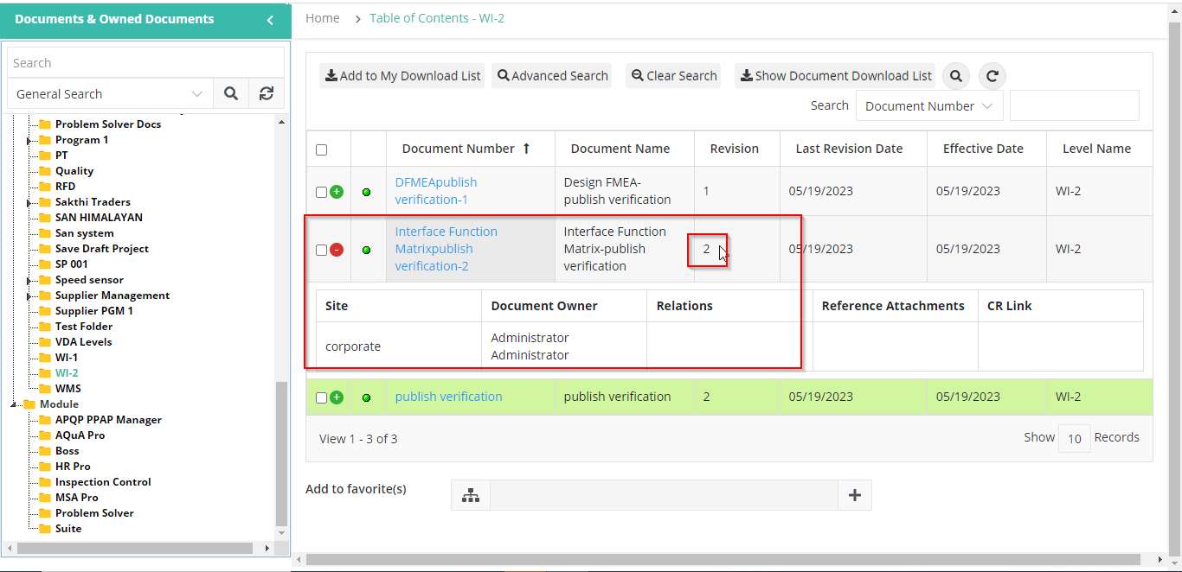
6. Approval Route for the second time, I cannot publish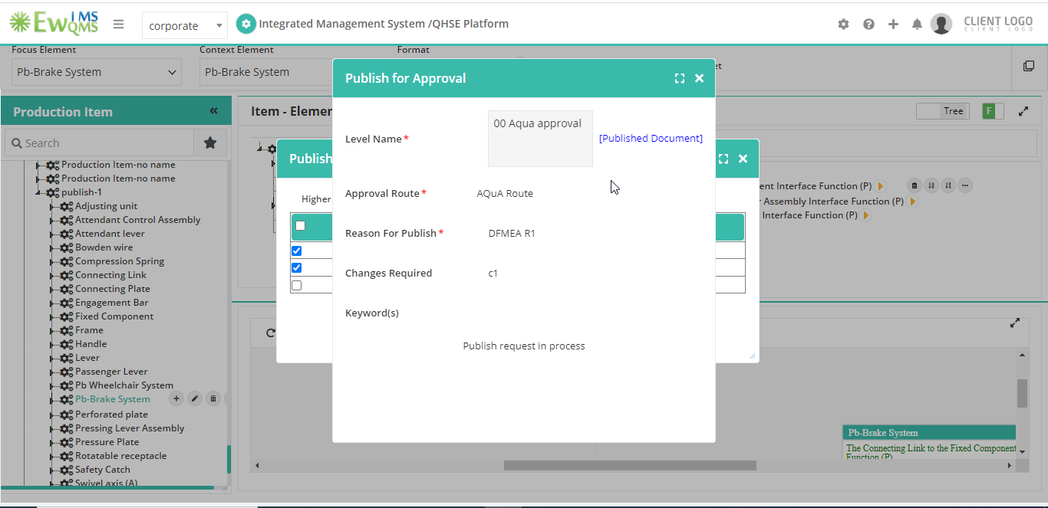
7. POT matrix document, requested by name of Administrator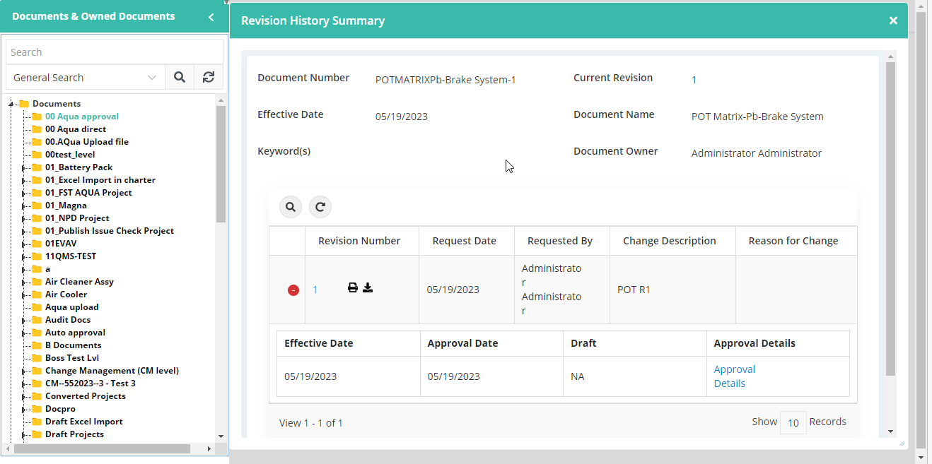
8. This document was already published from the PI tree; then again publish the document from IFM page. The existing level is not shown.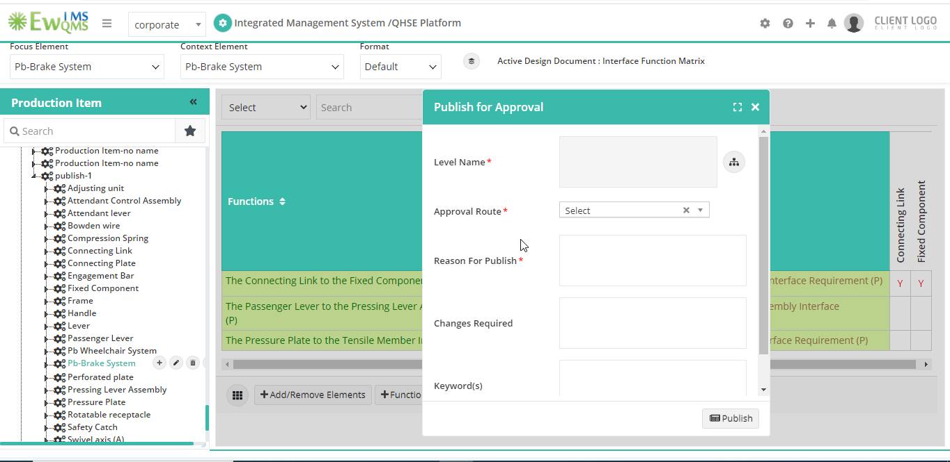
9. IFM document 404 Error

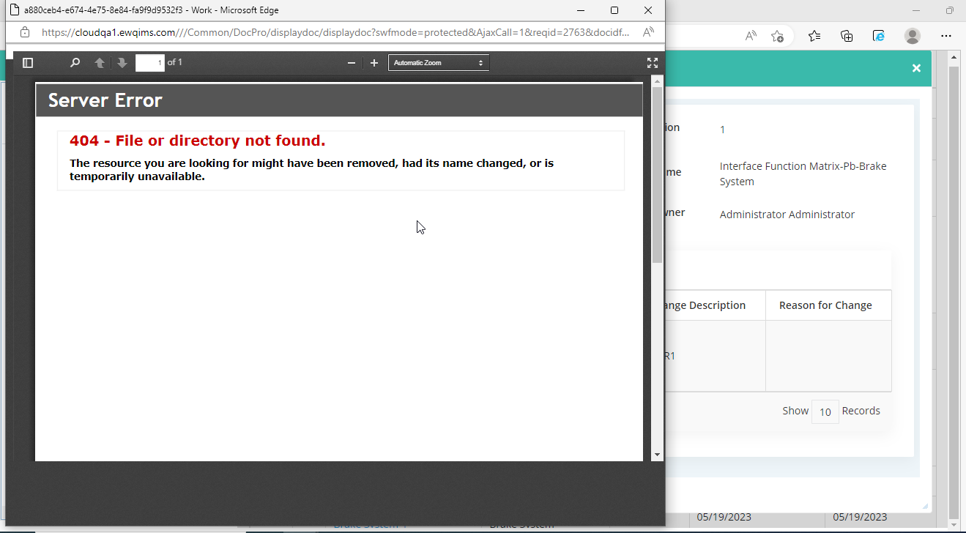

1. POT matrix document, requested by name of Administrator, document unable to open

