**AQuaPro – Polish Language Issues**

1.AQuaPro - ‘Administrator Actions’ not correctly converted in Polish language (‘Administrator Actions’ =Akcje administratora)

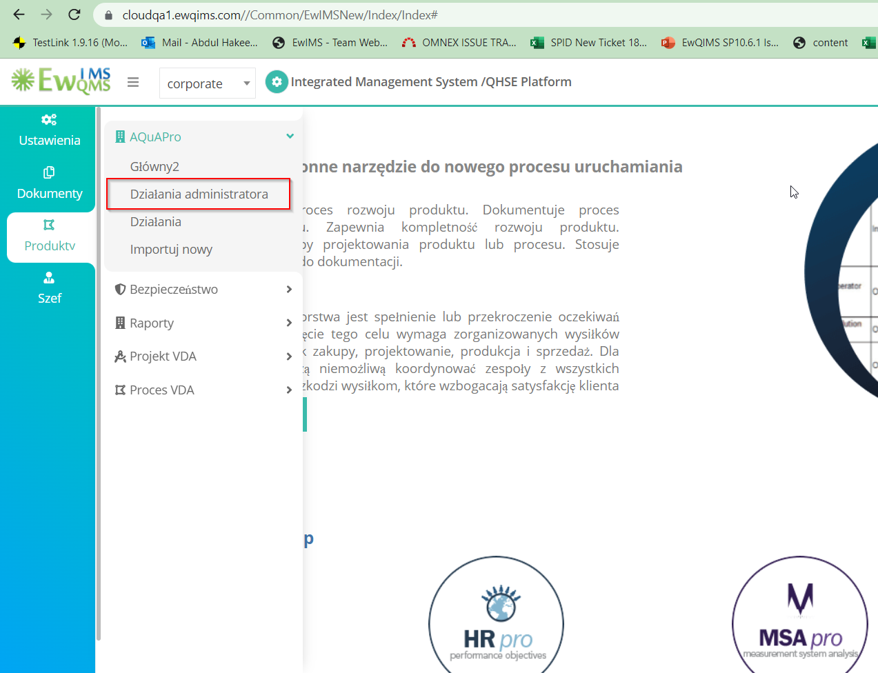

2.AQuaPro - Main2- ‘OK’ button not correctly converting to Polish language

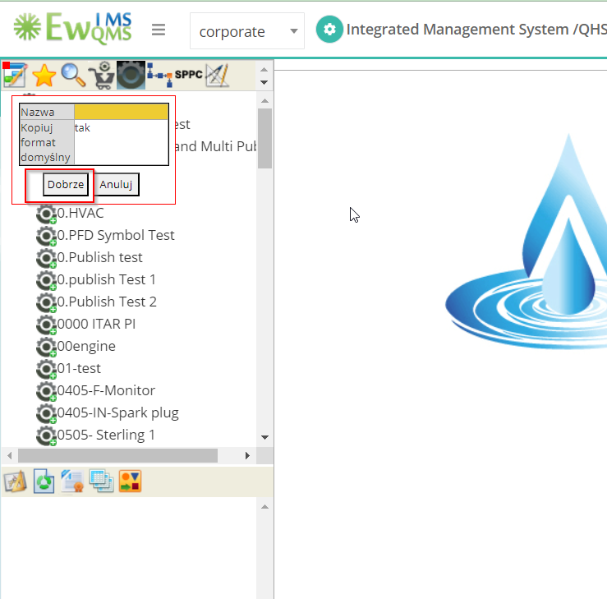

3.AQuaPro - Main2 – Add from other - ‘Select Format’ name is not converting in the Polish language

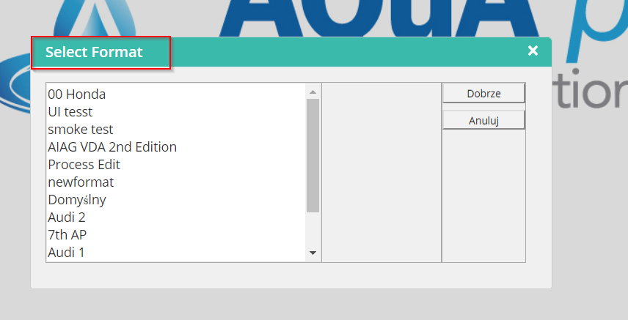

4.AQuapro - Main2- ‘Purchased Production item’ not correctly converting in Polish language (‘Purchased Production item’= Zakupiona pozycja produkcyjna)

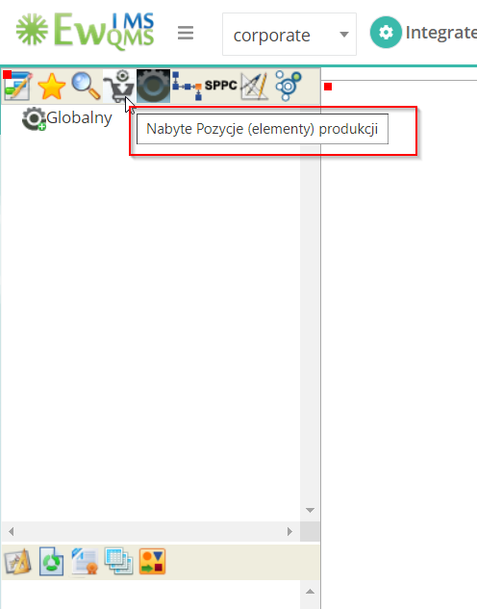

5.AQuaPro - Open document - ‘Some Fileds’ are not converting in Polish language

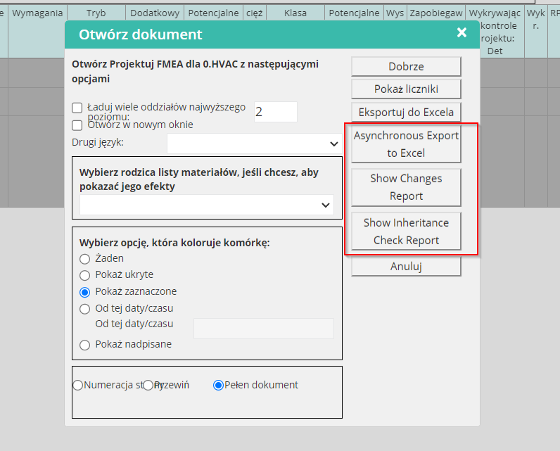

6.AQuaPro - Shoe changes Report and Show inheritance Report inside dialog box not converted in Polish language

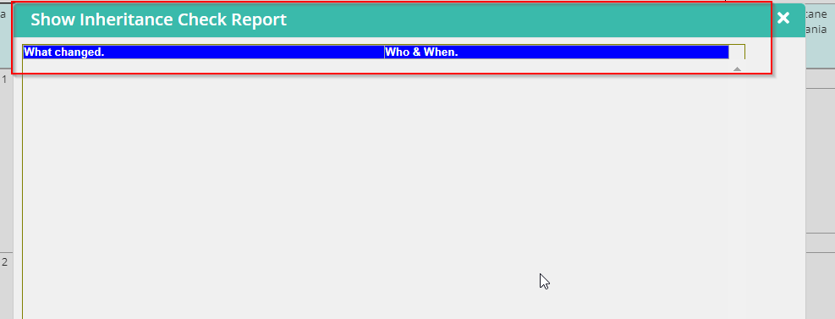

7.AQuaPro - Main2 - ‘Design FMEA – MSR' is not converting in Polish language

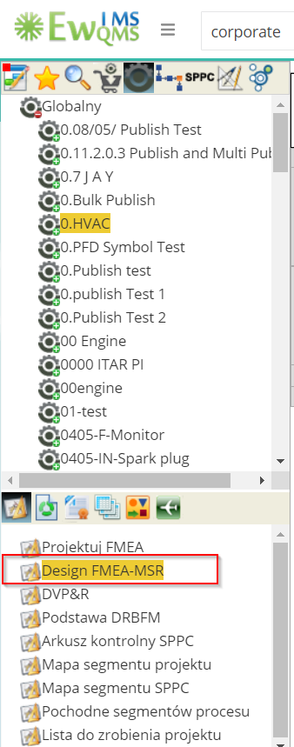

8.AQuaPro - Design FMEA – MSR - ‘Column Headers’ are not converting in Polish language

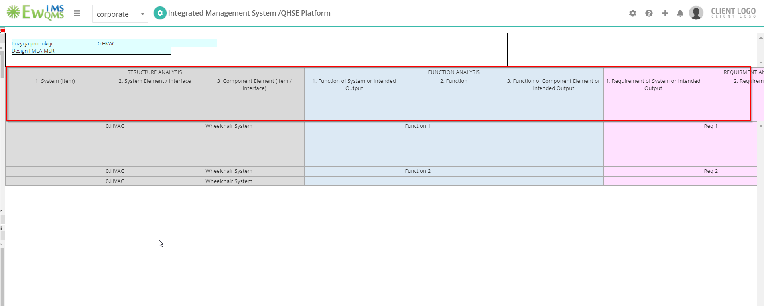

9.AQuaPro - Main2 - ‘DRBFM Base’ is not correctly converting in Polish language (‘DRBFM Base’ = Baza DRBFM)

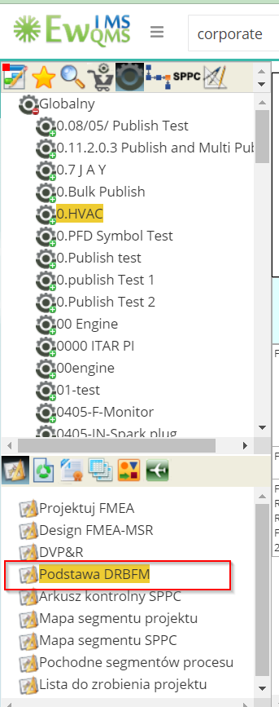

10.AQuaPro - Publish Page - ‘In process Document’ word is not converting in Polish language

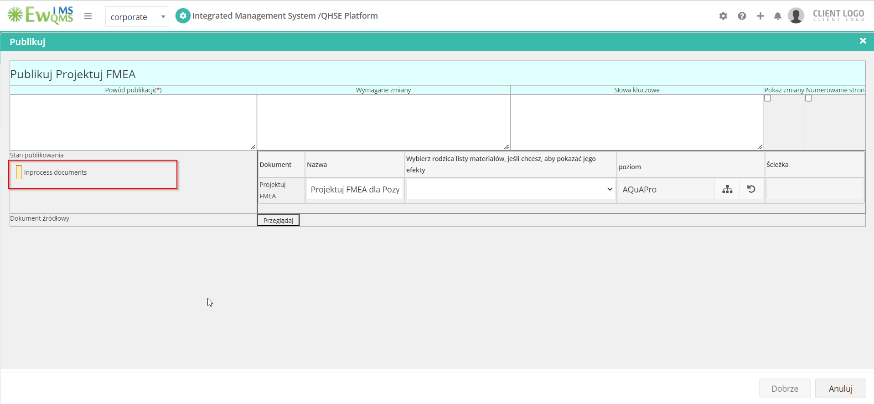

11.AQuaPro - Open Document – Some fields are overlapping when I changed the Polish language

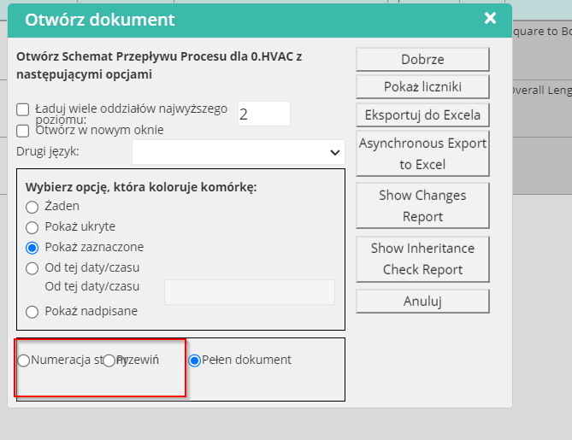

12.AQuaPro - Design/Process - document Headers AQuAColumn Headers and Cell right click option – Hyperlink – Ok and Cancel button not converting in Polish language

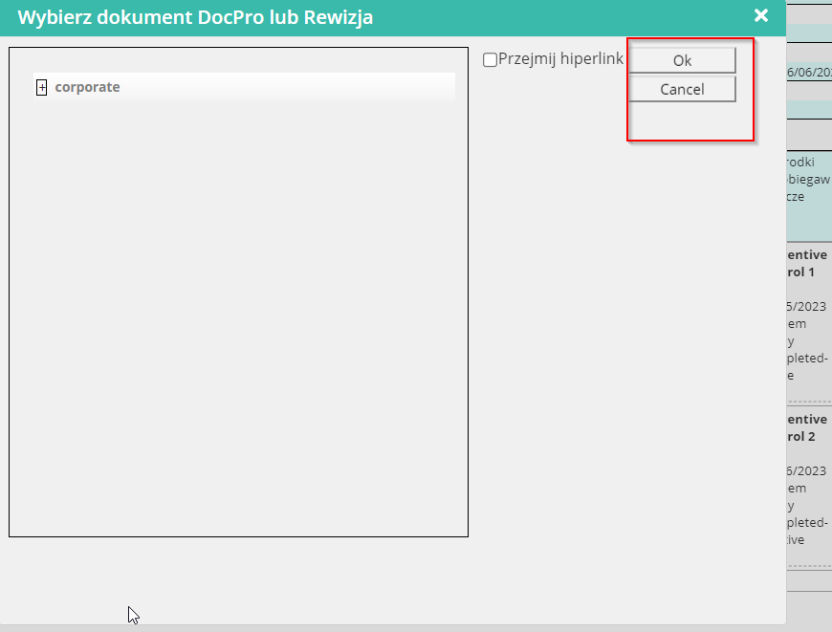

13.AQuaPro - Work Instruction – Some option Overlapping and Cancel button is not converted in Polish language

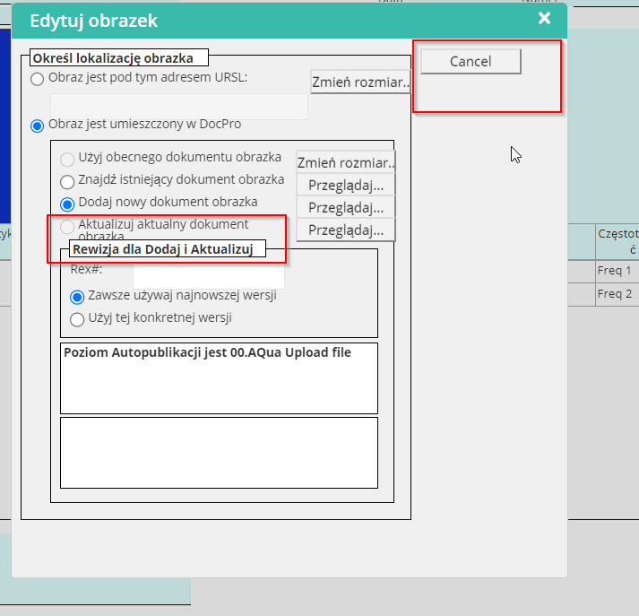

14.AQuaPro - WI – work Sequence - ‘Label Missing’ is Polish Language

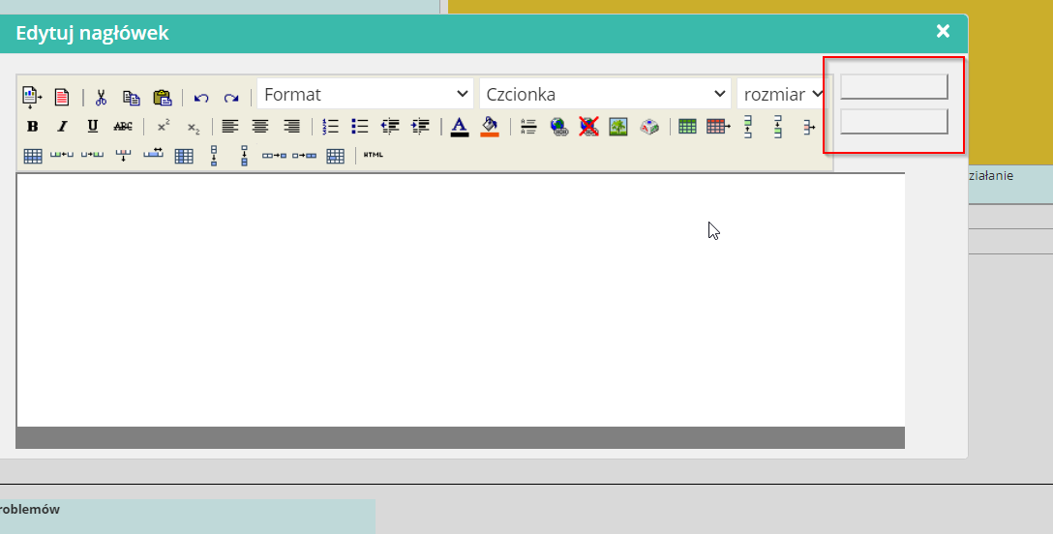

15.AQuaPro - PQCT 1 – Server error happened when I trying open the PQCT 1 Form in Polish Language

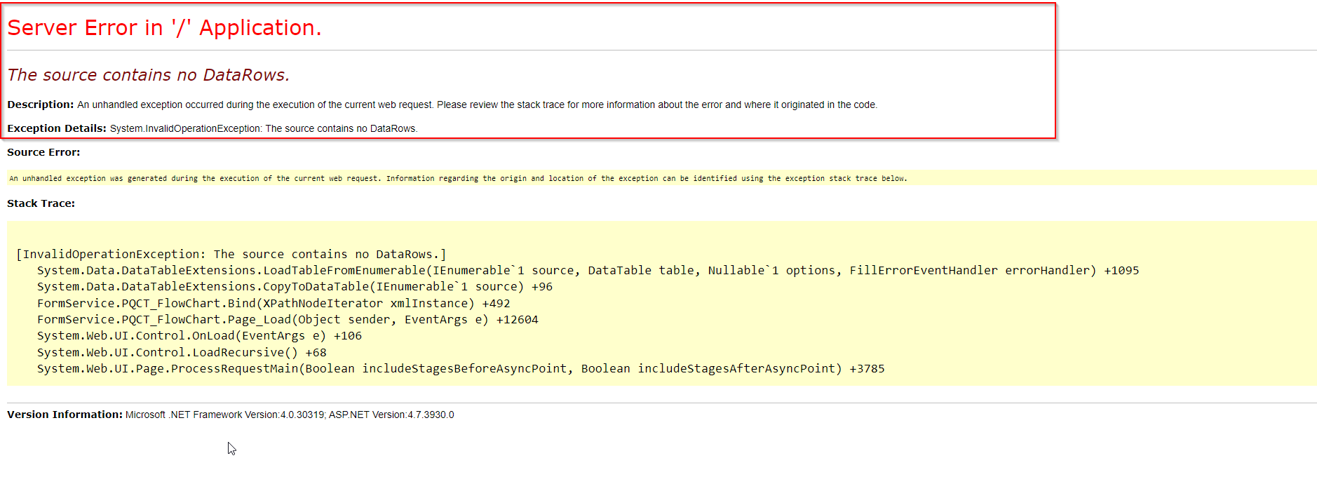

16.AQuaPro - PQCT 2 – Form not opened in Polish language

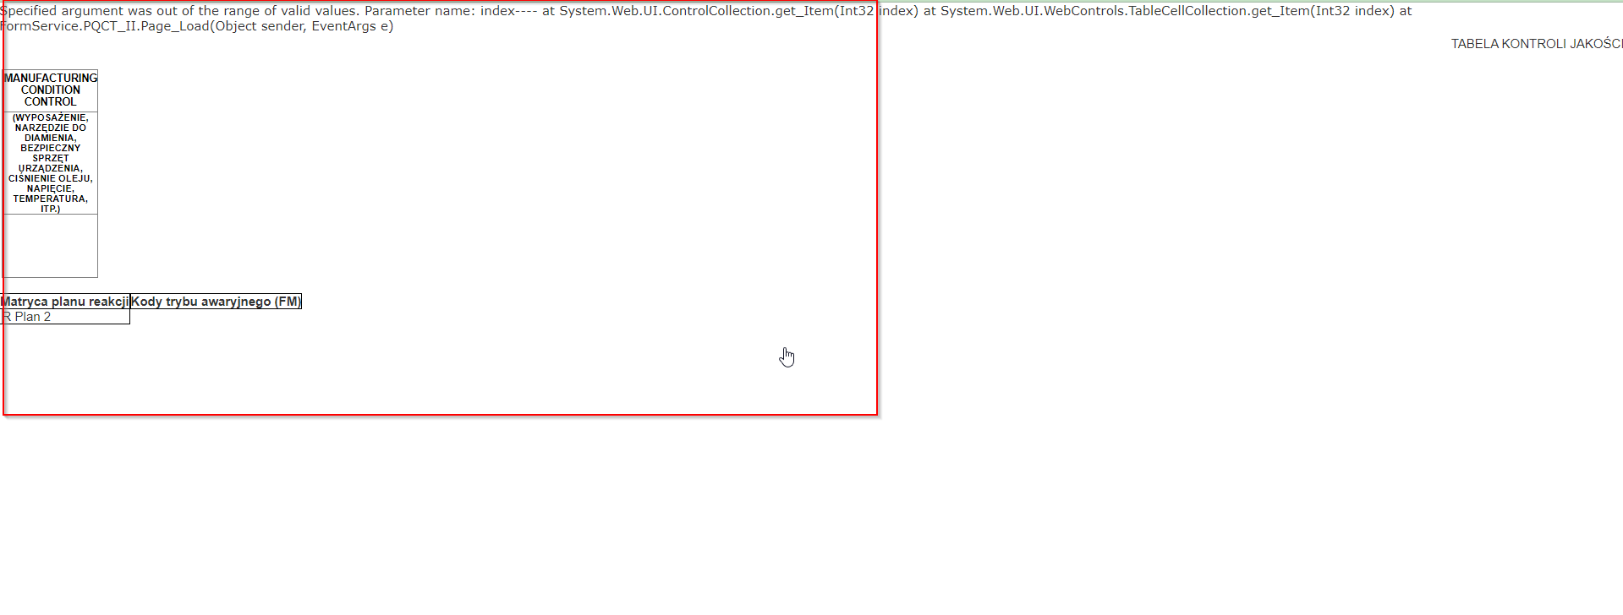

17.AQuaPro - PPAP Check sheet is not converting in Polish language

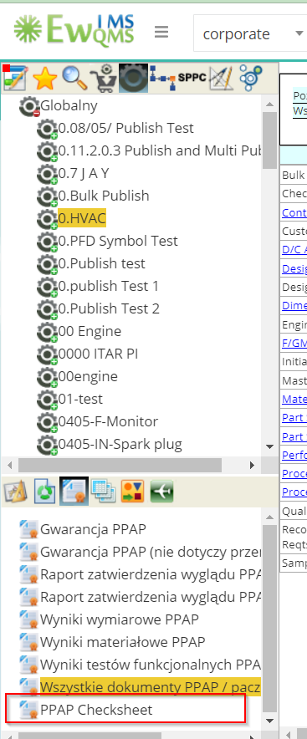

18.AQuaPro - Tables - ‘Mechanism’ table name was not converted in Polish language and Column headers are not converted in Polish language

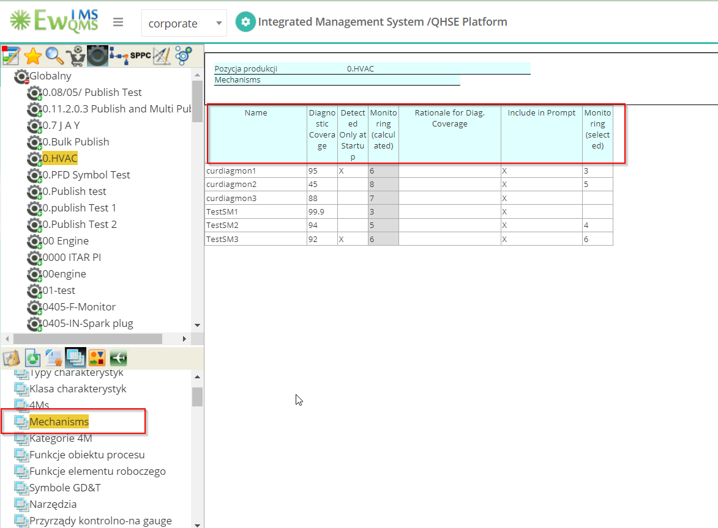

19.AQuaPro - Tables - ‘MSR Monitoring Values’ table name was not converted in Polish language and Column headers are not converted in Polish language

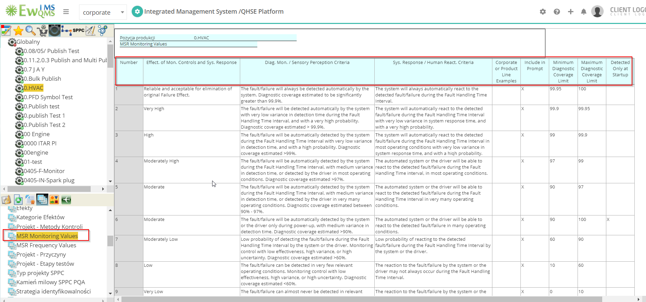

20. AQuaPro - Tables - ‘MSR Frequency Values’ table name was not converted in Polish language and Column headers are not converted in Polish language

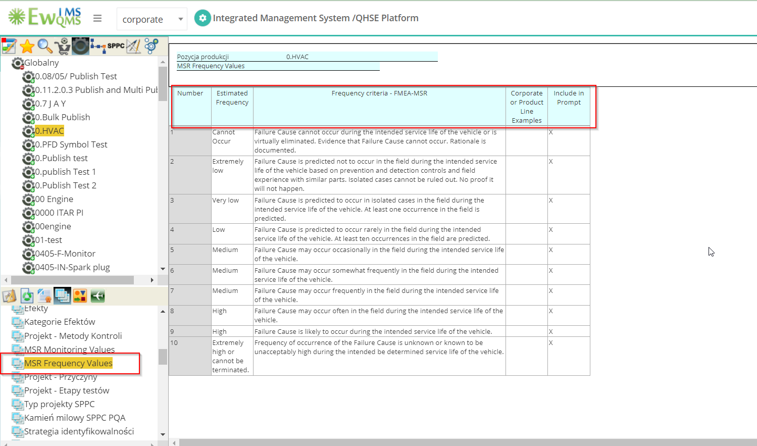

21. AQuaPro - Tables - ‘laboratories’ table name was not converted in Polish language and Column headers are not converted in Polish language

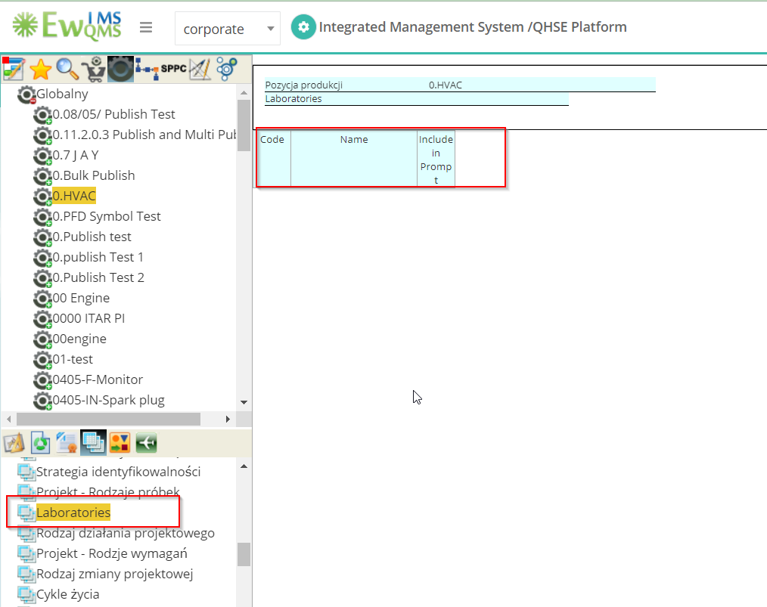

22.AQuaPro - FAI Forms – Inside a Form all the filed are not converted in Polish Language

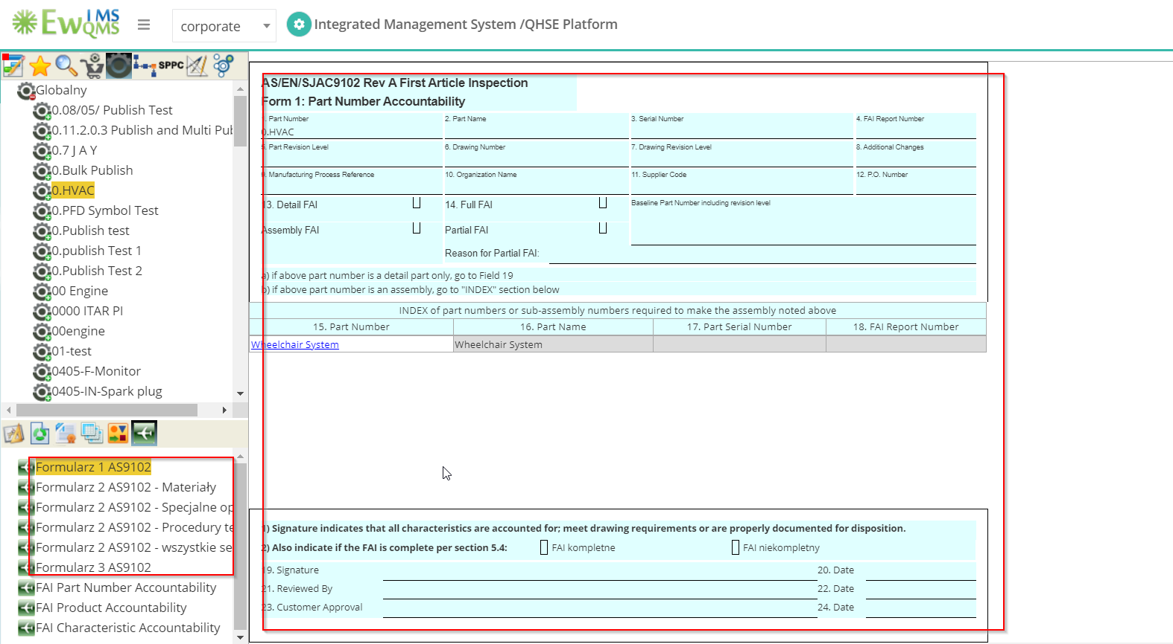

23.AQuaPro - TASL – Form name was not converted in Polish language

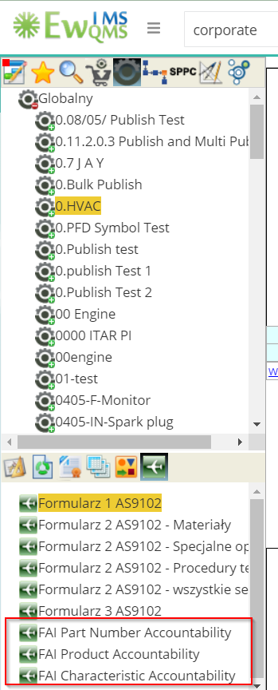

24.AQuaPro - Process Flow – PFD Symbol not showing in Polish language (Segments as well)

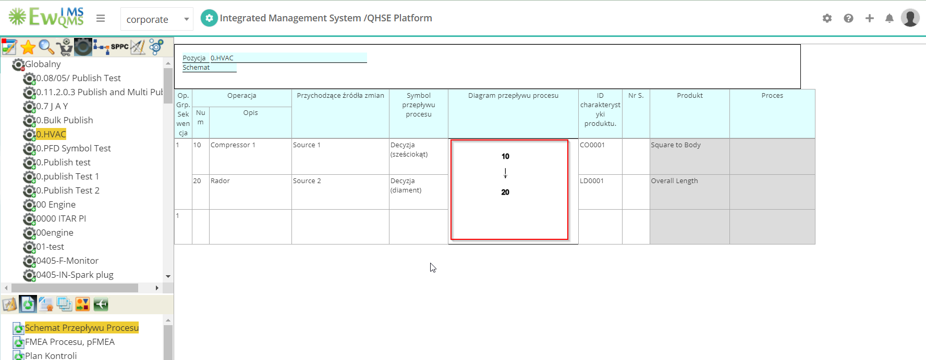

25.AQuaPro - Action - ‘Some sentence ‘not converted in Polish language

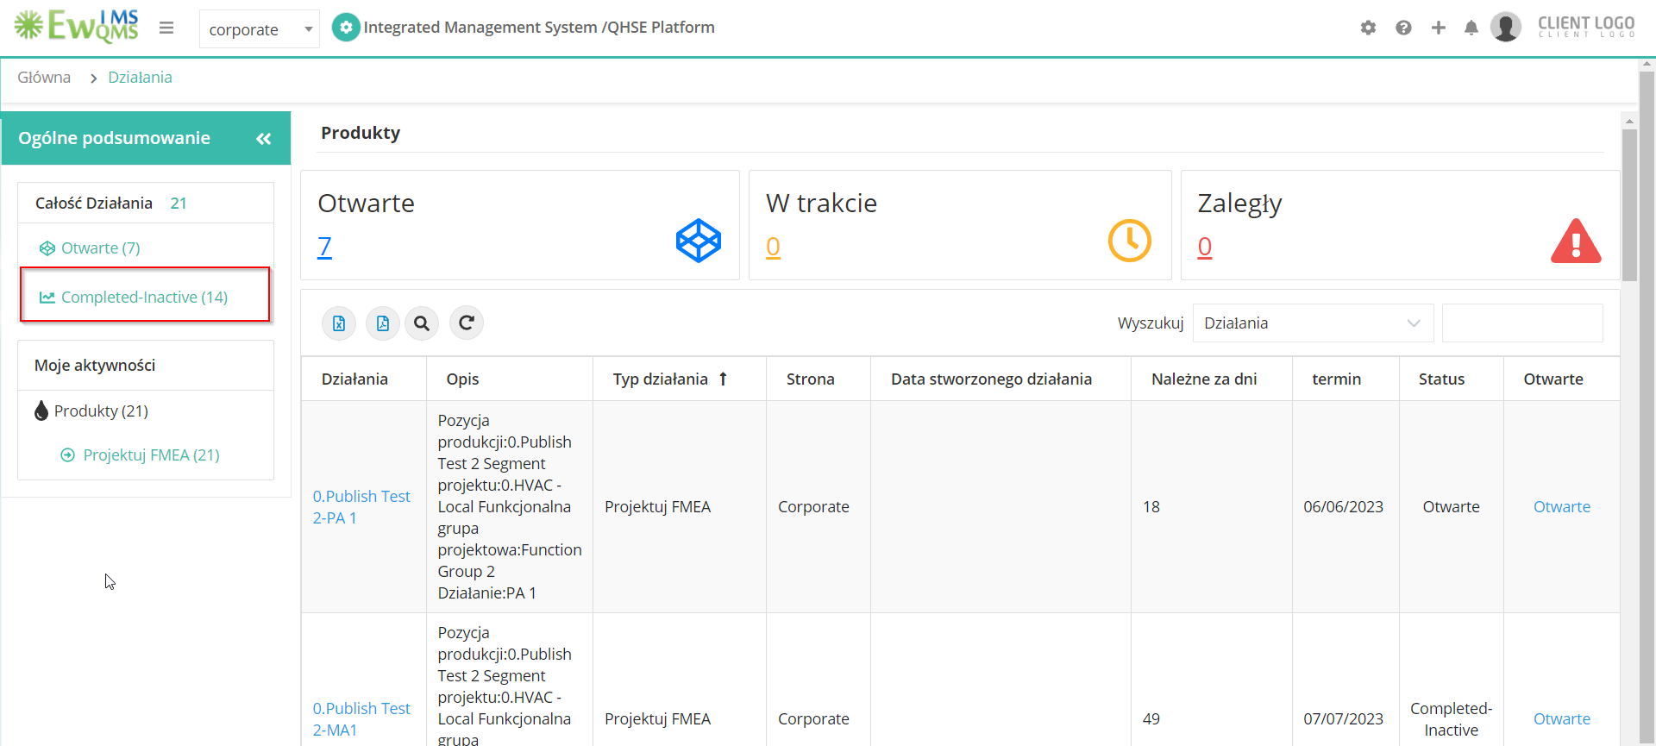

26.AQuaPro - Security option – Some dropdown option not converting in Polish Language

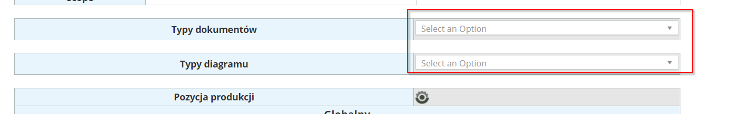

27.AQuaPor - ‘Home’ is not converting in Polish language

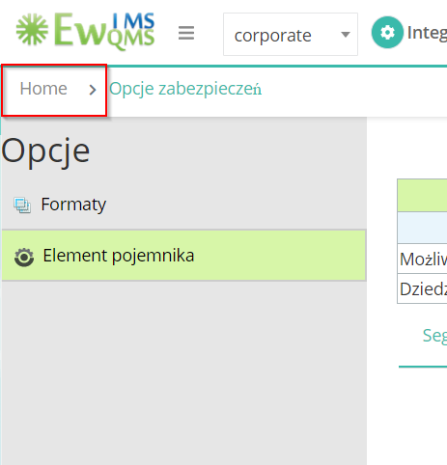

28.AQuapro - Preference New – Colors not showing in Polish language

