**AquaPro German Language Issues**

1.AQuaPro - ‘Main2’ the word converting is wrong name (Main2=’Haupt2’ actual word)

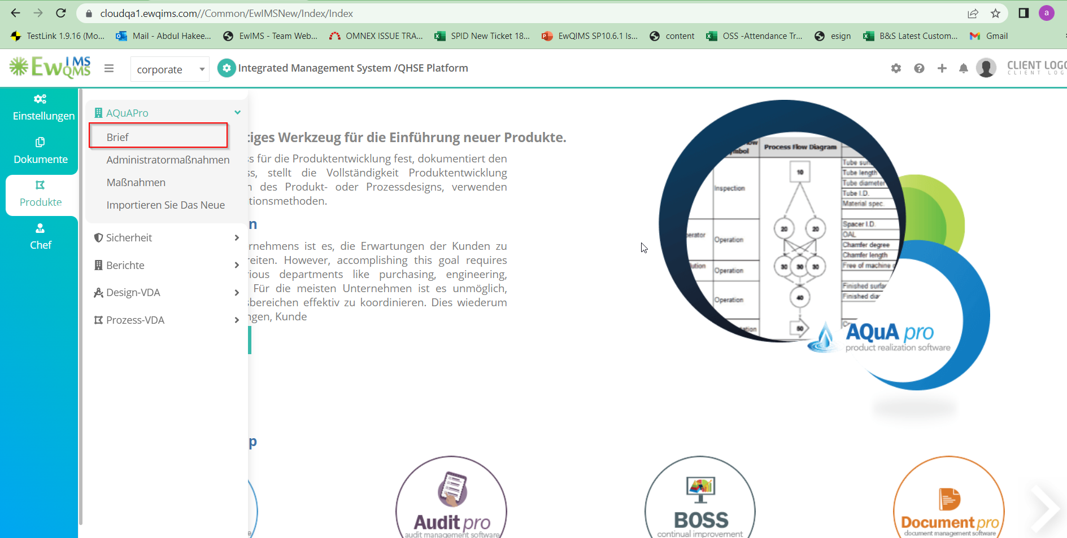

2.AQuaPro - ‘Administrator Actions’ and ‘Actions’ is converting to German is wrong and Actual word is ‘Administrator Actions’ = Administratoraktionen, ‘Actions’= Aktionen

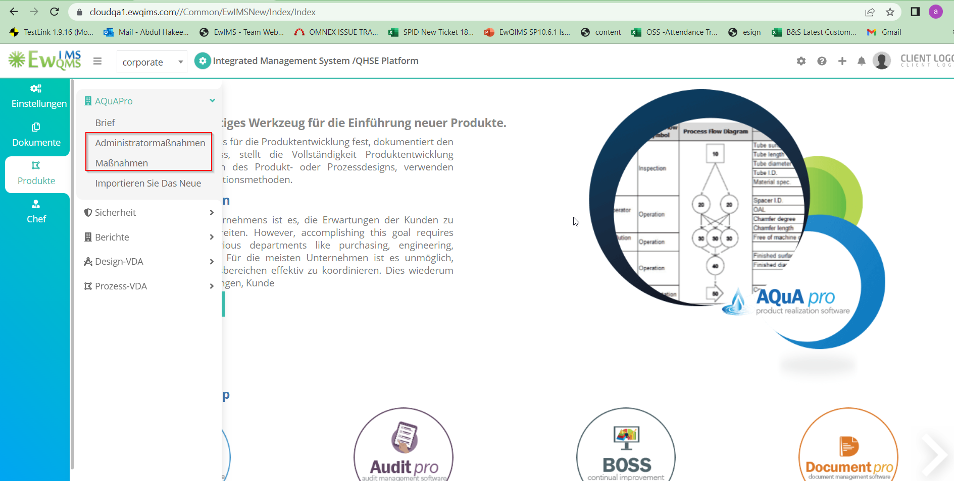

3.AQuaPro - ‘Import New’ not converting into the German language (Import New =Neu importieren)

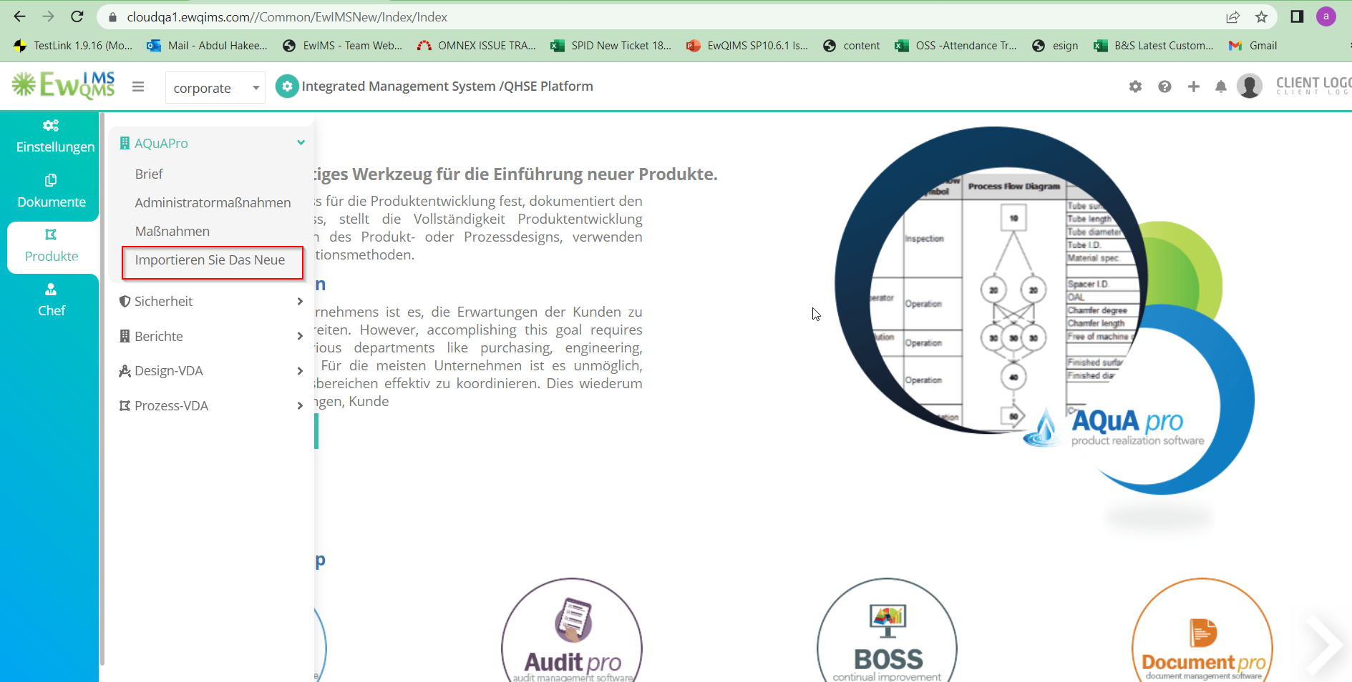

4.AQuaPro - Main2 - ‘Hide list’ not correctly converting to German language (‘Hide list’ = Liste ausblenden)

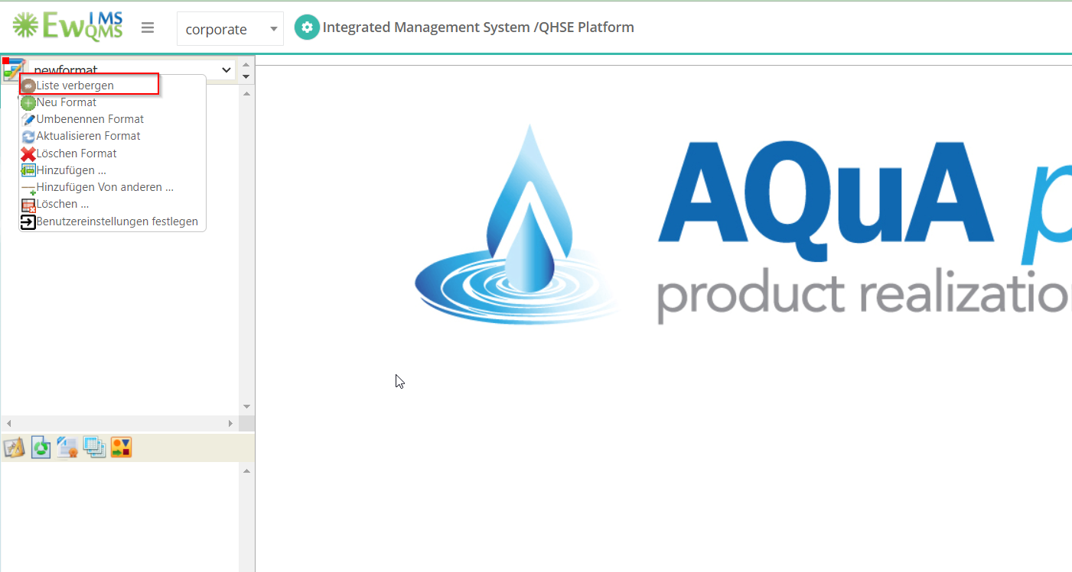

5. AquaPro - Main2 - ‘New Format’ not correctly converting to German language (‘New Format’ =Neues

Format)

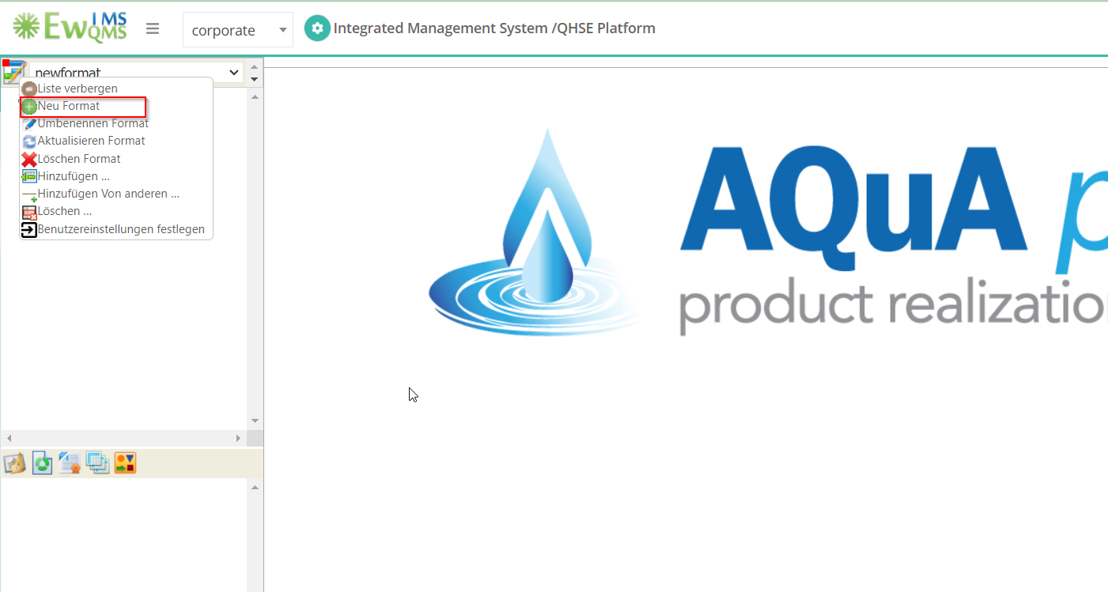

6.AQuapro - Mani2 – Format list not showing when I change language English to German

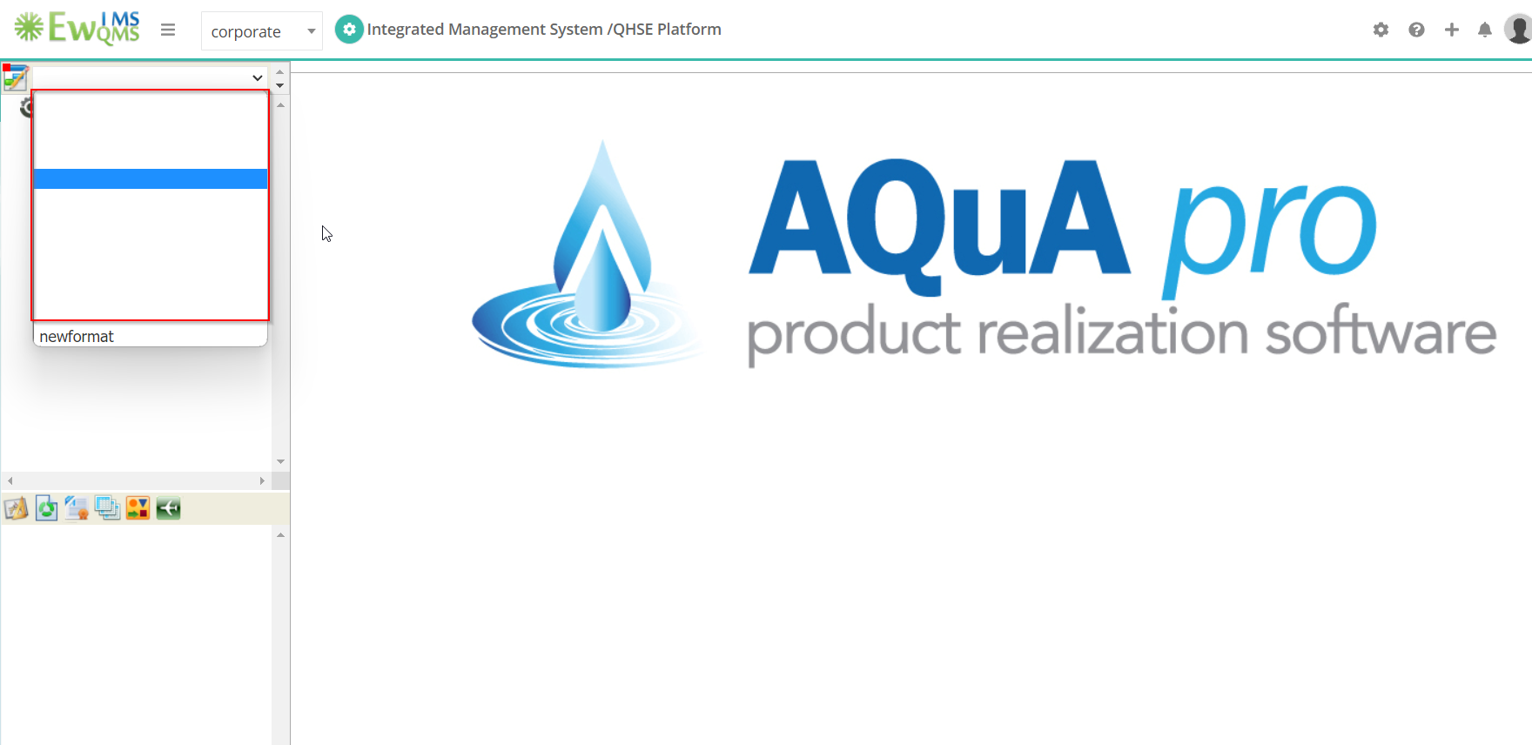

7.AQuaPro - Main2 - ‘Purchased Production Item’ Not Converting in German Language (‘Purchased Production Item = ‘Gekaufter Produktionsartike’)

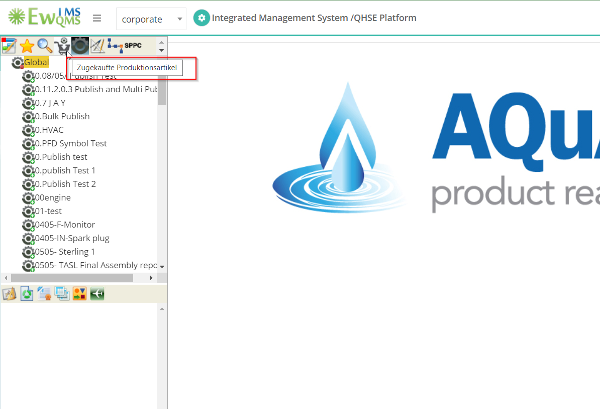

8.AQuaPr - Main2 - ‘Manufactured Production Item’ Not Converting in German Language (‘Manufactured Production Item = ‘Hergestellter Produktionsartikel’)

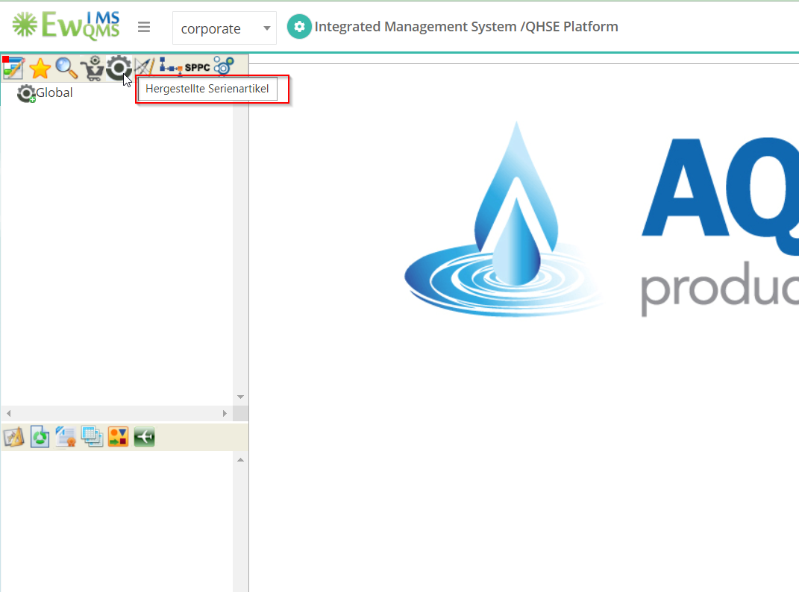

9.AQuaPro - Main2 - ‘Operations’ wrongly converted into the German language (‘Operations’ = Operationen)

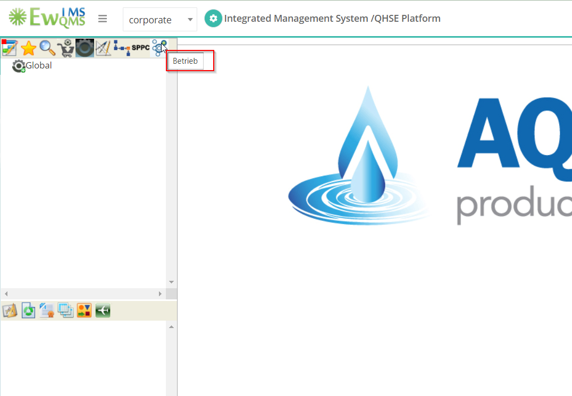

10. AQuaPro - Main2 - ‘Publish’ wrongly converted into the German language (‘Publish’ = Veröffentlichen...)

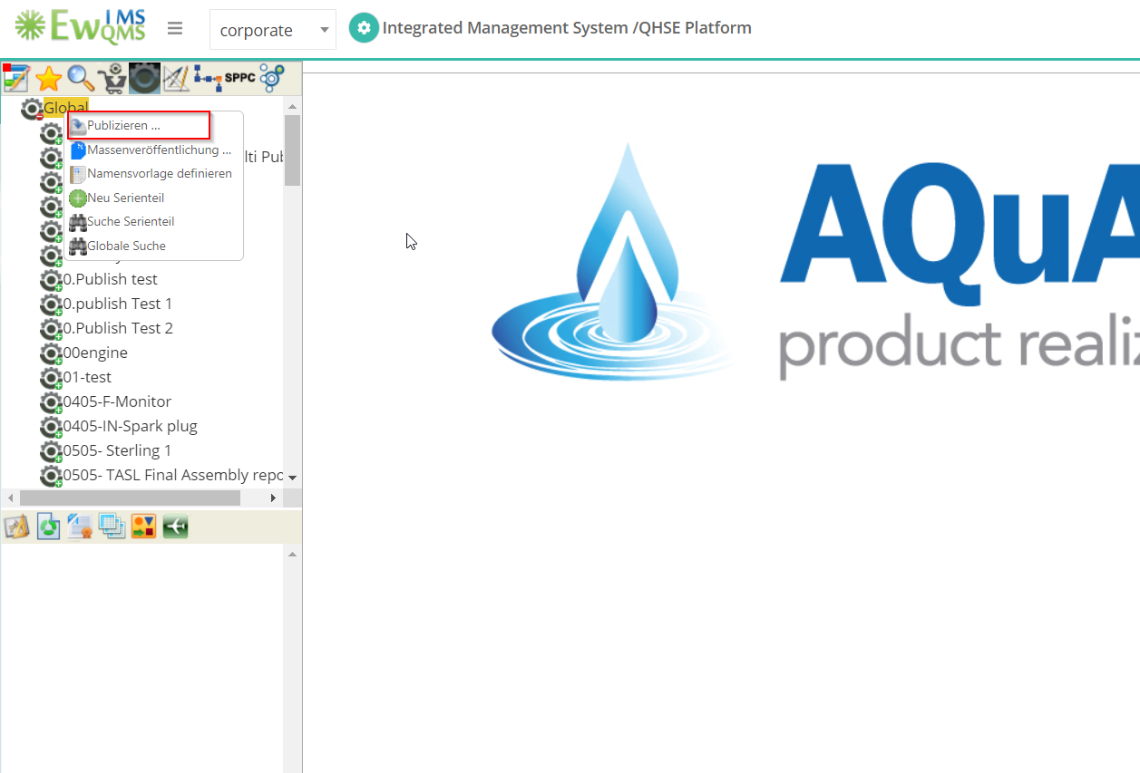

11.THL Error happened on session Timeout

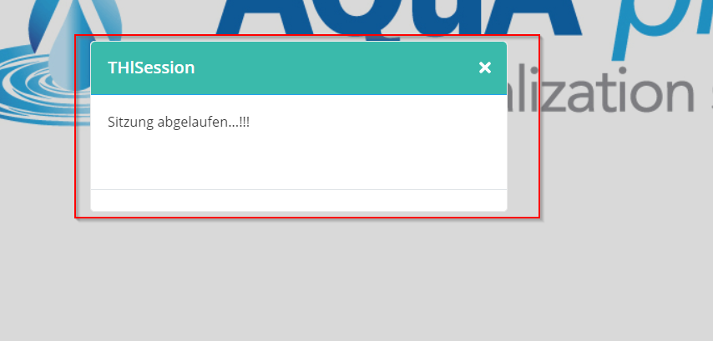

12.AQuaPro - main2 - ‘OK’ and ‘Cancel’ button not correctly converting in German language (For all page's same issue happened)

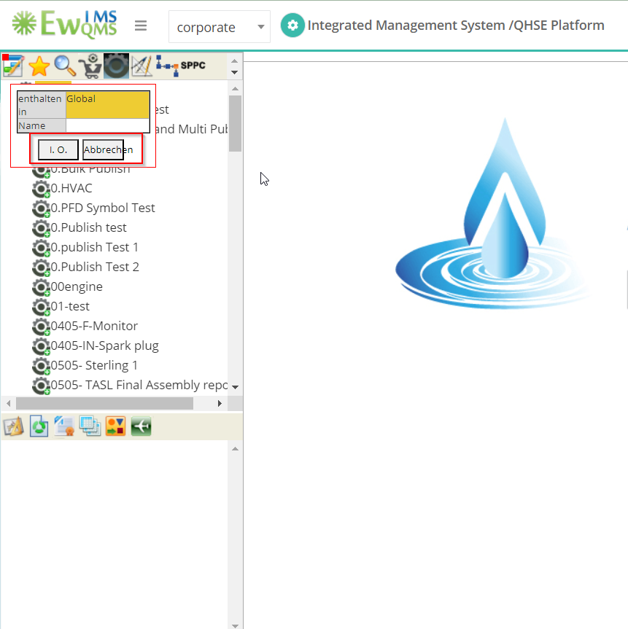

13.AQuaPro - Main2 – Descendant Design Segment and Design To Do List not correctly converting in German language (‘Descendant Design Segment’ = Nachkommende Designsegmente and Design Todo list = Design-To-Do-Liste)

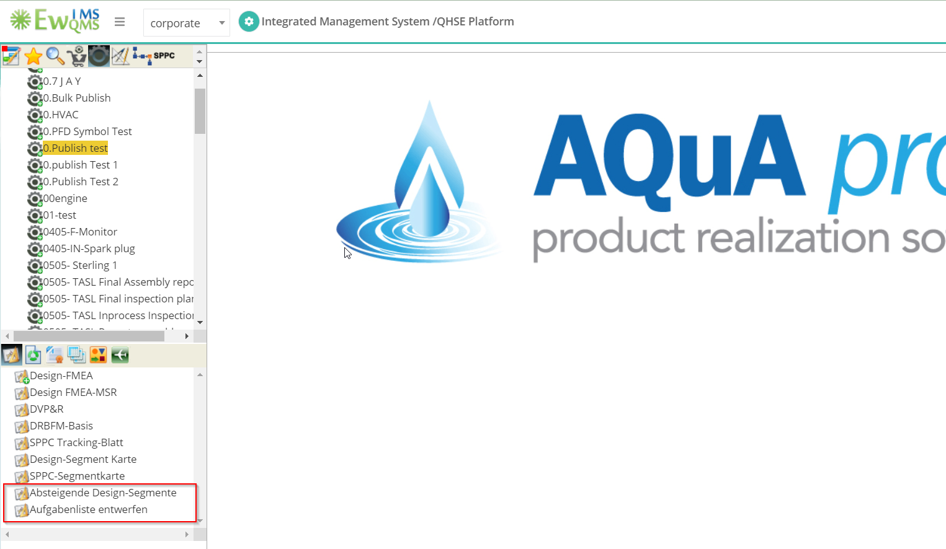

14.AQuaPro - Design FMEA MSR Column Headers are not converting in German language

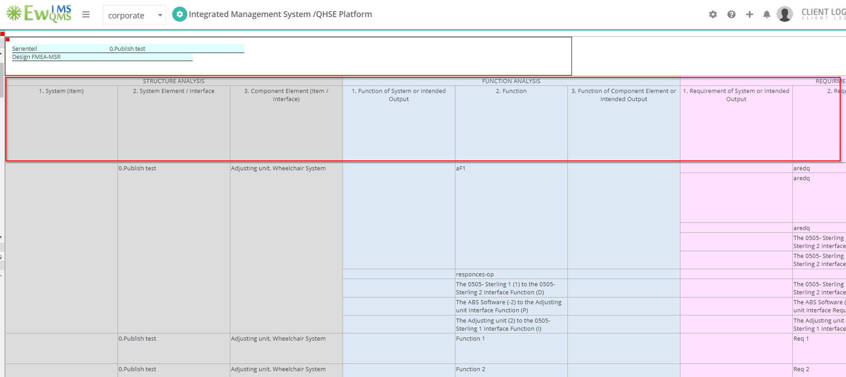

15.Aquapro - open documents- some option not converting in German language

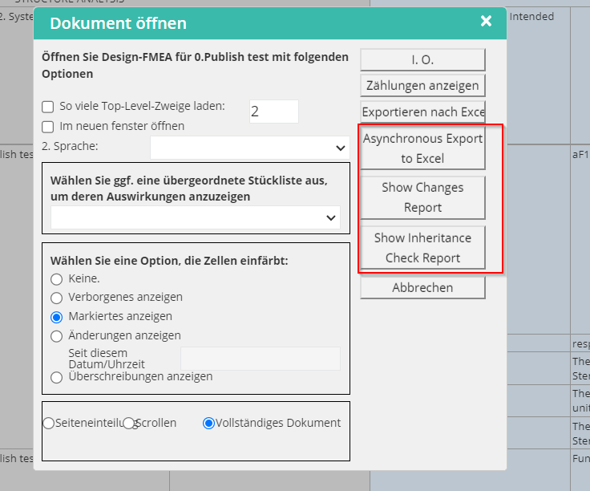

16.AQuaPro - Right click option not working in German language (it happened in Design/process and segments as well

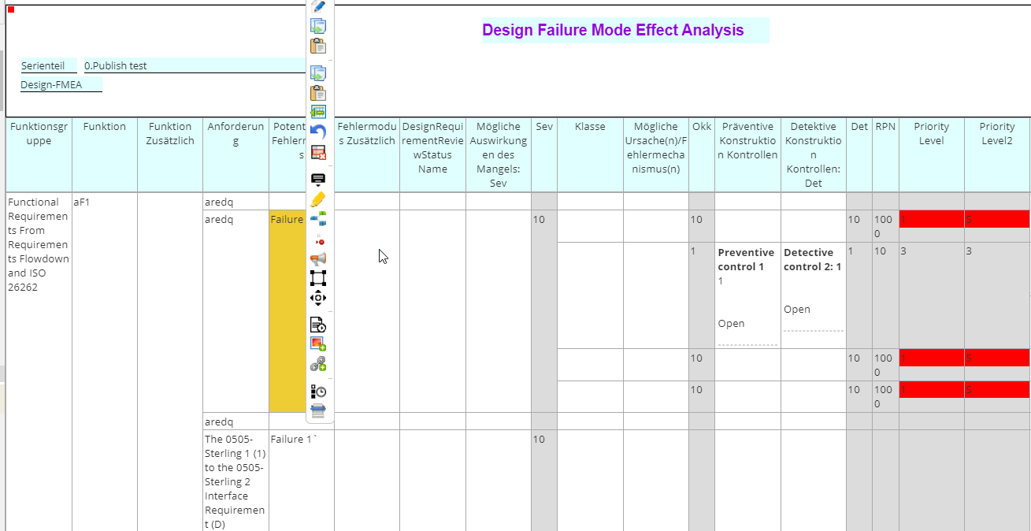

17.AQuapro - BOM – Some word not converting in German language

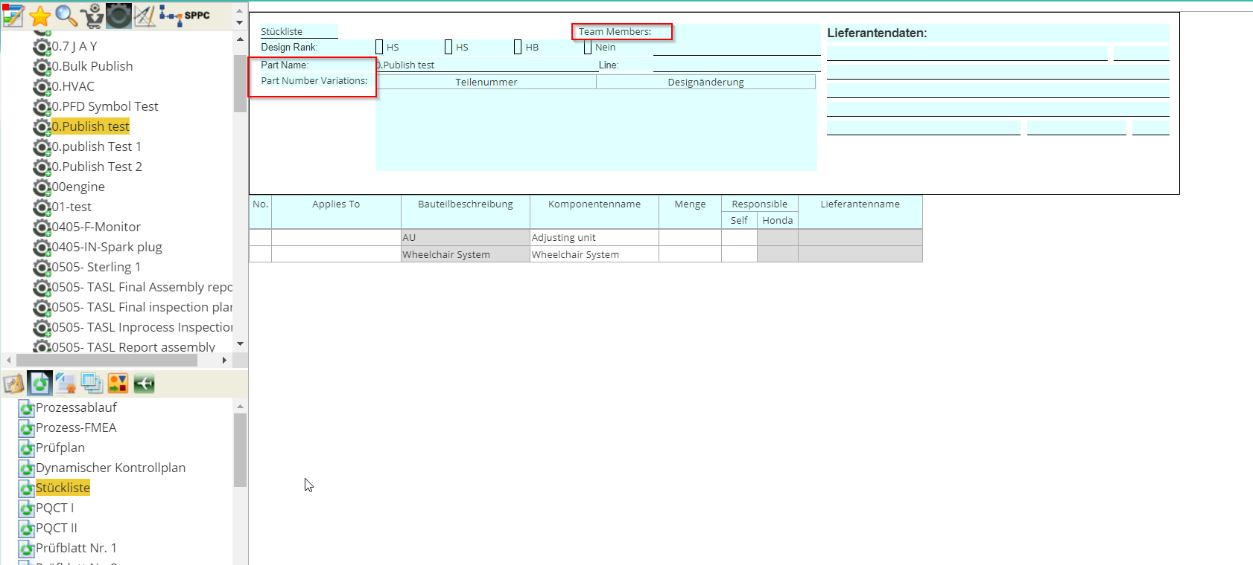

18.AQuapro - PFMEA – Some name was not converting in German language

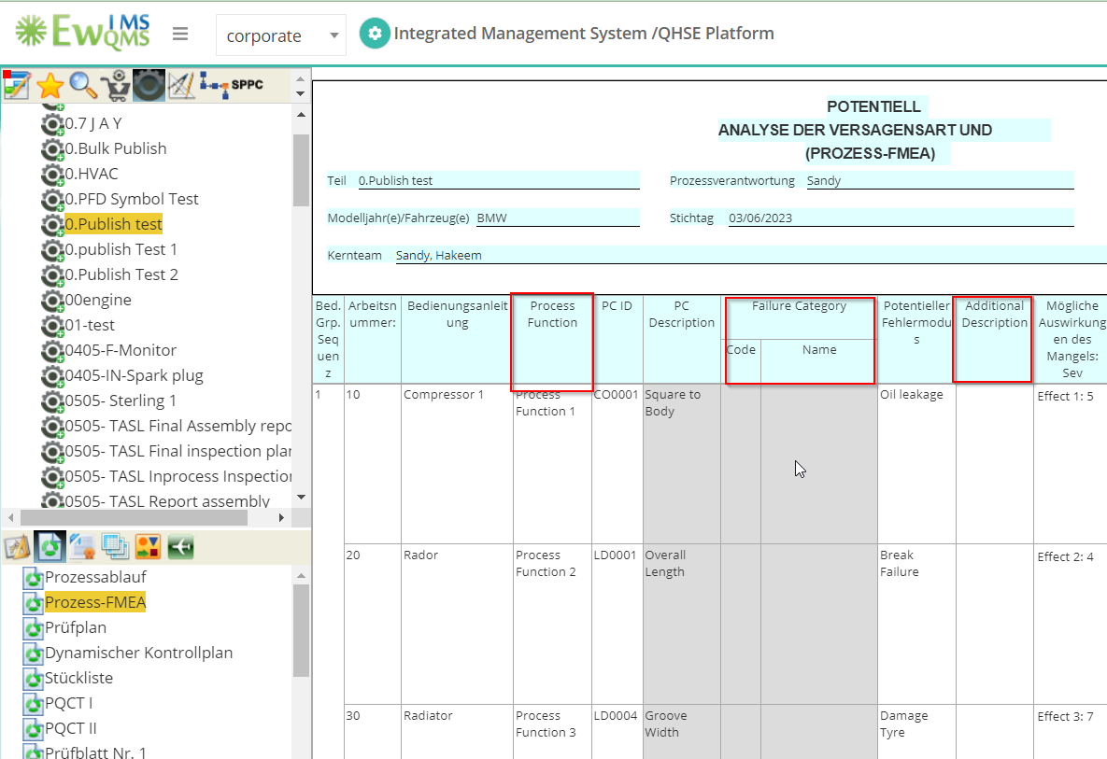

19.AQuaPro - Tables – MSR Frequency and Monitoring not converting in German language

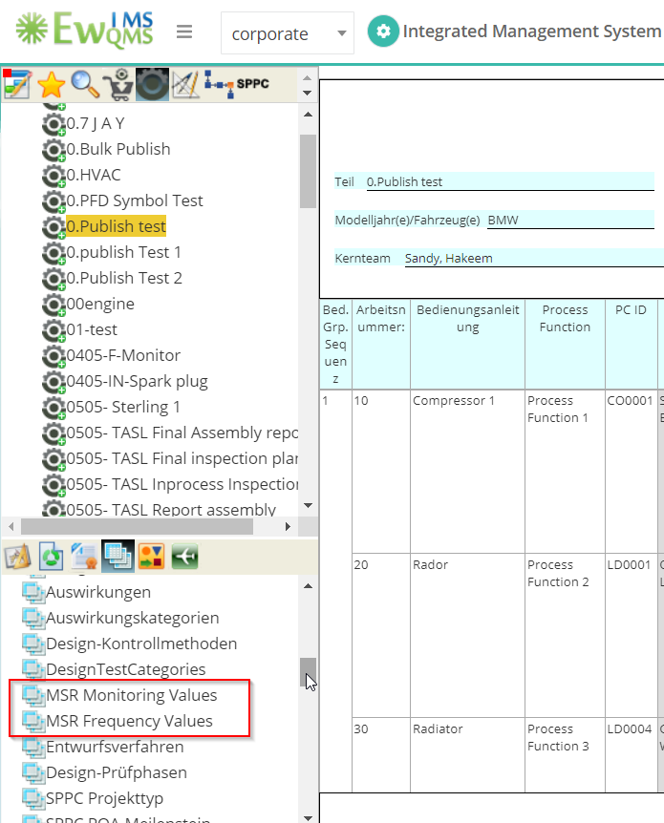

20.AQuaPro - Tables – Mechanism is not converting in German language

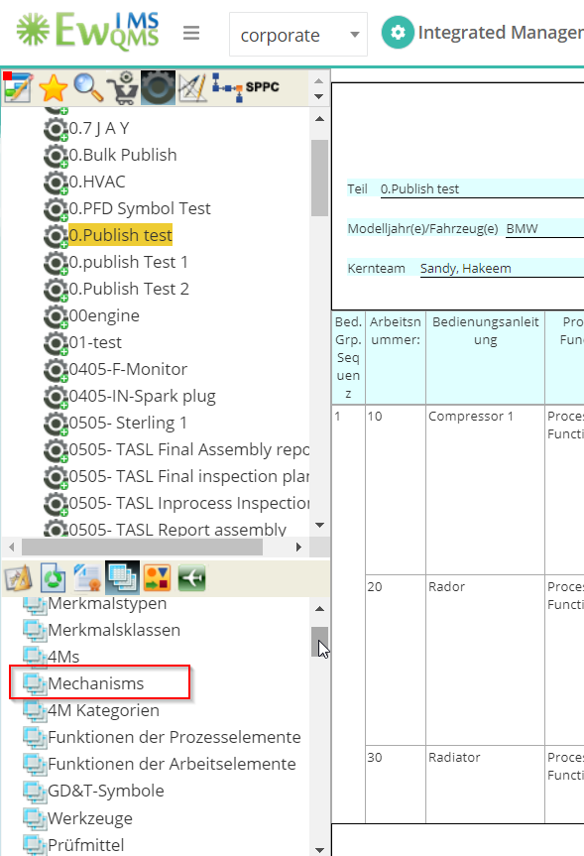

21.AQuaPro - Process documents - ‘Control Plan’ is not correctly converting in German language

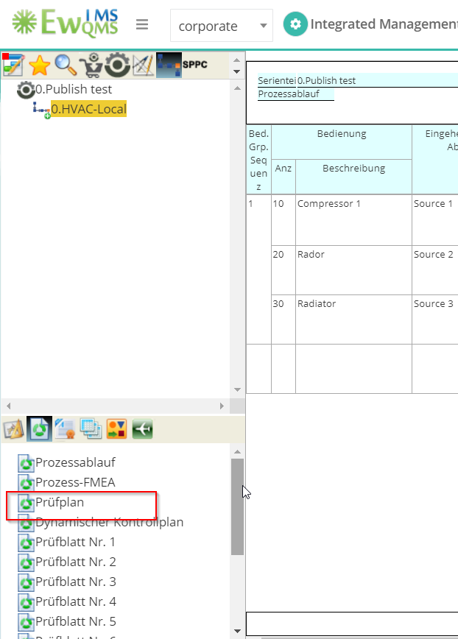

22.AQuaPro - WI – Overlapping the option

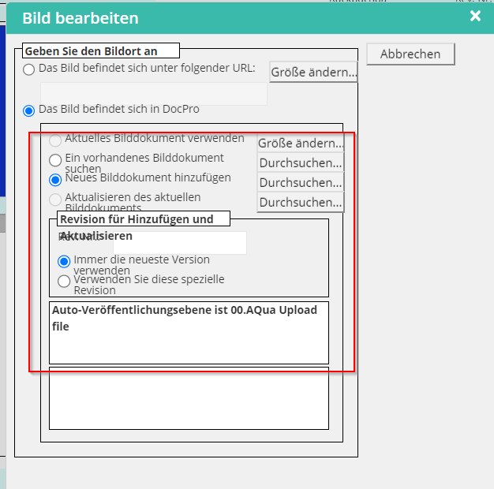

23.AQuapro - Admin Action - ‘Home’ word is not converting in German language

Lable missing in German language

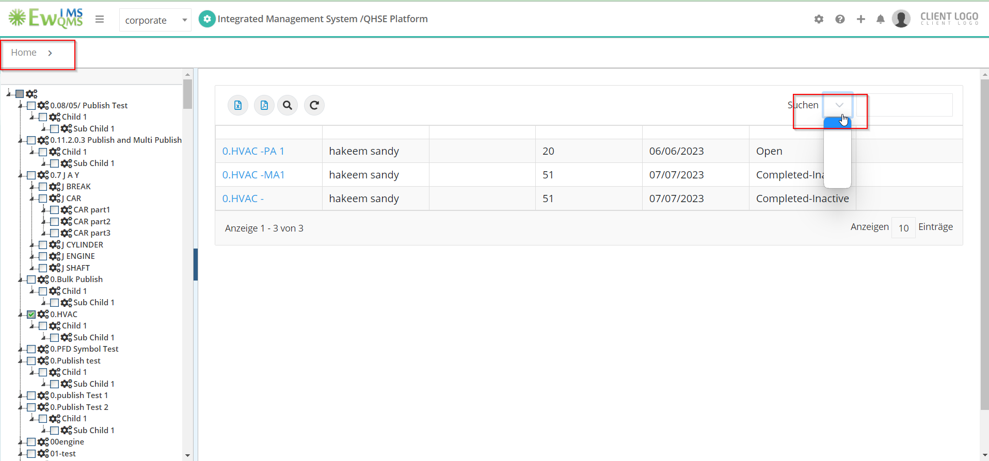

24.AQuaPro - Action name is not converting in German language

Lable missing in German language

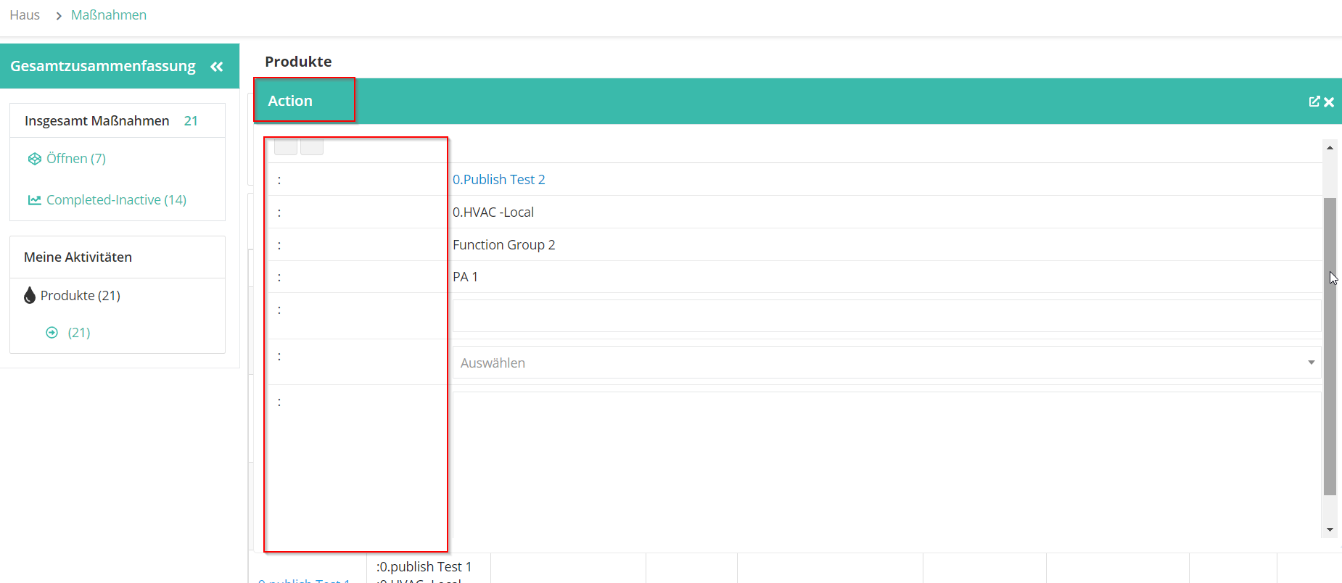

25.AQuaPro - Import New – Lable Missing in German language

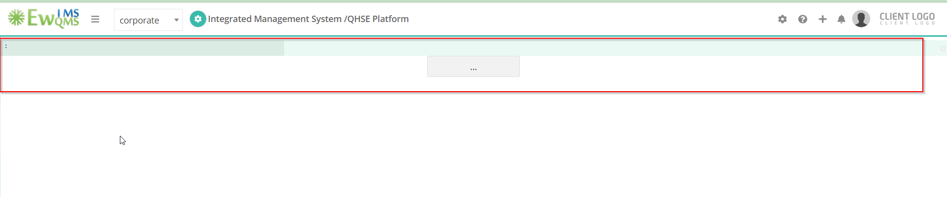

26.AQuaPro - Security Definition New – Some Lable Missing in German Language

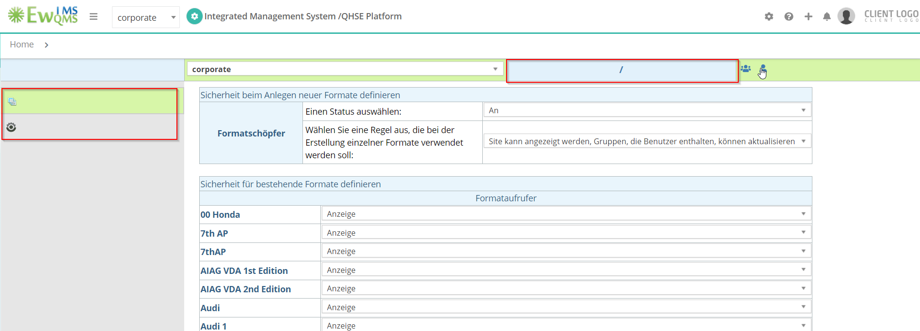

27.AQuaPro Security Definition New - ‘Global’ Production item Missing in German language

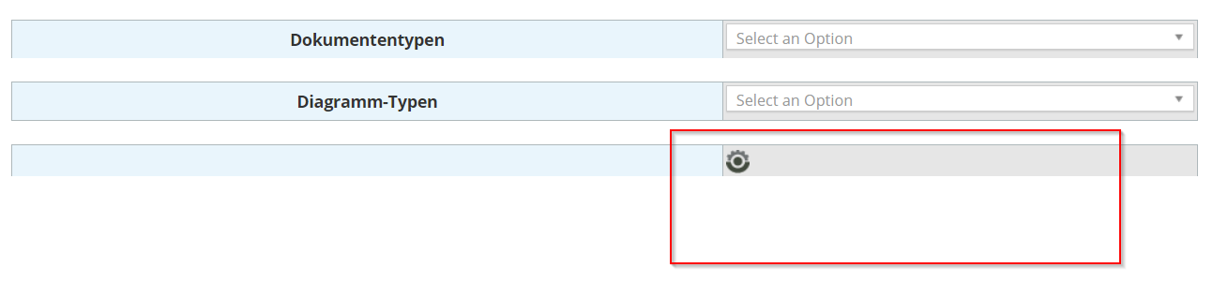

28.AQuaPro - Security Definition New - ‘Done’ Button Missing in German language

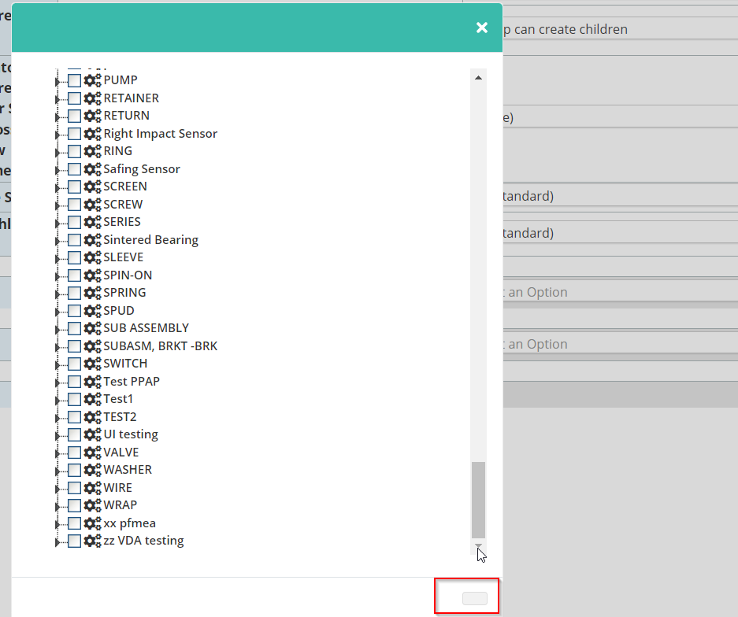

29.AQuaPro - Security Option New – Lable missing in German language

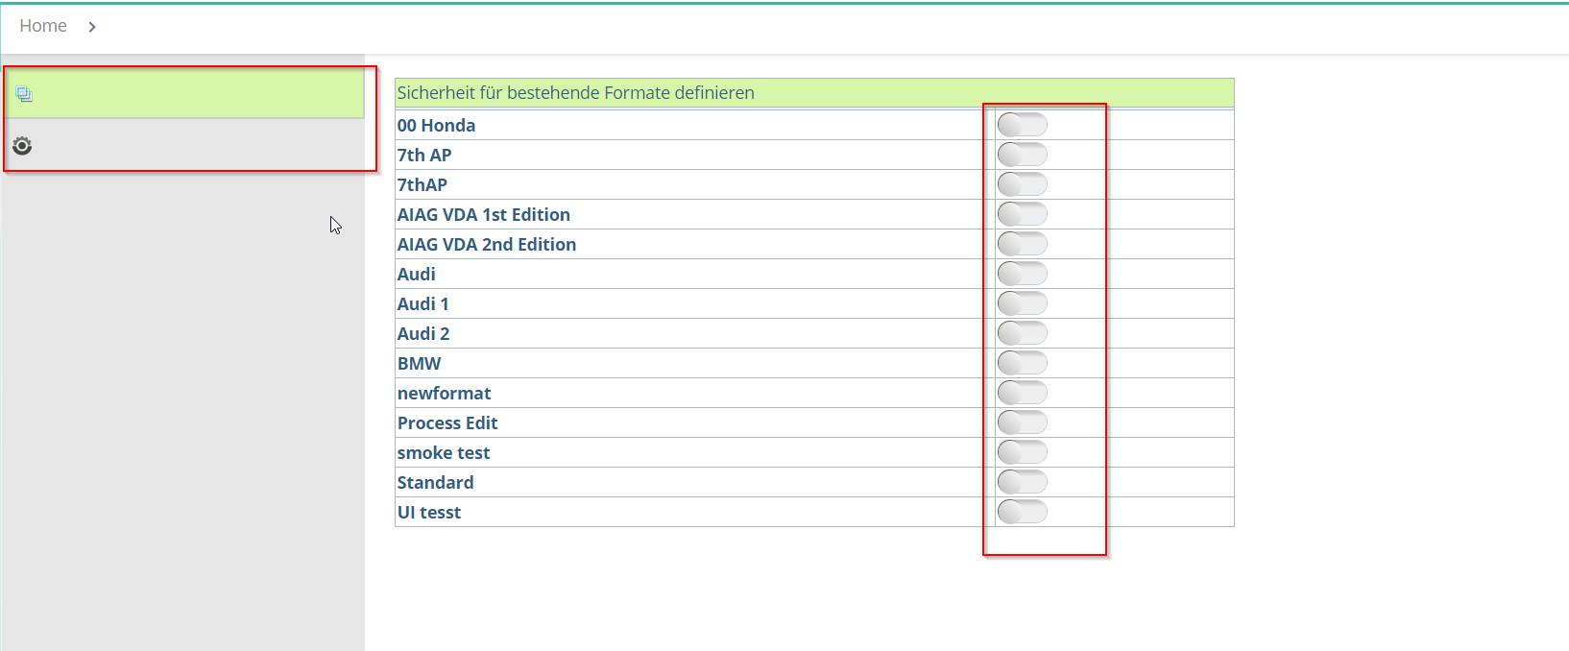

30.AQuaPro - Preference New - Some name is not converting in German language and color is missing in German language

