**Design VDA**

**Structure analysis-> new characteristic**

Maximize the popup and close, and again open the popup it will be maximized, not in the proper alignment

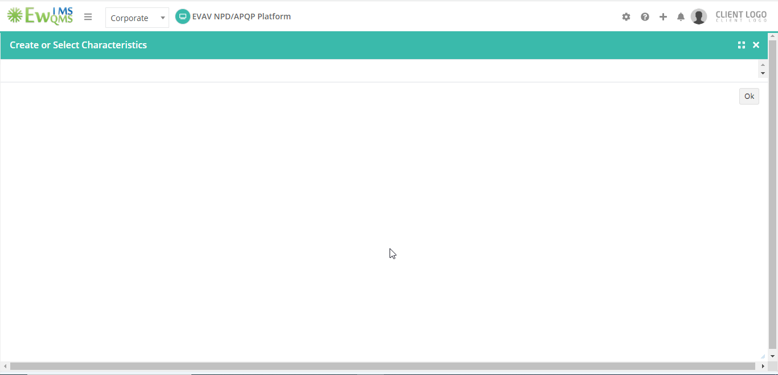

**Interface matrix ->Legend**

Maximize the popup and close, and again open the popup it will be maximized, not in the proper alignment

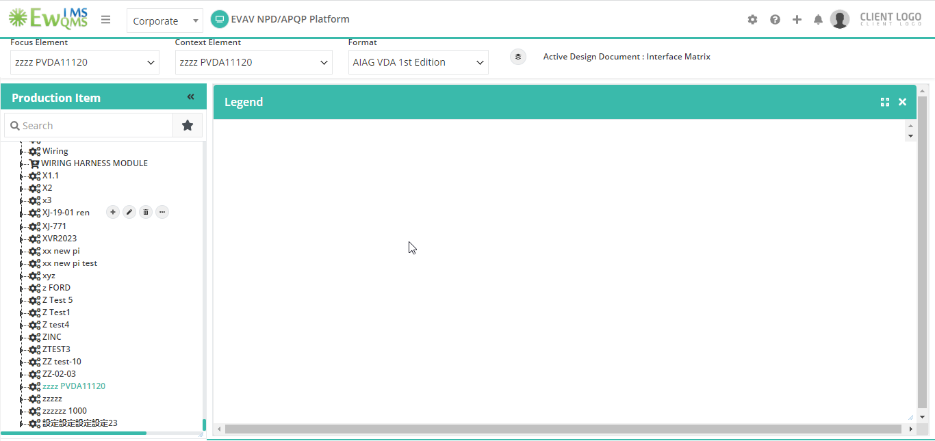

**Failure Analysis-Diagrammatic view->add design cause/New character/Add design effect**

Maximize the popup and close, and again open the popup it will be maximized, not in the proper alignment

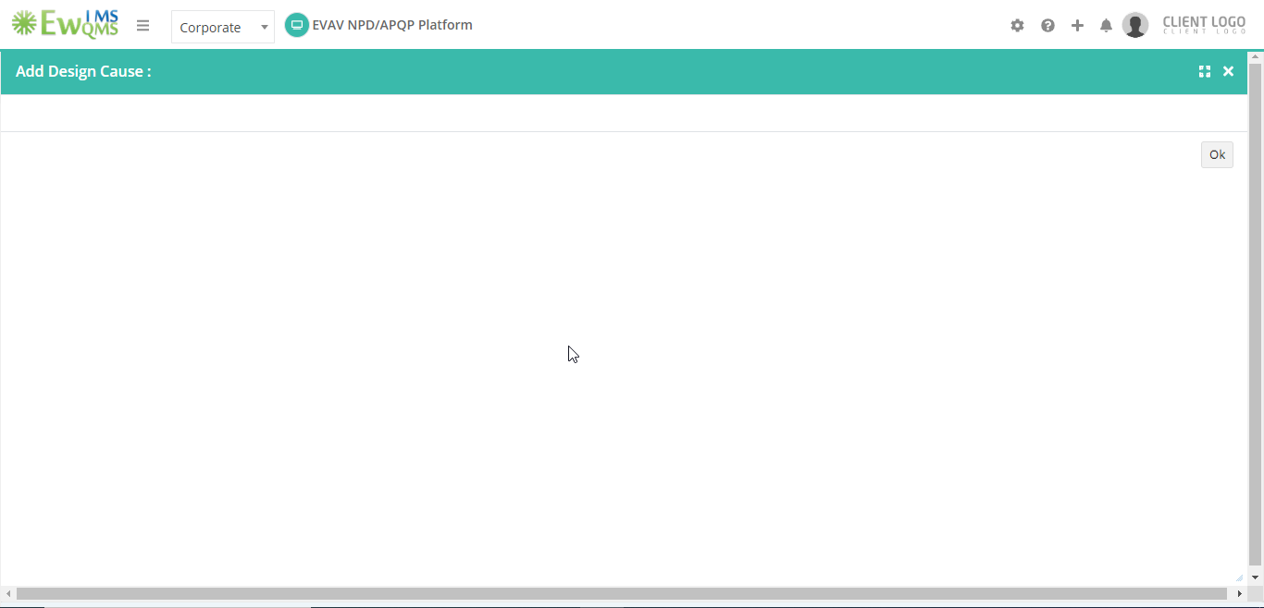

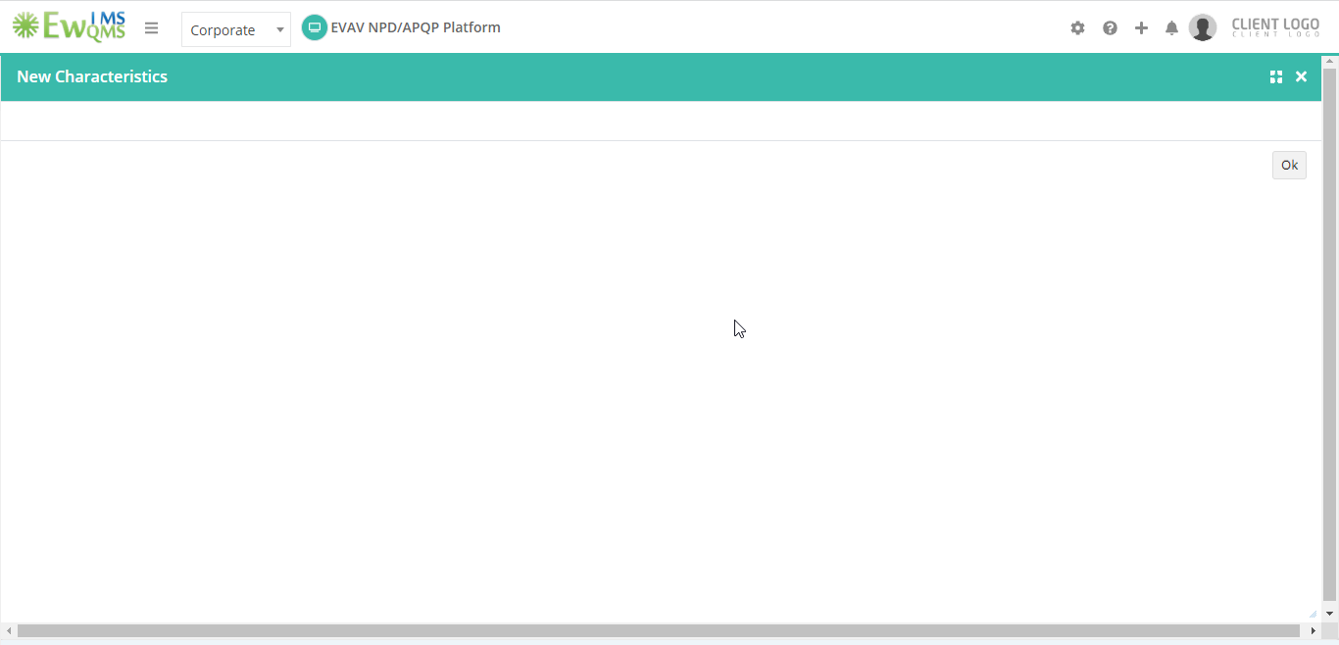

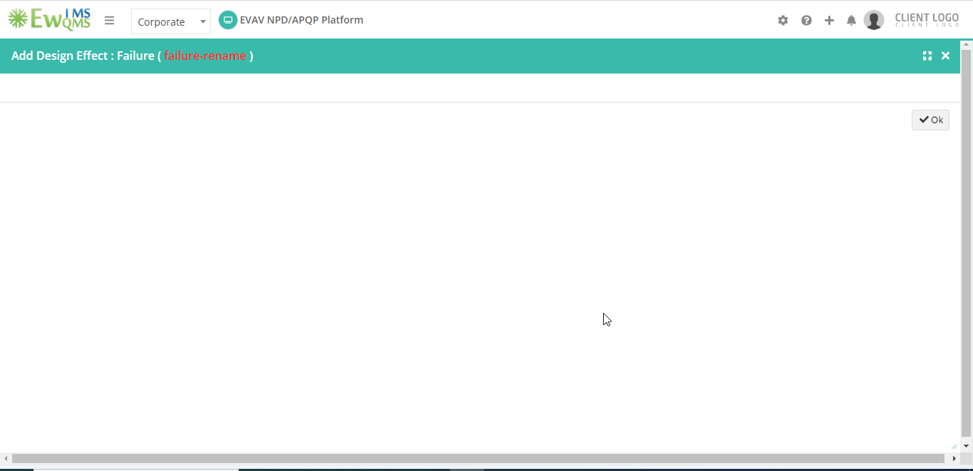

**PVDA**

**Failure analysis RHS-> change character/change failure/change cause/change effect**

Maximize the popup and close, and again open the popup it will be maximized, not in the proper alignment