**VOC**

**Add Existing element**

1. Select the Add existing element, add elements, maximize the popup and close, and again open the popup.

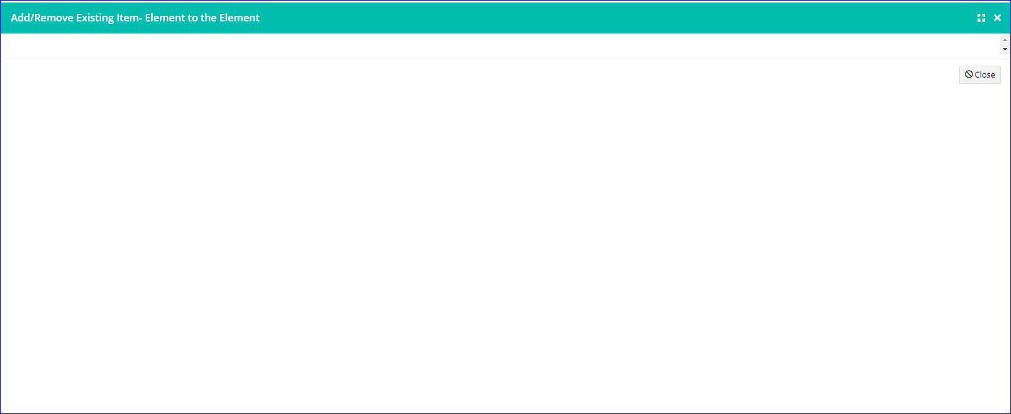

**Allocate to elements**

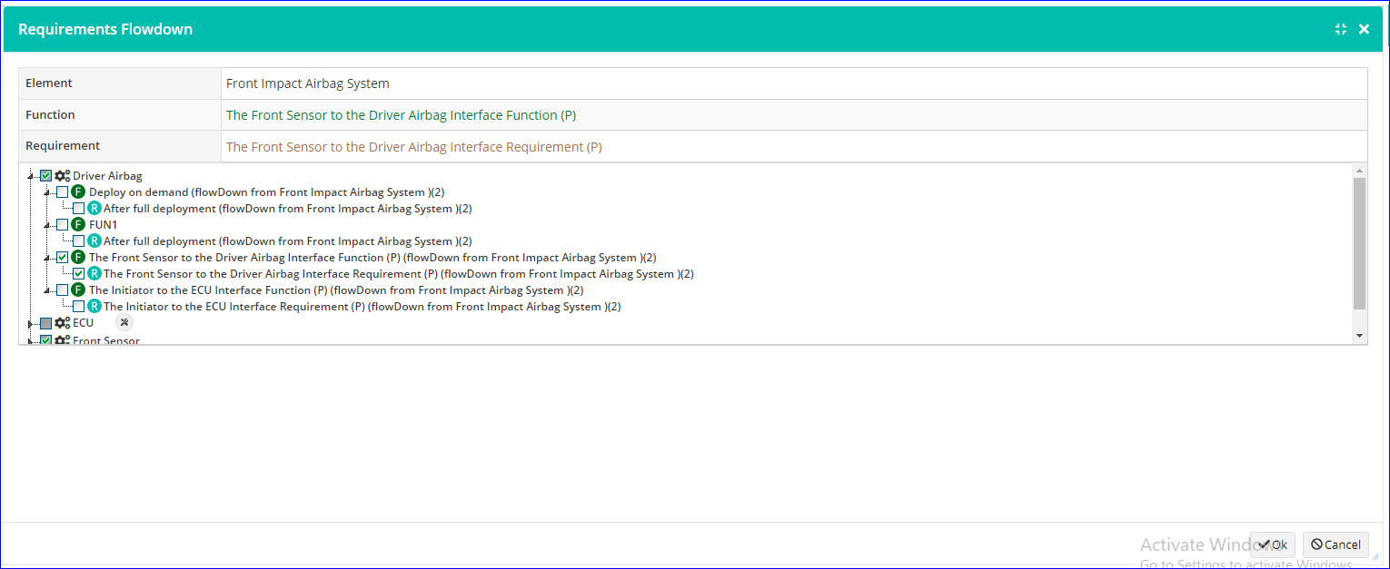

**Insert Image**

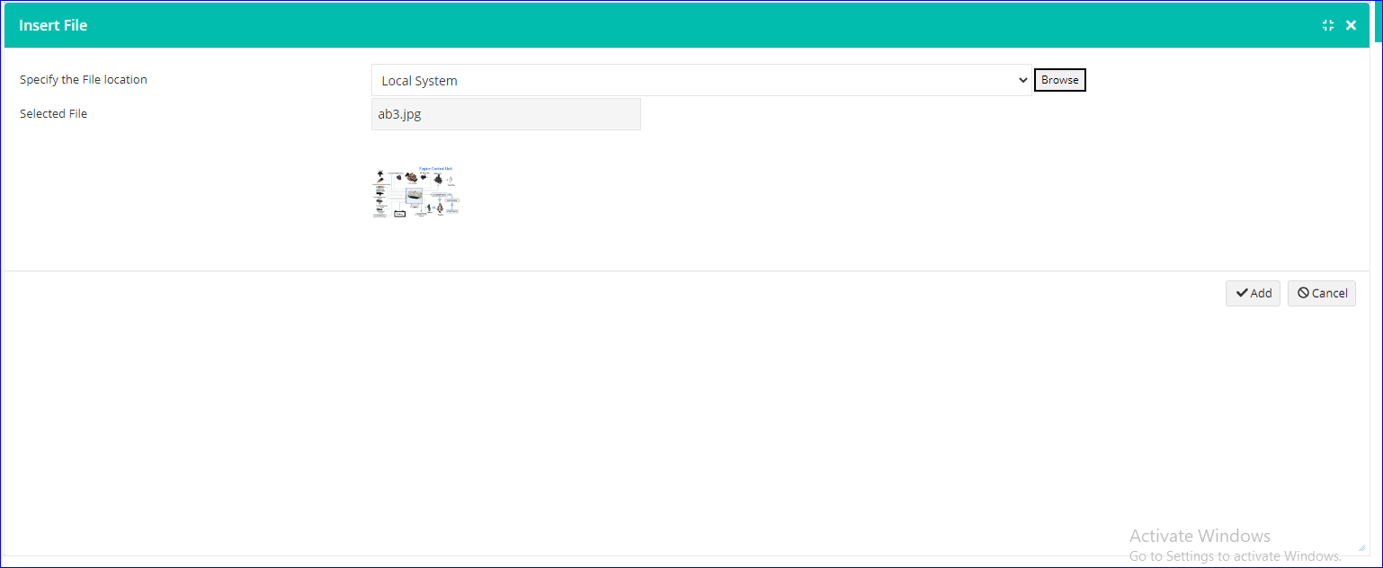

**Initiate change request**

1. For the second time, the maximize icon is missing.

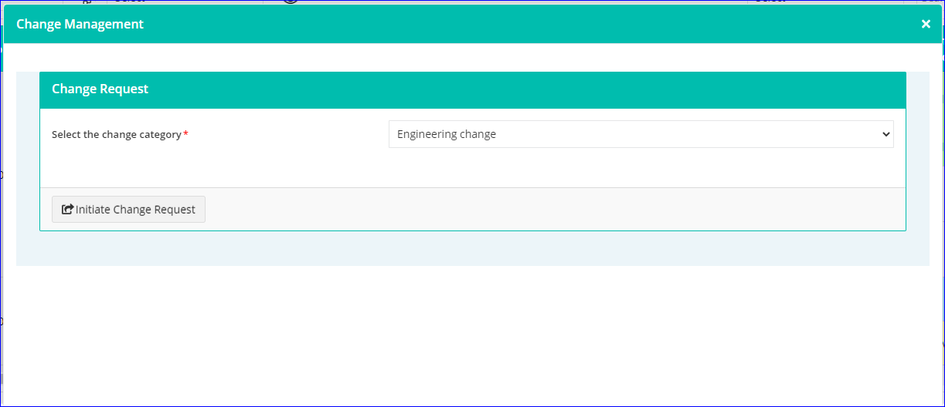

1. For the second time, the change request popup is not showing properly

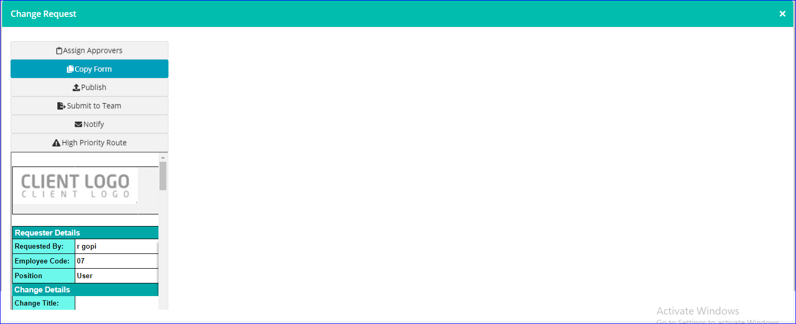

**Enable review**

1. Add reviewers popup space issue
2. Add reviewers popup Maximize icon is missing and not showing the next page option.

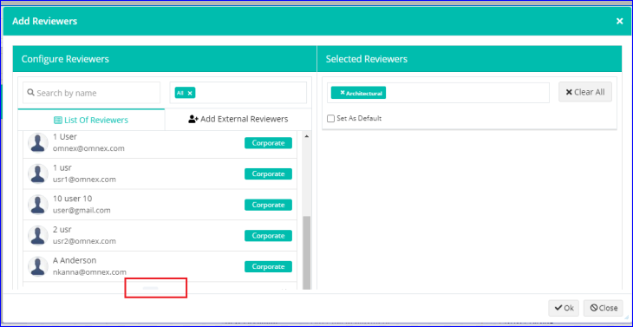

1. Select Configure reviewer from more options or Enable review and select Add Reviewers.
2. After closing the add reviewers popup the maximize icon is missing in all context menus of Function, Requirement, and Description, Requirement Flowdown and Flowup popups, Publish for approval popup, Document view, and Import excel.

**Add/Remove element space issue**

**Interface matrix**

Click on the Legends icon, maximizes the popup, and close it, again open the popup

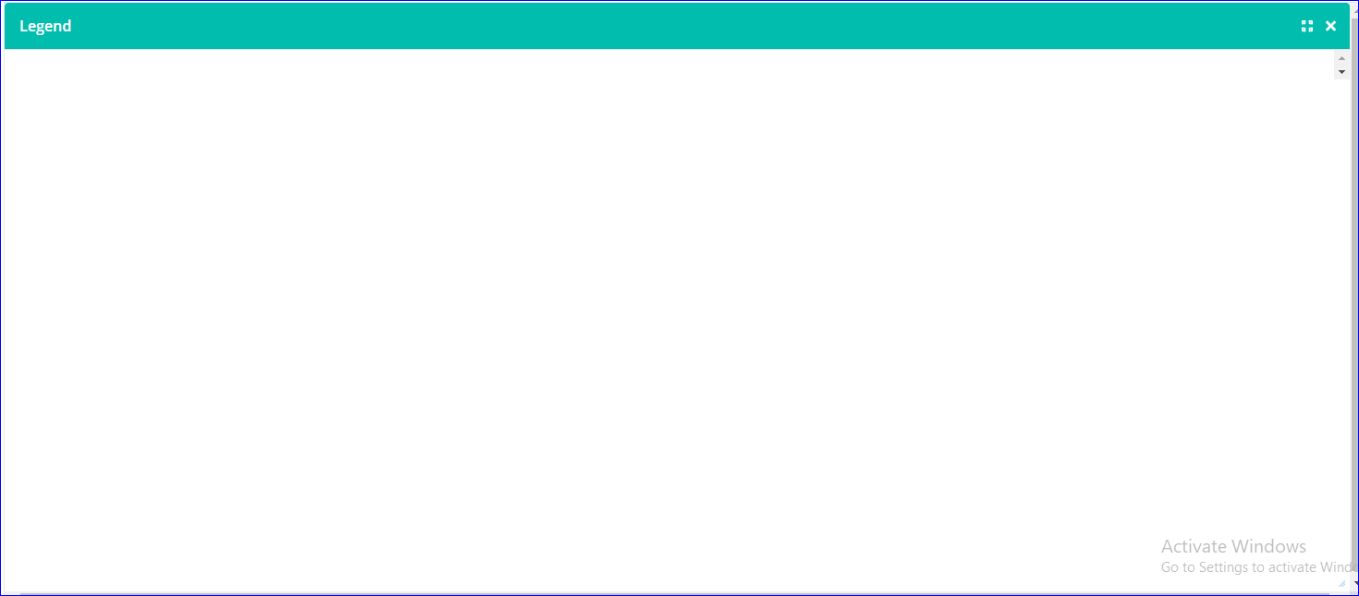

**HARA**

+Effect scrollbar issue and not able to add the new effect

**FSR**

Matrix cell value popup space issue

