**AQuaPro Language Verification (CZECH) SP 10.6.1.13 - 13.05.2022**

1. AQuaPro – Setup – ‘Page’ not converted into the CZECH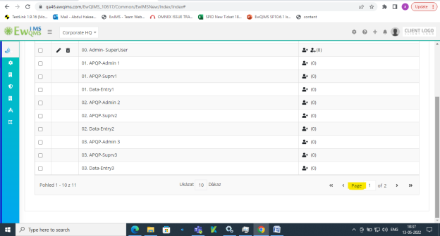

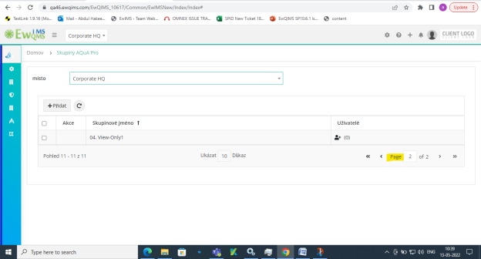

3.AQuaPro – Customize Email – Some names are not converted into the CZECH

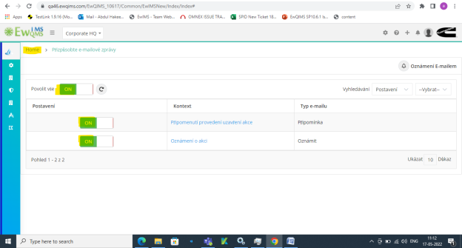

4.AQuaPro – Publish – some fields are not converted into the CZECH

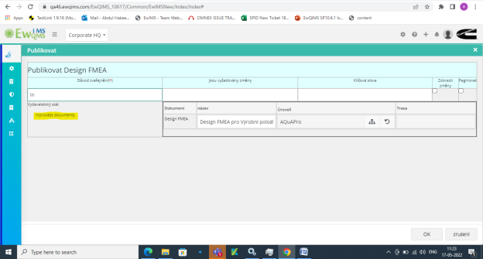

5.AQuaPro – Design FMEA – Column Header Name not showing in CZECH language

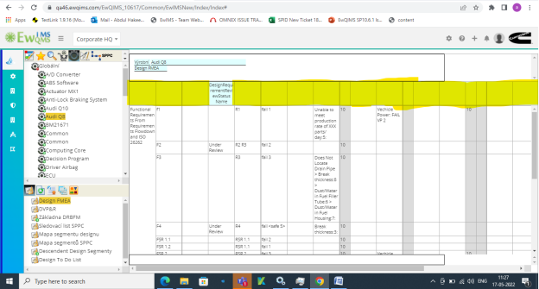

6.AQuaPro – Document Header Right Click – Some function are not converted in the CZECH

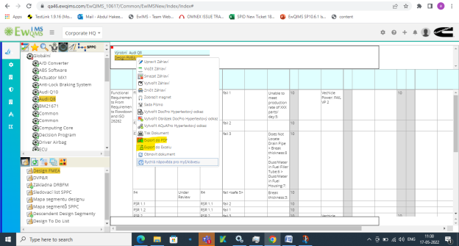

7.DVP&R – Some column header name not showing and some fields are not converted into the CZECH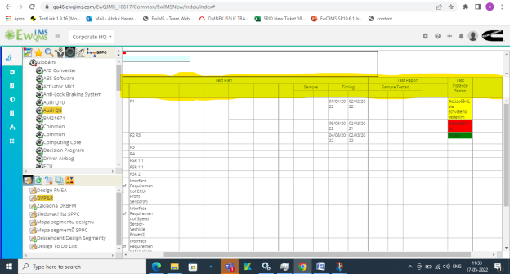

8.DRBFM Base - Some column header name not showing and some fields are not converted into the CZECH 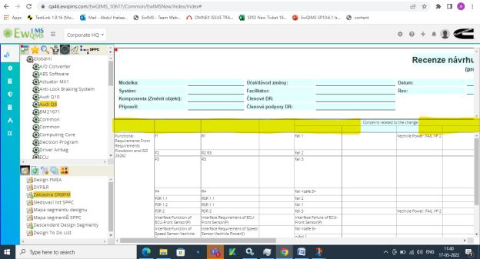

9.Design Segment Map – Column Header name not showing in CZECH language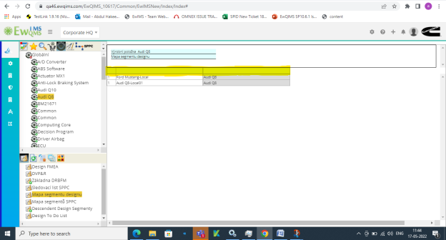

10.SPPC Segment Map - Column Header name not showing in CZECH language 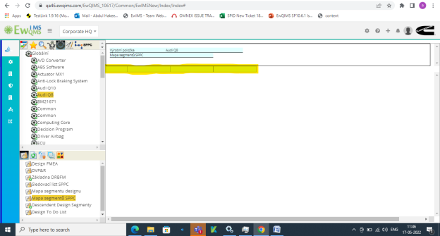

11.Descendant design segment - Column Header name not showing in CZECH language 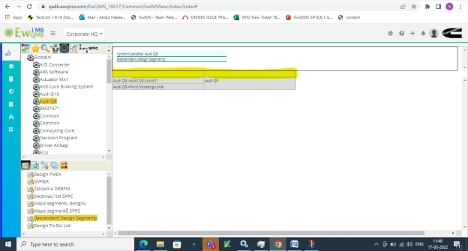

12.Design to do list not converted and column name not showing in CZECH 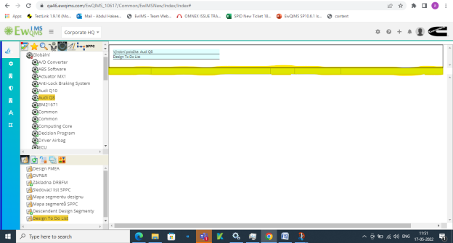

13.Process Flow- Column Header names are not converted into the CZECH 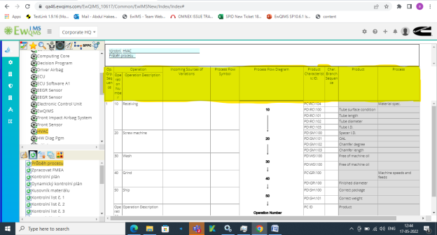

14.Process FMEA - Column Header names are not converted into the CZECH 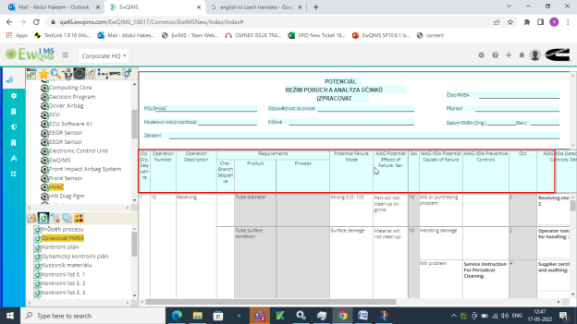

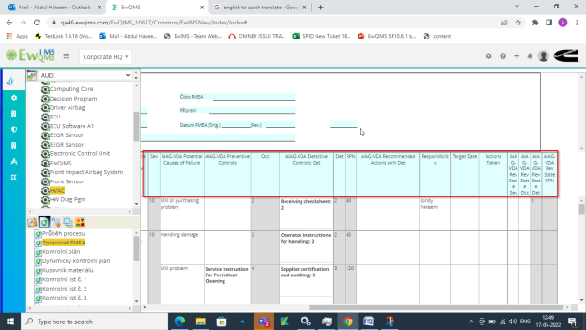

15.Control Plan - Column Header names are not converted into the CZECH 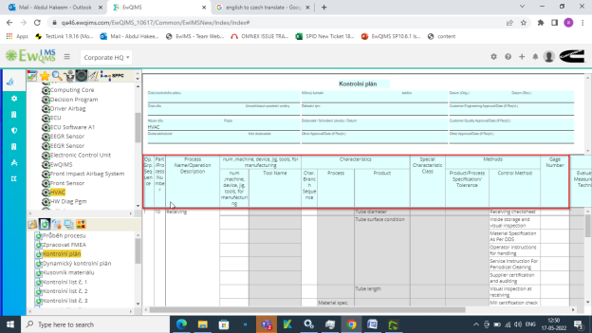

16.Dynamic Control Plan - Column Header names are not converted into the CZECH 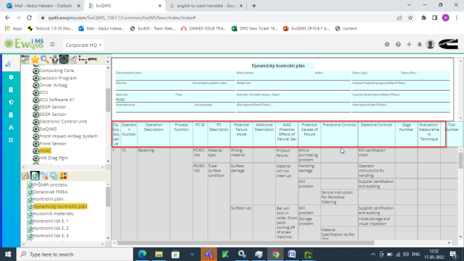

17.Bill Of Material - Column Header names are not converted into the CZECH 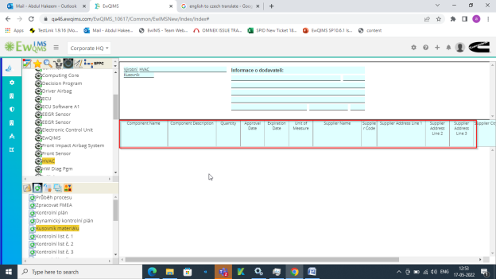

18. Checksheet 1 to 12 - Column Header names are not converted into the CZECH 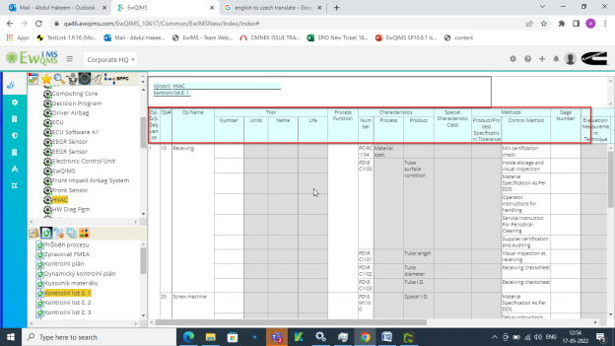

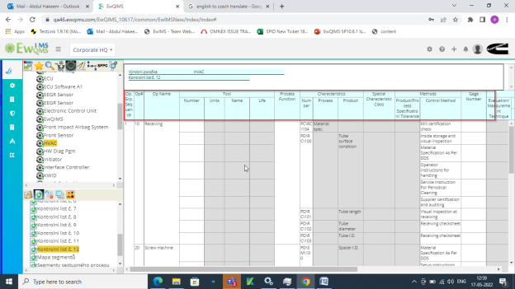

19. Segment Map - Column Header names are not converted into the CZECH 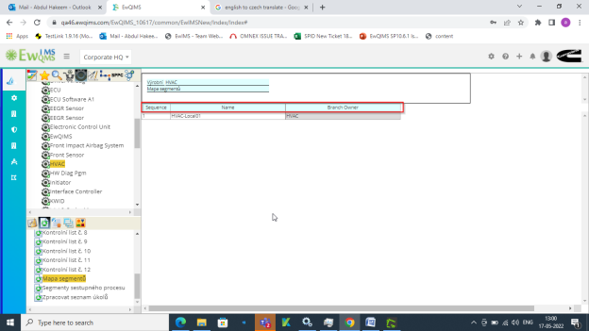

20.Desendant process Segents - Column Header names are not converted into the CZECH 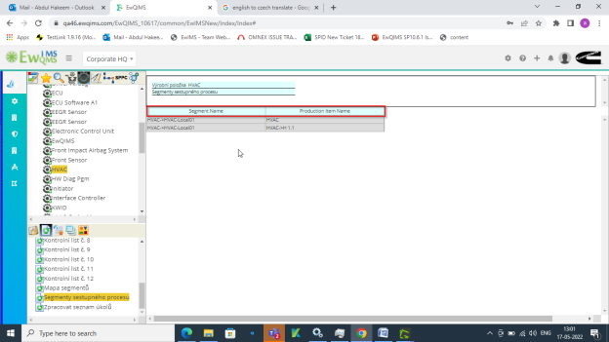

21. Process To Do list - Column Header names are not converted into the CZECH 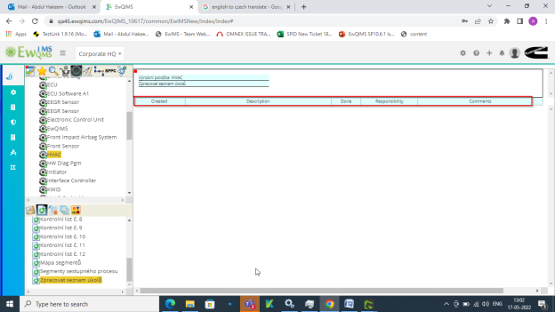

22.Operation Categories - Column Header names are not converted into the CZECH

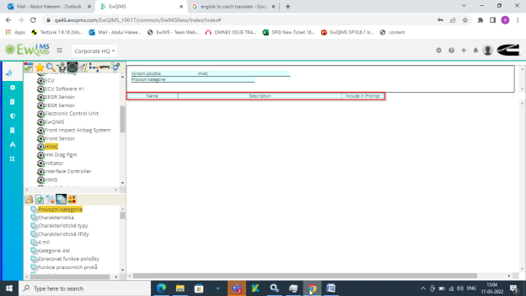

23. Charecterstics - Column Header names are not converted into the CZECH 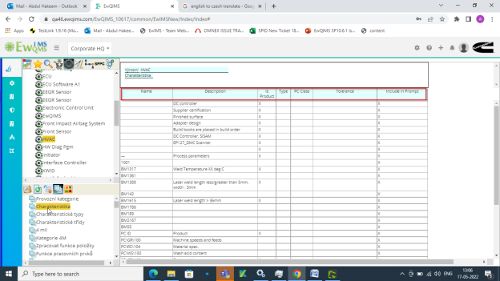

24.Charecterstics Types - Column Header names are not converted into the CZECH 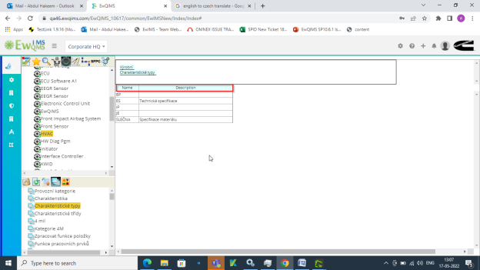

25.Charecterstics Classes - Column Header names are not converted into the CZECH 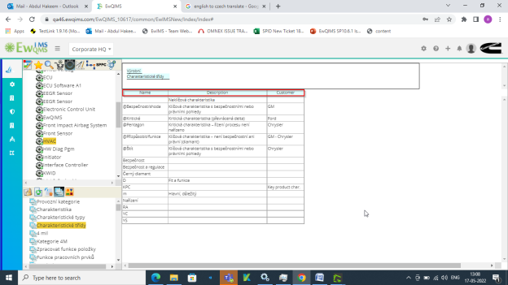

26. Count Units - Column Header names are not converted into the CZECH

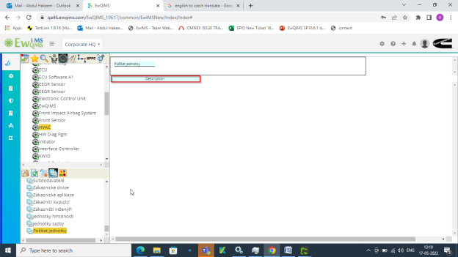

27.Administrator Action – “Home” and Mouse over option not converted into the CZECH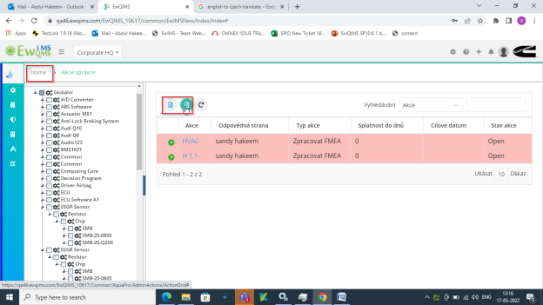

28. Action name is not converted into the CZECH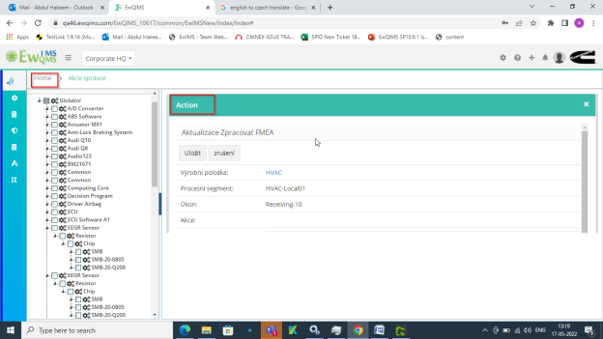

29.Action – ‘In Progress’ field is not converted in CZECH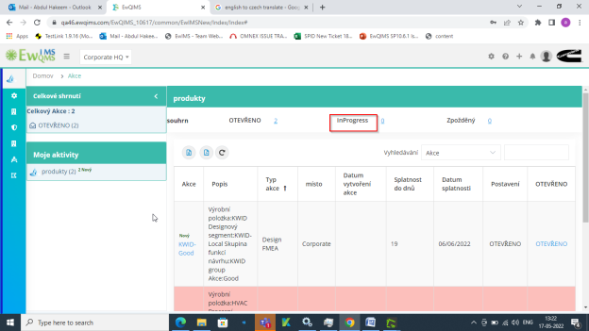

30. ‘Action’ field is not converted in CZECH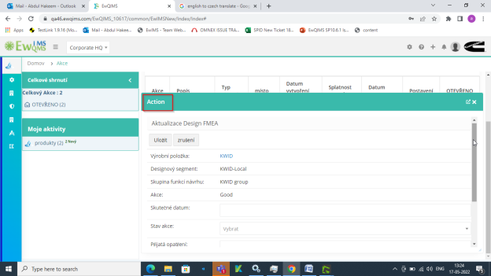

31.Security Definition New – “Home” field is not converted in CZECH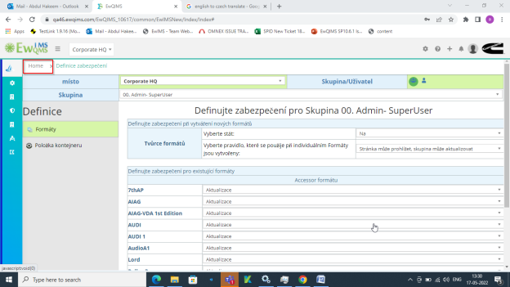

32.Security Definition New – ‘Select an Option’ not converted in CZECH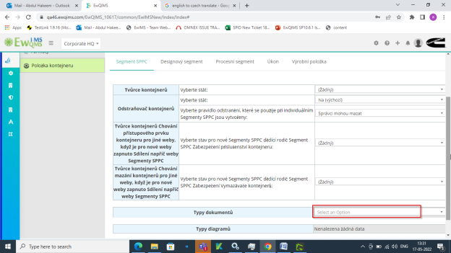

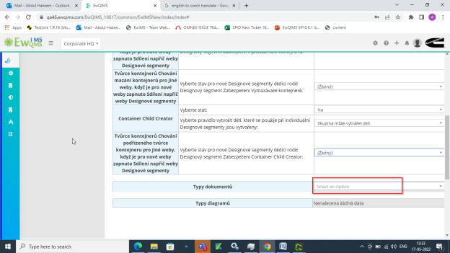

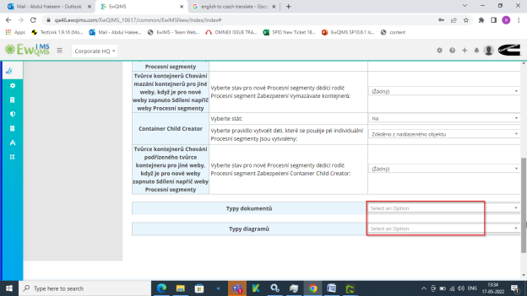

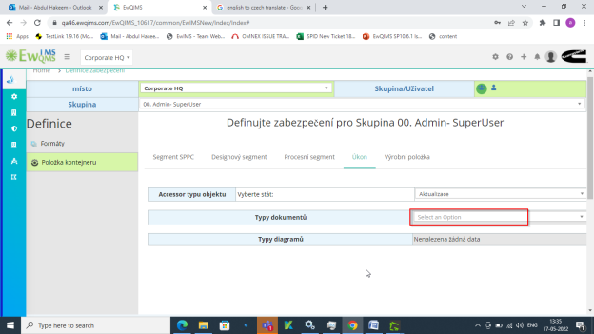

33.Security Definition New – ‘Allow Branch Hide and Highliigh’ is not converted into the CZECH

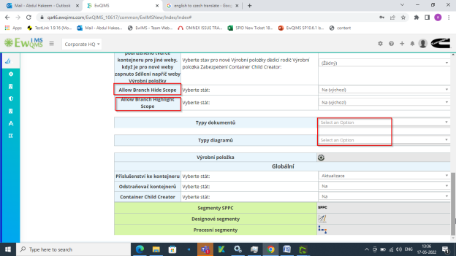

34.Security Option New – ‘Home’ is not converted into the CZECH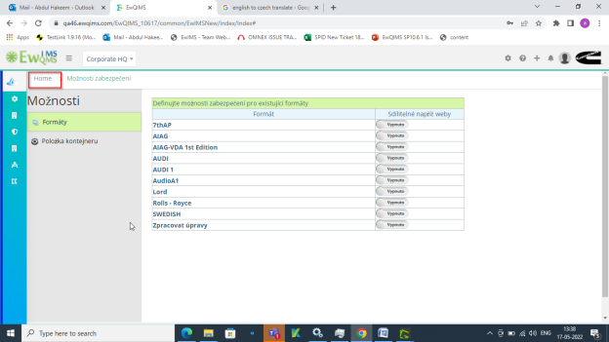

35.Security option new – ‘Global’ is not converted in CZECH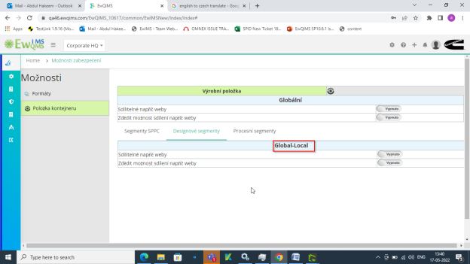

36.Prefernce New – Some field was not converted in CZECH

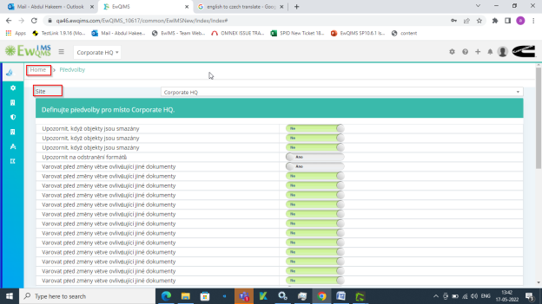

37.Preference New – ‘Select some options’ is not converted in CZECH

