**SWEDISH LANGUAGE VERIFICATION IN SP 10.6.1.13 (06.05.2022)**

1.AQuaPro-User page – ‘Page’ name not converted into the SWEDISH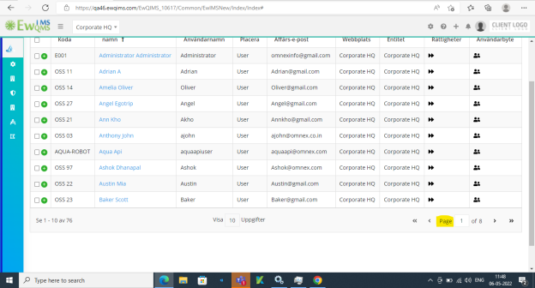

2.AQuaPro – Customize email – Some fields name are not converted into the SWEDISH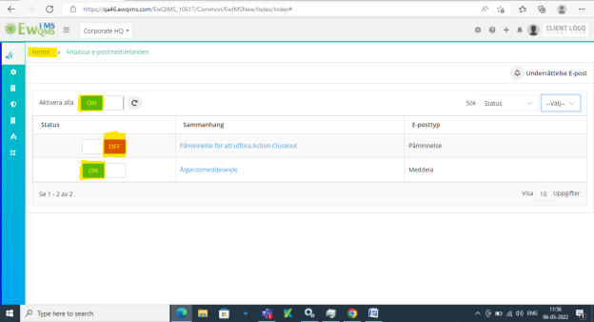

3.AQuaPro – New PI – ‘OK’ field not converted into the SWEDISH

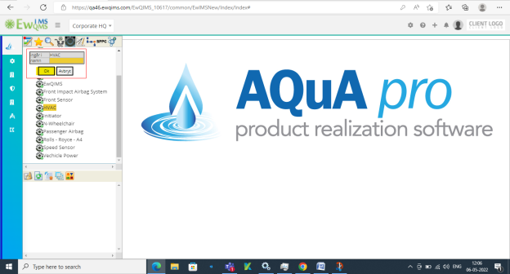

4.AQuaPro – Publish page – Some fields are not converted into SWEDISH

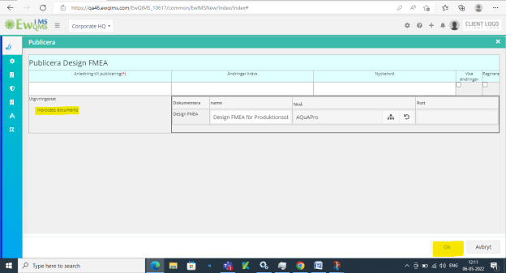

5.AQuaPro – New format – ‘OK’ fields was not converted into the SWEDISH

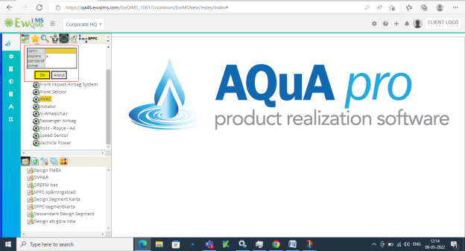

6. AQuaPro – Rename Format - ‘OK’ fields was not converted into the SWEDISH 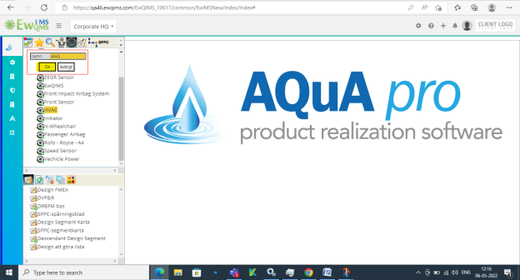

7. AQuaPro – User Preference - OK’ fields was not converted into the SWEDISH 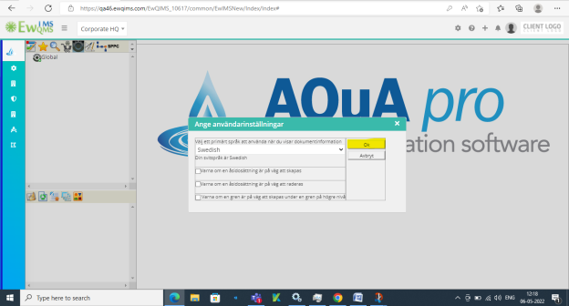

8. AQuaPro – Add Document – ‘OK’ button not converted into the SWEDISH 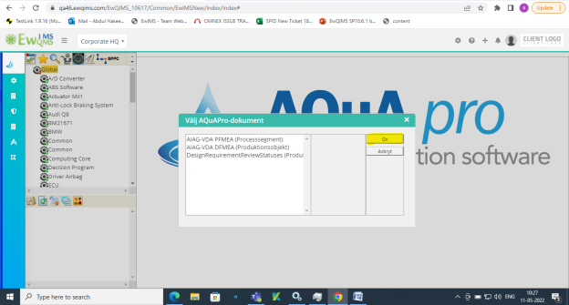

9. ‘SELECT FORMAT and OK’ names are not converted into the SWEDISH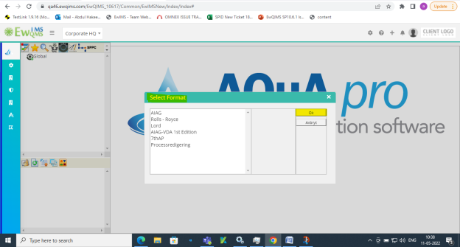

10. 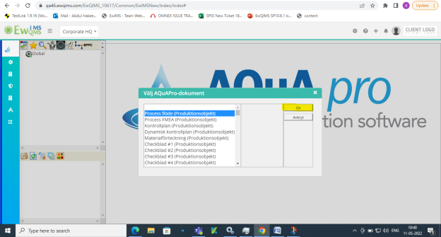

11.AQuaPro-Edit production item properties- ‘OK’ field was not connverted into the SWEDISH

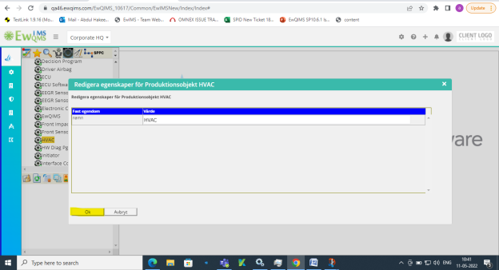

12.Design FMEA – Column Header not showing in SWEDISH language and also not converted into the SWEDISH 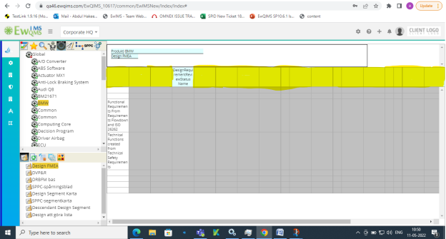

13. Docpro hyperlink – ‘OK’ button not converted into the SWEDISH language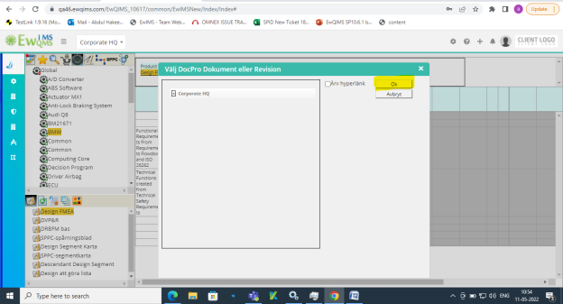

14.DVP&R – Column Header not showing in SWEDISH language and also not converted into the SWEDISH

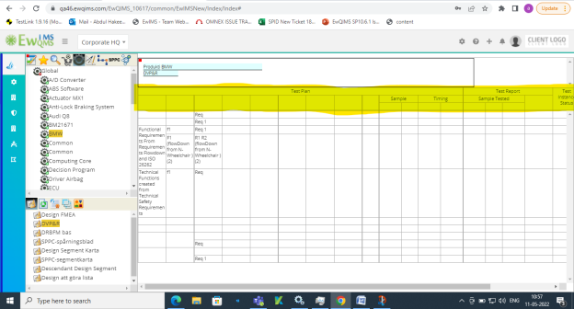

15. DRBM Base- Column Header not showing in SWEDISH language and also not converted into the SWEDISH

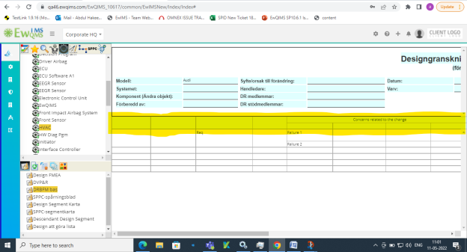

16.Design Segment Map - Column Header not showing in SWEDISH language and also not converted into the SWEDISH

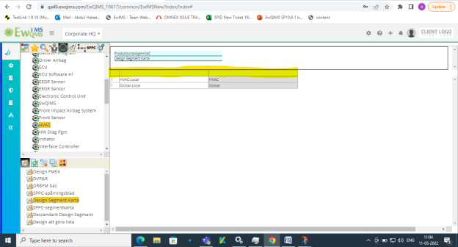

17.SPPC Segment map - Column Header not showing in SWEDISH language and also not converted into the SWEDISH

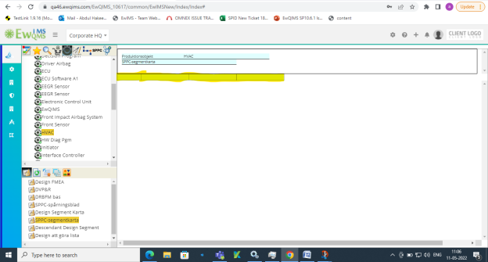

18.Desendant Design Segment – not converted into the SWEDISH language and Column Header not showing in SWEDISH language 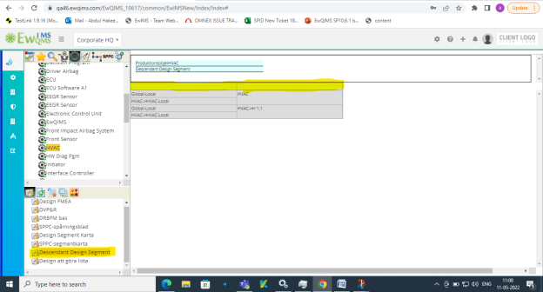

19.Design TO DO list - Column Header not showing in SWEDISH language and also not converted into the SWEDISH 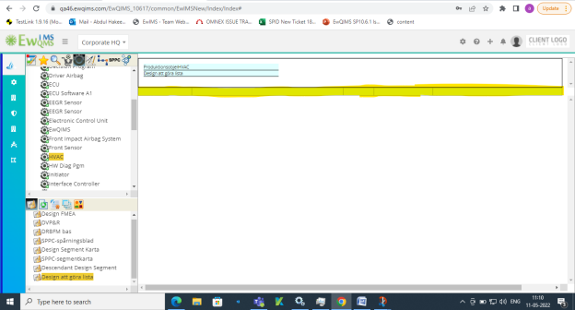

20.Process FLOW - Column Header not showing in SWEDISH language and also not converted into the SWEDISH 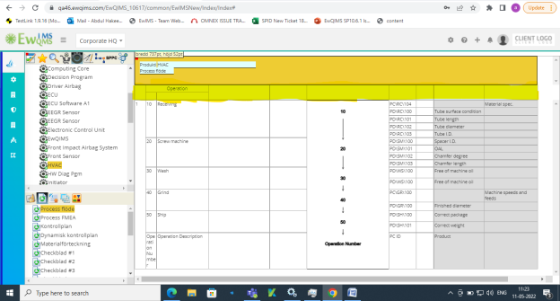

21.Process FMEA - Column Header not showing in SWEDISH language and also not converted into the SWEDISH 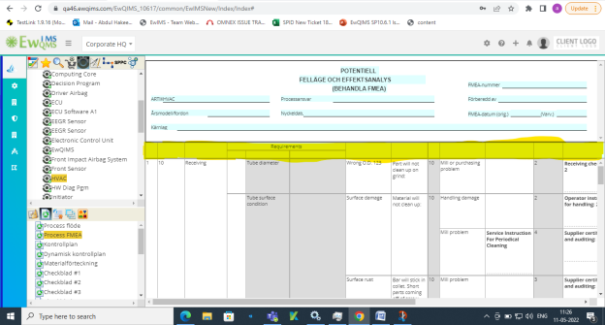

22.Control Plan - Column Header not showing in SWEDISH language and also not converted into the SWEDISH 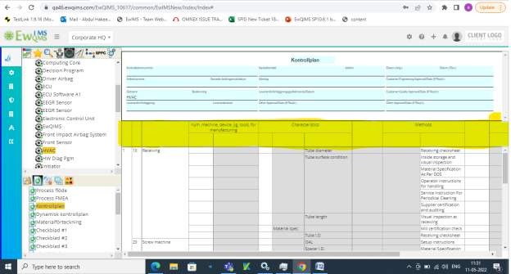

23.Dynamic Control Plan - Column Header not showing in SWEDISH language and also not converted into the SWEDISH 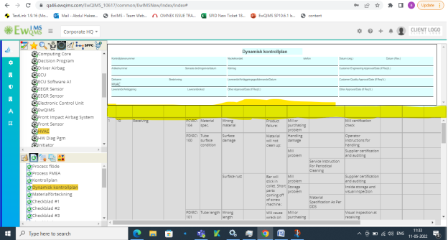

30.Bill Of Material - Column Header not showing in SWEDISH language and also not converted into the SWEDISH 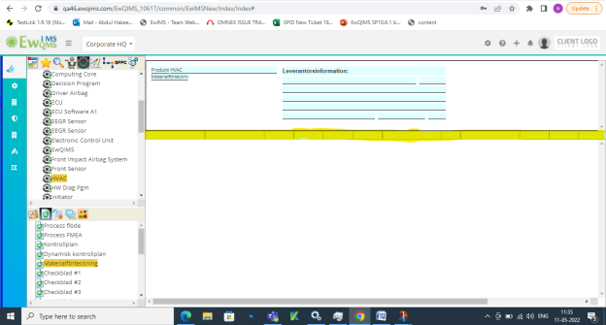

31.Checksheet 1 to 12 - Column Header not showing in SWEDISH language and also not converted into the SWEDISH 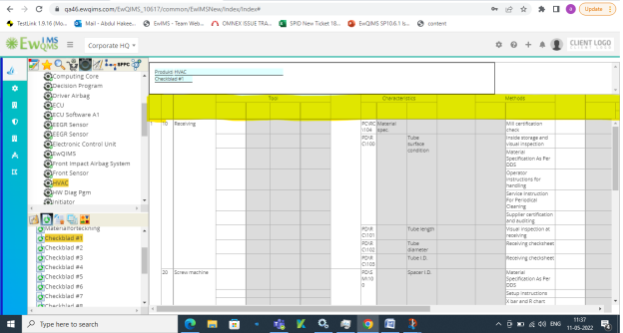

33.SegmentMap- Column Header not showing in SWEDISH language and also not converted into the SWEDISH 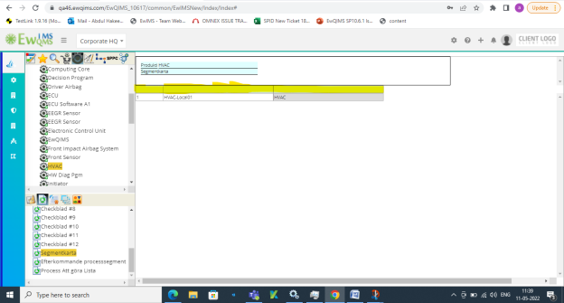

34.Desandant Process Segment - Column Header not showing in SWEDISH language and also not converted into the SWEDISH 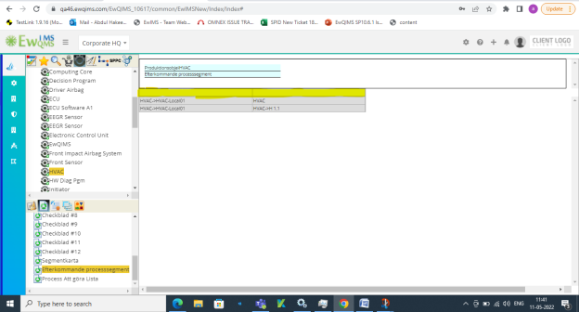

35.Process To DO list - Column Header not showing in SWEDISH language and also not converted into the SWEDISH 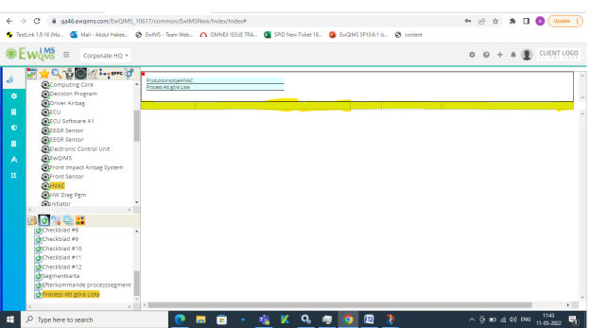

36. Operation categories - Column Header not showing in SWEDISH language and also not converted into the SWEDISH 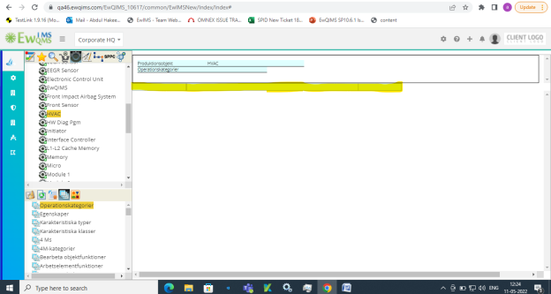

37.Characterstics - Column Header not showing in SWEDISH language and also not converted into the SWEDISH 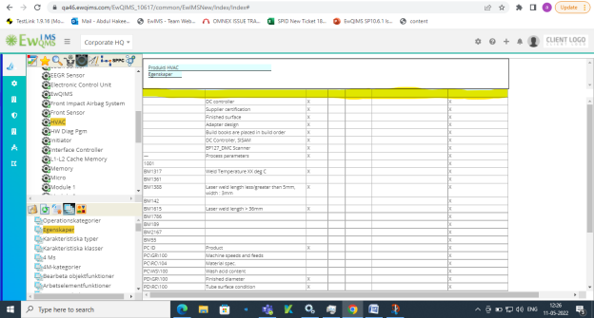

38. Charecterstics types - Column Header not showing in SWEDISH language and also not converted into the SWEDISH 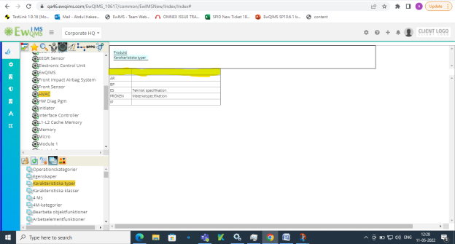

39.Charecterstics class - Column Header not showing in SWEDISH language and also not converted into the SWEDISH 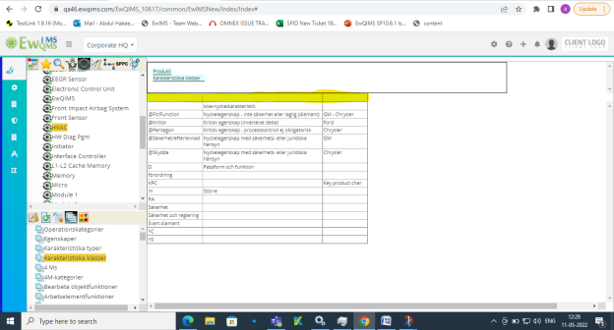

40. Production item assembly flow – Some field are not converted into the SWEDISH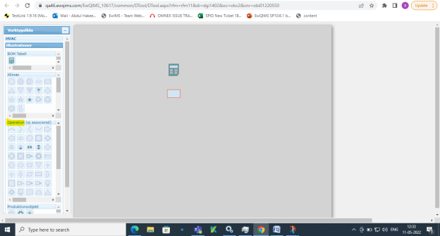

41.work Instruction – Column header name not showing in SWEDISH language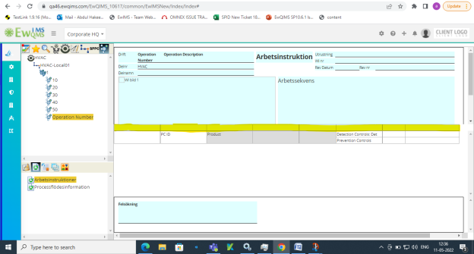

42.Process Flow information - Column header name not showing in SWEDISH language 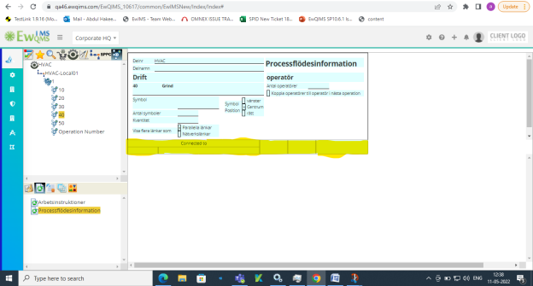

43.Administrator Action – ‘HOME’ not converted into the SWEDISH language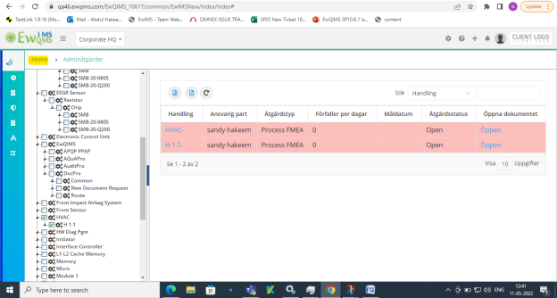

44.Action – Some name is not converted into the SWEDISH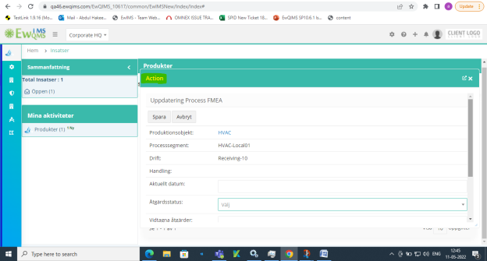

45.Security Definion New – Some fields are not converted into the SWEDISH 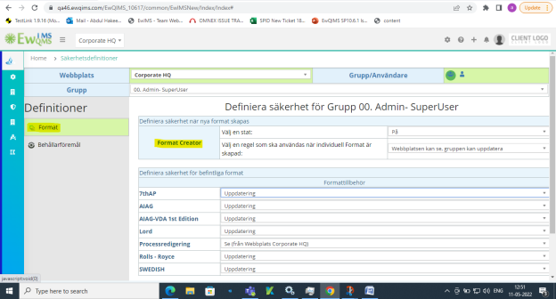

46.Security Definition new – SPPC Segment - s‘Container creator and Deleter’ not converted into the SWEDISH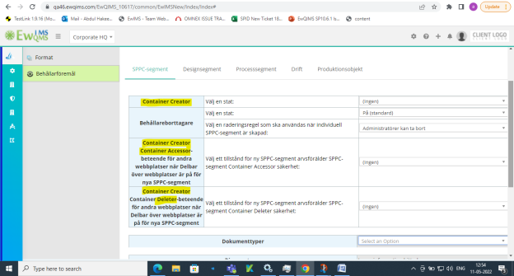

47. Security Definition new – Design Segment - s‘Container creator and Deleter’ not converted into the SWEDISH 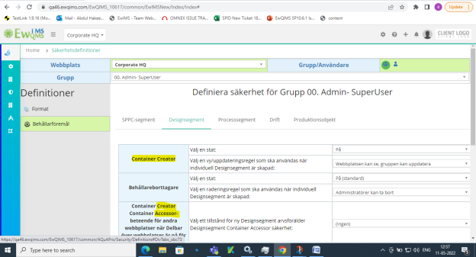

48. Security Definition new – Process Segment - s‘Container creator and Deleter’ not converted into the SWEDISH 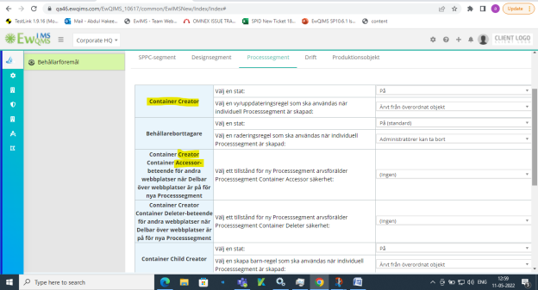

49. Operation – ‘Select an operation’ not converted into the SWEDISH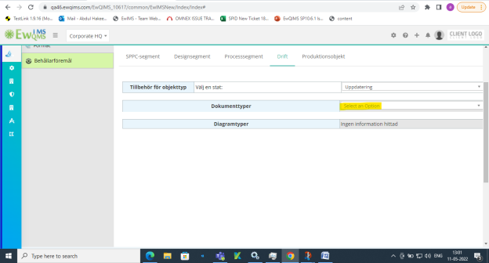

50.Security Definition New - Production Item – ‘Container Creator’ not converted into the SWEDISH 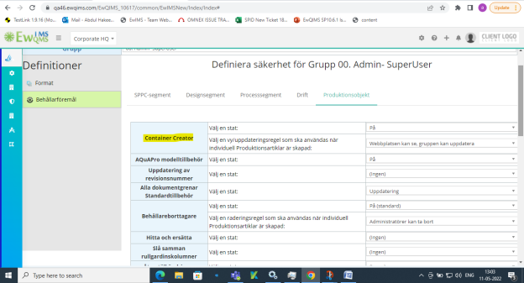

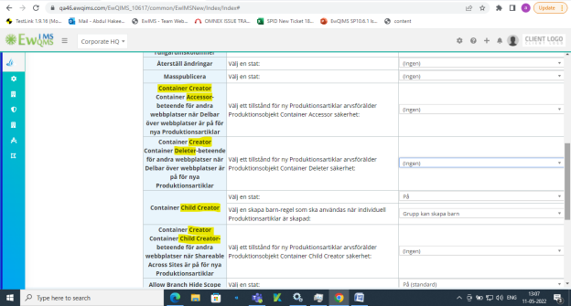 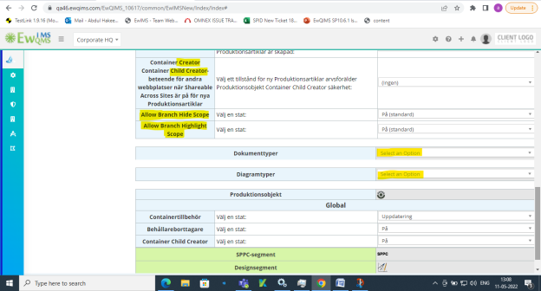

51.Security Options New – Some fields are not converted into the SWEDISH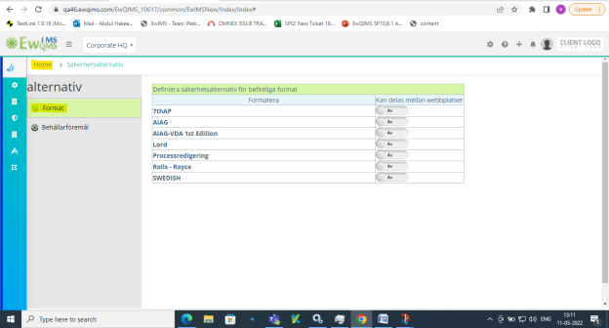

52.Preference New – Some fields are not converted into the SWEDISH